**Rallyteam Technical Exercise**

**Analysis:** You should have received an email to sign up for our preprod environment for this.

**Analysis - Part I**

Rallyteam’s core concept is the **Marketplace**. This is where users login to look for potential opportunities (Projects/Jobs) to work on and/or post opportunities asking for help. For some of our pilots, **user engagement is starting to drop** - users log in, **browse some opportunities** and **don’t come back.**

1. **How would you address this problem?**

As I understand, Rallyteam helps increase internal fill rates and reduce attrition by matching employees to new opportunities. There are two types of users for Rallyteam:

* Type I: Employees (Freelancers) come to look for opportunities/challenges (new projects/jobs)
* Type II: HRs/Project Managers/Project Owners come with an opportunity (projects/jobs), and look for helps

1. First, to address this problem, we need to figure out our targets, i.e., who are not engaged, Type I user, Type II user, or both? Furthermore, we would also like to know are there any patterns of users who are not engaged. For example, are users who are not engaged all work in finance?
   1. To do this, we need to collect data on user engagement: who start to be less engaged during the process? Are them all Type I user, or Type II user? Are them from specific fields, or in general from different fields?
2. Second, after we figure out the targets having engagement problems, we need to know why they are not engaged (the underlying reasons).
   1. Therefore, we need to talk to our users. Basically, we should sample pilot users from the less engaged pool, and then interview those users, to understand their thoughts, concerns, and needs.
      1. What are the things they like regarding the Marketplace?
      2. What are the things they don’t like, that stops them from revisiting the site and joining the opportunities?
      3. Do they feel it is hard to navigate/search the site, to find the useful information they want, or to post new opportunities (projects/jobs)?
      4. Are the searching results presented to them clear, easy to interpret, and informative?
      5. **For Type I user:** Are the opportunities provided on the Marketplace not of their interests? If yes, what kind of opportunities they will be more interested at?
      6. **For Type I user:** What are the things missing on the Marketplace that makes them less interested in the opportunities provided on the site? What are the things they want to know through Marketplace, about position/job posts?
      7. **For Type II user:** What are the things they want to know about potential candidates? Skillsets? Completion rate of projects they participate in?
      8. **For Type II user:** Is it easy to find a match for a project/job?
      9. ...
3. Another interesting aspect worth looking at is for those who are always engaged in the pilot study, what are the things that attract them to keep interacting with the site and participating the opportunities posted on the site. Hence, we might also want to find out the users who are engaged all the time, and then do interviews with them, to figure out what functionalities on Marketplace attract them most.

Afterwards, we will analyze all collected data, to summarize the underlying reasons why users are not engaged all the time and also what attract active users to be engaged, for Type I and Type II users. Things we expect to learn from the data include:

* Aspects of existing Marketplace that users like, don’t like.
* Any technical issues than hinder user from navigating smoothly with the sites and finishing their tasks.
* **For Type I user:** Additional things users want to know about positions/jobs after interacting with Marketplace, but are missing currently.
* **For Type II user:** Additional aspects they want to know about potential candidates on the Marketplace.
* ...

Last but not least, in addition to current pilot users, it would also be interesting to know in general, what are things that cheer people up while they are searching for new job/project opportunities. Hence, if time and budgets permit, an online questionnaire (which describes the usage scenarios of Rallyteam marketplace) should be done with a larger user pool, to collect people’s opinions on “what stimulates them”, while selecting new opportunities to work on. This can confirm our findings with all existing pilot users, and potentially extend the findings to a certain degree.

1. **What are some solutions you would propose to encourage users to post and join opportunities?**

First, I tried to play around the platform and collect data about what information the system presents now. Afterwards, I hypothesized the reasons of why users become less engaged based on my own experiences with the platform and the document “The Complete Guide to Working with Freelancers”, [1] and then come up with potential solutions. In the following table, I discuss my hypothesized potential reasons why users engage less and corresponding solutions for encouraging them to post/join opportunities based on the user type (Type I / II). (The original excel file of the following table is provided inside the zip file.)

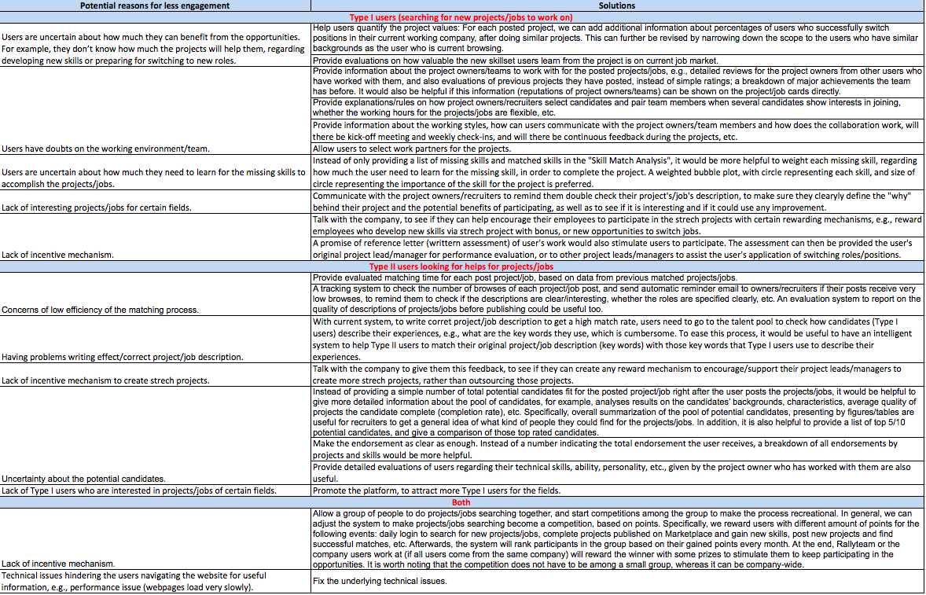

**Analysis - Part II**

The **core** piece of **data** that the Rallyteam platform relies on when matching users to opportunities is the **user profile**. A user’s profile constitutes of data elements that describe users’ experience, education and expertise. However, we’ve noticed that **not all users keep their profile up-to-date or never fill it out**.

1. **How would you encourage users to keep their profiles up-to-date?**

To answer this question, I first did a small survey among my friends, with detailed explanations of the usage scenario, to collect their preferences of incentives that would encourage profile updates. Based on the collected data, I summarize the suggestions I came up in the following list.

* First, we should take the advantage of connecting with external sources like LinkedIn, by enabling automatic updates of user’s profile based on their profile information on LinkedIn.
* Second, it is useful to help users vision the benefits/results they can get if they can keep profiles up-to-date. Hence, I would suggest to send users the following analysis results on a regular basis:
  + Distribution of chances of successfully switching jobs VS completeness of user profile.
  + Distribution of chances that project leads/managers view your profile VS completeness of user profile.
  + Predictions on number of new projects/jobs the users can be involved in if they keep their profile up-to-date.
    - This can be done based on the “Skills to develop” users provide initially, considering that these are potential skills they plan to develop and master.
  + Predictions on what kind of new opportunities (new positions/jobs they can switch to) will arise in the near future, to encourage them update profiles to get the opportunities.
    - The predictions can be done based on the company’s profile and developing situations.
* Third, it would be encourage if the system can track users’ profile changes (major updates of new skill sets) and notify project leads/managers, to help users get higher chances for getting new opportunities.

1. **How would you encourage users to fill it out after registration?**

To encourage users to fill out profiles after registration, there would be two options: force and incentive.

* First, we can specify the rules that only users who complete their profile can browse latest posted projects/jobs, or post new projects/jobs.
* Second, only users who have completed their profiles can comment.
* Third, users who have completed their profiles can have free access to relevant courses/trainings, etc.
* Fourth, allow users to connect with each other, and only users who have completed their user profiles can connect to expert users (or those who have successfully switched roles) for learning experiences.
* Fifth, provide recommendations on potential project lead/manager the users can build connections with, for users who have completed profiles.

**Technical Challenge – Job scraping and aggregation:**

**Scape** jobs **from** **Google and Microsoft** career sites. Store this data and use it to:

Build a job dashboard that shows:

* A list of all the scraped jobs. For each job in the list it shows the title and the company name.
* When you click on a job it takes you to a **Job details** view showing the **title** and **description** for the job and a list of **‘Similar jobs’**. **It's up to you to determine the criteria for similarity between jobs.**

**NOTES:-**

* You are allowed to use **any libraries or frameworks** (assuming no licensing restrictions).
* For the Job Dashboard UI we are looking for a fairly basic UI design, don’t spend too much time on this.
* Please check in and submit your source code into Github with instructions on how to run it.
* Feel free to reach out if you run into roadblocks.

1. [The Complete Guide to Working with Freelancers](https://rallyteam.com/portfolio/how-to-work-with-freelancers-guide/)