Screenshot AWS Configuration

S3 3

Gifs-group-8 3

Properties 3

Permissions 3

Management 4

images-group-8 5

Properties 5

Permissions 5

static-website-group-8 7

Permissions 7

API Gateway 8

GifAPI 8

/adduser 9

/upload 9

/user 9

Lambda 10

loginUser 10

Configuration 10

UploadImageNode 11

Configuration 11

creatUser 11

Configuration 11

createGif 12

Configuration 12

GIFDownloadLink 12

Configuration 12

DynamoDB 13

IAM 13

S3ReadOnly 13

lambda-gif-api-role 14

# S3

# 

## Gifs-group-8

### Properties



### Permissions

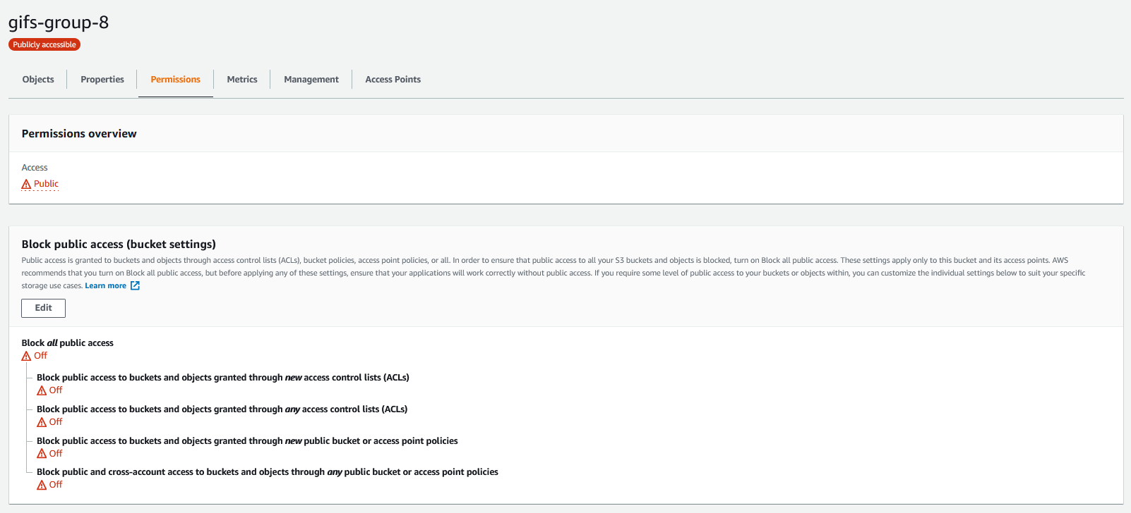

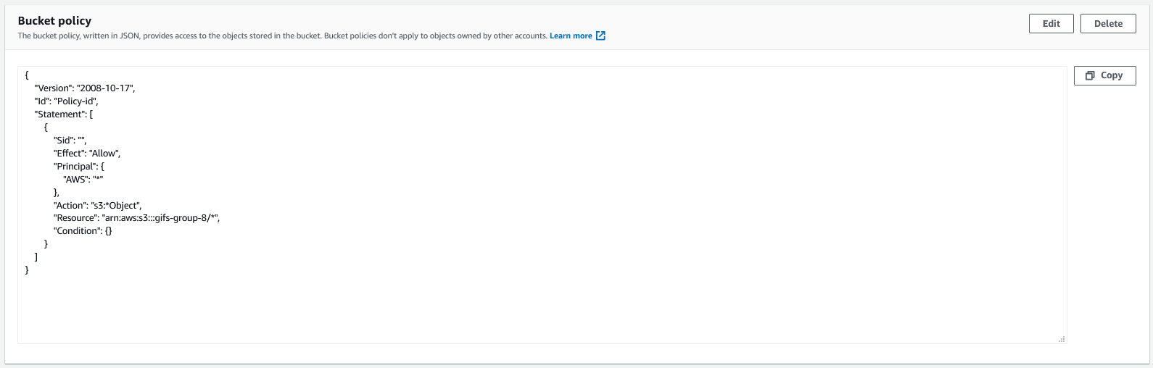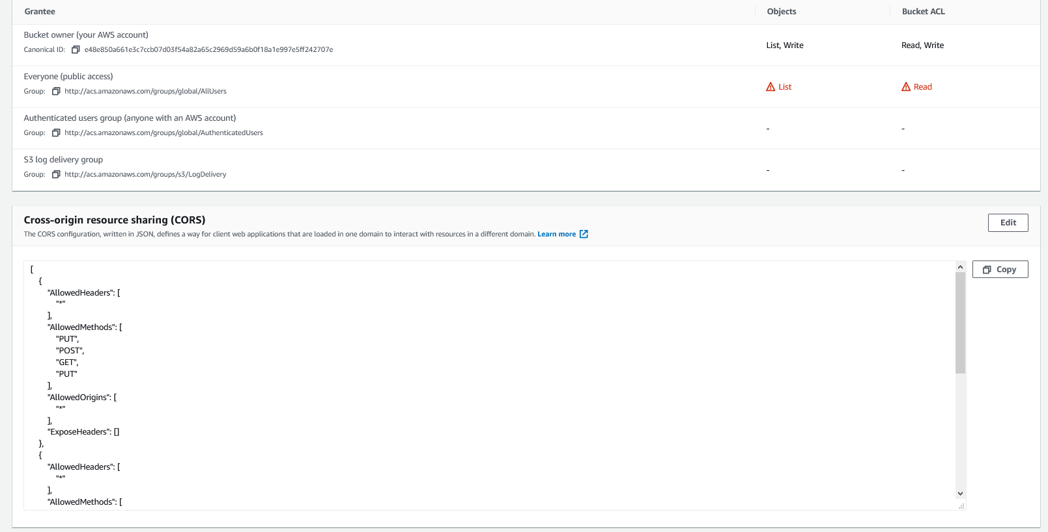

### Management

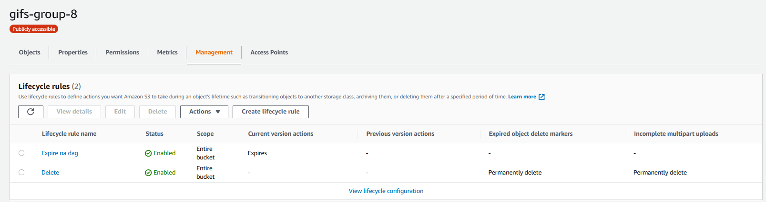

## images-group-8

### Properties



### Permissions

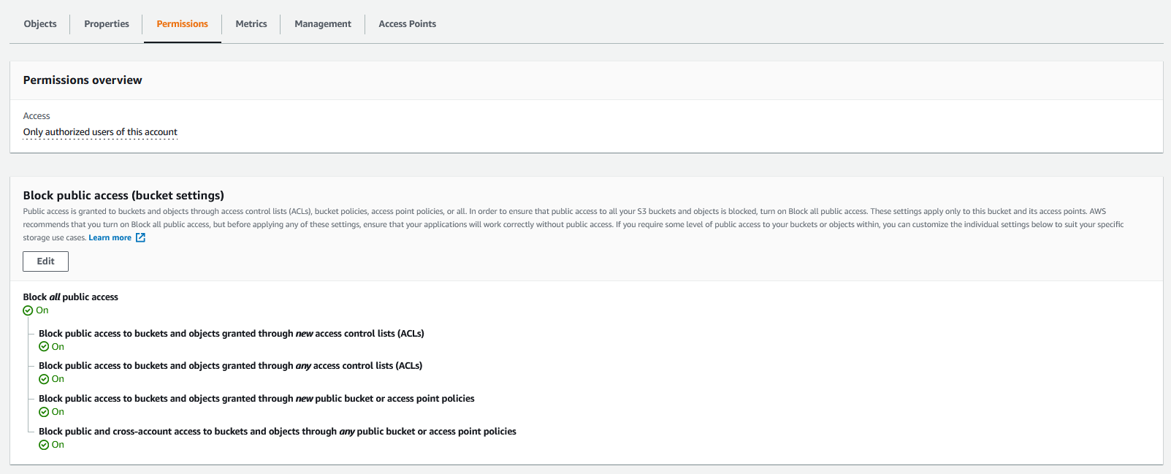

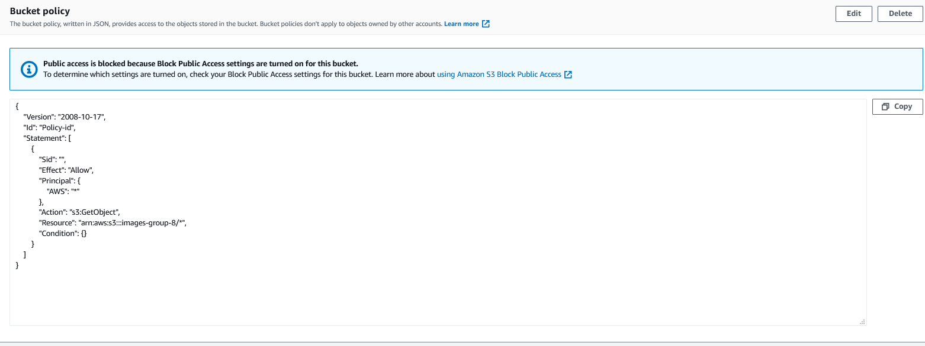

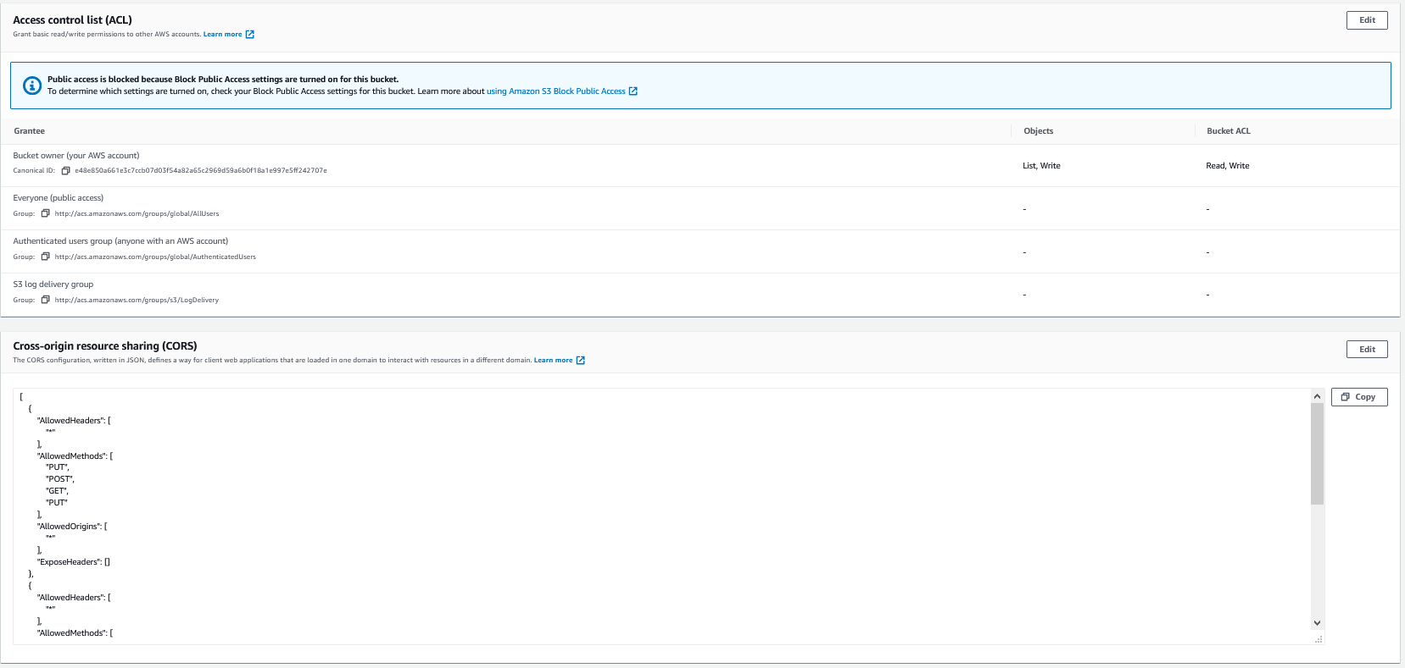

## static-website-group-8

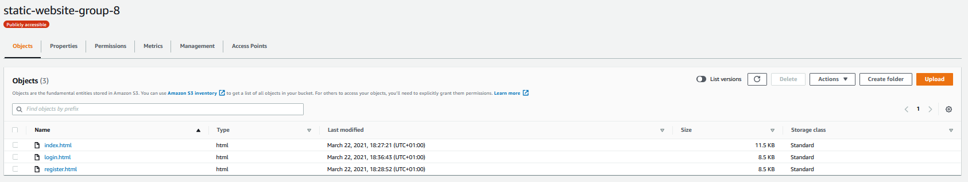

### Permissions

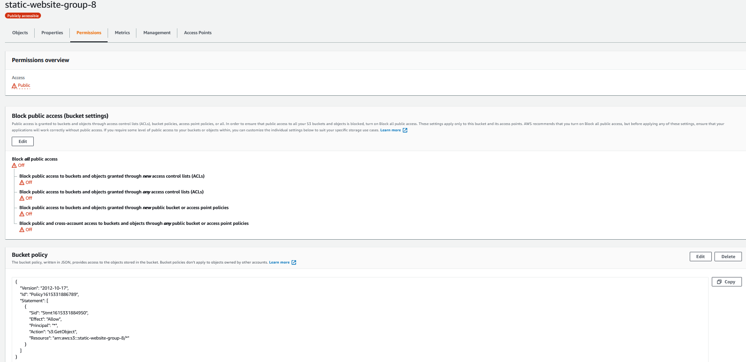

# API Gateway

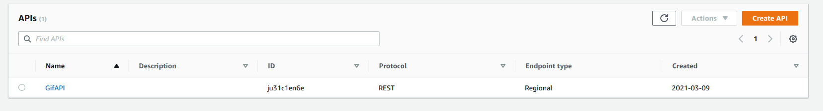

## GifAPI

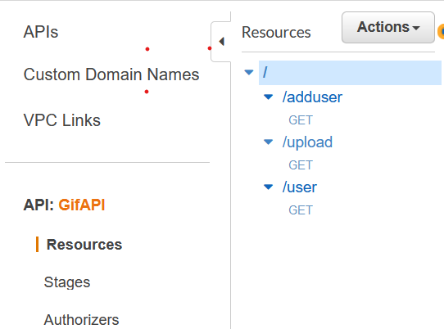

Alle “Request Validator Validate body, query string parameters, and headers” zijn verplicht.

### /adduser

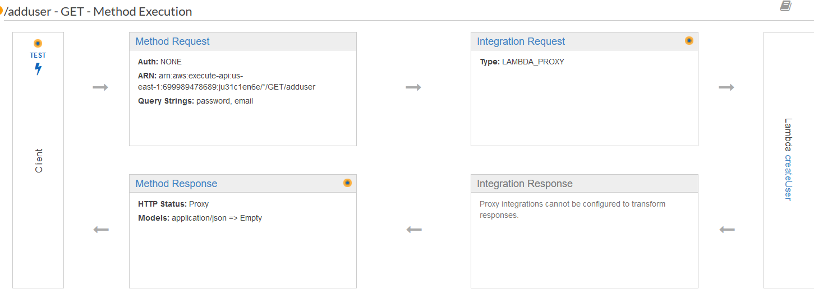

### /upload

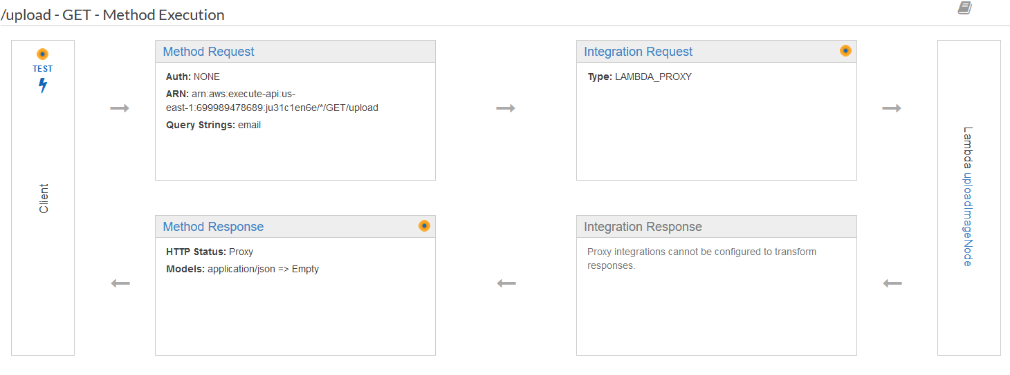

### /user

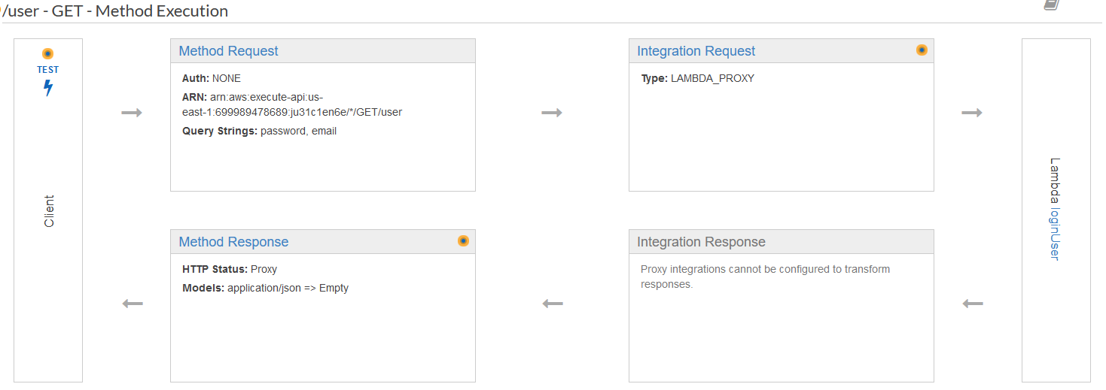

# Lambda

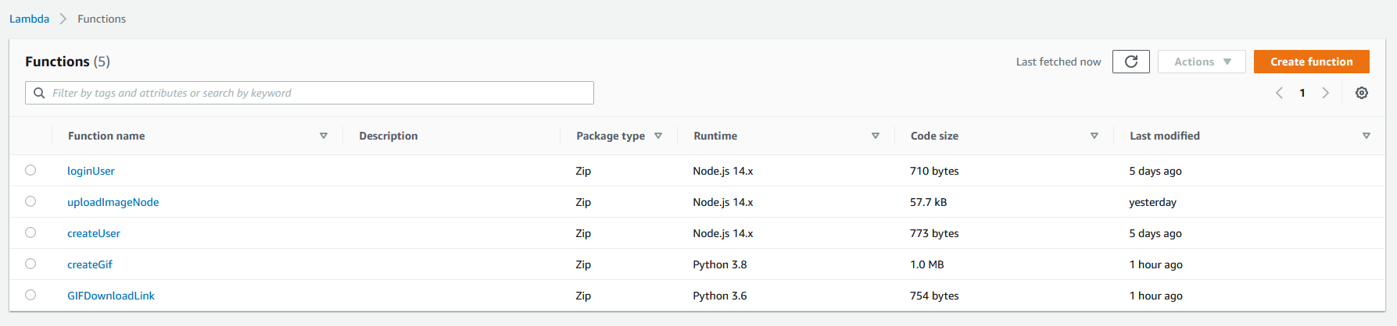

## loginUser

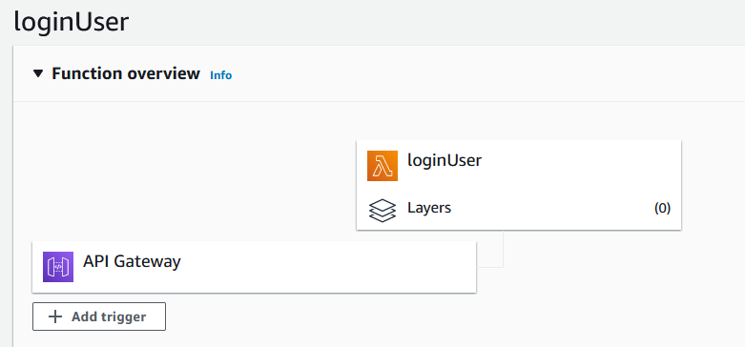

### Configuration

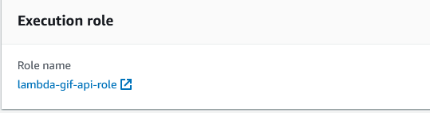

## UploadImageNode

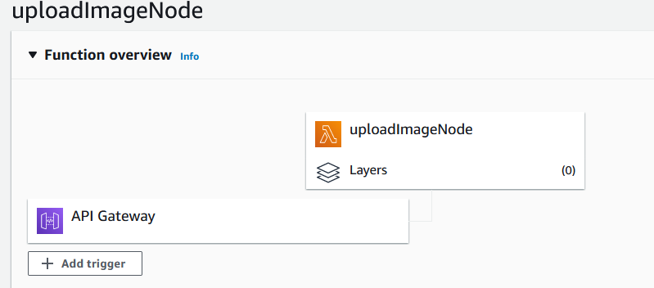

### Configuration



## creatUser

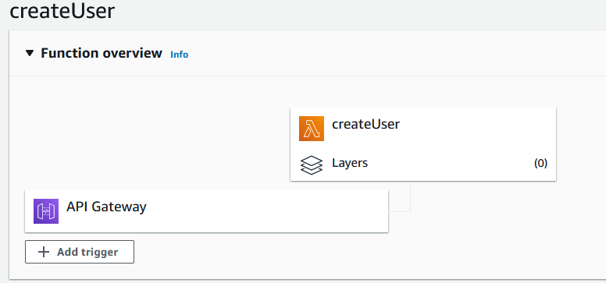

### Configuration



## createGif

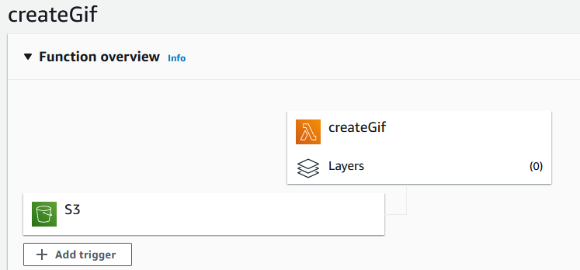

### Configuration



## GIFDownloadLink

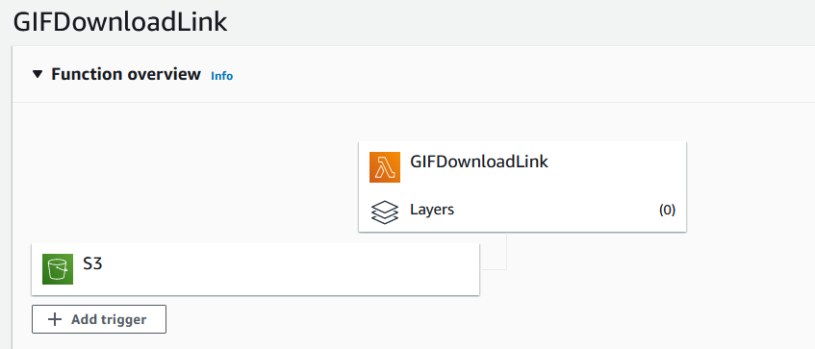

### Configuration

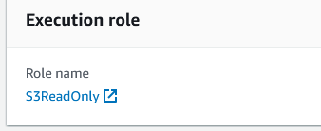

# DynamoDB

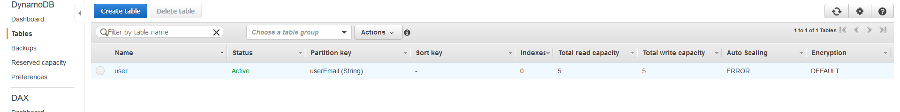

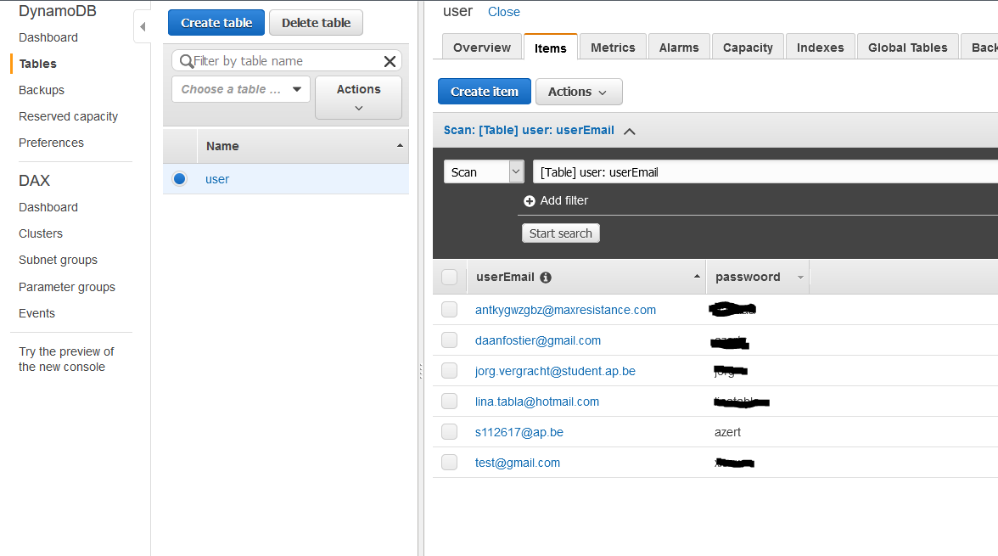

Password are saved in plain text.

# IAM

All IAM roles that we created.

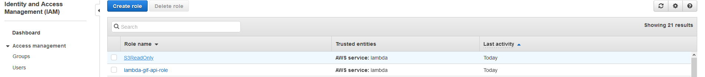

## [S3ReadOnly](https://console.aws.amazon.com/iam/home?region=us-east-1#/roles/S3ReadOnly)

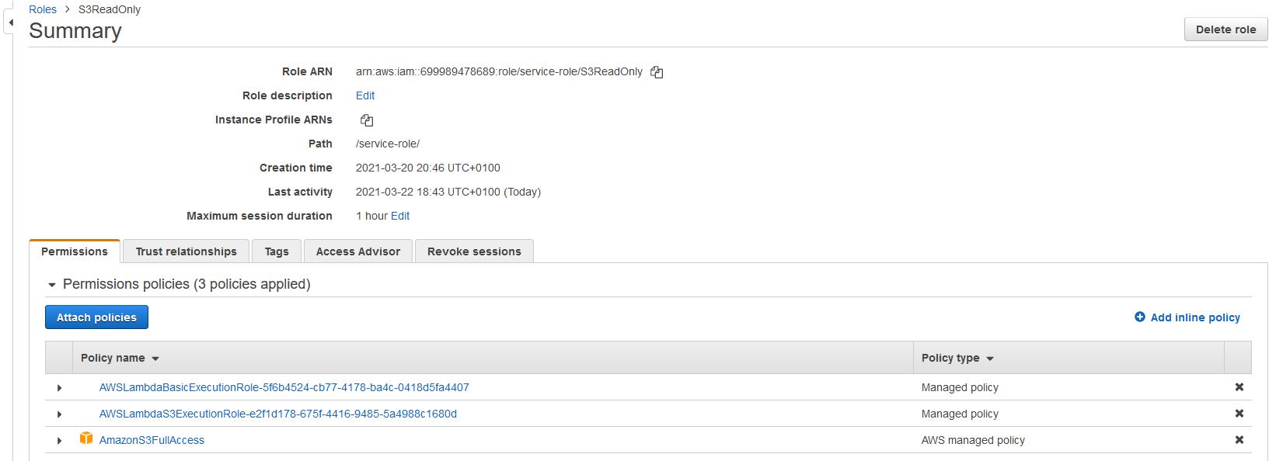

## [lambda-gif-api-role](https://console.aws.amazon.com/iam/home?region=us-east-1#/roles/lambda-gif-api-role)

