Assignment 1
Introduction
I built a website using AWS services, including EC2, EFS, S3, a Load Balancer, and Auto Scaling. The website is stored on EFS and can be accessed through a Load Balancer. In this report, I explain step by step what I did.

Step 1 – Virtual Private Cloud (VPC)
I created a VPC called webserver-vpc to have a private and secure network for my assignment. I used CIDR block 10.0.0.0/16, which gave enough IP addresses for all resources. Then I:
- created two subnets in different Availability Zones
- created and attached an Internet Gateway
- added a route 0.0.0.0/0 to allow internet access
- connected the route table to public subnets
I also made sure DNS resolution and DNS hostnames were enabled. This setup allowed EC2 instances to access the internet and be accessed using a public IP.
The VPC is the base of the whole system. It has EC2, Load Balancer, and EFS. It also keeps everything secure while allowing controlled internet access.
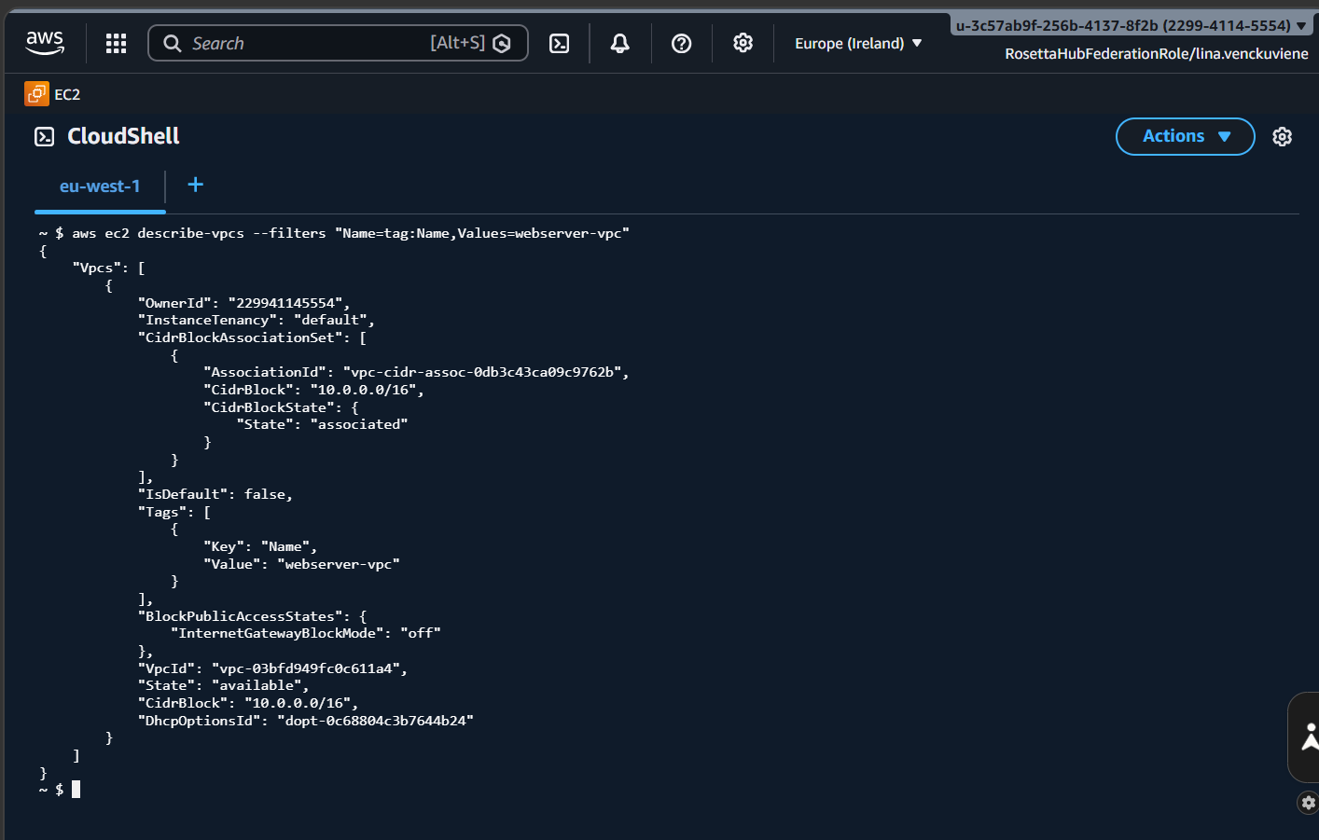

Step 2 – EC2 Web Servers
I created two EC2 instances: Web Server Public and Web Server Private. I used Amazon Linux and configured instance type: t2.micro, security group (HTTP and SSH) and key pair for access. Then I connected using SSH and installed software:
sudo yum update -y
sudo yum install httpd -y
sudo yum install php php-mysqlnd -y
sudo systemctl start httpd
sudo systemctl enable httpd
I created a PHP file in /var/www/html to show private IP and hostname. Both servers worked correctly. When I opened the public IP in a browser, the website showed the information, verifying that the web server was working.
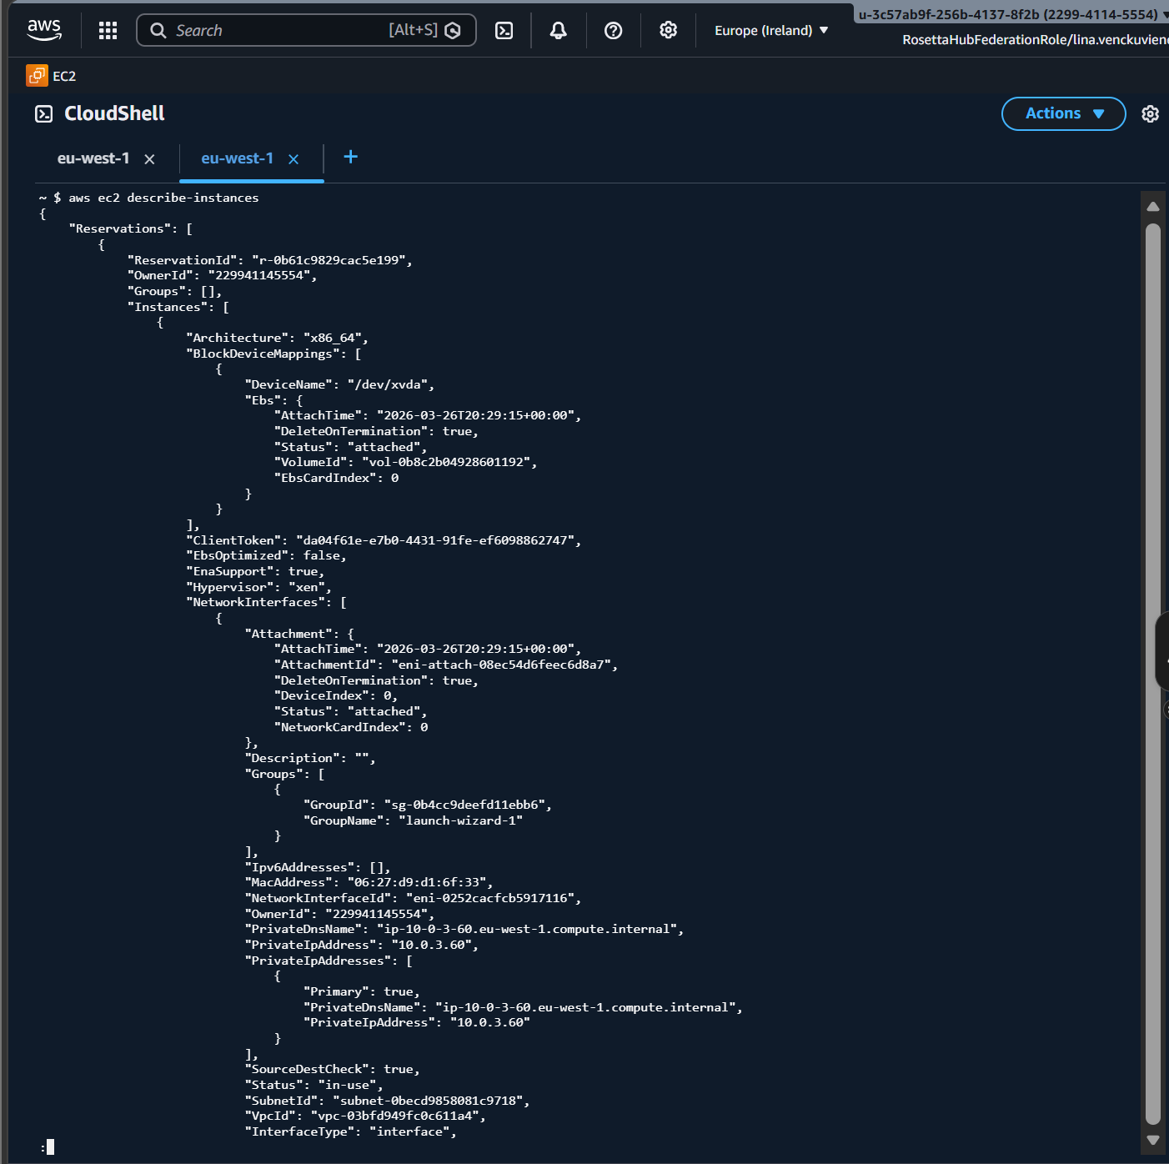

Step 3 – EFS
I created an EFS called webserver-efs to store website files shared between instances. I created EFS in the same VPC, mount targets in different zones and allowed NFS (port 2049) in security group. On EC2, I mounted EFS:
sudo yum install -y amazon-efs-utils
sudo mkdir /var/www/html
sudo mount -t efs fs-0ac749c2c7db0529e:/ /var/www/html
EFS worked correctly. All instances could use the same files. This helps with scaling and keeps the website the same on all servers.
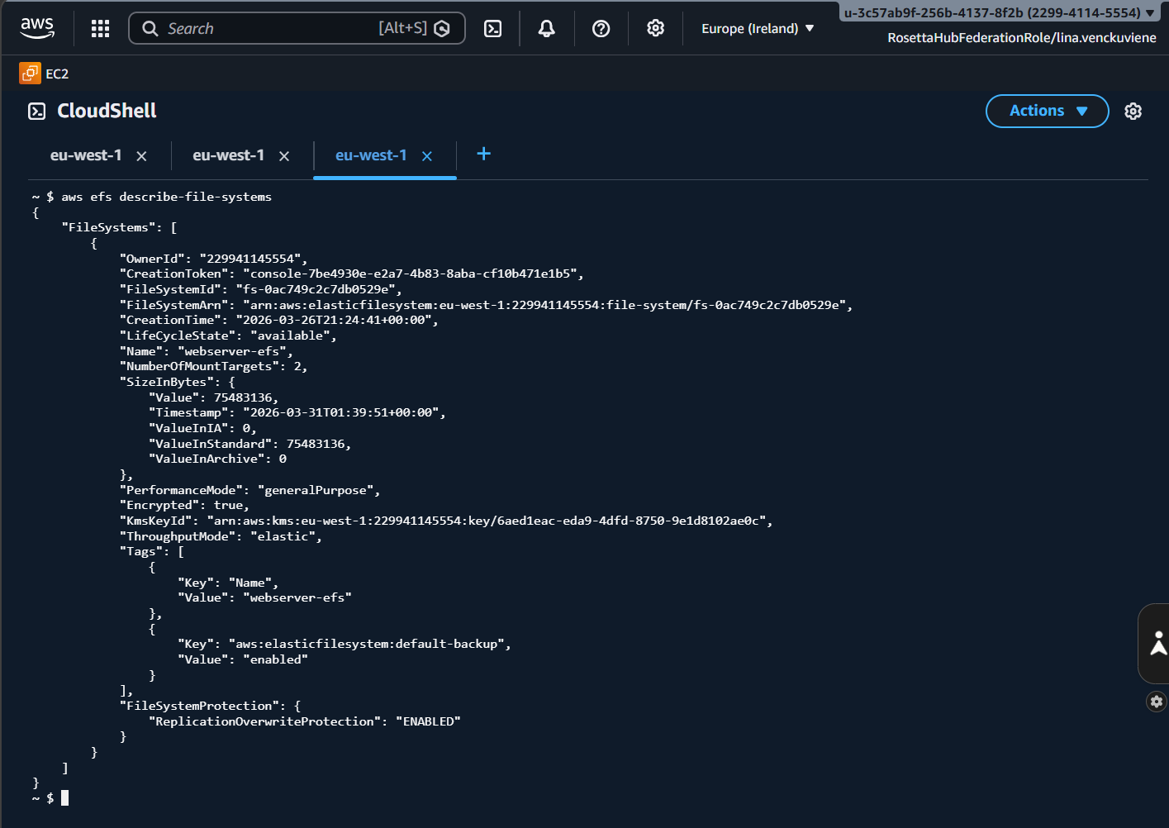

Step 4 – AMI
I created an AMI from my configured EC2 instance after installing Apache, PHP, and mounting EFS. Before creating the AMI, I made sure everything was working:
sudo systemctl status httpd
This checked that the Apache web server was running.
Then I created the AMI:
- selected the EC2 instance
- clicked Actions - Image - Create Image
- named it webserver-ami
The AMI saved the Apache installation, PHP setup and EFS mount configuration. This allowed me to launch new instances without repeating all commands.
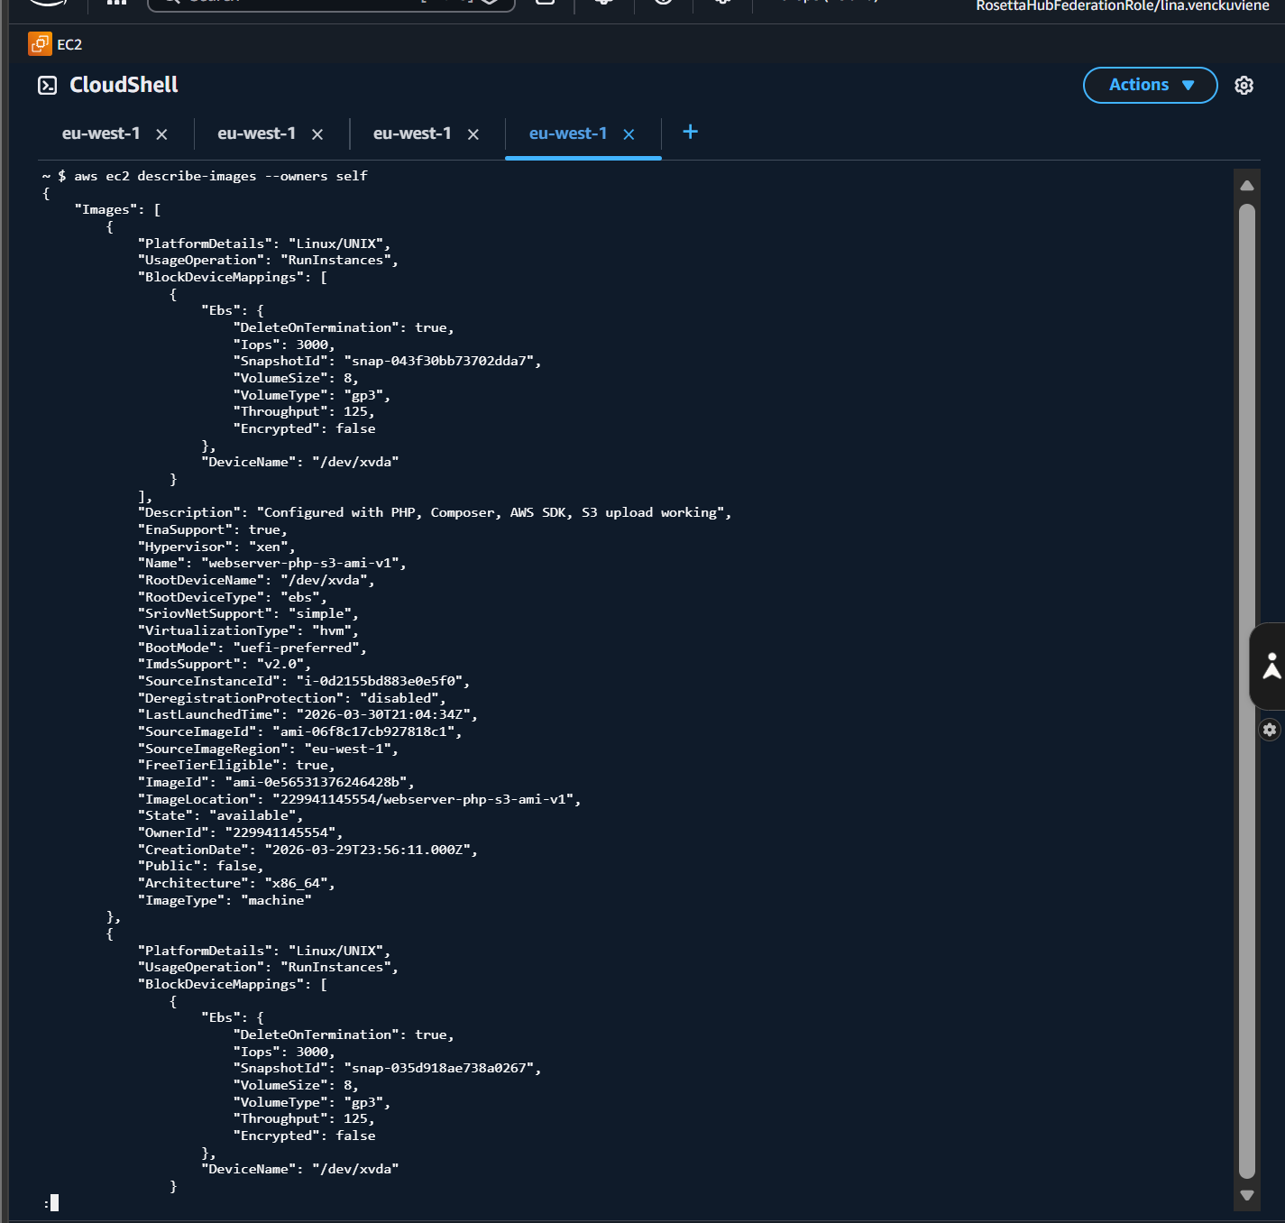

Step 5 – Target Group, Load Balancer and Auto Scaling
I created Target Group, Load Balancer and Auto Scaling Group. I configured HTTP traffic on port 80 and connected everything. To make sure Apache runs automatically on new instances, I added a user data script in the launch template:
#!/bin/bash
yum update -y
yum install -y httpd php php-mysqlnd amazon-efs-utils
systemctl start httpd
systemctl enable httpd
mkdir -p /var/www/html
mount -t efs fs-xxxx:/ /var/www/html
This script installs Apache and PHP, starts the web server and mounts EFS automatically. Without this, new instances would show an empty website. After adding this, all new instances worked correctly.
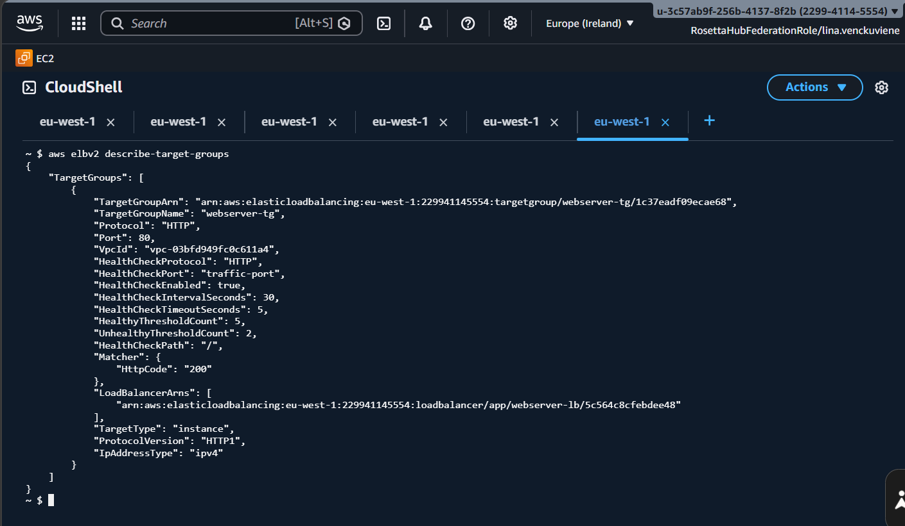
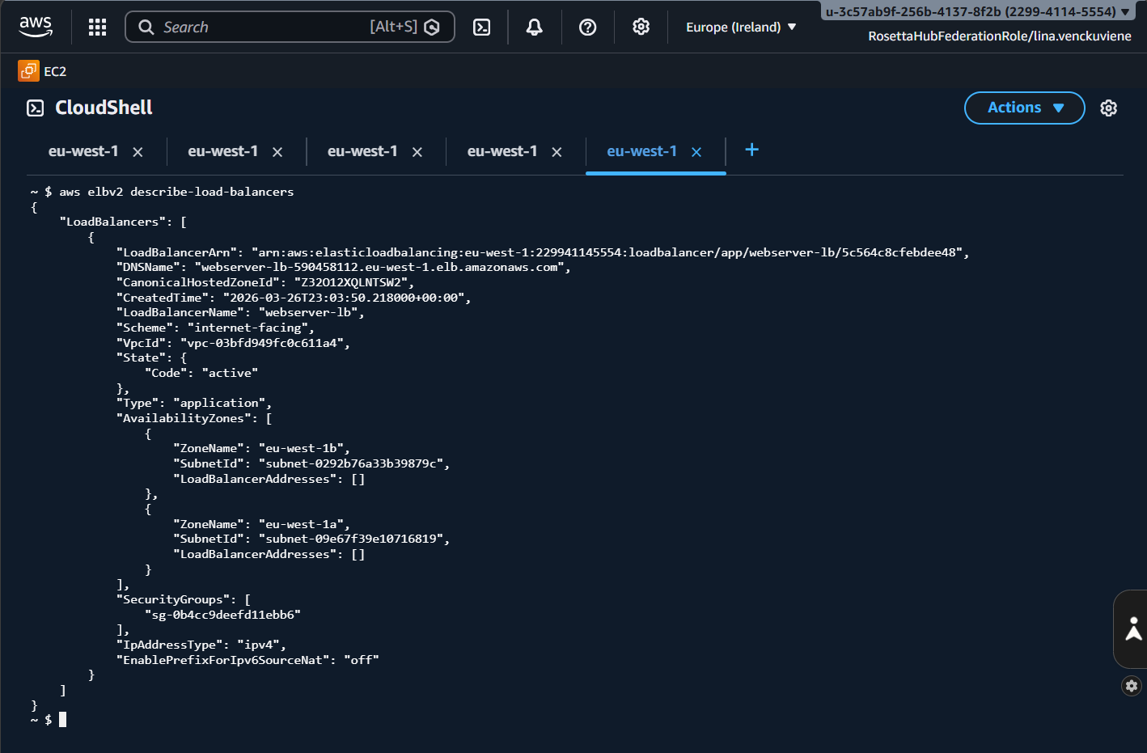
Step 6 – Build Website
I created website files inside cd /var/www/html
Then I created and edited files like:
sudo nano index.php
sudo nano style.css
sudo nano script.js
These files included server and EC2 instance information (PHP), styling (CSS) and current time (JavaScript).

Step 7 – S3 Upload
To enable file upload, I installed Composer and AWS SDK. Then I created upload.php:
sudo nano upload.php
At first, file upload did not work because the EC2 instance did not have permission to access S3. I attached an IAM role with S3 permissions to the instance. After that, uploads worked correctly.
Conclusion
The system works successfully. The website is available through the Load Balancer, and all EC2 instances used shared files from EFS. Users can upload files to S3 from the website. Another issue happened when EC2 instances were terminated by Rosetta Hub. New instances created by the Auto Scaling Group showed empty pages. This happened because Apache loaded index.html instead of index.php. I fixed this by removing the default file using:
sudo rm -f /var/www/html/index.html
Then I restarted Apache:
sudo systemctl restart httpd
After that, everything worked properly.

