Metal Stamping Simulator
Advanced Programming AI Project
Development Journal | 13 October 2026
Sumin Song | C00329682

What I did today
Today, I started working on the dashboard part of our Metal Stamping Simulator project. First, I wanted to get more familiar with raylib.h, so I tried to make a simple dashboard.
As we planned, I divided the screen into two parts. The left side is for the simulator (60%), and the right side is for the dashboard (40%). I used DrawRectangle() and DrawText() to make the basic layout.
I added some information to the dashboard, such as Total Produced, Good Products, Defective Products, and Success Rate. I also added Machine Status to show whether the machines are running or stopped.
After that, I made three buttons: Start, Pause, and Reset. I used GetMousePosition() and CheckCollisionPointRec() to check when the user clicks a button. The Start and Pause buttons can change the machine status, and the Reset button sets all the numbers back to zero.
For now, I am using example numbers because the simulation is not connected to the dashboard yet.
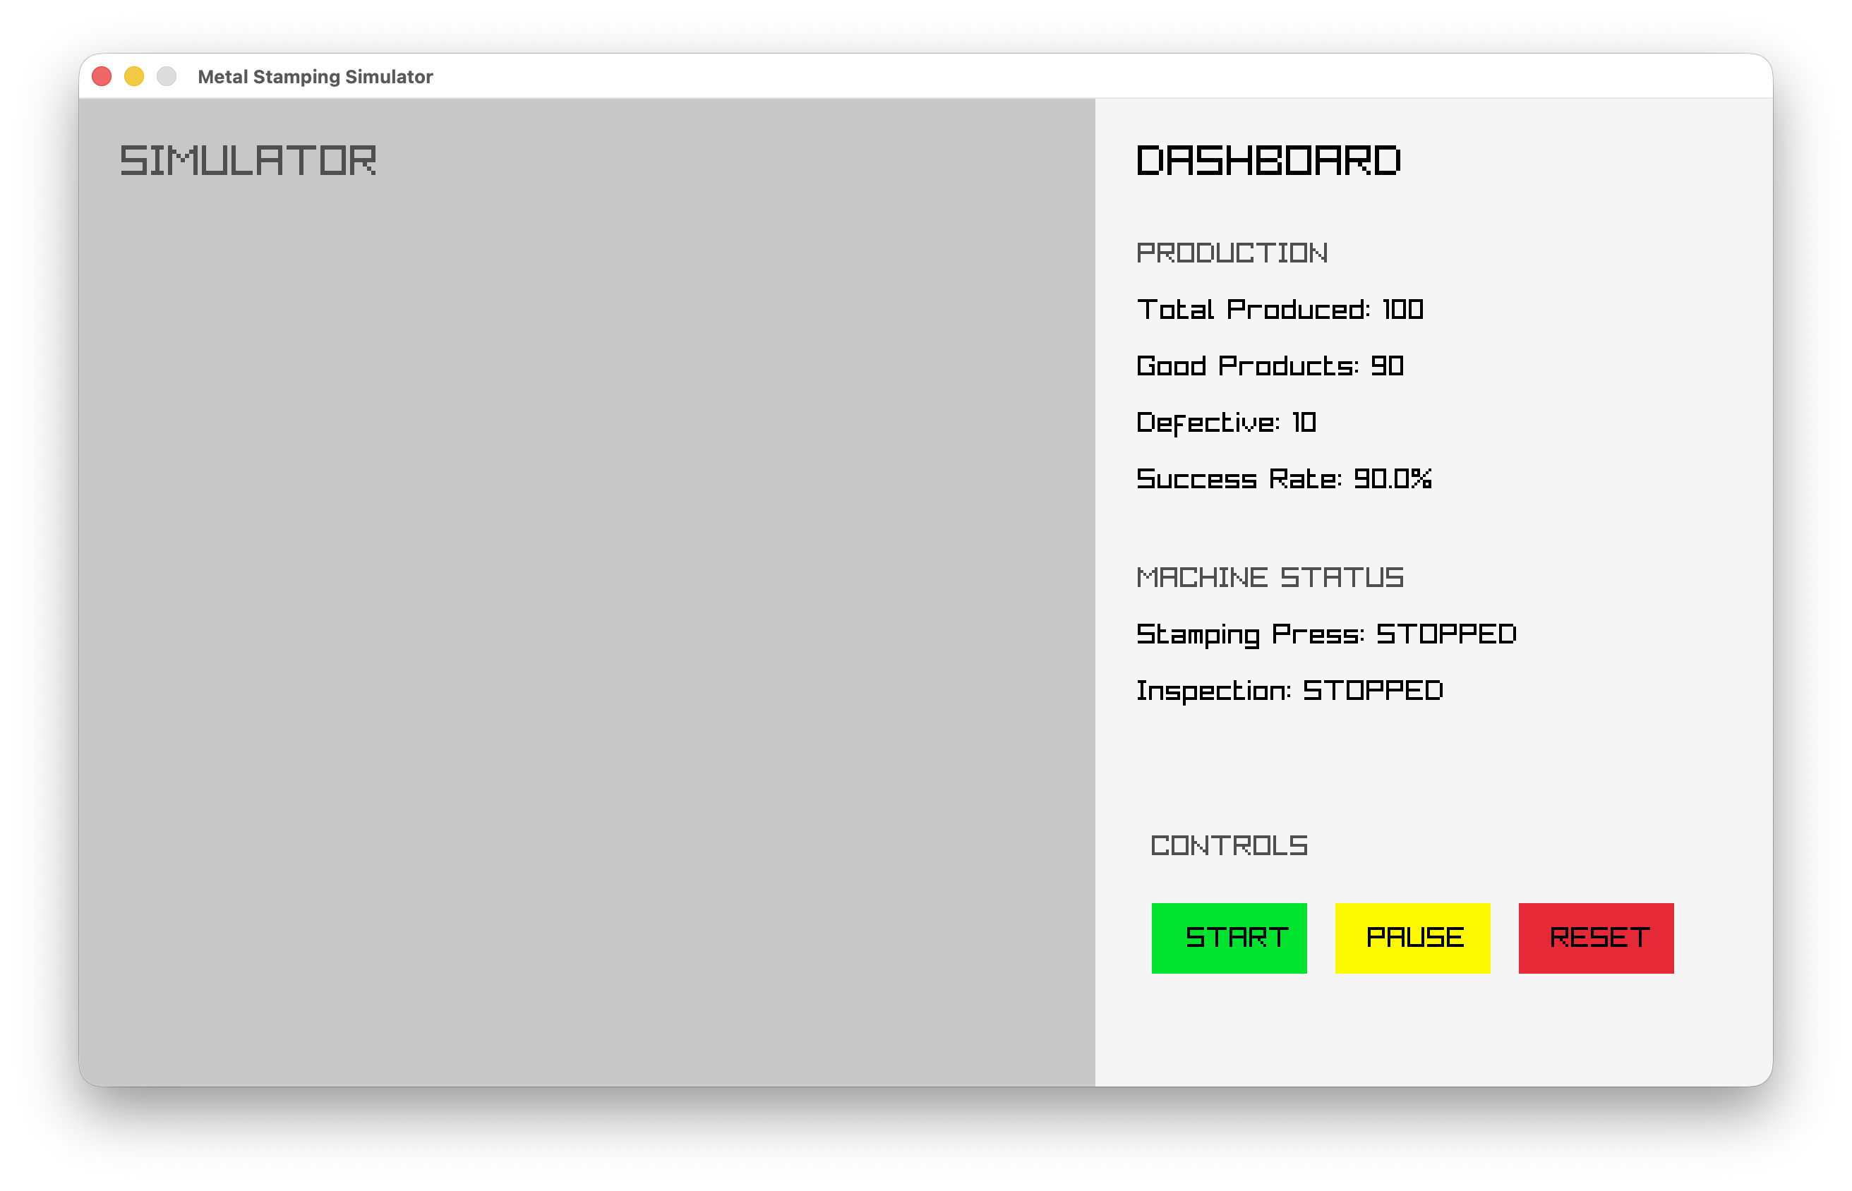

AI Usage
I asked AI to find some C + Raylib template projects on GitHub that are similar to our project. AI suggested several projects, and I started looking at their code.
I also tried to download and run one of the projects on my MacBook. I had some problems with raylib.h and raygui.h, so I used AI to help me understand and fix the errors. I am still looking at these projects to learn how they work and get some ideas for our simulator.

Next Step
Next, I will improve the dashboard design and try to connect it to the simulation part. I also want to understand more about how Raylib works.

