**Week 4 (ELECTRONICS):**

Two tasks for this week:

1-Design electric circuit that has an Analog sensor

2-Design electric circuit that has a Digital sensor

1-) An example of an Analog sensor is temperature sensor. Since this is an analog sensor, we attach this sensor to the Arduino through the Analog pin:

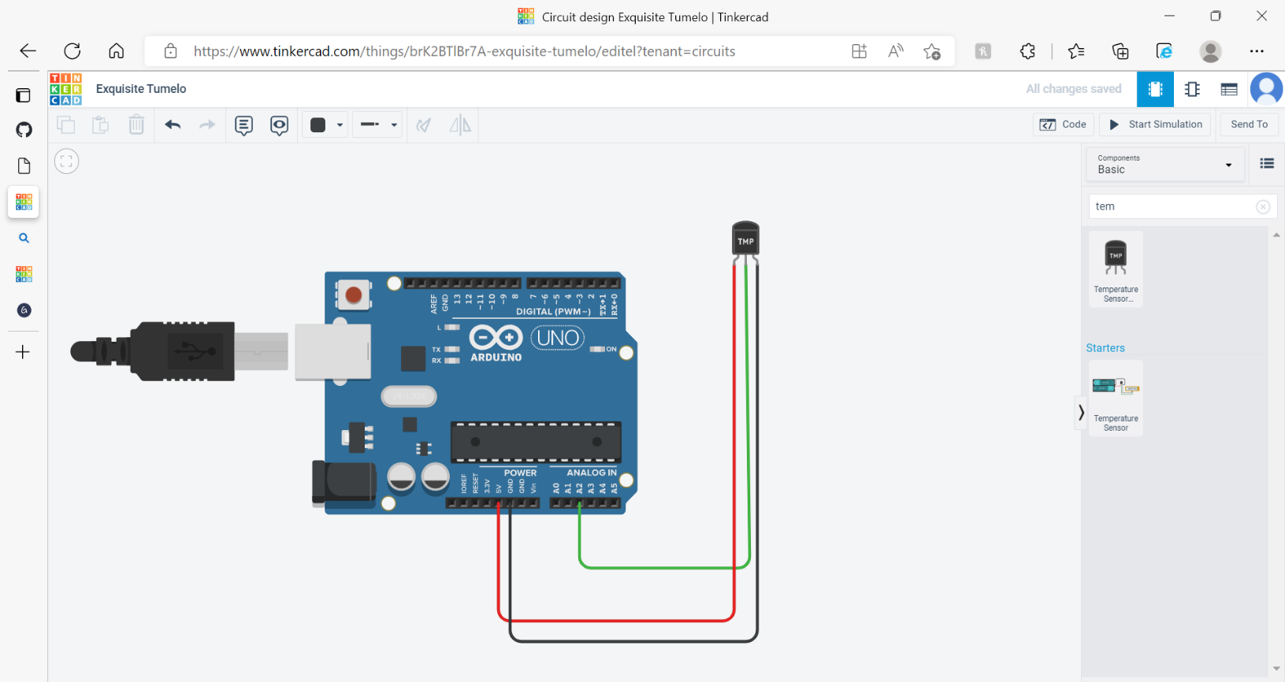

2-) An example of a Digital sensor is a pushbutton. Since this is a digital sensor, we attach this sensor to the Arduino through the Digital pin, I added resistors as well to the led and pushbutton. What this program will do is, when the button is pushed the led will turn on and when its not the led will turn off.

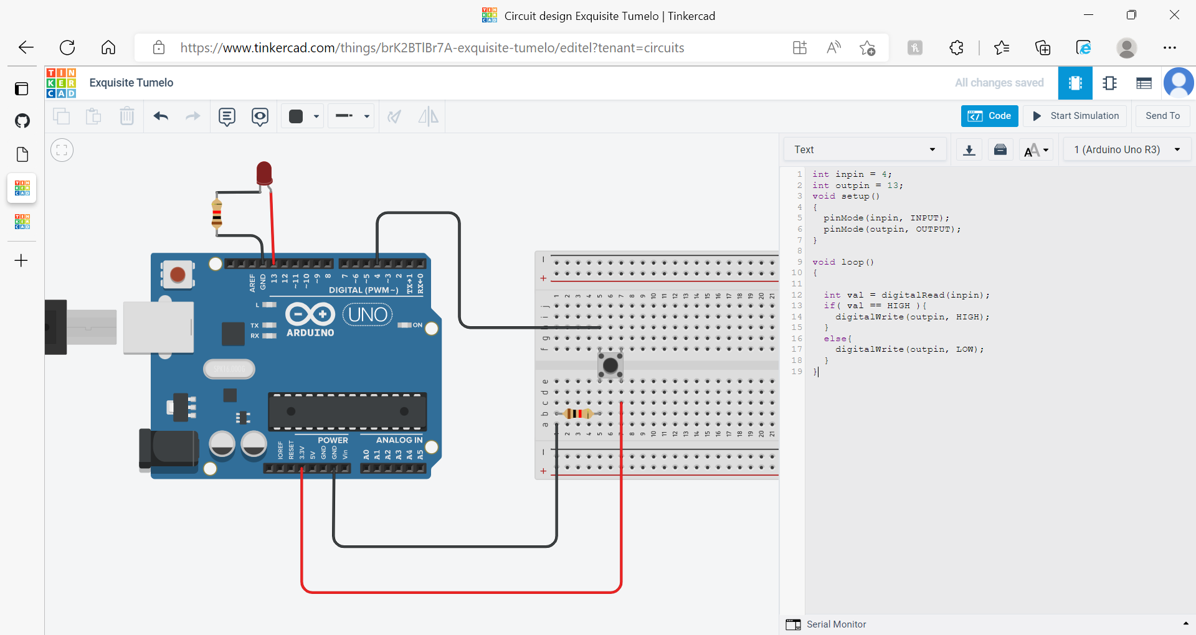



(this code was taken from [Push Button | Tinkercad](https://www.tinkercad.com/things/0aaOoMKskJR-push-button)