# Creating-ROS-Package

1- Download stl files:

This is the link to download stl files: <https://drive.google.com/drive/folders/18E0vgwkuOhObBcaOVkfFNj-FnycijkbE>

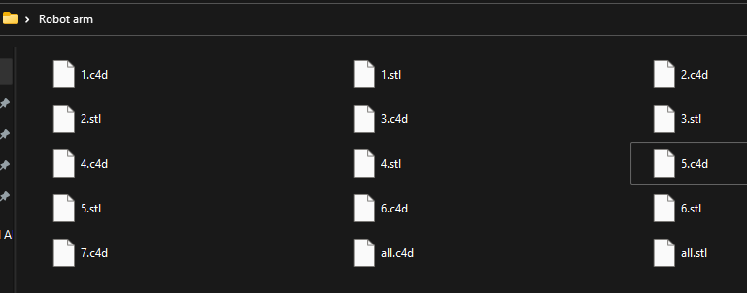

2- Download and use "blender program:



In this step you need to import all stl files to blender

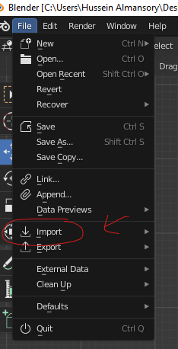

After import stl files you see they're in your program

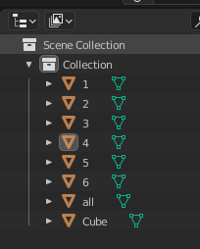

link to download blender: <https://www.blender.org/>

3- Export the project as "URDF" file and make joint:

this link: <https://www.youtube.com/watch?v=CrMvtlZl3LI>

4-Creating a ROS Package:

To do that follow all steps in this link:

<http://wiki.ros.org/ROS/Tutorials/CreatingPackage>

5- Run the urdf and move the robot:

PATH: ~\robot_arm\robot_arm_pkg\launch

Open the check_motors. Launch

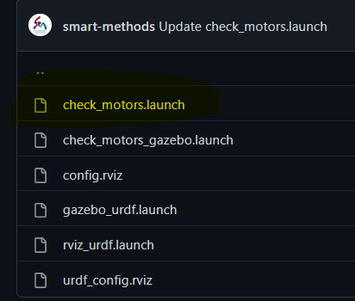

Change the textfile to the new "urdf" you made it before

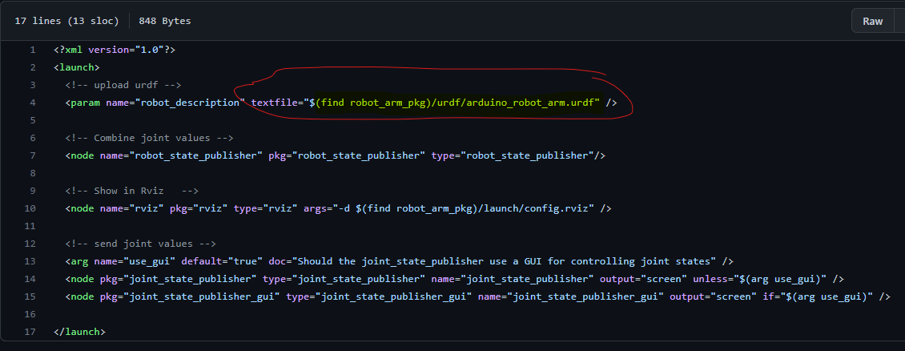

6- Finally:

