November 27, 2023
Nayan; lukas; lina; Junkai
University of Sussex
HCI
Limitless growth
Garden Planning App
Contents
Perrsona 2
Context Scenario 3
Design Requirements 4
Prototype 5
Breakdown 6
Usability Test Plan 14
User Test 14
Brief 14
Task Scenarios 14
Introduction Script 14
Post Interview Questions 15
Debrief Script 15
Result 15
Notes 16
Data Analysis 16
Conclusions 17

Perrsona
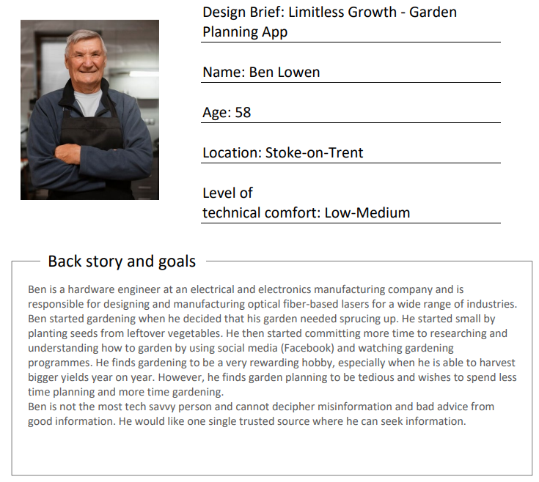
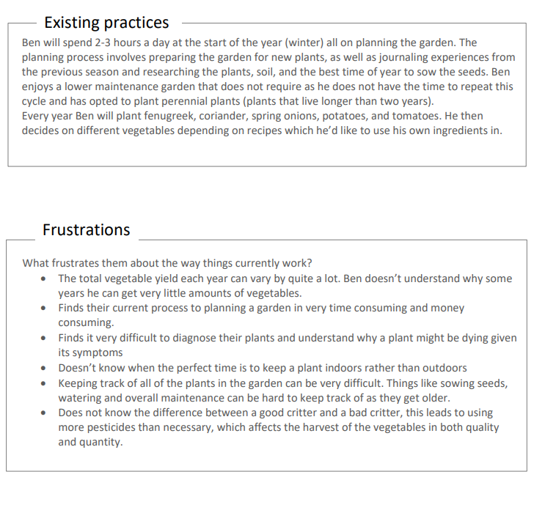

Context Scenario
Context Scenario
The following is a first iteration of a context scenario for a primary persona for a garden planning app. Our persona is Ben Lowen, a hardware engineer in Stoke-On-Trent, whose goals are to minimise time spent garden planning and maximising the potential vegetable harvest from their garden.

Ben’s context scenario:
- When going to his local garden centre, he often goes to browse their selection of seeds and plants. He will often make choices based on what he may like to eat at that point in time or an observation what flowers may look prettiest when they bloom. He goes very often and has built a rapport with the local staff, but sometimes may avoid asking stupid questions as he does not feel confident when asking them. Ben is able to ask and find such answers on the app.

- Ben often facetimes his siblings and will talk about a range of topics, including their gardens and what food they made. Ben will often showcase the progress in his garden and the food his may have made from it, while his siblings showcase theirs. These images are shared via the app.

- When visiting family members, they may offer up any stems of flowers and vegetables/herbs in their garden. Ben will seek their advice on how they grow them but will often forget said advice by the time he houses the plant in his garden. Ben can take notes on the app.

- Ben is not able to remember every possible time of the year when he needs to sow the seeds for the best chances of blooming.

- Ben suffers from poor eyesight during the cold months of the year and would appreciate accessibility features to facilitate Ben’s love for gardening. Apps help Ben with big and easy to read user interfaces make the user experience extremely simple to use. Easy to reach functions are necessary for Ben as phones get bigger.

- Ben participates at the local community garden. The app allows him to collaborate with his friends at the local community garden and plan the layout of the garden and the plants within.

Design Requirements
Design Requirement
Here are design requirements.
- Take notes when getting advice.
- Share plants with community.
- Ask questions on a forum.
- Find diagnosis of dying plants.
- Sow plants at the optimum time of the year.
- View a list of critters when understanding if the critters in the garden are good or bad.
- Harvest vegetables at the right time to provide optimum harvest.
- Good User Interface design and User experience
- Accessibility features
- Garden collaboration

Prototype
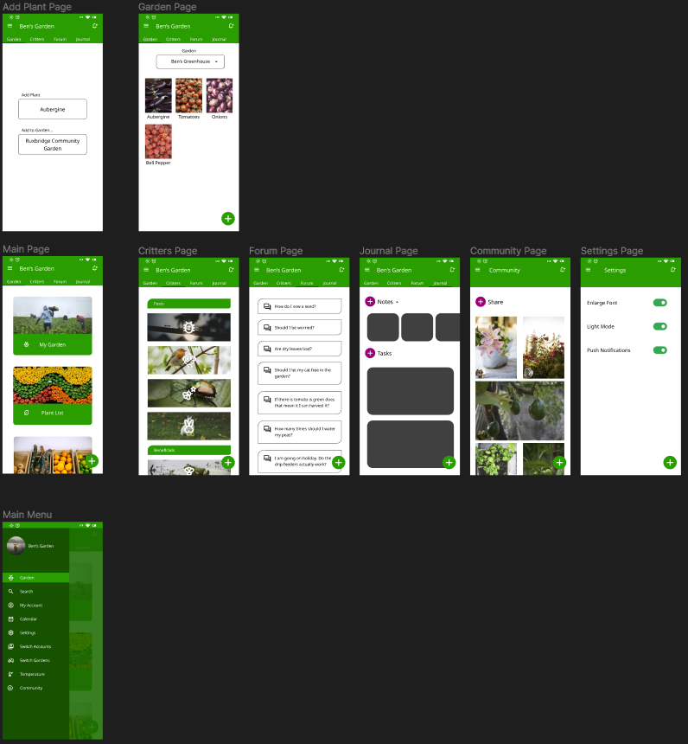

Breakdown
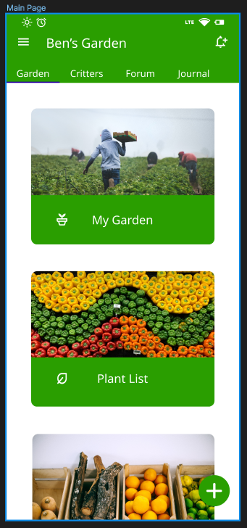
This is the default page when opening the app. The gardening page serves as a landing page for the most used functions on the app. There are buttons to access to view their current, most recently selected garden, a list of all plants that exist on the app, and the user’s grow box where personalised tasks can be set for the plants in the currently selected garden.
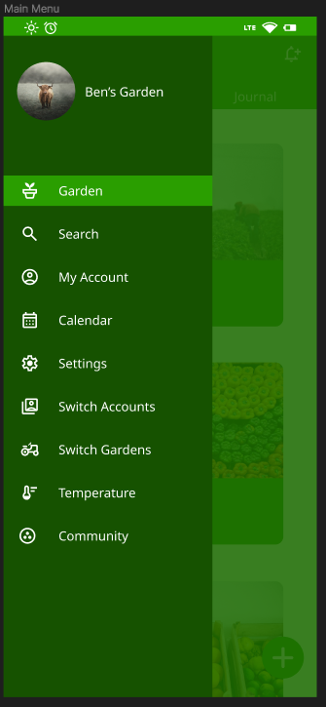
This is the sliding menu, that can be viewed when the burger menu icon in the top right is selected. It shows the currently selected page, which is the Garden page. The options include the pages: Search, Account, Calendar, Settings, Account Switch, Garden Switch, Weather and Community.
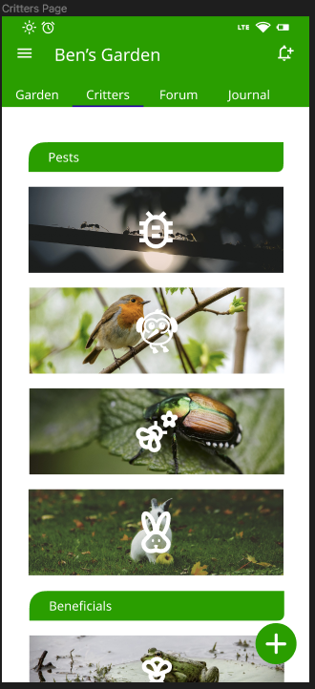
This page is the critters page which can be accessed from the top selection menu that is easily accessed. This page lists pests and beneficial critters, each with their own knowledge and information when clicked on.
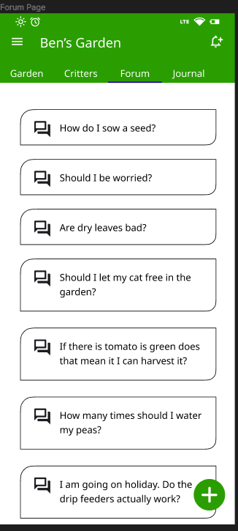
This is the Forum Page where users are able to ask and answer questions.
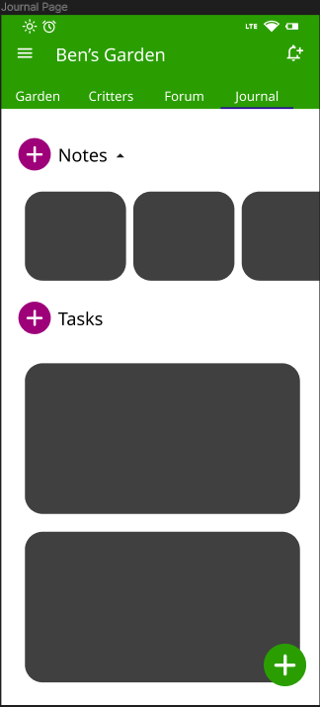
This is the notes page where users are able to make notes and list tasks using a checklist. When making notes, the user can add a voice note, images/screenshots, pencil to draw, checkboxes and text formatting. The tasks can send notifications to the user using the reminder functionality.
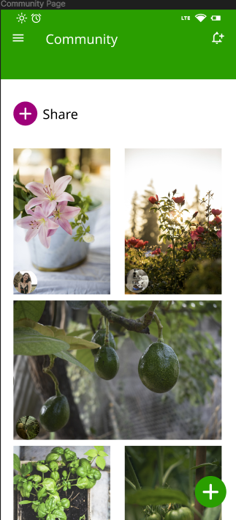
This is the community page where users are able to share images with other users. The images are automatically sorted by the most viewed of the week.
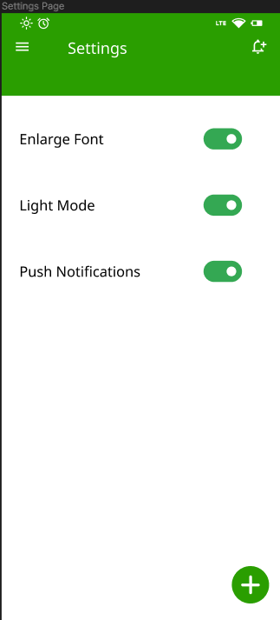
The settings page includes accessibility features that improve the user experience for all users.
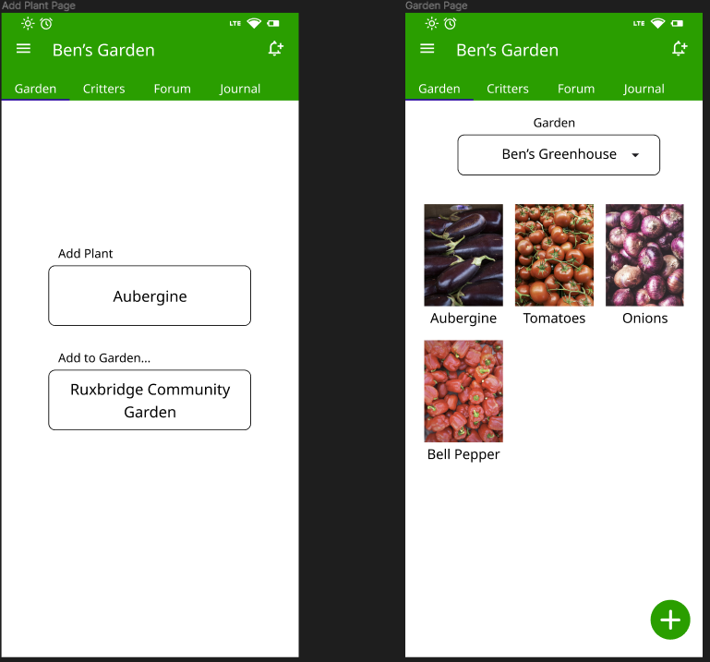
The ‘Add Plant Page’ and ‘Garden Page’ is where the user is able to add a plant to a selected garden using a given dropdown menu when clicking on the button. When viewing the garden, the user can select each plant, where they are able to view information about the plant including the best time to sow, maintain and harvest the plant. Each plant will have its own set of beneficial critters and time to harvest, among other knowledge that the gardener may require.

Usability Test Plan
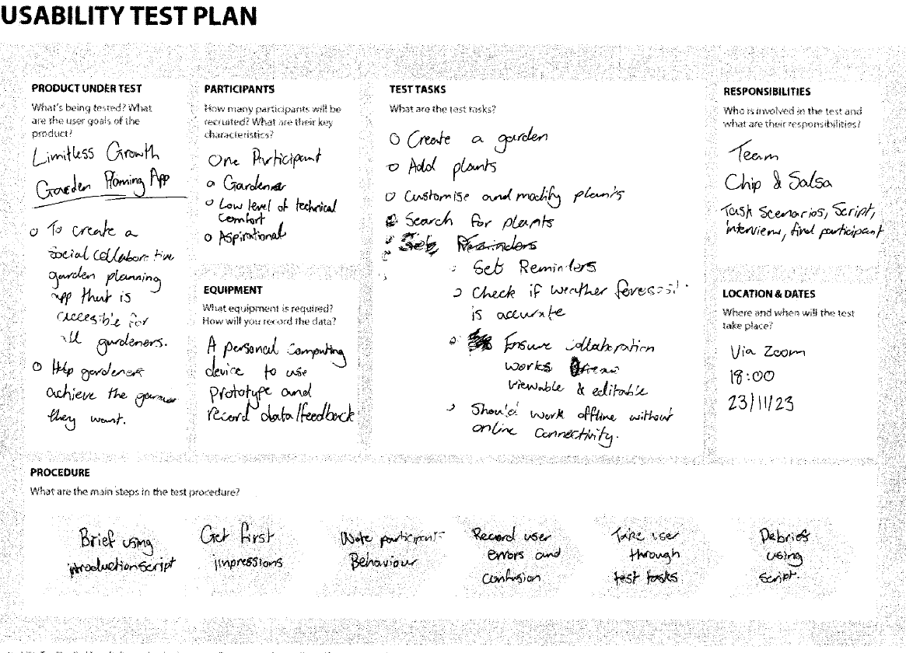

User Test

Brief

Task Scenarios
You’re planning a community garden and need to share these plans with other community garden members. The garden must contain tomatoes, potatoes and radishes.
You’ve gained some insightful knowledge from the local garden centre staff that you wish to record. They are also giving you a visualisation of how the plant should look at different times of the year. You want to take notes of this conversation as you will need this knowledge at a later date, when you may also be able to share this wisdom with others.
You want to share the flowers that are beginning to bloom in your garden. You need an app to both take pictures of the flowers, and then to share it with others. You would also like to share your specific post on social media using a link.

Introduction Script
"Welcome! We're excited to have you test our new garden planning app.
During this session, we'll ask you to perform a series of tasks within the app. As you navigate through the features, you are welcome to share your thoughts, impressions, and any challenges you may face. If you have any questions or encounter issues, feel free to let us know.
Before we begin, do you have any questions or concerns?

Post Interview Questions
How would you describe the user experience when using the app?
If you had to choose one aspect of the app, what would be the worst part of the user experience?
How easy was it to use the app?
What features were the most useful, and which were the least useful?
How was the experience of collaboration features?
Is there anything else you’d like to share about your thoughts on this app?

Debrief Script
Thank you for participating in the user test for this garden planning app. Your contribution will be extremely helpful.

Result
How would you describe the user experience when using the app?
Participant claims to like the colour scheme and the minimalistic design of the app. The experience of using the app is intuitive. The Add Plant button needs a better explanation. When tapping around the Add Plant button I accidentally press the button. The main menu could be improved visually as it currently looks out of place.
If you had to choose one aspect of the app, what would be the worst part of the user experience?
The aspect of the app that could be improved the most is the garden itself. There are not enough options to manage the garden itself. It is not possible to multi-select the plants within the garden.
How easy was it to use the app?
The app is easy to use.
What features were the most useful, and which were the least useful?
The most useful features are the forum and notes within the app. They are easy to access and make asking questions and noting gardening knowledge down very useful.
The least useful features are the grow box. This has either been implemented incorrectly or is not necessary in the app.
How was the experience of collaboration features?
The experience of the use of the collaboration features weas very good.
Is there anything else you’d like to share about your thoughts on this app?
It would be good for app components to remain the same width on the page; switching between pages, the main app components on the page sometimes get wider and are inconsistent with the overall design language.

Notes
Errors made, Moments of confusion, Success Observed.
Participant found it confusing to use the ‘Add Plant’ button in the bottom right corner as they had been given no prior context to how it is used. They instead went through the longer journey of going through ‘My gardens’.
Participant added the same plant multiple times, they then did not know how to reduce the quantity of the plant.
Participant found that navigating the menus was an ease and was impressed how intuitive it is.
Participant was able to create, manage and create tasks without any guidance.
Participant accidentally kept managing the wrong garden.
Participant was confused as to how to ask a question on the forum page.
Participant found that the critters page was confusing as it does not name the categories on the page, and the icons could be improved.
The purpose of the grow box was found to be confusing and needed explaining.

Data Analysis
Problem found during low-fi prototype testing (what? And where? In the app) | Found by the following test user | Found during testing or interview? | Severity of the problem (Scale = 0-4) | How would you fix this problem in the prototype?
Accidentally pressing the plus button in the bottom right when scrolling and is sometimes missed when trying to press on it | Participant 1 | Interview | 2 | This problem will be fixed by making sure that components do not clutter and overlay one another while being in the range of the thumb when scrolling. The components on the screen will now be even simpler
Not knowing what the plus (add plant) button does on the main page | Participant 1 | Testing | 3 | This problem will be fixed by adding a tutorial that will be an onboarding process to make sure that the user understands the tools within the app so that they can utilise it to its full potential
When managing the garden there is no multi-select option on the plants, slowing down the workflow | Participant 1 | Interview | 3 | This problem will be fixed by adding multi-select functionality on the plants in the manage garden page.
When using the app it is noticeable that the width of the components on different pages can change dramatically, reducing user experience. | Participant 1 | Interview | 2 | This problem will be fixed by adding a fixed width for components that stretch the width of the screen
The app does not scale very well on differing display sizes. Users using devices with unique sizes have issues with using the app (Sony Xperia, Moto Razr, Samsung Fold, Xiaomi Tab devices) | Participant 1 | Testing | 4 | This problem will be fixed by testing the app on a range of device sizes to ensure a working and optimal user experience for all users.
Although the garden is named at the top, user was still managing the wrong plants within the wrong garden and has caused confusion | Participant 1 | Testing | 3 | This problem will be fixed by using colour. Where each garden will be assigned a colour that will be applied to an essential component on screen so that the user is constantly reminded of the garden they are currently managing.
Confusion about the grow box and its uses and its position in the main page | Participant 1 | Testing | 2 | This problem will be fixed by moving the component to the manage gardens page. A description will be added to the grow box to define its functionality.

Conclusions
After completing user testing we can conclude that the prototype succeeded in meeting all user goals. However, there are many frustrations when using the app that weren’t covered by user tests and user goals. The base app works for garden planning, however it is an app that needs further user testing to flesh out and develop on existing and new features. The app provides some new features such as the collaborative and community features, but it is currently not at a stage where it can be considered as a solution to solve existing problems and they exist to create more problems for most users. The app overcomes frustrations for users who have never used garden planning apps before, but does not overcome frustrations for users already using similar garden planning apps.
The user testing has been beneficial to find many problems that exist in the prototype. Many of the issues found by “Participant 1” are concise and easily fixable, however it would be helpful to get more users to test individually and within focus groups to ensure that once the prototype becomes a product that it is not broken and is a product solution that will offer new ways to solve problems when compared to existing products.

