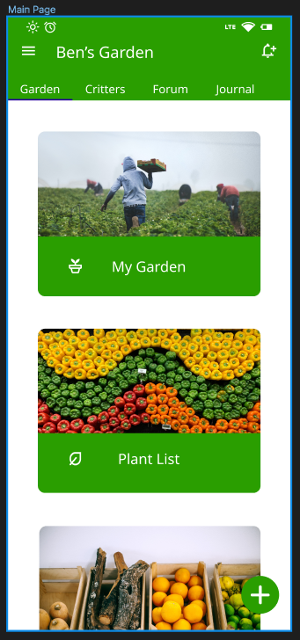
This is the default page when opening the app. The gardening page serves as a landing page for the most used functions on the app. There are buttons to access to view their current, most recently selected garden, a list of all plants that exist on the app, and the user’s grow box where personalised tasks can be set for the plants in the currently selected garden.
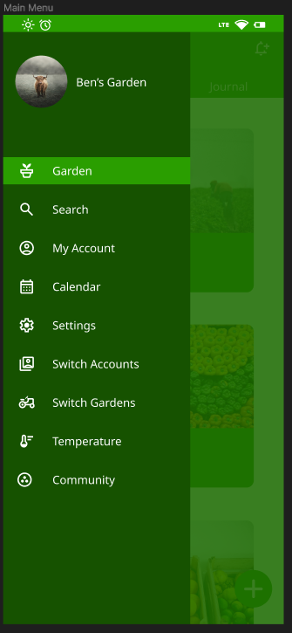
This is the sliding menu, that can be viewed when the burger menu icon in the top right is selected. It shows the currently selected page, which is the Garden page. The options include the pages: Search, Account, Calendar, Settings, Account Switch, Garden Switch, Weather and Community.
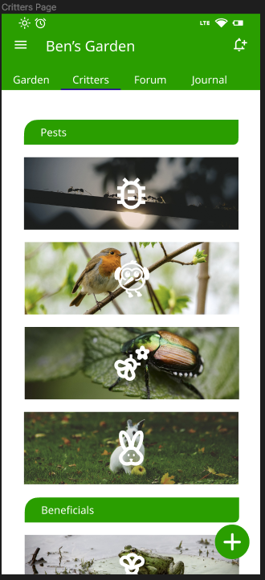
This page is the critters page which can be accessed from the top selection menu that is easily accessed. This page lists pests and beneficial critters, each with their own knowledge and information when clicked on.
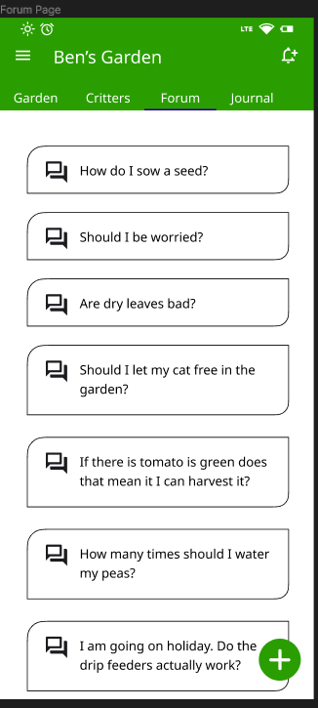
This is the Forum Page where users are able to ask and answer questions.
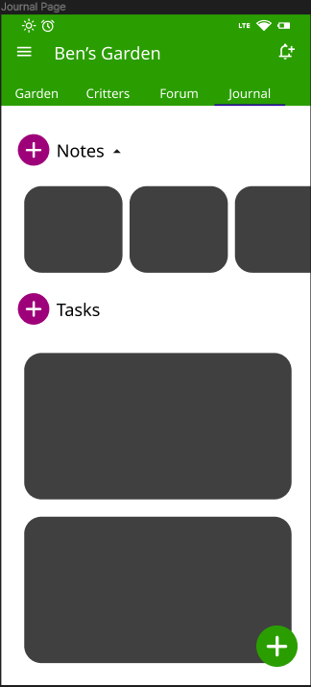
This is the notes page where users are able to make notes and list tasks using a checklist. When making notes, the user can add a voice note, images/screenshots, pencil to draw, checkboxes and text formatting. The tasks can send notifications to the user using the reminder functionality.
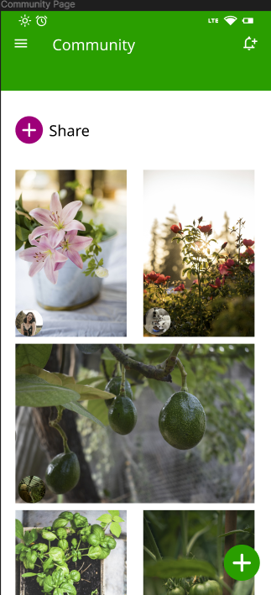
This is the community page where users are able to share images with other users. The images are automatically sorted by the most viewed of the week.
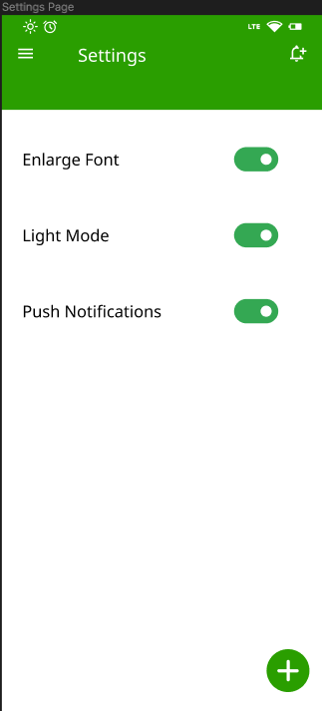
The settings page includes accessibility features that improve the user experience for all users.
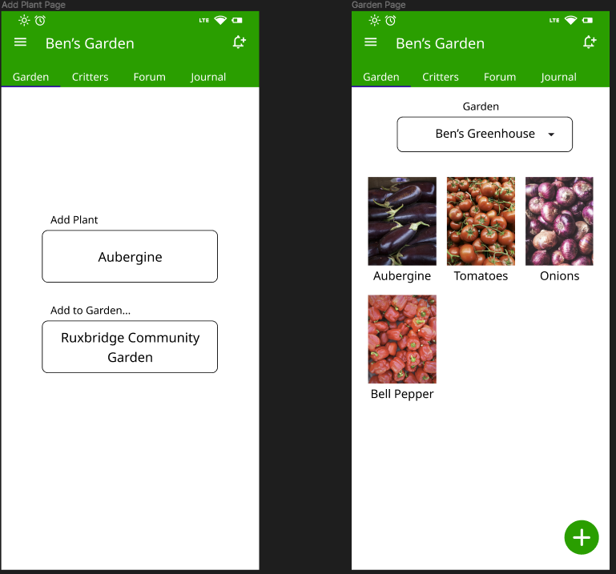
The ‘Add Plant Page’ and ‘Garden Page’ is where the user is able to add a plant to a selected garden using a given dropdown menu when clicking on the button. When viewing the garden, the user can select each plant, where they are able to view information about the plant including the best time to sow, maintain and harvest the plant. Each plant will have its own set of beneficial critters and time to harvest, among other knowledge that the gardener may require.

