1. Download nucleotide entry NC_045512 from NCBI and save as fasta. If interested - look at available coronavirus sequences in RefSeq with search term betacoronavirus[orgn].

https://www.ncbi.nlm.nih.gov/nuccore/NC_045512.2?report=fasta

1. Lets collect related genomes.

Paieška (a-g):

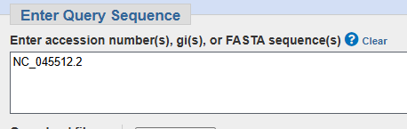

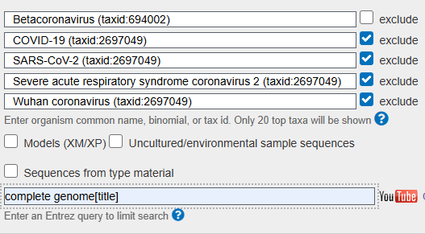

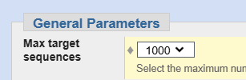

Rezultatai (h):

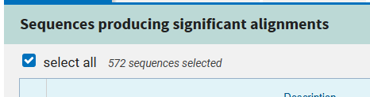

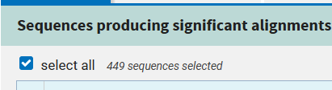

Rastos 572 sekos. Pritaikius coverage >=50% gauname 449 sekas. Id 2697049 pašalinimas iš paieškos leidžia susitelkti į SARS-CoV-2 kilmės ir evoliucijos analizę, išvengiant duomenų, susijusių su NC_045512 sekų kartotinėmis kopijomis, kurios gali užgožti giminingų virusų informaciją.

Ieškome NC_045512 su duombaze RefSeq Genome Database (j), pašalinus taxid 2697049:

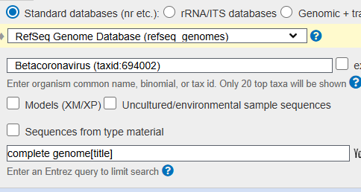

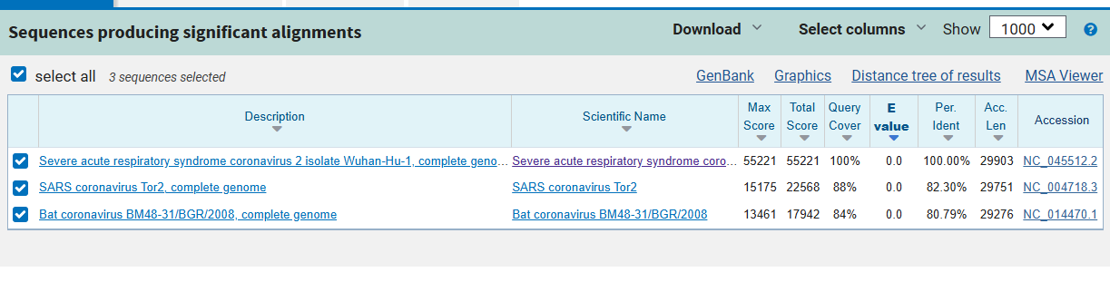

Gauname 449 + 3 + NC_045512 + virus (MN514967.1) = 454 sekos.

1. Remove redundant sequences:
   1. Download and compile <https://github.com/niu-lab/gclust>
   2. Sort the input genomes in decreasing order of length (look at gclust github page)

#Sort

!perl script/sortgenome.pl --genomes-file /content/gclust/outputs/all_sequences.fasta --sortedgenomes-file /content/gclust/outputs/sorted_all.fasta

* 1. Cluster with gclust at 97 identity cut-off.

#Cluster

!./gclust -minlen 20 -both -nuc -threads 8 -ext 1 -sparse 2 -memiden 97 /content/gclust/outputs/sorted_all.fasta > /content/gclust/outputs/clustering.out

Total clusters: 147

* 1. Play with grep/linux utilities and get ids of the representatives.

#Get ids of the representatives

!grep ".*\*" /content/gclust/outputs/clustering.out | cut -d'>' -f2 | awk '{print $1}' | sed 's/\.\.\.$//' > /content/gclust/outputs/representative_ids.txt

* 1. Use seqkit grep to extract representatives from the initial set.

#Use seqkit to extract sequences

!./seqkit grep -i -f /content/gclust/outputs/representative_ids.txt /content/gclust/outputs/all_sequences.fasta -o /content/gclust/outputs/result.fasta

1. Protein based analysis
   1. Search this protein <https://www.uniprot.org/uniprot/D3W8N4.> against the collected viral genomes using tblastn (word size 2, e=10).

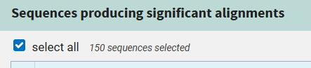

e visur 0.

* 1. Download the aligned parts.

Išsaugota aligned.fasta dokumente.

* 1. Translate with seqkit translate command.

#Translate

!./seqkit translate /content/gclust/outputs/aligned.fasta -o /content/gclust/outputs/translated_proteins.fasta

* 1. By using seqkit seq -m discard all protein sequences that are shorter than 800.

#Filter shorter than 800

!./seqkit seq -g -m 800 /content/gclust/outputs/translated_proteins.fasta -o /content/gclust/outputs/filtered_proteins.fasta

* 1. Align with mafft ($ mafft --maxiterate 1000 --localpair)

#mafft alignment

!mafft --maxiterate 1000 --localpair /content/gclust/outputs/filtered_proteins.fasta > /content/gclust/outputs/output_aligned.fasta

* 1. For easier interpretation and annotation you could remove “:” and spaces from the alignment files.

input_file = "/content/gclust/outputs/output_aligned.fasta"

output_file = "/content/gclust/outputs/output_cleaned_aligned.fasta"

# Open the input file, clean it, and write to the output file

with open(input_file, "r") as infile, open(output_file, "w") as outfile:

    for line in infile:

        # Remove spaces and ':' characters

      cleaned_line = line.replace(" ", "_").replace(":", "_")

      outfile.write(cleaned_line)

* 1. Generate tree with fasttree (use option “-gamma”). Google about this program.

!FastTree -gamma /content/gclust/outputs/output_cleaned_aligned.fasta > /content/gclust/outputs/phylogenetic_tree.txt

1. Analysis
   1. Use ETE3 python package to add root on the camel virus (http://etetoolkit.org/docs/latest/tutorial/index.html). Command “set_outgroup”

tree = Tree("/content/gclust/outputs/phylogenetic_tree.txt")

camel_virus_label = "lcl|Query_4358037_4901-8458_MN514967.1_Dromedary_camel_coronavirus_HKU23_isolate_DcCoV-HKU23/camel/Nigeria/NV1385/2016"

tree.set_outgroup(camel_virus_label)

1. Interpretation.
   1. How did the Covid-19 evolve, what path through hosts was taken?

OVID-19, caused by SARS-CoV-2, likely evolved from a bat coronavirus (e.g., RaTG13) and may have passed through an intermediate host, such as a pangolin, before spilling over to humans.

* 1. Would it be different interpretation if out-group is not used?

Without an out-group, the phylogenetic tree would be unrooted, making it difficult to determine the direction of evolution and which lineage is ancestral. This would complicate the interpretation of SARS-CoV-2’s origin and could lead to inaccuracies in identifying the primary host (e.g., bats or pangolins).

Without an out-group, the phylogenetic tree might misleadingly suggest that the Dromedary camel virus is another type of COVID-19 or closely related to SARS-CoV-2. However, this is not accurate—camel coronavirus is not a type of COVID-19 but rather part of a common ancestor of various betacoronaviruses.

* 1. What about Urbani SARS origin?

Urbani SARS originated from bat coronaviruses.

* 1. Is the Palm Civet origin evident?

While the tree does not explicitly include a palm civet-derived coronavirus, the evolutionary position of SARS-CoV (Urbani) and historical evidence strongly indicate the involvement of palm civets as the intermediate host.