Value types and Reference types
值类型和引用类型
Not all memory allocations we make within Mono will go through the heap.
不是所有我们在Mono中分配的内存都是通过堆内存进行分配。
The .NET Framework(and by extension the C# language, which merely implements the .NET specification) has the concept of Value Types and Reference types, and only the latter of which needs to be marked by the Garbage Collector while it is performing its Mark-and-Sweep algorithm.
.NET Framework(以及拓展为C#语言，仅实现.NET规范)具有值类型和引用类型的概念，并且只有后者需要在垃圾回收器执行Mark-and-Sweep算法。
Reference types are expected to (or need to) last a long time in memory either due to their complexity, their size, or how they’re user.
因为引用类型的复杂性，大小或者什么时候使用。所以引用类型在内存中可能需要（或者需要时）持续很长时间。
Large datasets, and any kind of object instantiated from a class, is a Reference.
大型数据集以及从类里面实例化的任何对象都是引用类型；
This also includes arrays(whether it is of Value types or Reference types), delegates, all classes, such as MonoBehaviour, GameObject, and any custom classes we define.
这个同样包含数组（无论是值类型还是引用类型），委托，所有的类，像monoBehaviour，游戏物体，和任何我们定义的任何自定义类。
Value types are normally allocated on the stack.
值类型通常在栈上面分配。
Primitive data types such as bools, ints, and floats are examples of Value types, but only if they’re standalone and not a member of a Reference types.
原始数据类型像bool，int 和float 都是值类型的示例，但是前提是他们是独立而不是引用类型的成员。
As soon as a primitive data types is contained within a Reference type, such as a class or an array, then it is implied that it is either too large for the stack or will need to survive longer than the current scope and must be allocated on the heap instead.
一旦原始数据类型包含着引用类型，像类或者数组，那么就意味着它对于栈来说就太大，或者将需要比当前范围更长的生存时间，就必须在堆上面分配。
All of this can be best explained through examples.
所有关于他的最好解释就是通过示例。
The following code will create an integer as a Value that exists on the stack only temporaily:
以下代码将会创建一个整数，作为一个临时存在于栈上面的值：
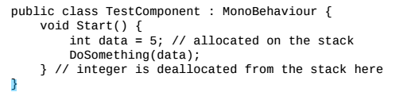
As soon as the Start() method ends, then the integer is deallocated from the stack.
一旦这个Start()函数结束，那么这个整数会从栈上面释放。
This is essentially a free operation since, as mentioned previously, it doesn’t bother doing any cleanup; it just move the stack pointer back to the previously memory location in the call stack.
这个基本上是一个自由的操作，因为如先前所属，它不需要做任何清理工作；它只是将栈指针移回到调用栈中的先前任何位置。
Any future stack allocations simply overwrite the old data.
任何未来的栈分配都是在覆盖旧数据；
Most importantly, no heap allocation took place to creat the data, and so, the Garbage Collector would be completely unaware of its existence.
最重要的是，没有堆分配发生来创建数据，因此垃圾回收器将完全不知道它的存在；
But, if we created an integer as a member variable of the monoBehaviour class definition, then it is now contained within a Reference type(a class) and must be allocated on the heap along with its container:
但是，如果我们创建的是一个整数作为monoBehaviour 类定义的成员，那么他是现在必须包含在一个引用类型（类）中，并且必须与它的容器一起分配在堆上：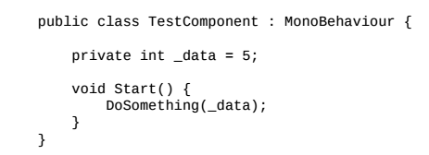
Similarly, if we put the integer into an independent class, then the rules for Reference types still apply, and the object is allocated on the heap:
简单的来说，如果我们将一个整数放入一个独立的类中，那么引用类型的规则仍然适用，并且这个对象在堆上分配；
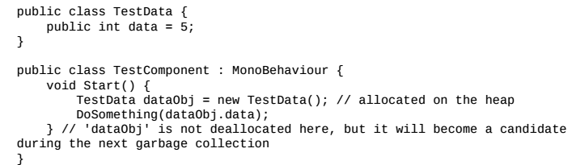
So, there is big difference between temporarily allocating memory within a class method and storing long-term data in a class’member data.
因此，在类方法里面临时分配内存和类成员数据存储长期数据之间存在很大差异；
In both cases, we’re using a Reference type (a class) to store the data, which means it can be referenced elsewhere.
在这两种情况，我们使用引用类型（类）来保存数据，这意味着他可能会其他地方引用。
For example, imagine DoSomething() stored the reference to dataObj within a member variable:
例如，假设DoSomething()在成员变量中存储了对dataObj的引用

In this case, we would not be able 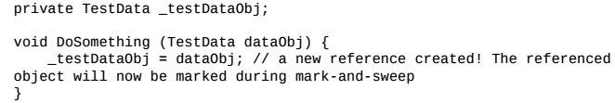to deallocate the object pointed to dataobj as soon as the Start() method ended because the total number of things referencing the object would go from 2 to 1.
在这中情况下，一旦Start（）方法结束，我们将无法释放指向dataobject的对象，因为引用该对象的事物总数将从2变为1。
This is not 0, and hence the Garbage Collector would still mark it during mark-and-sweep.
这不是0，所以垃圾回收器仍然在mark-and-sweep期间标记它。
We will also need to set _testDataObj to null, or make it reference something else, before the object was no longer reachable.
在对象不再可访问之前，我们还需要将_testDataObj设置为null，或使其引用其他内容。
Note that a Value type must have a value, and can never be null.
注意一个值类型必须有值，并且值不能为null。
If a stack-allocated Value type is assigned to a Reference type, then the data is simply copied.
如果栈分配的值类型分配给引用类型，则只需要复制数据。
This is true even for arrays of the Value types:
即使对于值类型的数组也是如此：
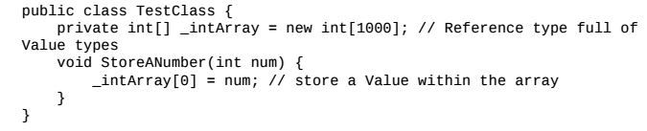
When the initial array is created(during object initialization),1000 integers will be allocated on the heap set to a value of 0.
当数组被创建的时候（在对象初始化期间），在对上面会被分配1000个整数，设置它们的值为0。
When the StoreANumber() method is called, the value of num is merely copied into the zeroth element of the array, rather than storing a reference to it.
当StoreANumber()方法调用时，num的值会被仅复制到数组的第0号元素，而不是存储对它的引用。
The subtle change in the referencing capability is what ultimately decides whether something is a Reference type or a Value type, and we should try to use standalone Value types whenever we have the opportunity, so that they generate stack allocations instead of heap allocations.
引用功能的细微变化最终决定某些东西是引用类型还是值类型，我们应该在有机会是尝试使用独立的值类型，以便他们生成栈分配而不是堆分配。
Any situation where we’re just sending around a piece of data that doesn’t need to live longer than the current scope is a good opportunity to use a Value type instead of a Reference type.
任何情况下，我们只需要发送一个不需要比当前范围更长的数据，这是一个使用值类型而不是引用类型的好机会。
Ostensibly, it does not matter if we pass the data into another method of the same class or a method of another class; it still remains a Value type that will exist on the stack until the method that created it goes out of the scope.
表面上，它将数据传递到同一个类的另一个方法或另一个类的方法并不重要，它仍然是栈上存在的值类型，知道创建它的方法超出了范围。
Pass by value and pass by reference
值传递和引用传递
Technically, something is duplicated every time a data value is passed as an argument from one method to another, and this is true whether it is a Value type or a Referenve type.
技术上来说，每次讲数值作为参数从一个方法传递到另一个方法时，都会复制某些内容，无论是值类型还是引用类型都是如此。
This is known as passing by value.
这就是所谓的值传递
The main difference is that a Reference type is merely a pointer which consumes only 4 or 8 bytes in memory(32-bit or 64 bit, depending on the architecture) regardless of what it is actually pointing to.
这主要的不同点在于引用类型只是一个指针，在内存中只消耗4或者8字节（32bit或者64bit，具体取决于架构），无论它实际指向什么。
When a Reference type is passed as an argument it is actually the value of this pointer that gets copied, which is very quick since the data is very small.
当应用类型作为参数传递的时候，真实传递的是复制这个值的指针，这是非常快，因为数据非常小。
Meanwhile, a Value type contains the full and complete bits of data stored within the object.
同时，值类型包含存储在这个对象里面完整和完整数据bit。
Hence, all of the data of a Value type gets copied whenever they are passed between methods,or stored in other Value types.
因此，只要在方法之间传递或存储在其他值类型中，就会复制Value类型的所有数据。
In some cases, it can mean that passing a large Value type as arguments around too much can be more costly than just using a Reference type.
在某些情况下，它可能意味着将大的值类型作为参数传递给过多可能可能仅比使用引用类型更昂贵。
For most Value types, this is not a problem, since they are comparable in size to a pointer.
对于大多数值类型，这不是一个问题，因为他们在大小上与指针相同。
But this becomes important when we begin to talk about structs, in the next section.
但是当我们开始谈论关于结构体时，这一点变得很重要，在下一个节中。
Data can be passed around by reference as well, by using the ref important to keep them distinct in our mind when we try to understand what is going on under the hood.
数据可以通过引用传递，通过使用ref关键字，当我们试图理解引擎盖下发生的事情时，将它们保持在我们的脑海中。
We can pass a Value type by value, or by reference, and we can pass a Reference type by value, or by reference.
我们可以通过值或者引用传递值类型，并且我们按值或者引用传递引用类型。
This means that there are four distinct data passing situations that can occur depending on which type is being passed and whether the ref keyword is being used or not.
这意味者可能会发生四种不同的数据传递情况，具体取决于传递的类型以及是否正在使用ref关键字。
When data is passed by reference (even if it is a Value type!) then making any changes to the data will change the original.
当数据通过引用类型传递（即使它是一个值类型），则任何对数据的更改都会改变原始数据；
For example, the following code would print the value 10：
例如，以下的代码将打印值10：
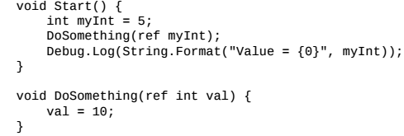
Removing the ref keyword from both places would make it print the value 5 instead.
从这两个地方移除ref关键字，将会打印值5；
This understanding will come in handy when we start to think about some of the more interesting data types we have access to. Namely, structs, arrays, and strings.
当我们开始考虑一些更有趣的数据类型是，这种理解将会排上用场，既结构体，数组和字符串。

Struct are Value types
结构体是值类型
Structs are an interesting special case in C#.
结构体是C#中是一个有趣的特例。
If we come from a C++ background to C#, then we would probably assume that the only difference between a struct and a class is that a struct has a default access specifier, public, while a class defaults to private.
如果我们从C++后台到c#，则我们可能会假设结构体和类之间的唯一区别是结构具有默认的访问说明符public,而类默认为private。
However, in C#, structs are similar to classes in that they can contain other private/protected/public data, have methods, can be instantiated at runtime, and so on.
然而，在c#中，结构体类似于类，因为它们都包含其他private /protected / public数据，具有方法，可以在运行时实例化，等等。
The core difference between the two is that structs are Value types and classes are Reference types.
两个之间的核心区别是结构体是值类型，类是引用类型。
There are some other important difference between how structs and classes are treated in C#; structs don’t support inheritance, their properties cannot be given custom default value(member data always defaults to values such as 0 or null, since it is a Value type), and their default constructors connot be overridden.
在c#中如何处理结构体和类之间还有一些其他重要的区别；struct不支持继承，它们的属性不能给定自定义默认值（成员数据总是默认为0或者null等值，因为他是值类型），并且它们的默认构造函数不能被覆盖。
This greatly restricts their usage compared to class, so simply replacing all classes with structs(under the assumption that it will just allocate everything on the stack) is not a wise course of action.
跟类相比，这极大的限制了它们的使用，因此简单地用结构替换所有类（假设他只是在堆栈上分配所有内容）并不是明智的做法。
However, if we’re using a class in a situation whose only purpose is to send a blob of data to somewhere else in our application, and it does not need to last beyond the current scope, then we should use a struct instead, since a class would result in a heap allocation for no particularly good reason:
但是，如果我们在一个情景中使用一个类，其唯一的目的是将一大块数据发送到我们的应用程序中的其他位置，并且它不需要超出当前范围，那么我们应该使用结构体代替，因为一个类会导致堆分配，没有特别好的理由：
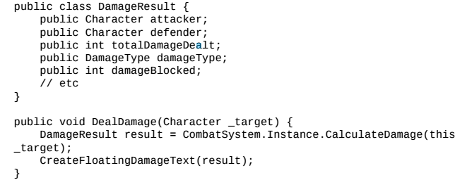
In this example, we’re using a class to pass a bunch of data from one subsystem (the combat system) to another(the UI system).
在这个实例中，我们使用一个类把一堆数据从一个子系统（战斗系统）传递给另一个系统（UI系统）。
The only purpose of this data is to be calculated and read by various subsystems, so this is a good candidate to convert into a struct.
这些数据的唯一目的是由不同的子系统计算和读取，因此这是转换为结构的一个很好的候选者
Merely changing the DamageResult definition from a class to a struct could save us quite a few unnecessary garbage collections, since it would be allocated on the stack.
仅仅将DamageResult定义从类更改为结构体可以为我们节省相当多的不必要垃圾收集，因此它将在堆栈上分配。
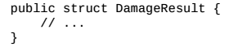
This is not a catch-all solution.
这不是一个完全可行的解决方案。
Since structs are Value types, this means something rather unique when it is passed as an argument between methods.
由于结构体是一个值类型，因此当它作为方法之间的参数传递时， 这意味者相当独特。
As we previously learned, every time a Value type is pass as an argument between one function and another, it will be duplicated since it is passed by value.
正如我们之前所知，每次将value类型作为一个函数与另一个函数之间的参数传递时，它将被复制，因为它是按值传递的。
This creates a duplicate Value type for the next method to use, which will be deallocated as soon as that method goes out of scope, and so on each time it is passed around.
这为下一个要使用的方法常见一个重复的值类型，一旦方法超出了范围就会被释放，并且每次传递时都会释放。
So，if a struct is passed by value between five different methods in a long chain, the five different stack copies will occur at the same time.
所以，如果结构体在长链中的5个不同的方法之间通过值传递，则5个的栈副本将同时发生。
Recall that stack deallocations are free, but data copying is not.
回想一下，栈释放是免费，但是数据复制不是。
The copying is pretty much negligible for small values, such as a single integer or float, but passing around ridiculously large datasets through structs over and over again is obviously not a trivial task and should be avoided.
对于小值（例如单个整数或浮点数），复制几乎可以忽略不计，但是一遍又一遍地通过结构体遍布大量数据集显然不是一项微不足道的任务，应该避免。
In such case, it would be wiser to pass the struct by reference using the ref keyword to minimize the amount of data being copied each time(just a 32-bit or 64-bit integer for the memory reference).
在这种情况下，使用ref关键字通过引用传递结构体会更明智，以最小化每次复制的数据量（内存引用只是一个32位或64位整数）。
However, this can be dangerous since passing by reference allows any subsequent methods to make changes to the struct, in which case it would be prudent to make its data values readonly(it can only be initialized in the constructor, and never again, event by its own member functions) to prevent later changes.
然而，这可能很危险，因为通过引用传递允许任何后续方法对结构体进行更改，在这种情况下，谨慎地使其数据值只读（它只能在构造函数中初始化，并且永远不会再次，事件由它自己的成员函数）以防以后的更改。
All of the above is also true when structs are contained within Reference types:
当结构体包含在引用类型中时，以上所有内容都是正确的：
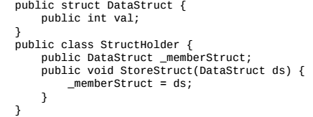
To the untrained eye, the preceding code appears to be attempting to store a stack-allocated struct within a Reference type.
对于未经训练的眼睛，前面的代码似乎试图在Reference类型中存储栈分配的结构；
Does this mean that a StructHodler object on the heap can now reference an object on the stack?
这是否意味者堆上的StructHoder对象现在可以引用堆栈上的对象？
What will happen when the StoreStruct() method goes out of scope and the struct is erased?
当StoreStruct()函数超出范围并删除结构是会发生什么？
It turns out that these are the wrong questions.
事实证明这些是错误的问题。
What’s actually happening is that, while a DataStruct object(_memberStruct) has been allocated on the heap within the StrucHodler object, it is still a Value type and does not magically transform into a Reference type.
实际发生的是，虽然DataStrcutd对象（_memberStruct）已经在StrucHodler对象中的堆上分配，它仍然是一个值类型，并且不会神奇地转化成引用类型。
So, all of the usual rules for Value types apply.
因此，适用于Value类型的所有通用规则。
The _memberStruct variable cannot have a value of null and all of its fields will be initialized to 0 or null values.
_memberStruct变量的值不能为null，并且其所有的字段都将初始化为0或null值。
When StoreStruct() is called, the data form ds will be copied into _memberStruct.
当StoreStruct()调用的时候,ds的数据格式将会复制到_memberStruct中.
There are no references to stack objects taking place, and there is no concern about lost data.
没有对栈对象的引用，也不用担心丢失数据。
Arrays are Reference types
数组是引用类型。
Arrays can potentially contain a huge amount of data within them, which make them difficult to treat as a Value type since there’s probably not enough room on the stack to support them.
数组可能包含大量数据，这使得它们很难被视为值类型，因为栈上可能有足够的空间来支持它们。
Therefore, they are treated as a Reference type so that the entire dataset can be passed around via a single reference, instead of duplicating the entire array every time it is passed around.
因此，它们被视为引用类型，以便整个数据集可以单个引用传递，而不是每次传递时复制整个数组。
This is true irrespective of whether the array contains Value types or Reference types.
无论数组包含值类型还是引用类型，都是如此。
This means that the following code will result in a heap allocation:
这意味者下面代码的结果都是在堆上分配。
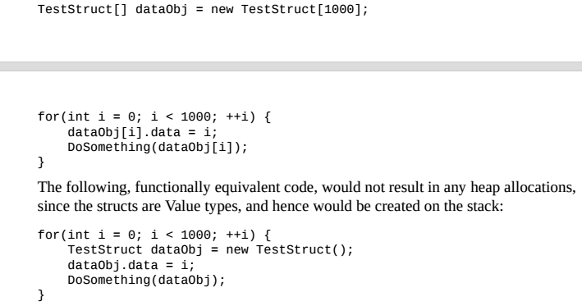
The subtle difference in the second code-block is that only one TestStruct exists on the stack at a time(at least for this function DoSomething() can potentially create more), whereas the first block needs to allocate 1000 of them via an array.
第二个代码块的细微差别在于，一次只有一个TestStruct存在于栈中（至少对于DoSomething（）可能会创建更多），而第一个块需要通过数组分配1000个。
Obviously, these methods are kind of ridiculous as they’re written, but they illustrate an important point to consider.
显然，这些方法有点荒谬，但它们说明了一个需要考虑的重点。
The compiler isn’t smart enough to automatically find these situations for us and make the appropriate changes.
编译器不够智能，无法自动为我们找到这些情况并进行适当的更改。
Opportunities to optimize out memory usage through Value type replacements will be entirely down to our ability to detect them, and understand why a change will result in stack allocations, rather than heap allocations.
通过值类型替换来优化内存使用的机会完全取决于我们检测它们的能力，并理解为什么更改将导致栈分配，而不是堆分配。
Note that, when we allocate an array of Reference types, we’re crating an array of references, which can each reference other locations on the heap.
请注意，当我们分配一个Reference类型数组时，我们正在创建一个引用数组，每一个引用都可以引用堆上的其他位置。
However， when we allocate an array of Value types, we’re creating a packed list of Value types on the heap.
然而，当我们分配一个值类型数组时，我们在堆上面创建一个值类型的打包列表。
Each of these Value types will be initialized with a value of 0(or equivalent),since they cannot be null, while each reference within an array of Reference types will always initialize to null, since no references have been assigned, yet.
这些值类型中的每一个都将值0（或等效值）进行初始化，因为他们不能为null,而引用类型数组中的每一个引用将始终初始化为null,因为尚未分配任何引用。

String are immutable Reference types
String是不可变的引用类型
We briefly touched upon the subject of strings back in Chapter 2, Scripting Strategies, but now it’s time to go into more detail about why proper string usage is extremely important.
我们在第二章“脚本策略”中简要的介绍了字符串的主题，但是现在是时候详细了解为什么正确的字符串使用非常重要。
Because string are essentially arrays of characters (chars), they are Reference types; the value that is actually copied and passed between functions is merely a pointer, and they will be allocated on the heap.
因为字符串本质上是字符数组（字符），所以它们时引用类型；在函数之间实际复制和传递的值只是一个指针。
The confusing part really begins when we discover that strings are immutable, meaning they cannot be changed after they’ve been allocated.
当我们发现字符串是不可变的时，这个令人困惑的部分真的开始了，这意味者它们在分配之后就无法更改。
Being an array implies that the entire list of characters must be contiguous in memory,which cannot be true if we allowed strings to expand or contract at-will within a dynamic memory space(how could we quickly and safely expand the string if we’ve allocated something else immediately after it?).
一个数组意味着整个字符列表必须在内存中是连续的，如果我们允许字符串在动态内存空间中随意扩展或收缩（如果我们在它之后立即分配了其他东西，那么如何快速安全地扩展字符串），那么这是不可能的。
The means that, if a string is modified, then a new string must be allocated to replace it, where the contents of the original will be copied and modified as-needed into a whole new character array.
这意味着，如果修改了字符串，则必须分配一个新的字符串来替换它，其中的原始内容将会被复制和修改为一个新的完整的字符数组。
In which case， the old version will no longer be referenced anywhere, will not be marked during mark-and-sweep and will therefore eventually be garbage-collected.
在这种情况下，旧版本将不再任何地方引用，在mark-and-sweep期间经不会被标记，因此最终将被垃圾回收器回收。
As a result, lazy string programming can result in a lot of unnecessary heap allocations and garbage collection.
因此，惰性字符串编程可能导致大量不必要的堆分配和垃圾回收。
For example, if we believed that strings worked just like other Reference types, we might be forgiven for assuming the log output of the following to be world!:
举个例子，如果我们相信字符串像其他引用类型一样工作，那么假设下面的日志的输出为world，我们可能会被原谅。
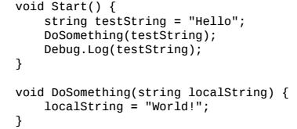
However, this is not case, and it will still print out hello.
但是，情况并非如此，它仍然会打印Hello。
What is actually happening is that the localString variable, within the scope of DoSomething(), starts off referencing the same place in memory as testString, due to the reference being passed by value.
实际发生的是，在DoSomething()范围内的localString变量开始引用内存中与testString相同的位置，因为引用是通过值传递的。
The given us two references pointing to the same location in memory as we would expect if we were dealing with any other Reference type. So far, so good.
给定的两个应用指向内存中的同一个位置，如果我们处理任何其他引用类型，我们会期望。到目前为止，一切都很好。
But, as soon as we change the value of localString, we run into a little bit of a conflict.
但是，只要我们更改localString的值，我们就会遇到一些冲突。
Strings are immutable, and we cannot change them, so therefore we must allocate a new string containing the value world! and assign its reference to the value of localString; now the number of references to the Hello string returns back to one.
字符串是不可改变的，我们无法更改它们，因此我们必须分配一个包含值world的新字符串！并赋予其对localString值的引用；现在，对hello字符串的引用数量返回到一个。
The original string（hello）will remain in memory because the value of testString has not been changed, and that is still the value which will be printed by Debug.log().
原始的字符串（hello）将保留在内存里面，因为testString的值尚未更改，这仍然是debug.log()打印的值。
All we’ve succeeded in doing by calling DoSomething() is creating a new string on the heap which gets garbage-collected, and doesn’t change anything.
我们通过调用DoSomething()成功完成了在堆上创建一个新的字符串，它被垃圾回收，并且不会改变任何东西。
This is the textbook definition of wasteful.
这是浪费的教科书定义。
If we change the method definition of DoSomething() to pass the string by reference, via the ref keyword, the output would indeed change to world!.
如果我们改变DoSomething()方法定义以通过引用传递字符串，通过ref关键字，输出确实会改变为world！.
This is what we would expect to happen with a Value type, which leads a lot of developers to incorrectly assume that string are Value types.
这是我们期望在Value类型中发生的事情，这导致许多开发人员错误地认为字符串是Value类型。
But, this is an example of the fourth and final data-passing case where a Reference type is being passed by reference, which allows us to change what the original reference is referencing!
但是，这是第四个也是最后一个数据传递的例子，其中reference类型通过引用传递，这允许我们更改原始引用内容！
Note
So, to recap; if we pass a Value type by value, we can only change the value of the copy.
所以，回顾一下；如果我们按值传递Value类型，我们只能更改副本的值。
If we pass a Value type by reference, we can change the actual value attributed to the original version.
如果我们通过引用传递Value类型，我们可以更改原始版本的实际值。
If we pass a Reference type by value, we can make changes to the object that the original reference is referencing.
如果我们按值传递Reference类型，我们可以更改原始引用的对象。
And finally, if we pass a Reference type by reference, we can change which object the original reference is referencing.
最后，如果我们通过引用传递Reference类型，我们可以更改原始引用的引用对象。
String concatenation
字符串连接
Concatenation is the act of appending strings to one another to form a larger string.
连接是将字符串附加到另一个以形成更大字符串的行为。
As we’ve learned, any such cases are likely to result in excess heap allocations.
正如我们所了解的那样，任何此类情况都可能导致堆积分配过多。
The biggest offender in string-based memory waste is concatenating strings using the + and += operators， because of the allocation chaining effect they cause.
基于字符串的内存浪费最大的攻击者是使用+和+=运算符连接字符串，因为他们会导致分配链接效应。
For example, the following code tries to combine a group of strings together to print some information about a combat result:
例如，一下代码将尝试将字符串组合在一起以打印有关战斗的结果的一些信息：
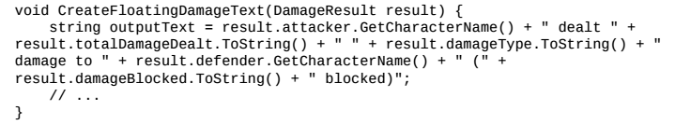 An example output of this function might be a string that reads:
这个函数的一个实例输出的可能是一个字符串。
Dwarf dealt 15 Slashing damage to Orc (3 blocked)

This function features a handful of string literals(hard-coded strings that are allocated during application initialization) such as dealt, damage to , and blocked.
这个函数具有少量的字符串（在应用初始化的期间的分配的硬编码字符串），例如dealt，damage、blocked。
But，because of the usage of variable within this combined string, if cannot be complied away at build time, and therefore must be generated dynamically at runtime.
但是，由于在这个组合字符串里面使用变量，如果在构建的时候无法编译，因此必须在运行时动态生成。
A new heap allocation will be generated each time a +,or +=, operator is executed; only a single pair of strings will be merged at a time, and it allocates a new string each time.
每次运行+，或+=运算符时，都会生成一个新的堆分配；一次只合并一对字符串，每次都分配一个新的字符串。
Then, the result of one merger will be fed into the next, and merged with another string, and so on until the entire string has been built.
然后，一个合并的结果将被送入下一个，并与另一个字符串合并，以此类推，直到构建完整的字符串。
So, the previous example will result in 9 different strings being allocated all in one go.
因此，前面的实例将导致一次性分配9个不同的字符串。
All of the following strings would be allocated to satisfy this instruction, and all would eventually need to be garbage collected(note that the operators are resolved from right-to-left);
将分配一下所有字符串以满足此指令，并且最终需要对所有字符串进行垃圾收集（请注意，操作符是从右到做解析的）；
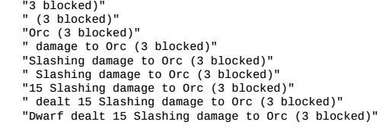
That’s 262 characters being used, instead of 49; or because a char is a 2-byte data type, that’s 524 bytes of data being allocated when we only need 98 bytes.
这是使用262个字符，而不是49个；或者因为char是一个2字节的数据类型，而当我们需要98个字节时，就会分配524个字节数据。
Chances are that, if this code exists in the codebase once, then it exists all over the place, so for an application that’s doing a lot of lazy string concatenation like this, that is a ton of memory being wasted on generating unnecessary strings.
可能的是，如果这个代码存在于代码库中一次，那么就他存在于任何地方，因此对于进行大量像这样的延迟字符串连接的应用程序来说，这是浪费在生成不必要的字符串上的大量内存。
Tip
Note that big, constant string literals can be safely combined using the + and += operators to make them more readable within the codebase, but only if they will result in a constant string.
请注意，可以使用+和+=运算符安全地组合大的常量字符串文字，以使它们在代码库中更具有可读性，但前提是它们将产生一个常量字符串。
If so, the compiler will take care of merging all of the string literals together at compile time.
如果是这样，编译器将在编译时将所有的字符串文字合并在一起。
Better approaches for generating strings are to use either the StringBuilder class, or one of several string class methods.
生成字符串的更好方法是使用StringBuilder类或几个字符串类方法之一。
The StringBuilder class is effectively a mutable(changeable) string class.
StringBuilder类实际上是一个可变（可更改）的字符串类。
It works by allocating a buffer to copy the target strings into and allocates additional space whenever it is needed.
它的工作原理是分配一个缓冲区来复制目标字符串，并在需要的时候分配额外的空间。
We can retrieve the string using the ToString() method which, naturally, results in a memory allocation for the resultant string, but at least we avoided all of the unnecessary string allocations we would have generated using the + or += operators.
我们可以使用toString（）方法来检索字符串，这自然会导致结果字符串分配，但至少我们避免了使用+或+=运算符生成的所有不必要的字符串分配。
Conventional wisdom says that if we roughly know the final size of the resultant string, then we can allocate an appropriate buffer ahead of time and save ourselves undue allocations.
传统观点认为，如果我们粗略地知道结果字符串的最终大小，那么我们可以提前分配适当的缓冲区并节省自己过多地分配。
For our example above, we might allocate a buffer of 100 characters to make room for long character names and damage values:
对于上面的实例,我们可能会分配一个100个字符的缓冲区，以便为长字符名称和损坏值腾出空间：
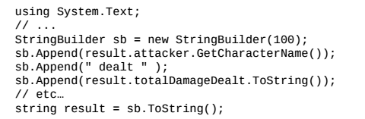
If we don’t know the final size, then using a StringBuilder class is likely to generate a buffer that doesn’t fit the size exactly,or closely.
如果我们不知道最终大小，那么使用StringBuilder类可能会生成一个不完全符合大小或紧密匹配的缓冲区。
We will either end up with a buffer that’s toot large(wasted allocated time and space), or, worse, a buffer that’s too small, which must keep expanding as we generate the complete string.
我们要么最终得到一个大的缓冲区（浪费分配的时间和空间），或者更糟糕的是，一个太小的缓冲区，它必须在我们生成完整的字符串是继续拓展。
If we’re unsure about the total size of the string, then if might be best to use one of the various string class methods.
如果我们不确定字符串的总大小，那么最好使用各种字符串类方法之一。
There are three string class methods available for generating strings; Format(), Join(), and Concat().
有三种字符串类方法可用于生成字符串；Format()、Join()、Concat()
Each operates slightly differently, but the overall output is the same; a new string is allocated containing the contents of the string(s) we pass into them, and it is all done in a single action which reduces excess string allocations.
每个操作略有不同，但总体输出是相同的；分配一个新字符串，其中包含我们传入其中的字符串的内容，并且所有这些都在一个操纵中完成，这减少了多余的字符串。
It is surprisingly hard to say which one of the two approaches would be more beneficial in a given situation as there are a lot of really deep nuances involved.
令人惊讶的是，很难说这是两种方法中的哪一种在特定情况下会更有益，因为涉及很多真正深刻的细微差别。
There’s a lot of discussion surrounding the topic(just do a Google search for “c sharp string concatenation performance” and you’ll see what I mean), so the best approach is to implement one or the other using the conventional wisdom described previously.
关于这个主题有很多讨论（只是谷歌搜索“c sharp string concatenation performance”,你会明白我的意思），所以最好的方法是使用前面描述的传统智慧实现其中一个。
Whenever we run into bad performance with one method, we should try the other, profile them both, and pick the best option of the two.
每当我们使用一种方法遇到不良表现是，我们应该尝试另一种方法，对它们进行分析，然后选择两种方法的最佳选择。

