CAPIS-2511
Demo Kit and Click-by-Click Guide
A presentation runbook for the DMC export-consolidation workflow
Recommended method: Use CAPSTONE_PRESENTATION_FLOW.md for the speaking sequence and this kit for the actual clicks, inputs, checkpoints, and recovery steps. Do not try to force every module through one newly created order during the live presentation.

What this kit solves
- Which website or page to open for setup and for each role.
- Exactly what to click and what sample values to enter.
- Which seeded order to use for each checkpoint.
- Which current screens are safe to change live and which should be shown only.
- What to say, what result to expect, and how to recover if a step fails.
Prepared from the repository UI, database schema, migrations, seed script, demo-endtoend.md, and CAPSTONE_PRESENTATION_FLOW.md.

ABOUT CAPIS-2511
CAPIS-2511 is DMC Enterprise's role-based export-consolidation system. It connects a customer quotation request to PFI approval, payment verification, supplier purchase orders, warehouse receiving and staging, shipment, and final completion.
This demo kit follows one primary order from beginning to end. Each step is a separate demonstration scenario, but every scenario is a continuation of the same business transaction. The presenter records the generated QT, PFI, ORD, and PO references and reuses them at every role handoff.
Scope: demonstrate the implemented web workflow and role handoffs. Do not claim live carrier, banking, email, customs, or external ERP integration unless those services have been separately configured and verified.

IMPORTANT NOTES BEFORE THE DEMONSTRATION
- Apply the database schema and migrations through migration 011 before testing the Warehouse role.
- Use four separate browser profiles: Customer, Administrator, Supplier, and Warehouse.
- Create one primary quotation live. Continue using its resulting ORD and linked PO numbers until the order is completed.
- Write every generated reference on the Presenter Tracking Sheet immediately after it appears.
- Prepare a sample bank-transfer slip and supplier waybill before the presentation.
- Run a full dry run before presentation day. Keep the seeded records only as recovery checkpoints, not as separate stories.
- The included screenshots identify the correct website pages. Replace any empty-state image with a signed-in screenshot containing your final seeded or live demonstration data before submission.

HOW THE SCENARIOS CONNECT
Yes—each numbered step is a scenario. The scenarios are sequential, not independent: Customer creates the request → Admin prepares the PFI → Customer approves and pays → Admin verifies and creates the PO → Supplier dispatches → Warehouse receives, labels, and stages → Admin ships and completes the same order.

1. Use the two existing demo documents this way
Document | Use it for | Do not use it as
CAPSTONE_PRESENTATION_FLOW.md | Main presentation order, speaker cues, architecture, results, Q&A | A literal click script
demo-endtoend.md | Short rehearsal checklist and the one-order story | Proof that one record currently traverses every screen automatically
This demo kit | Live operator instructions, data inputs, checkpoints, risks, and reset notes | A replacement for your formal capstone manuscript

Decision: Present one connected business story, but operate the software using prepared checkpoints. This preserves the end-to-end narrative without risking missing purchase-order automation or warehouse status incompatibilities.

2. Websites and windows to prepare
Window | Address / section | Purpose
CAPIS application | Local: http://localhost:3000  or your deployed Vercel URL | All customer, admin, supplier, and warehouse screens
Supabase dashboard | Project > SQL Editor | Run migrations, seed/reset demo data, and retrieve database IDs
Supabase dashboard | Authentication > Users | Create and auto-confirm demo login accounts
Supabase dashboard | Table Editor > profiles | Assign each Auth user the correct application role
Supabase dashboard | Storage > payment-proofs | Confirm the private payment-proof bucket exists after migration 010
Browser profiles | Customer / Admin / Supplier / Warehouse | Stay signed in to all roles; avoid repeated logout/login during the demo

If presenting from localhost: In PowerShell, open the project folder and run npm run dev, then use http://localhost:3000. Keep the terminal visible only before the presentation; hide it during the business flow.

3. One-time setup in Supabase

3.1 Database
- Open Supabase > SQL Editor > New query.
- Apply the base schema and all applicable migrations in numeric order. At minimum, the existing demo notes depend on migrations 005 and 007; customer locations require 006; chatbot reads require 008; PFI expiry approval requires 009; payment proof and payment RLS require 010.
- Confirm that at least one customer and at least two available products already exist. The seed script reuses existing customer/product rows; it does not create them.
- Paste and run db/seed_demo.sql.
- Run the verification query below and confirm QT-2026-910, ORD-2026-911, and ORD-2026-912 appear.
Verification SQL: select order_number, quotation_number, status from customer_orders where order_number in ('QT-2026-910','ORD-2026-911','ORD-2026-912') order by order_number;

3.2 Demo users and accounts
Below are the accounts used to demonstrate CAPIS role-based access. Each account represents a participant in the export-consolidation process and displays only the functions required for that participant's responsibilities.
Account | Login email | Description / purpose | Main demo pages and actions | Setup note
Customer  Role: customer | [Enter customer demo email] | Represents a DMC customer. This account browses products, requests a quotation, reviews and approves the PFI, records payment, tracks orders, views documents, and uses the read-only order assistant. | Product Catalog; Request Quotation; My Orders; Documents; Dashboard chatbot. | The profile must be linked to the customer record that owns the demo orders and should have a saved delivery location.
Administrator  Role: admin | [Enter admin demo email] | Represents DMC management or sales staff with the broadest operational view. This account reviews customer orders, prepares PFIs, monitors multi-supplier consolidation, purchase orders, billing, suppliers, customers, and compliance. | Order Management > Customer Orders; PFI Builder; Purchase Orders; Billing & Payments; Suppliers. | Use this account to prepare the PFI and show ORD-2026-911. Do not edit or delete seeded records during the presentation.
Supplier  Role: supplier | supplier@test.com | Represents Universal Robina Corp. The supplier sees only purchase orders assigned to its company, opens PO details, records full or partial dispatches, uploads a delivery receipt or waybill, and reviews delivery history. | Supplier Dashboard; Purchase Orders; PO-2026-901; Log Dispatch; Delivery History. | The authentication email must exactly match suppliers.email for Universal Robina Corp. Row-Level Security limits access to the supplier's own records.
Warehouse Staff  Role: warehouse | [Enter warehouse demo email] | Represents personnel who confirm incoming deliveries, compare dispatched and received quantities, record condition discrepancies, assign rack locations, monitor stock, update labeling progress, stage goods, and mark preparation complete. | Warehouse Overview; Log Delivery; Confirm Delivery Receipt; Staging Tracker; Warehouse Locations; Stock. | The profiles row must use role = warehouse. Apply migration 011 before using the warehouse portal and dry-run all state-changing actions.

- In Supabase, open Authentication > Users > Add user.
- Enter the email and a shared demo-only password; enable auto-confirm.
- Open Table Editor > profiles and ensure the Auth user ID has the required role above.
- For the customer account, confirm its profile/customer relationship owns the seeded orders.
- Log in once in each browser profile and leave the correct dashboard open.
Security: Do not place real passwords in this document or in presentation slides. Keep a separate private credential note.

4. Primary demonstration: one order from request to completion
Primary rule: Create one customer quotation and keep using the same database record throughout the demonstration. The roles change, but the order does not. Prepared seeded orders are recovery checkpoints only.
The record initially displays a QT reference. When the customer approves the PFI, the same record receives an ORD reference while retaining its quotation number. Write both references on the presenter tracking sheet and use the ORD reference for every later act.

4.1 How the order identity changes
Point in flow | Reference shown | Meaning
Quotation request submitted | QT-[year]-[number] | The customer's original request reference.
PFI prepared | PFI-[year]-[number] | Billing document linked to the same customer-order record.
Customer approves | ORD-[year]-[number] | Official order number assigned to the same record; the QT reference is retained.
Procurement begins | PO-[year]-[number] | One or more supplier purchase orders linked back to the same ORD record.

4.2 End-to-end lifecycle
Stage | Account | Action on the same order | Expected result
1 | Customer | Create and submit quotation request | QT reference created; status submitted
2 | Admin | Price items and create PFI | PFI linked; order remains submitted
3 | Customer | Approve PFI | Same record receives ORD reference; awaiting down payment
4 | Customer | Submit down-payment record | Payment enters verification queue
5 | Admin | Verify down payment | Order advances to payment_verified
6 | Admin / Procurement | Create supplier POs linked to the ORD | Procurement begins; supplier work is traceable
7 | Supplier | Record dispatch against its PO | Delivery becomes pending_confirmation
8 | Warehouse | Confirm quantities, condition, and rack | PO becomes delivered or partially delivered
9 | Warehouse | Update labeling / sticker progress | PO advances to pending_label, then staging
10 | Warehouse | Assign final location and confirm staging | PO reaches ready_for_shipment
11 | Customer | Open My Orders and assistant | Customer sees the latest recorded progress
12 | Admin | Record shipment and completion | Order reaches shipped, then completed

4.3 Presenter tracking sheet
Reference to record | Write it here during the demo
Quotation number | QT-____________________________
PFI number | PFI-___________________________
Official order number | ORD-__________________________
Supplier PO 1 | PO-____________________________
Supplier PO 2 (if used) | PO-____________________________
Presenter discipline: After each role handoff, say the order number aloud and confirm it on screen. This proves that the presentation is following one connected record.

4.4 Backup checkpoints only
Checkpoint | Use only if | Resume the story at
QT-2026-910 | A new quotation or PFI save fails | PFI preparation
ORD-2026-911 | PO creation, supplier, or consolidation data is unavailable | Multi-supplier procurement / dispatch
ORD-2026-912 | Warehouse preparation cannot be advanced live | Labeling, staging, and customer tracking
How to explain a fallback: Say: 'I am opening the prepared checkpoint of the same business process so we can continue the workflow.' Do not introduce it as a new scenario or unrelated customer order.

5. Scenarios: step-by-step single-order demo flow

Step 0 - Prepare the demo environment
Scenario: The presenter prepares verified accounts, sample files, and clean browser sessions so the audience sees a continuous workflow without setup delays.
- Apply the required migrations through migration 011 and load any required reference data.
- Confirm Customer, Admin, Supplier, and Warehouse accounts can sign in.
- Open a separate browser profile for each role and keep all four sessions signed in.
- Prepare a harmless sample transfer slip and supplier waybill file.
- Keep the presenter tracking sheet visible and leave all reference fields blank.
- Dry-run purchase-order creation, warehouse receipt, labeling, staging, shipment, and completion before presentation day.
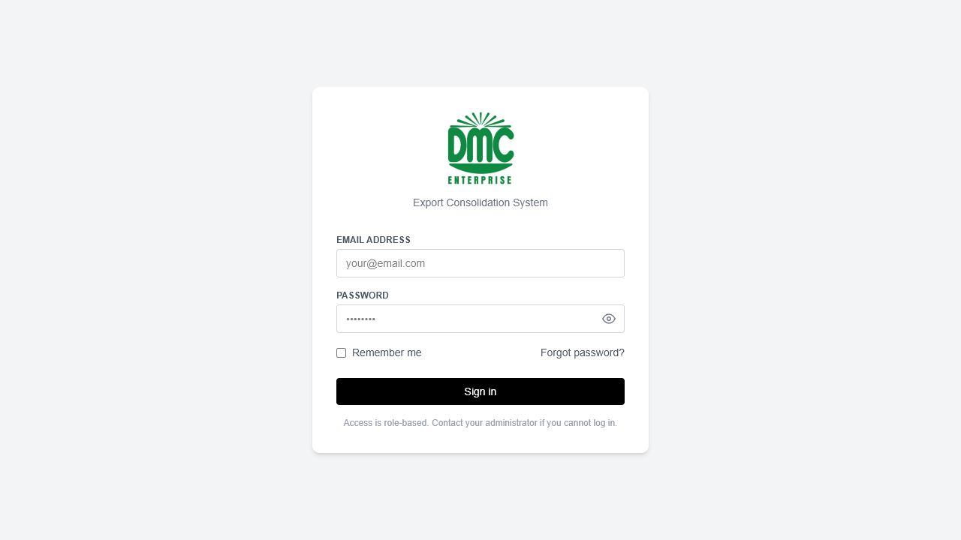
Figure 1. CAPIS sign-in page used by all role-based demo accounts.

Step 1 - Customer creates the quotation request
Scenario: A customer in Hong Kong needs Philippine products consolidated into one shipment and submits a quotation request with quantities, destination, preferred date, and labeling instructions.
Account: Customer | Route: /customer/catalog, then /customer/quotation/new
- Open Product Catalog and add two available products.
- Open Request Quotation. Enter quantities such as 24 and 36 cases.
- Select the saved delivery location Main warehouse - Kowloon.
- Choose a future preferred ship date.
- Enter Special Instructions: Apply Hong Kong nutrition labels and consolidate into one shipment.
- Review the estimated quantity, CBM, weight, and destination.
- Click Submit quotation request.
- Write the generated QT number on the tracking sheet.
Expected result: One submitted quotation exists. Every later step must open this same record.

Step 2 - Admin prepares the PFI
Scenario: The administrator reviews the customer's new QT reference, prices every line item, adds estimated shipping, and issues a pro forma invoice.
Account: Administrator | Route: /order-management/customer-orders
- Find the QT number created in Step 1.
- Click PFI, or click View and then Build PFI.
- Enter a USD unit price greater than zero for every line item; suggested values are 10.80 and 11.50.
- Enter Estimated shipping: USD 220.00.
- Set the expiry date to 14 days from today.
- Point out subtotal, total, 50% down payment, and balance.
- Click Create PFI.
- Write the PFI number on the tracking sheet.
Expected result: The PFI is linked to the same submitted QT record.
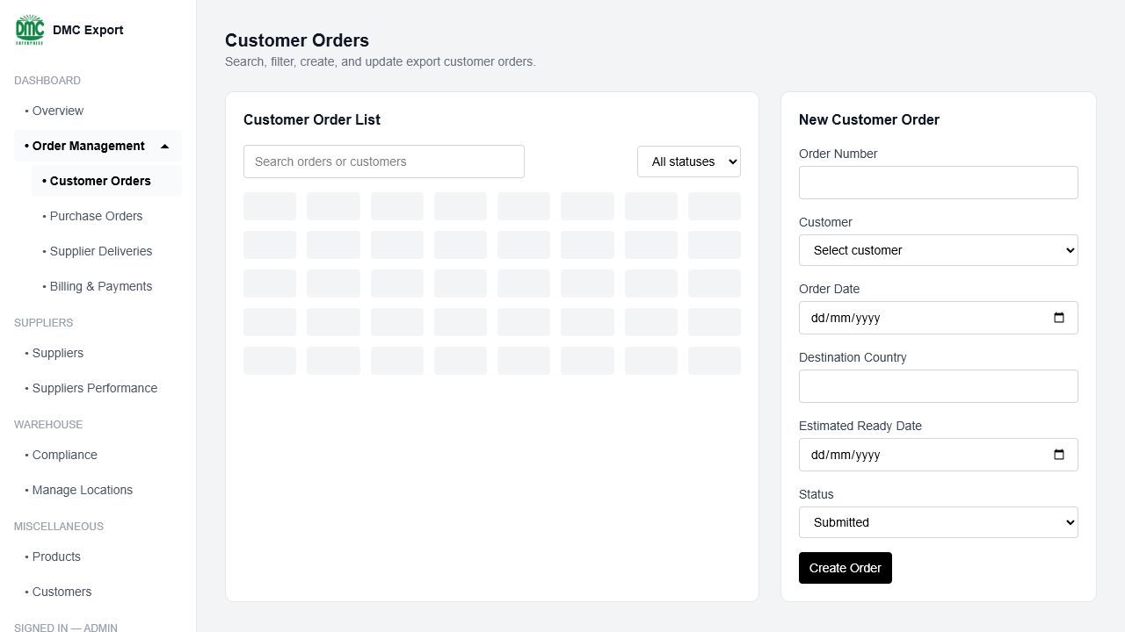
Figure 2. Administrator Customer Orders workspace for locating the tracked QT/ORD.

Step 3 - Customer approves the PFI
Scenario: The customer checks the commercial terms and approves the quotation. The same record becomes an order and receives an ORD reference.
Account: Customer | Route: My Orders > the QT reference
- Open the same quotation and verify its products, quantities, shipping, total, and validity date.
- Click Approve quotation.
- Confirm that the status becomes awaiting_down_payment.
- Confirm that an ORD number is assigned while the QT reference remains visible.
- Write the ORD number on the tracking sheet. Use this ORD number for the remainder of the demo.
Key explanation: The QT and ORD references belong to the same database row. Approval changes the lifecycle stage; it does not create an unrelated order.

Step 4 - Customer submits the down payment
Scenario: To activate procurement, the customer records the required 50% down payment and uploads proof of transfer for verification.
Account: Customer | Route: the approved quotation / order
- In the down-payment panel, choose Bank: BDO.
- Use the displayed 50% amount and today's payment date.
- Attach the prepared sample transfer slip.
- Click Submit payment record.
- Confirm that the payment displays Pending Verification.
Expected result: The payment is linked to the billing record for the same ORD and enters the staff verification queue.

Step 5 - Admin verifies payment
Scenario: The administrator checks the uploaded proof and verifies the payment so the order can proceed to supplier purchasing.
Account: Administrator | Route: Order Management > Billing & Payments
- Find the pending down payment belonging to the same ORD.
- Click View proof and identify the uploaded sample file.
- Click Verify.
- Return to Customer Orders and confirm the order status is payment_verified.
Expected result: Payment verification releases this order for procurement.
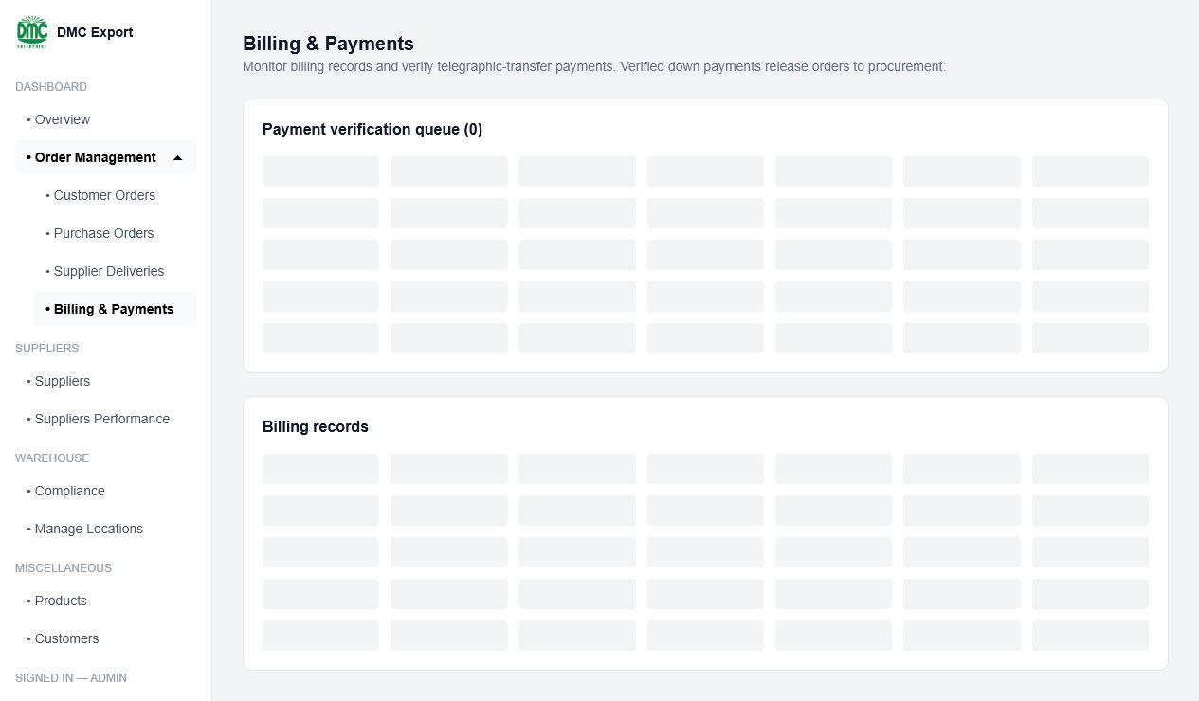
Figure 3. Billing & Payments page used to verify the tracked order's payment.

Step 6 - Admin or Procurement creates supplier purchase orders
Scenario: Procurement converts the verified customer order into one or more supplier purchase orders while keeping every PO linked to the same ORD.
Account: Administrator / Procurement | Route: Order Management > Purchase Orders
- Under New Purchase Order, select the same ORD number from the Customer Order list.
- Select Universal Robina Corp. and set a future expected-delivery date.
- Create the PO with a valid sent status and record its PO number.
- If demonstrating consolidation, create a second PO for another supplier using the same ORD.
- Open the ORD details and confirm both POs appear under Linked Purchase Orders.
Pre-demo requirement: The current build must support automatic PO numbering and a lowercase sent status. If your deployed build does not, prepare the POs in advance but link them to the same ORD created for the rehearsal.

Step 7 - Supplier records dispatch
Scenario: The supplier finds its assigned PO and records the truck, driver, quantity, and waybill when the goods leave for the DMC warehouse.
Account: Supplier | Route: Supplier > Purchase Orders
- Find the PO number recorded in Step 6.
- Open it and click Log dispatch.
- Enter the quantity being dispatched. For a partial scenario, enter less than the remaining quantity.
- If partial, enter Reason: Balance arriving next truck.
- Enter Courier / truck plate: ABC-1234 and Driver: Juan Dela Cruz.
- Attach the prepared waybill and click Submit dispatch record.
- Open Delivery History and show pending_confirmation.
Expected result: The supplier action updates a PO that is linked to the same customer ORD.
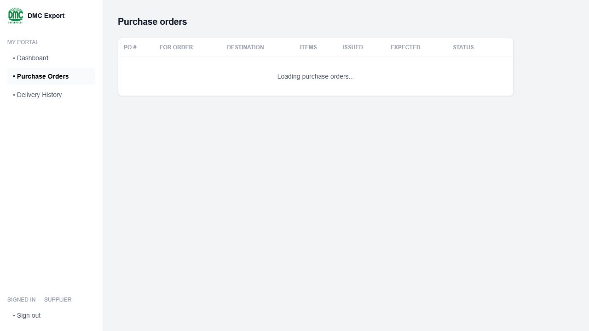
Figure 4. Supplier Purchase Orders page used to locate and dispatch the linked PO.

Step 8 - Warehouse confirms receipt
Scenario: Warehouse staff receive the supplier delivery, compare dispatched and actual quantities, record condition and location, and confirm receipt.
Account: Warehouse | Route: Warehouse > Log Delivery or the prepared PO receipt link
- Open the pending delivery for the same PO.
- Compare Supplier said with Actually received.
- Select Condition: Good, or demonstrate a discrepancy if planned.
- Assign an empty warehouse location.
- Enter receipt remarks and click Confirm receipt.
- Confirm the PO becomes delivered or partially_delivered.
Expected result: Inventory and receiving data remain traceable from the warehouse record back to the PO and the same ORD.
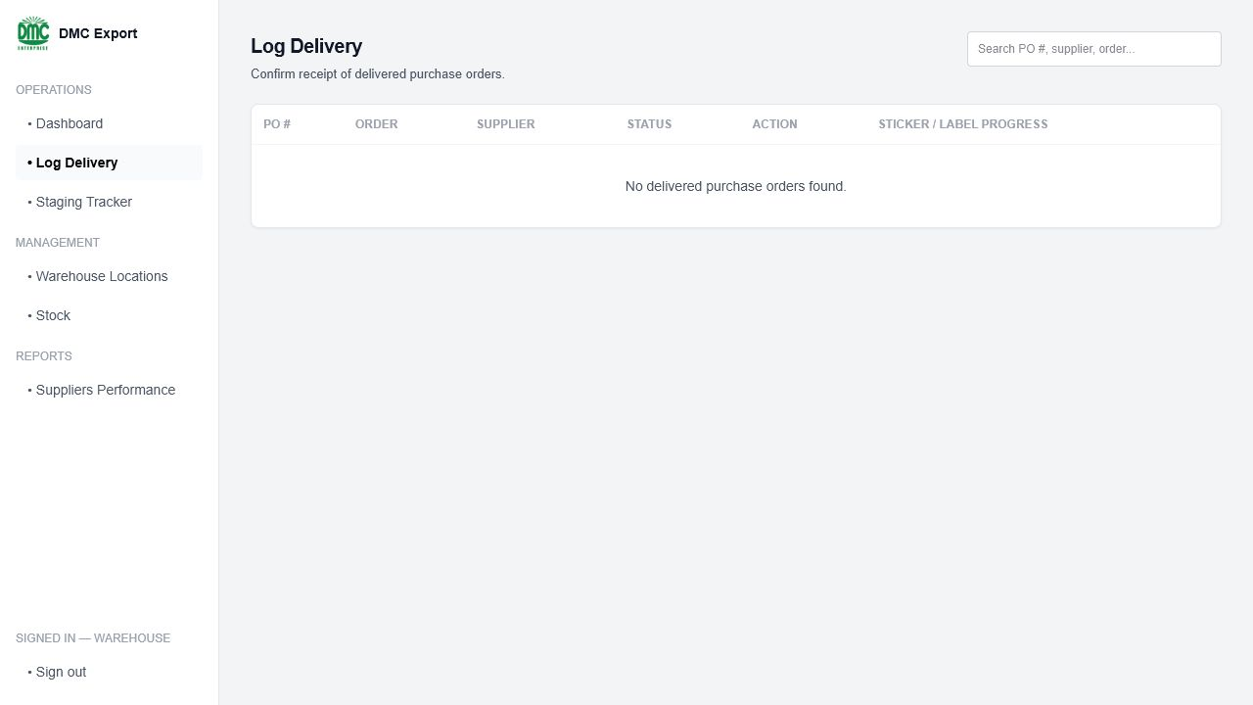
Figure 5. Warehouse Log Delivery route. The linked PO appears here after supplier dispatch.

Step 9 - Warehouse updates labeling progress
Scenario: Warehouse staff apply the destination labels and update sticker progress until all received quantities are ready for staging.
Account: Warehouse | Route: Warehouse > Log Delivery > Progress
- Open Progress for the received PO.
- Move each Stickered value toward its received quantity.
- Click Save.
- When all received quantities are labeled, confirm the PO advances to staging.
Expected result: The labeling activity is part of the same supplier PO and customer order lifecycle.

Step 10 - Warehouse completes staging
Scenario: The fully labeled goods are moved to the final staging location and marked ready for shipment. All linked POs must reach this point.
Account: Warehouse | Route: Warehouse > Staging Tracker
- Find the staged PO linked to the tracked ORD.
- Select the final warehouse location.
- Click Confirm.
- Confirm that the PO becomes ready_for_shipment.
- If multiple POs exist, repeat receiving, labeling, and staging for each PO before declaring the customer order ready.
Control rule: One ready PO does not automatically mean the entire customer order is ready when other supplier POs are incomplete.
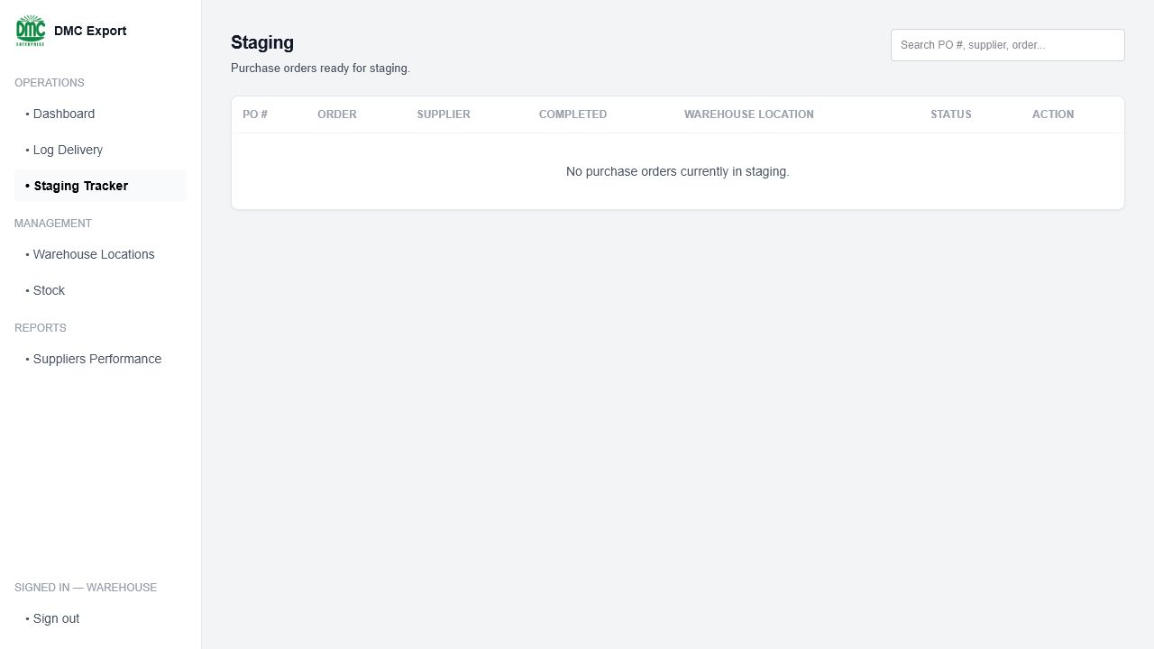
Figure 6. Warehouse Staging Tracker. The PO appears after receiving and labeling are complete.

Step 11 - Customer checks the same order
Scenario: The customer returns to the original order, reviews its latest progress, and uses the assistant for read-only status questions.
Account: Customer | Route: My Orders > the tracked ORD; Customer Dashboard assistant
- Open the ORD number recorded in Step 3.
- Show its progress tracker and latest recorded status.
- Select the order in the assistant.
- Ask: What is the current status of my order?
- Ask: Have supplier deliveries been completed?
- Ask: What steps are still remaining?
- Ask: Cancel my order. Confirm that the assistant refuses the write action.
Expected result: The customer sees progress on the same order without accessing internal supplier or warehouse records.

Step 12 - Shipment and completion
Scenario: After all supplier and warehouse work is complete, the administrator records shipment and closes the same ORD after delivery and payment requirements are satisfied.
Account: Administrator | Record: the same ORD
- Confirm that every linked supplier PO is complete or ready for shipment.
- Record the shipment details and advance the customer order to shipped.
- Show the customer tracker with the shipped status and any available shipping document.
- After final delivery and balance-payment requirements are satisfied, advance the order to completed.
- End by showing the same ORD number and its complete lifecycle history.
Current-build note: If the deployed application does not yet expose shipment and completion controls, present these as the final prepared checkpoint. Do not claim that an unavailable button was demonstrated live.

5.1 Role handoff script
From | To | Suggested handoff line
Customer | Admin | The customer has submitted [QT]. DMC will now price that same request.
Admin | Customer | PFI [PFI] is now linked to [QT] and ready for customer approval.
Customer | Admin / Procurement | Approval assigned [ORD]. DMC can begin after payment verification.
Admin / Procurement | Supplier | PO [PO] was created under [ORD] and is now visible to the assigned supplier.
Supplier | Warehouse | The supplier dispatched against [PO]; warehouse will confirm the same delivery.
Warehouse | Customer | Receiving and preparation updates now appear on the customer's [ORD] tracker.
Customer | Admin | The tracked order is ready for the final shipment and completion stage.

6. Operator input sheet
Field | Demo value | Rule / note
Delivery location name | Main warehouse — Kowloon | Required for a new quotation
Country | Hong Kong | Choose from the list
Address | 18 Container Port Road, Kwai Chung | Optional
Product quantities | 24 and 36 cases | Must be at least 1
Special instructions | Apply Hong Kong nutrition labels and consolidate into one shipment. | Optional
Unit prices | USD 10.80 and USD 11.50 | Every PFI line must be > 0
Estimated shipping | USD 220.00 | May be zero or positive
PFI expiry | Today + 14 days | Cannot be in the past
Payment bank | BDO | BDO / Chinabank / Other
Courier / plate | ABC-1234 | Supplier dispatch
Driver | Juan Dela Cruz | Supplier dispatch
Partial reason | Balance arriving next truck | Required for partial-story clarity
Warehouse condition | Good | Or Damaged / Missing / Wrong item
Warehouse location | Any empty A- or B-code | Select an available location

7. Current repository reality: what to claim
Capability | Current evidence | Presentation wording
PFI preparation | Implemented in PFI Builder; prices, shipping, expiry, and 50/50 split | “Implemented and demonstrated.”
PFI PDF | Customer has Print / save PDF through the browser | “Printable/saveable from the browser”; do not claim a finalized server PDF generator
Payment proof | Implemented on customer quotation/order pages; migration 010 adds RLS and bucket | “Implemented when migration 010 is applied.”
Supplier dispatch | Implemented; creates a pending-confirmation delivery | “Implemented and role-restricted.”
Warehouse receipt | Implemented on a direct PO route, but not linked from the current list for pending dispatches | “Implemented with a navigation gap.”
Sticker/staging | UI exists, but schema/status mismatch is present in this repository | “Prototype / requires schema alignment before live mutation.”
Predictive analytics | Architecture/story mentions it; reliable prediction depends on data and completed module work | “Planned/iterative; estimates are not guarantees.”
Odoo sync | Described as planned integration | “Planned and subject to production validation.”

8. Pre-presentation checklist

Night before
- ☐ Apply/verify migrations and run db/seed_demo.sql.
- ☐ Confirm the three checkpoint records and the supplier email match.
- ☐ Confirm customer delivery location and at least two available products.
- ☐ Run npm test, npm run lint, and npm run build.
- ☐ Dry-run the exact clicks in this kit using a disposable/resettable database.
- ☐ Prepare the direct warehouse receipt bookmark for PO-2026-901.
- ☐ Capture screenshots for every act, especially warehouse receipt and staging.
- ☐ Prepare a harmless sample transfer slip and waybill file.

Immediately before presenting
- ☐ Start CAPIS and confirm the correct URL.
- ☐ Open four browser profiles and sign in to Customer, Admin, Supplier, and Warehouse.
- ☐ Put Customer Catalog, Admin Customer Orders, Supplier Purchase Orders, and the warehouse receipt bookmark in tabs.
- ☐ Disable notifications and close unrelated tabs.
- ☐ Keep this kit open on a second screen or printed.
- ☐ Write the newly generated QT number on the presenter cue card.

9. Recovery rules during the live demo
Problem | Immediate recovery
New quotation fails | Switch to QT-2026-910 and continue with PFI Builder.
PFI save fails | Show the prepared PFI screenshot; state that the write depends on staff RLS/migration 007.
Customer payment upload fails | Stop after approval; mention migration 010/storage requirement.
Supplier dispatch already exists | Show Delivery History instead of creating another dispatch.
Warehouse page shows no pending dispatch | Use the screenshot and continue; do not debug the UUID or RLS live.
Sticker/staging save fails | Expected repository mismatch; show only and move to customer tracker.
Gemini is unavailable | Use deterministic supported prompts; do not retry repeatedly.
Network/deployment fails | Use screenshots in the same Act 1–8 order and keep narrating the connected workflow.

Final presenter rule: Never debug database policies, IDs, or status constraints in front of the panel. Switch to the prepared checkpoint or screenshot, explain the business meaning, and keep the one-order story moving.

10. Suggested presentation flow around the live demo
Section | Time | What to show
Opening + DMC problem | 2–3 min | Title and Customer → DMC → Suppliers → Warehouse → Export diagram
Objectives + architecture | 2 min | Modules, Next.js/React → Supabase/Auth/PostgreSQL, role-based security
Live demo | 8–10 min | Acts 1–8 from this kit
Technical validation | 1–2 min | RLS, document numbering, chatbot safeguards, automated tests
Value + limitations | 1–2 min | Less re-entry, shared consolidation view, honest current gaps
Closing | 30 sec | One traceable workflow with role-appropriate access

Closing line: CAPIS turns DMC’s export-consolidation process into one traceable workflow. Every role contributes to the same business outcome, while each user sees only the information needed for their responsibility.

