PortfoliAI |Investment agent|

Lincks Morara 148312

Supervisor: Vincent Omwenga

An Informatics and Computer Science Project Proposal Submitted to the School of Computing and Engineering Sciences in partial fulfillment of the requirements for the award of a Degree in Bachelor of Science in Informatics and Computer Science

School of Computing and Engineering Sciences
Strathmore University
Nairobi, Kenya
May 2025

Declaration and Approval
I declare that this project proposal has not been submitted to Strathmore University or any other University for the award of a Degree in Bachelor of Science in Informatics and Computer Science or any other Degree. To the best of my knowledge and belief, the research proposal contains no material previously published or written by another person except where due reference is made in the research proposal itself.

Student Admission Number:
Sign: ________________________
Date: ________________________

The document of Morara Lincks Apiemi has been reviewed and approved by Prof Vincent Omwenga
Supervisor’s Signature:
Sign: ________________________
Date: ________________________

Acknowledgment
I would like to express my sincere gratitude to my supervisor for their unwavering guidance and support throughout this project. Special thanks go to my family and friends for their encouragement, patience, and belief in me during every stage of this journey. I am also thankful to the unit lecturer for providing the academic foundation and inspiration that shaped this work. This project would not have been possible without your contributions.

Abstract
In recent years, retail investor participation in financial markets has increased dramatically, driven by greater digital access, market volatility, and growing interest in personal finance. However, many beginner and intermediate investors still struggle with making informed investment decisions due to a lack of financial literacy, confidence, and personalized guidance. Traditional investment platforms often overlook behavioral differences and risk preferences, offering generic tools that may not meet individual needs.
This project presents the design and development of an AI-powered investment assistant web application tailored for beginner and intermediate investors. The system leverages a combination of unsupervised and supervised machine learning techniques to generate personalized investor profiles and risk tolerance scores based on behavioral and demographic data. Using a publicly available investor survey dataset from Kaggle, the system applies Gaussian Mixture Models (GMM) and Principal Component Analysis (PCA) to uncover latent behavioral archetypes and derive continuous risk metrics. A Random Forest-based multi-output regression model is then trained to predict risk scores, investor archetype probabilities, and behavioral traits from short-form survey inputs.
The application integrates a user-friendly React frontend with Firebase for authentication and database management, while backend ML services are deployed using Python as serverless cloud functions. Real-time financial data is incorporated through the Finnhub API, and the chatbot interface offers conversational, tailored investment guidance based on predicted profiles.
This project contributes to the growing need for accessible financial tools by offering a personalized, scalable, and educational platform that empowers users to make informed investment decisions. Additionally, the modular design supports future extensions, such as personality-based advice and portfolio optimization.

Keywords:
AI investment assistant, investor profiling, risk tolerance modeling, Gaussian Mixture Models, Principal Component Analysis, Random Forest, chatbot, financial technology, behavioral finance, machine learning.

Table of Contents

Declaration and Approval 3
Acknowledgment 4
Abstract 5
Chapter One: Introduction 12
1.1 Background 12
1.2 Problem Statement 14
General Objective 14
1.3.1 Specific Objectives 15
1.3.2 Research Questions 15
1.4 Justification 15
1.5 Scope and Limitations 16
Chapter Two: Literature Review 19
2.1 Introduction 19
2.2 Challenges Faced by Beginner Investors 19
Chapter three: Development Methodology 24
3.1 Introduction 24
3.2.1 Data Acquisition 25
3.2.2 Data Preprocessing and feature engineering 25
3.2.3 Deriving Continuous Risk Score and Archetype Profile 26
3.2.4 Model Training 27
3.2.5 Model Validation and Testing 27
3.3 Software Development Methodology/Approach 28
3.4 System Analysis and Design 28
3.4.1 Use Case Diagram 28
3.4.2 Class Diagram 28
3.4.3 Entity Relationship Diagram (ERD) 29
3.4.5 System Architecture 29
3.5 System Development Tools and Techniques 30
3.6 System Deliverables 31
References 32

LIST OF FIGURES
Figure 2. 1: Conceptual Framework 20

List of Abbreviations
AI – Artificial Intelligence
ML – Machine Learning
GMM – Gaussian Mixture Model
PCA – Principal Component Analysis
PWA – Progressive Web Application
API – Application Programming Interface
MAE – Mean Absolute Error
R² – Coefficient of Determination (R-squared)
ERD – Entity-Relationship Diagram
UI – User Interface
UX – User Experience
BFI – Big Five Inventory
CRUD – Create, Read, Update, Delete
SPA – Single Page Application
JSON – JavaScript Object Notation
HTML – HyperText Markup Language
CSS – Cascading Style Sheets
JS – JavaScript

Chapter One: Introduction

1.1 Background
Investment is the act of allocating resources, typically money, with the expectation of earning additional income or profit over time (Lusardi & Mitchell, 2014). People invest to grow their savings, beat inflation, and achieve long-term goals like retirement, education, or financial independence. Through productive assets, investors benefit from compound growth, income streams, and asset appreciation, helping build long-term wealth (Tabot, 2024).
In Kenya, traditional investment channels such as real estate and Savings and Credit Cooperative Organizations (SACCOs) have long been preferred. Property ownership—urban or rural—has been seen as the safest path to wealth, while SACCOs, which grew in the 1970s and 80s, enabled community-based saving and lending (Kabaiku, 2018). However, these options offer limited diversification and often lower returns compared to financial markets (WANJIRU & WAWERU, 2025).
Economic liberalization in the 1990s and early 2000s saw Kenya’s capital markets expand, led by the Nairobi Securities Exchange. Mobile money innovations from 2007 further improved access. Yet, participation in stocks, bonds, or mutual funds remains low. By 2021, although 83% of adults held formal financial accounts, fewer than 15% owned capital market instruments (Central Bank of Kenya, 2021). Financial illiteracy, perceived complexity, and lack of personalized advice remain major barriers.
Over the last decade, fintech platforms and global digital brokerages have enabled Kenyans to invest via mobile apps. Local platforms have emerged, offering Shilling-based products alongside global market access. But while access has improved, many users still struggle with understanding. FSD Kenya reports that over 70% of new investors feel overwhelmed by the jargon, choices, and risk assessment processes these platforms present (FSD Kenya, 2024).
As a result, Kenya’s investment landscape faces a paradox: while technology has broadened access to financial products, confidence and meaningful participation continue to lag. Traditional reliance on property and SACCOs still shapes many people’s investment mindset, while digital platforms often assume a level of financial knowledge and risk awareness that many new users do not possess. This disconnect has led many novice investors to abandon investment platforms after encountering confusion or early setbacks (Lusardi & Mitchell, 2014). At the same time, access to personalized guidance remains concentrated among high-net-worth individuals, deepening inequality in investment knowledge and outcomes.
Moreover, investor diversity—differences in risk appetite, financial goals, and decision-making styles—is frequently overlooked. When users are presented with generic advice or exposed to an overwhelming amount of static information, they struggle to align their choices with their personal needs. This often results in frustration, disengagement, and suboptimal financial decisions (Nguyen et al., 2016). In such an environment, the promise of democratized investing remains unfulfilled—not because tools are unavailable, but because they are not designed to educate, empower, or guide users in a way that reflects their individuality and supports their long-term success.

1.2 Problem Statement
While the expansion of digital investment platforms in Kenya has significantly improved access to financial products, it has not equally translated into confident, informed investor participation. A large proportion of new and aspiring investors continue to face two major challenges that hinder their ability to make sound, goal-aligned decisions.
First is the issue of information overload. Many platforms offer extensive but static content—ranging from investment product descriptions to market analysis—without tailoring it to the user's level of experience or immediate needs. For novice investors in particular, this deluge of technical language and unstructured options can be disorienting(Guo et al., 2023). Instead of building clarity, it often reinforces a sense of inadequacy, leading many to disengage or rely on familiar but suboptimal options such as fixed deposits, SACCOs, or land.
Second, there is a misalignment between investor personality and investment decisions. Individual differences in financial goals, risk tolerance, and behavioral traits significantly influence investment success (Amponsah et al., 2025). However, most investment tools do not assess or accommodate these differences. As a result, users often receive generic advice that does not match their needs or mindset, leading to dissatisfaction, underperformance, or poor decision-making over time.
Together, these two challenges—cognitive overload and lack of behavioral personalization—undermine the potential benefits of democratized market access. These challenges point to a deeper issue: improved access alone is not sufficient. Many emerging investors are not simply seeking entry into financial markets—they require support systems that foster clarity, relevance, and trust. In a space crowded with jargon and generalized content, the absence of personalized, contextual guidance makes it difficult for users to develop the confidence and discipline required for long-term investing. Without tools that recognize individual differences and deliver knowledge in a structured, digestible manner, digital platforms risk reinforcing the very barriers they were meant to overcome.

General Objective
To develop a web-based investment assistant that uses machine learning to identify users’ investor profiles and employs conversational AI to deliver personalized, easy-to-understand guidance—empowering users to make confident, informed financial investment decisions in the financial markets.

1.3.1 Specific Objectives
- To analyze the current financial investment landscape in Kenya, including user behaviors, access challenges, and adoption of digital platforms.
- To evaluate existing investment tools and advisory platforms with a focus on their suitability for beginner investors.
- To identify gaps in personalization, user education, and engagement within these tools, particularly in addressing investor confidence and decision-making.
- To design and implement a web-based system that uses machine learning for investor profiling and conversational AI to provide personalized investment guidance tailored to individual user traits and needs.
- To assess the effectiveness of the developed system in improving user confidence, understanding, and participation in financial markets.

1.3.2 Research Questions
- What are the key characteristics and challenges of the current financial investment landscape in Kenya, particularly for beginner investors?
- How effective are existing investment tools and advisory platforms in supporting personalized decision-making for new or inexperienced investors?
- What are the major gaps in personalization, user education, and engagement within current digital investment platforms?
- How can a web-based system combining machine learning and conversational AI be designed to deliver personalized investment guidance tailored to individual investor profiles?
- To what extent does the proposed system improve user confidence, understanding, and participation in financial markets?

1.4 Justification
While digital investment platforms have made access to financial markets more convenient, many users—particularly beginners—still struggle to make informed and confident investment decisions (Ariwangsa et al., 2024). Challenges such as financial illiteracy, overwhelming static information, and a lack of personalized support continue to discourage participation, leading to poor financial outcomes or complete disengagement from investing.
This project proposes a web-based investment assistant that addresses these gaps by integrating machine learning and conversational AI into a unified solution. The machine learning component is used to classify users based on their risk tolerance, behavior, and investment goals, while the conversational AI delivers personalized, easy-to-understand investment guidance in an interactive format. This approach ensures that users receive relevant, contextual support aligned with their individual profiles, rather than generic advice that often fails to resonate or build trust.
Unlike conventional platforms that offer vast repositories of static content or one-size-fits-all recommendations, this system provides a tailored, conversational learning experience. Users can ask questions in plain language and receive responses progressively, based on their needs and understanding. This not only makes investing more approachable for new entrants to the financial markets but also offers experienced investors a more efficient and focused way to engage with complex information.
The use of established AI APIs ensures that the system remains cost-effective, scalable, and adaptable, making it suitable for widespread use without sacrificing performance or personalization. While the solution is particularly designed to support beginner investors, it also holds value for more experienced users seeking dynamic, insightful engagement with their investment strategies.
By focusing on accessibility, relevance, and trust, the assistant supports smarter investment decisions, encourages greater participation in financial markets, and contributes to reducing inequalities in financial knowledge. It bridges the gap between access and understanding, offering a modern, inclusive, and scalable way to empower individuals to grow their wealth through informed investing.

1.5 Scope and Limitations
This project aims to develop a web-based, AI-powered investment assistant tailored to helping users—particularly beginner investors—make confident, informed financial investment decisions. The core deliverables include a machine learning model that classifies users based on their risk profile and financial personality, derived from a guided onboarding survey. This classification is then used by a conversational AI interface to deliver personalized, easy-to-understand investment education and guidance aligned with each user's goals and experience level.
In addition, the assistant will feature a manual portfolio tracking component, allowing users to input and monitor their investments over time. This includes recording details such as date of purchase, investment type, quantity, and price, enabling the system to display basic performance summaries and assist in reflective financial planning. The assistant will also connect to third-party financial APIs to provide real-time market data for contextually relevant advice.
The platform will be delivered as a browser-accessible web application, offering a responsive, mobile-friendly interface. It is designed primarily to serve global English-speaking users interested in financial market instruments such as stocks, bonds, and mutual funds. It does not include automated trading functionality or integration with brokerage accounts.
Several challenges are anticipated during the development and deployment of this system. First, the assistant's guidance is heavily dependent on the accuracy of third-party AI and financial APIs, which may occasionally provide outdated, generic, or contextually ambiguous responses. Second, the portfolio management feature relies entirely on user-provided data, which introduces the risk of human error and limits the automation of performance tracking.
Furthermore, while the assistant is designed to simulate personalized advisory support, it does not replace licensed financial professionals. As such, it is not suitable for users seeking certified investment recommendations. The application will only support English at launch, potentially limiting accessibility for non-English-speaking or region-specific users.
Development constraints such as limited training datasets, time, and computational resources may also affect the performance and scalability of the machine learning model. Additionally, ensuring data privacy, ethical AI usage, and algorithmic fairness remains a continuous challenge, especially when handling sensitive financial profiling.

1.5.1 Delimitations
To maintain a focused and feasible research scope, several boundaries have been set. The study will be limited to the design, implementation, and evaluation of a prototype system aimed at beginner and intermediate-level investors. The population primarily includes individuals with limited investment experience who are seeking financial education and decision support via digital tools.
The project will be conducted within one semester academic timeframe and will focus on a functional prototype rather than a commercial-grade, fully scaled product. It will exclude automated financial trading, live brokerage integration, and advanced portfolio optimization features. The assistant will be evaluated using test data and hypothetical scenarios, rather than real financial accounts, to uphold ethical considerations and ensure data privacy.
The system will only support English content and will focus on general global financial market structures, without tailoring to local regulatory frameworks or market conditions in specific countries. These exclusions are intentional to ensure the project remains achievable within the academic context while addressing the core research problem.

Chapter Two: Literature Review

2.1 Introduction
This chapter explores existing literature related to the challenges faced by beginner investors, the tools currently available to assist them, and the technological possibilities that can bridge the gap between access and confident financial decision-making. The review aligns with the research objectives outlined in Chapter 1, particularly focusing on understanding the investment environment, assessing the strengths and weaknesses of existing digital tools, identifying key challenges such as limited financial literacy and misalignment of investment strategies with user personality, and justifying the design of a solution that integrates machine learning and conversational AI.

2.2 Challenges Faced by Beginner Investors
Kenya has made substantial progress in financial inclusion. As of 2021, 83% of adults had access to formal financial services, a major leap from just 26% in 2006 (Ndung’u, 2021). Yet, this access does not translate to active participation in structured investment products. Most individuals continue to prefer real estate, chamas (informal savings groups), SACCOs, or mobile savings wallets like M-Shwari, which feel more familiar, tangible, and low-risk (FSD Kenya, 2024).
Globally, beginner investors face similar psychological and educational challenges. Lusardi and Mitchell (2014) argue that financial literacy remains distressingly low even in developed economies, with fewer than 40% of adults understanding basic concepts such as compound interest and inflation. In Kenya, this figure is even lower—38%—especially among rural populations and youth (Central Bank of Kenya, 2021).
New investors often lack clarity about their risk tolerance, goals, and suitable investment products. Studies have found that poor decision-making—such as excessive trading, panic selling, and herding behavior—stems from both cognitive biases and emotional responses to market fluctuations (Jain & Kesari, 2022).
Behavioral finance literature emphasizes that without tailored guidance, novice investors experience regret aversion, confirmation bias, and loss aversion—all of which contribute to early exit from markets (Jain & Kesari, 2022). These patterns are especially pronounced in environments where trust in financial institutions is historically weak or volatile, as is often the case in Sub-Saharan Africa (Anthony, N., & Sharma, 2024)
In summary, while access barriers have been largely resolved through fintech and mobile money innovations, confidence and education barriers persist, limiting the capacity of new investors to build wealth in financial markets.

2.3 Evaluation of Currently Existing Investment Tools
A variety of global and local digital investment platforms have emerged in recent years with the aim of simplifying the investment process. Globally, applications such as Robinhood and Binance have enabled millions of users to access stocks, exchange-traded funds (ETFs), and cryptocurrency markets through affordable, mobile-first interfaces (Tan, 2021). In Kenya, localized platforms such as Hisa and Ndovu have extended these capabilities by allowing users to purchase global stocks and ETFs using familiar mobile payment systems (FSD Kenya, 2024).
Robinhood gained popularity in the U.S. for offering commission-free trading in a sleek, beginner-friendly app. However, despite its ease of use, the platform has been criticized for encouraging impulsive trading and lacking structured education or risk assessment tools. It does not incorporate investor profiling or provide tailored investment strategies.
Binance, a globally dominant crypto exchange, offers a vast array of digital assets and low fees. Its rich feature set supports advanced traders, but its complex interface often overwhelms newcomers. Although Binance Academy exists, its resources are static and not personalized to user experience or behavior.
Fidelity Investments offers a broad set of long-term investment tools, including access to professional advisors and educational content. However, the majority of these services are only available to users with significant capital. Fidelity does not feature AI-driven interaction or real-time, behavior-informed investment guidance.
Despite their achievements in democratizing access, these platforms exhibit several critical limitations. First, personalization is minimal. Most tools are built primarily for transaction execution, offering limited investor profiling or personality-informed recommendations (Kanaparthi, 2024). Second, educational resources are often fragmented and static, making them difficult for users to find and insufficiently adaptive to individual learning needs (Lusardi & Mitchell, 2014). Third, the onboarding processes tend to treat all users uniformly, assuming a baseline level of financial literacy and confidence. This can leave inexperienced investors feeling disoriented or unsupported (FSD Kenya, 2024).
The consequences of these limitations are significant. Research indicates that nearly 60% of first-time users on digital trading platforms abandon their accounts within the first three months, primarily due to feelings of confusion, information overload, and a lack of accessible guidance (Singh & Malhotra, 2016). This highlights a pressing need for platforms that support learning and decision-making, rather than simply enabling transactions.
The potential for technology to close this gap is considerable. Just as platforms like Duolingo personalize language learning (Jiang & Liu, 2024) and Khan Academy adapts math instruction to individual users (Tassell et al., 2024), digital investment platforms can be redesigned to prioritize the learner. Rather than focusing solely on products, these systems can offer adaptive guidance, tailored education, and a more supportive user experience that nurtures long-term investor engagement.

2.4 Gaps in Personalization, Education, and Engagement
1. Lack of Personalization
Despite advancements in recommender systems in other sectors (e.g., Netflix, Spotify), most investment tools do not assess or use behavioral data to tailor user experiences. Research by (Riar & Kumar, 2022a) demonstrates that aligning investment advice with behavioral biases and personality types—such as “methodical,” “spontaneous,” or “individualist” investor archetypes—can improve both satisfaction and outcomes.
A machine learning approach can enhance this personalization. Classification models trained on survey data (e.g., Big Five traits, financial behavior scales) can accurately assign users to investment styles and risk categories, which can then drive tailored advice(Riar & Kumar, 2022b).
2. Insufficient Educational Support
Platforms rarely provide real-time help when it’s most needed—during key decisions or mistakes. Financial literacy is not just about knowing facts but about applying knowledge in context. AI tutors have proven effective in contexts like Coursera, EdTech, and digital health. They provide adaptive content, real-time explanations, and ongoing support (Julius et al., 2023).
This model can be translated into finance. A chatbot can function as an “investment coach,” answering questions in plain language, clarifying terms, offering encouragement, and directing users to additional learning content based on their needs.
3. Weak Engagement and Retention
Most fintech apps do not engage users beyond transactional interactions. Yet sustained investment success depends on building consistent habits, learning from feedback, and adjusting strategy over time. Engagement increases when users feel understood, guided, and supported—especially through conversational AI, which offers a low-friction, non-judgmental interface (Tariq et al., 2024).

2.5 Conceptual Framework
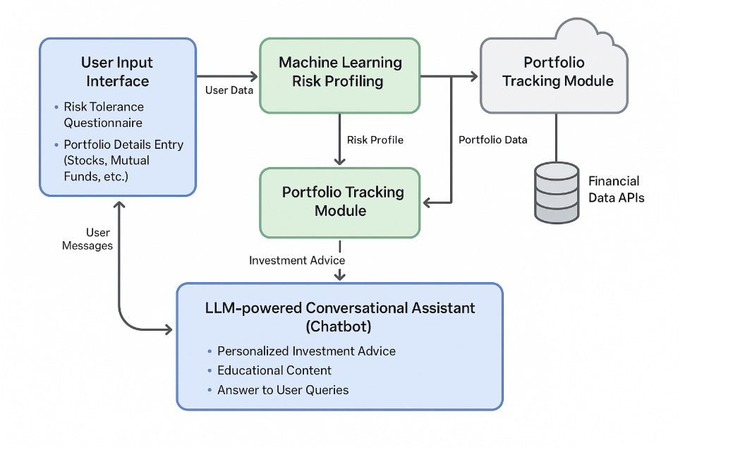
Figure 2. 1: Conceptual Framework

The conceptual framework is built around five interconnected components that together enable the proposed AI-powered assistant:
- User Interface (UI): This is the primary access point through which users interact with the system. It allows users to register an account, complete an investor profiling questionnaire, input or sync investment data, and engage with the AI assistant via a chat interface. The UI is designed to be intuitive and accessible to ensure ease of use for individuals with minimal financial or technical experience.
- Investor Profiling Engine: This module utilizes a machine learning classification model trained on behavioral, demographic, and psychometric data to categorize users into distinct investor types—such as conservative, moderate, or aggressive. The profiling process is initiated via a survey that captures risk appetite, investment goals, and decision-making preferences. These profiles serve as the foundation for subsequent advice and guidance.
- Conversational AI (LLM Integration): At the heart of the assistant lies a large language model (LLM), such as GPT, which powers natural language interactions. This component interprets user queries, offers context-aware explanations, answers financial questions, and adjusts the tone and complexity of its responses based on the user’s profile and history. The goal is to simulate a personalized, empathetic, and always-available investment coach.
- Portfolio Tracking System: This system allows users to manually enter or optionally sync their investment portfolios. It integrates with financial APIs to fetch real-time asset prices, enabling the system to compute performance metrics such as gains/losses, asset allocation, and historical trends. This helps users track their progress and receive feedback based on live market data.
- Personalized Recommendation Engine: Based on the user's investor profile and portfolio data, this engine generates personalized suggestions. These may include strategies for diversification, rebalancing, risk management, and time-based goal planning. The recommendations evolve as the system collects more behavioral and market interaction data, allowing for continual refinement of advice.
Together, these five components create a feedback-driven ecosystem where each module informs and enhances the others. For instance, the profiling engine shapes the assistant’s tone, the tracking system informs the recommendation engine, and the assistant’s responses can adapt in real-time based on new data. This loop ensures the assistant remains contextually aware, increasingly personalized, and supportive of long-term financial growth and learning.

Chapter three: Development Methodology

3.1 Introduction
This chapter details the methodological framework for developing the proposed AI-driven investment assistant. A mixed research paradigm will be adopted, combining exploratory analysis (to uncover latent investor behavioral patterns) with experimental modeling (to train predictive algorithms). The process begins with data acquisition (a Kaggle “Investor Behavior” survey) and thorough preprocessing, followed by feature engineering of demographic and psychometric predictors. Machine learning (ML) techniques are then applied to generate continuous investor profiles and scores. Model performance is validated using standard cross-validation and error metrics. Concurrently, an Agile Scrum process guides the software development, culminating in a system architecture that integrates a React-based frontend, serverless back end, ML services in the cloud, and financial data APIs. Finally, we describe the expected deliverables: the trained ML model, a web application (PWA), documentation, testing suite, and usability logs.

3.2 Research Paradigm
A mixed-method research paradigm will be adopted, combining exploratory and experimental approaches to support the understanding and prediction of investor behavior. The exploratory phase will address the lack of predefined labels in the dataset—such as “aggressive” or “conservative” investor types—through the use of unsupervised learning techniques like clustering. These methods are particularly effective for high-dimensional behavioral data and will be used to uncover latent structures or investor archetypes without relying on prior assumptions (Tumminello et al., 2011; Verbeeck et al., 2020). For instance, clustering algorithms will help identify groups of investors who exhibit similar patterns in preferences, investment habits, and financial objectives.
Concurrently, the experimental phase will involve the development and evaluation of supervised machine learning models, such as regression algorithms, to predict continuous investor attributes—including risk tolerance and personality trait scores—based on input features derived from survey responses. This will enable the generation of individualized investment insights.
By integrating data-driven pattern discovery (via exploratory clustering) with predictive modeling (via supervised learning), the approach will capture both novel and expected variations in investor behavior, resulting in a more robust and personalized profiling system.

3.2.1 Data Acquisition
The primary data source will be the publicly available "Investor Behavior on Investment Avenues" dataset from Kaggle (Investors, 2023). This dataset comprises over 1,000 individual responses, capturing a wide range of variables essential for investor profiling. It includes demographic data such as age, gender, income level, and education, as well as investment preferences, including chosen asset classes, risk appetite, and investment time horizons. Additionally, it covers behavioral attributes such as trading frequency, portfolio review cadence, and financial objectives. The dataset also incorporates self-reported psychological data, which can be mapped to the Big Five personality traits—openness, conscientiousness, extraversion, agreeableness, and neuroticism (Riar & Kumar, 2022b). This rich and multidimensional dataset will serve as the foundation for training machine learning models to uncover patterns and generate personalized investor profiles.

3.2.2 Data Preprocessing and feature engineering
To prepare the dataset for modelling, several cleaning and preparation steps will be applied to improve data quality and consistency. Unnecessary fields like timestamps will be removed. Missing values will be filled in using common techniques—such as the median for numbers and mode for categories. Categorical data like gender, education level, and occupation will be converted into numbers using one-hot or ordinal encoding, depending on the type of data. Numerical fields such as age, income, and investment frequency will be standardized using Z-score normalization so that they can be compared fairly. Outliers will be either removed or adjusted to prevent them from distorting the model. The dataset will also be checked for duplicates and errors to make sure it is clean and reliable.

After cleaning, extra features will be created to help the model better understand investor behavior and personality. These will include Big Five personality scores—Openness, Conscientiousness, Extraversion, Agreeableness, and Neuroticism—based on answers from the survey. These traits are known to affect how people make financial decisions (Jiang et al., 2024). Probabilities for each of the seven investor types—such as Risk-Averse, Cautious Planner, Passive Saver, Balanced Strategist, Opportunist, Growth Seeker, and Speculative Trader—will be calculated using clustering algorithms like k-means or Gaussian Mixture Models (GMM). These models will group similar patterns in the data and assign each user a probability score for how closely they match each profile
In the first version of the model, the focus will be on basic behavioral features that are simple to calculate. These include the contribution rate (how often and how much someone invests), review cadence (how often they check their portfolio), and time horizon (how long they plan to invest). A basic risk preference score will also be included based on whether someone prefers high-risk investments like stocks or safer ones like bonds. These features are useful for understanding different types of investors and predicting their behavior (Tumminello et al., 2011). Together, these features will create a detailed input for the machine learning models. More advanced features—such as how users describe their investment goals, how they prefer to receive information (charts, text, dashboards), or how diversified their investment preferences are—can be added later to improve the system’s accuracy and personalization.

3.2.3 Deriving Continuous Risk Score and Archetype Profile
Since the dataset does not contain predefined investor risk categories, a novel metric will be introduced to represent investor temperament. Each investor will be assigned a continuous risk score ranging from 0 to 1, where 0 indicates very conservative investment behavior and 1 represents a highly aggressive investment style. To derive this score and additional user profile features, a multi-step unsupervised learning pipeline will be applied.
The first step will involve determining the appropriate number of investor archetypes based on behavioral clustering. Guided by literature and expert input, the number of clusters will be fixed at seven. Gaussian Mixture Models (GMM) will then be employed to cluster investors using their behavioral responses. This approach provides posterior probabilities of belonging to each cluster (soft labels), allowing each investor to be associated probabilistically with multiple archetypes (Liu & Li, 2025). The GMM-derived risk score will be calculated as a weighted average of cluster-assigned risk levels.
In parallel, Principal Component Analysis (PCA) will be applied to the engineered feature space to extract dominant behavioral patterns. The first principal component—capturing the greatest variance—will be scaled to a 0–1 range and interpreted as an alternative risk metric (Greenacre et al., 2022).
To select the most representative risk score, both the GMM and PCA-derived metrics will be evaluated based on their correlation with independent behavioral signals such as equity allocation preferences and investment monitoring frequency. The method demonstrating stronger alignment with these signals will be selected as the final risk scoring approach (Jain & Kesari, 2020).
Following risk score selection, each GMM cluster will be characterized by analyzing centroid values and average behaviors across features. This will support the assignment of meaningful archetype labels (e.g., “Risk-Averse,” “Cautious Growth,” “Opportunist”) to improve interpretability.

3.2.4 Model Training
Once pseudo-labels have been generated from the unsupervised learning phase, a supervised regression model will be trained to replicate these outputs for new users. The objective will be to enable real-time inference from short survey inputs without requiring re-clustering. The training process will involve predicting four types of outputs:
- Continuous Risk Score: The final GMM- or PCA-derived score will serve as the regression target (Liu & Li, 2025; Greenacre et al., 2022).
- Archetype Probabilities: GMM posterior probabilities for each of the seven clusters will be treated as multi-output regression targets.
- Behavioral Metrics: Additional outputs will include continuous predictions for investment time horizon, contribution rate, and portfolio review frequency.
- Big Five Personality Scores: Although not available in the original dataset, these scores will be collected from new users via a short embedded BFI questionnaire. Future versions of the system may use these labeled entries to learn a mapping from behavioral profiles to psychological traits—supporting transfer learning across datasets.
The model architecture will consist of a RandomForestRegressor embedded in a MultiOutputRegressor wrapper from scikit-learn. Grid search will be applied for hyperparameter optimization, improving the generalization capability of the model. This hybrid pipeline—beginning with unsupervised clustering and followed by supervised regression—will ensure scalability and personalization while preserving model interpretability.

3.2.5 Model Validation and Testing
To ensure reliability, the model is validated using k-fold cross-validation. This approach checks whether the model performs consistently across different subsets of the data. In addition to statistical validation, functional testing is conducted by integrating the model into a chatbot environment. This allows simulation of real-world interactions where the system provides investment advice based on the predicted risk score.

3.3 Software Development Methodology/Approach
An Agile Scrum-inspired development methodology is adopted to structure the iterative implementation of the AI-powered investment assistant. Although development is conducted individually, Agile principles—such as incremental delivery, sprint-based planning, and continuous feedback—are employed to manage complexity and ensure responsiveness to evolving design requirements.
Each development sprint focuses on a specific system module, beginning with a planning phase that outlines the sprint objectives and deliverables. This is followed by design, coding, and testing stages, with review sessions at the end of each sprint to assess progress, identify bottlenecks, and implement refinements. Functional decomposition of the system into discrete services—such as authentication, investor profiling, chatbot interaction, and portfolio tracking—facilitates parallel development and modular testing.
Key functional requirements are derived from the project’s goals and literature, including user onboarding, behavioral risk profiling, personalized investment advice via chatbot, and manual portfolio tracking. Modern development frameworks and libraries are used to accelerate implementation and ensure compatibility across devices. The final system is deployed as a progressive web application (PWA), supporting mobile accessibility and offline functionality.

3.4 System Analysis and Design
A component-based system design is employed to decompose the application into interdependent yet modular subsystems. UML diagrams are used to visualize system behavior, data relationships, and user interactions.

3.4.1 Use Case Diagram
A use case diagram will be developed to outline the key functionalities of the system. The primary actors will include the end-user and a system administrator. The diagram will capture all critical user interactions, including registration and login, completion of a risk profiling questionnaire, visualization of results, chatbot communication for investment advice, and manual entry of portfolio data. These use cases will form the backbone of the system’s functional requirements.

3.4.2 Class Diagram
A class diagram will define the logical structure of the system through several key classes. These will include User for managing authentication and demographic details, ProfileService for processing survey inputs, MLService for interacting with deployed predictive models, and PortfolioService for storing and retrieving investment records. Additional classes such as ChatSession and RecommendationEngine will handle conversation management and the generation of tailored advice, respectively. These classes will work in coordination to ensure modularity and reusability.

3.4.3 Entity Relationship Diagram (ERD)
The ERD will represent the NoSQL schema used in Firebase Firestore. Core collections will include users, risk assessments, portfolios, and chat sessions, each storing relevant documents indexed by unique user identifiers. This schema will ensure fast retrieval, scalability, and support for asynchronous data queries. Relationships among collections will be implemented through references to user IDs, enabling structured data linkage.

3.4.4 Database Schema
The database schema will define how data is stored in Firestore documents. The users collection will contain fields such as uid, email, and created_at. The risk_assessments collection will store numerical risk scores and archetype probabilities. The portfolios collection will manage user-entered asset data including names, quantities, and timestamps. The chat_sessions collection will capture conversation logs, preserving message content and time information. This document-based schema will be optimized for real-time updates and mobile accessibility.

3.4.5 System Architecture
The system architecture will follow a multi-layered model. The presentation layer will be implemented using React.js and Next.js to build a responsive and dynamic frontend. The logic layer will consist of Firebase Cloud Functions that handle key computations, form processing, and API integrations. Machine learning models will be hosted in the cloud to deliver risk profiling services. The data layer will rely on Firestore for data persistence, while external APIs such as Finnhub will provide market data for portfolio tracking. A client-side caching layer using browser storage will ensure offline availability and improved responsiveness.

3.4.6 Wireframes
Wireframes will be created to guide frontend development and define user experience. The main screens will include the onboarding interface, profiling questionnaire, risk score dashboard, portfolio entry module, and chatbot panel. These wireframes will serve as blueprints for UI design and help ensure consistency in layout and navigation across the application.

3.5 System Development Tools and Techniques
The development of the AI-driven investment assistant prototype will utilize a combination of modern web and machine learning technologies suitable for student-led academic projects. The frontend of the application will be developed using React.js, supported by Next.js to enable fast routing and server-side rendering where needed. These frameworks will allow the creation of a responsive, modular user interface optimized for both desktop and mobile environments.
The backend services will be managed using Firebase, a cloud-based platform offering user authentication, NoSQL database storage (Firestore), and hosting capabilities. Firebase will simplify deployment and reduce infrastructure complexity, making it a suitable choice for a student project with limited resources.
For machine learning tasks, the project will employ Python and libraries such as scikit-learn, Pandas, and NumPy. These tools will be used to preprocess data, train and evaluate regression models, and deploy the final predictive model. The trained model will be exported and deployed as a cloud function, accessible via a simple REST API. This will allow the React frontend to send user responses to the model and receive real-time predictions.
To provide market-related data for portfolio tracking, the Finnhub API will be integrated. This free API will supply up-to-date financial information, including stock prices and company data. Due to API limitations and for improved performance, basic caching techniques using browser local storage will be implemented to reduce the frequency of API requests.
In order to support offline access and enhance mobile usability, the web application will be designed as a Progressive Web App (PWA). This will ensure that essential features remain accessible even when internet connectivity is limited.
Design and modeling will be supported using Figma for wireframing and interface planning, while Lucidchart or equivalent tools will be used to create use case diagrams, class diagrams, and entity-relationship models.
Altogether, the selected tools and techniques will ensure that the system is lightweight, cost-effective, and functional, aligning with the objectives and constraints of a final-year academic project.

3.6 System Deliverables
The final year project will result in a functional prototype of an AI-assisted investment advisor tailored for beginner and intermediate investors. As a student project, the deliverables will focus on demonstrating core functionalities, technical feasibility, and proof of concept, rather than a production-level system.
The main deliverable will be a working web-based prototype, accessible through modern browsers, that enables users to create accounts, complete a risk profiling questionnaire, and receive feedback in the form of a dynamic risk score and categorized investor type. The application will also include a simple interface for entering and viewing personal investment portfolio data.
A conversational interface will be integrated into the system to simulate investment advice through a chatbot. This chatbot will draw from predefined response templates and basic logic linked to the user’s risk profile. The chatbot will not rely on real-time AI generation during the demonstration phase but will be designed with a modular structure to allow future integration with large language models.
The project will deliver a basic machine learning model, developed using Python and scikit-learn, capable of predicting a continuous risk tolerance score based on survey input. The model will be trained on a sample dataset and deployed to a cloud platform such as Firebase or Streamlit for integration into the prototype.
In addition, the project will include technical documentation outlining the system architecture, model training process, and implementation details. This documentation will support future development or academic evaluation. Wireframes, UML diagrams, and dataset descriptions will also be provided to illustrate the design and analytical approach taken during development.
The system will be hosted using free-tier cloud services, such as Firebase Hosting, to enable online access for demonstration purposes. A user guide and test cases will be prepared to validate core features, ensuring that the prototype meets the project objectives and can be evaluated effectively by academic supervisors.
Overall, the deliverables will demonstrate the feasibility of using AI-powered tools to support beginner investors and lay the foundation for future development beyond the scope of the academic project.

Chapter 4: System Analysis and Design
4.1 Introduction
This chapter describes the system requirements, analysis, and design of the AI-driven investment assistant web application. It outlines the functional and non-functional requirements, explains the system’s workflow, and presents the design diagrams that guide implementation. The proposed system leverages Supabase as the backend service for authentication, data persistence, and real-time updates, integrating with a React-based frontend, machine learning services, and external financial APIs.

4.2 System Requirements
4.2.1 Functional Requirements
The following services are essential for the system:
i. User Authentication and Profile Management
- Users register and log in via Supabase authentication (email/password or OAuth).
- User profiles store demographic details, risk preferences, and survey responses.
ii. Risk Profiling and Investor Archetype Prediction
- The system collects survey data and processes it using the ML pipeline.
- Users receive a continuous risk tolerance score and probabilistic investor archetype classification.
iii. Conversational AI Assistant
- A chatbot powered by a large language model answers financial queries.
- The assistant adapts responses based on the user’s risk profile, behavior, and investment history.
iv. Portfolio Tracking
- Users can manually add investment records (e.g., stock symbol, units, price, date).
- Real-time market prices are fetched from the Finnhub API to compute performance.
v. Personalized Recommendations
- The system suggests diversification strategies, rebalancing options, and contextual advice.
- Recommendations evolve dynamically based on user engagement and updated data.
vi. Logging and Session Management
- Supabase stores chat logs and activity sessions to maintain continuity and improve personalization.

4.2.2 Non-Functional Requirements
i. Scalability – Supabase’s managed PostgreSQL and real-time APIs ensure the system supports multiple users concurrently .
ii. Performance – Risk profiling and chatbot responses should be processed within two seconds for a smooth user experience. .
iii. Accuracy – Machine learning predictions must be validated to ensure profiling reflects user inputs reliably. .
iv. Data Privacy and Security – All personal and financial data is encrypted at rest and in transit. Role-based access control (RBAC) is implemented in Supabase.
v. Usability – The interface must be intuitive, responsive, and mobile-friendly.
vi. Reliability – The system should be highly available with minimal downtime.

4.3 System Narrative (it’s too short make it at least half a page)
The system automates investor profiling and advice delivery by combining behavioral data, ML predictions, and conversational AI. Users sign up, complete a guided survey, and receive a risk score alongside investor archetype probabilities. This profile shapes all subsequent chatbot interactions and recommendations. Users can also track portfolios manually while the assistant provides contextual insights using real-time financial data. Unlike static investment platforms, this solution offers dynamic, adaptive guidance that reflects the unique needs and goals of each investor.

4.4 System Analysis Diagrams
The diagrams in this section illustrate how the system operates to meet the stated requirements. They include the use case diagram, system sequence diagram, entity relationship diagram, class diagram, and activity diagram. Each diagram provides a different perspective of the system, showing how users interact with it, how processes are carried out, and how data is structured.

4.4.1 Use Case Diagram
Figure 4-1 illustrates how the user interacts with the system to access its core functionalities. The system has one main actor, the investor, who can register, log in, and log out. Once authenticated, the investor can complete a profiling questionnaire to generate their risk score and archetype profile. The investor can also add and manage investment portfolios, interact with the chatbot for financial guidance, and view personalized recommendations. The system components, such as the machine learning model and the Finnhub API, support these use cases by processing profiling data and providing real-time financial updates.

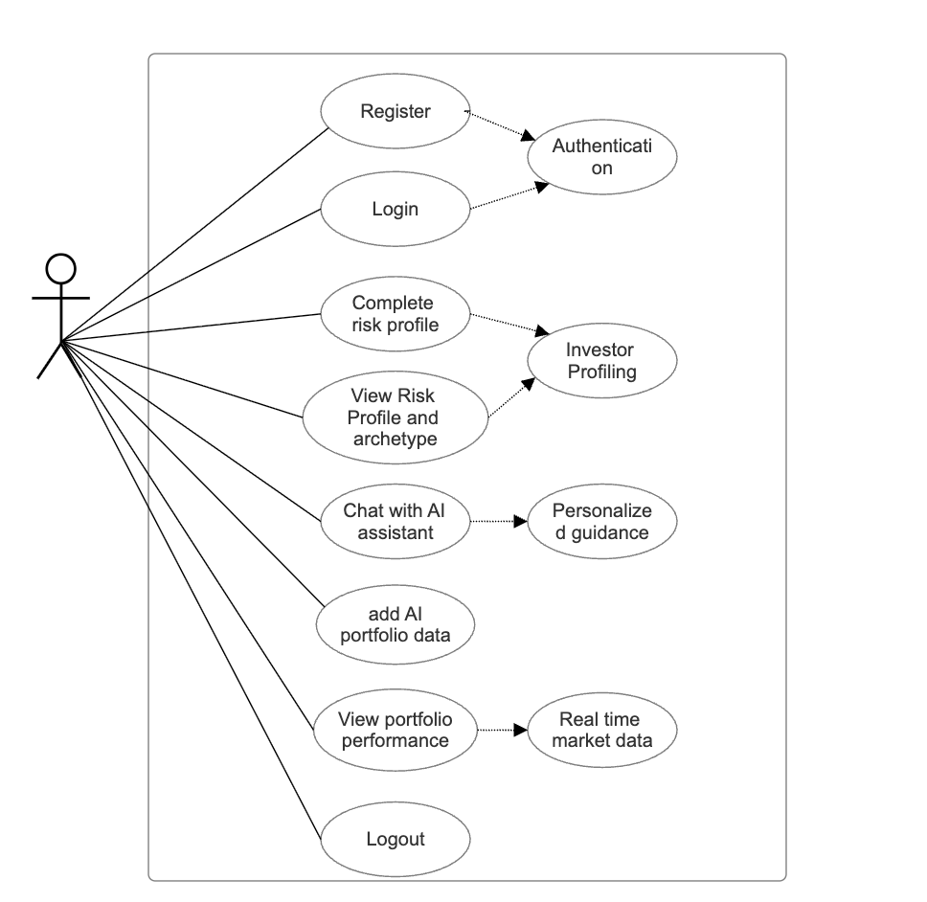
<<includes>>
<<includes>>
<<includes>>
<<includes>>
<<includes>>
<<includes>>
Figure 4.1: Use Case Diagram (name the user investor)

4.4.2 System Sequence Diagram
Figure 4-2 illustrates how the tasks related to user profiling and advice generation are accomplished. During sign-in, the investor enters their email and password, which are verified by Supabase authentication. Once verified, the investor is redirected to the dashboard where they can access system functionalities. The diagram also illustrates the risk profiling process. The investor completes the onboarding questionnaire, and the inputs are sent to the machine learning model. The model processes the responses, generates the investor’s risk score and archetype probabilities, and stores the results in the database. When the investor interacts with the chatbot, the system retrieves their stored profile and combines it with live market data from the Finnhub API. Finally, personalized advice is displayed as output to the investor.

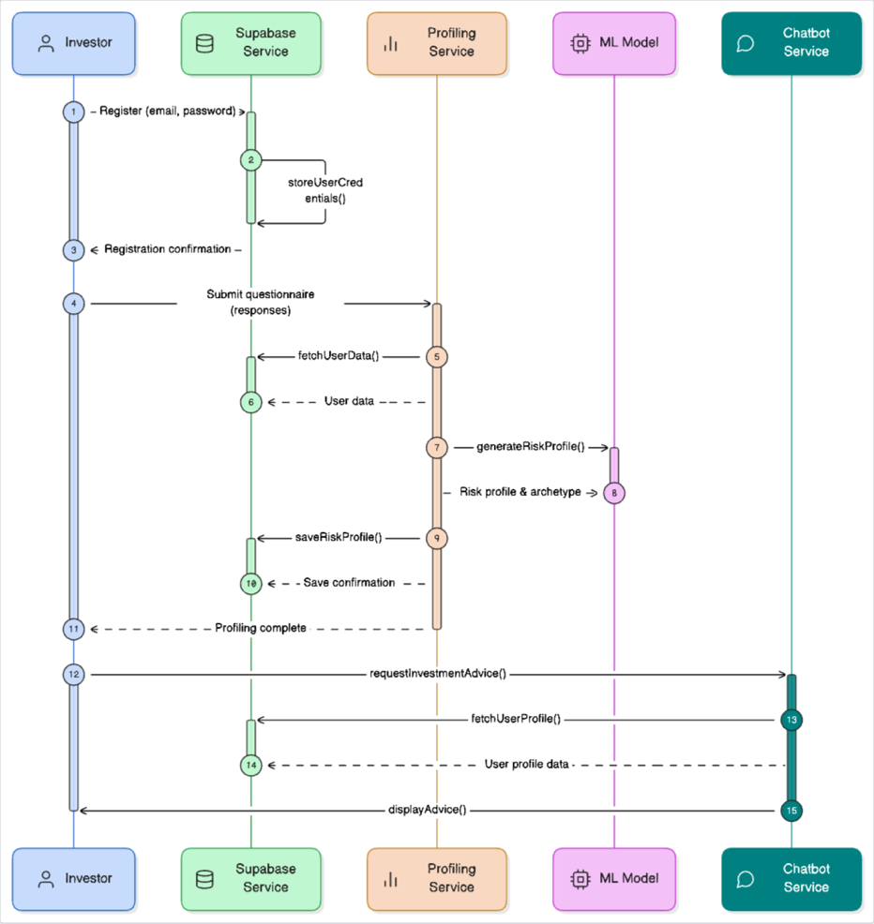

Figure 4.2 System Sequence Diagram

4.4.3 Entity Relationship Diagram
Figure 4-3 shows how the main entities of the system relate to one another. The investor entity is central to the system and is linked to their profile, portfolios, and chat sessions. Each investor has one profile containing their risk score and archetype probabilities. An investor can have multiple portfolios, each containing investment assets and their details. An investor can also have multiple chat sessions, with stored messages and timestamps. These relationships ensure that all investor activities are tracked, stored, and retrievable when needed.

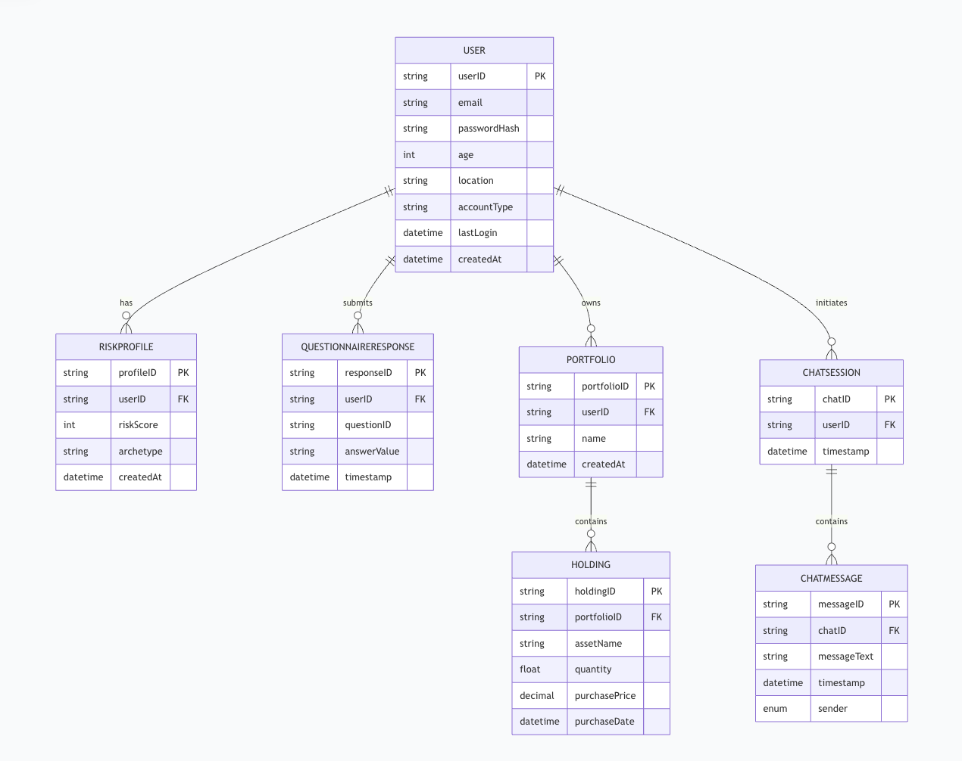

Figure 4.3: Entity Relationship Diagram

4.4.4 Class Diagram
Figure 4-4 presents the logical structure of the system in terms of classes, their attributes, and methods. The User class manages authentication details such as email and password and includes methods for registration and login. The Profile class stores the risk score and archetype data, with methods to update and retrieve profile information. The Portfolio class captures details such as asset symbol, quantity, price, and date of entry, and provides methods to add or view portfolio performance. The Chatbot class manages conversations by recording session history and returning responses to investor queries. Finally, the RecommendationEngine class generates tailored investment suggestions based on the user’s risk profile and market conditions.
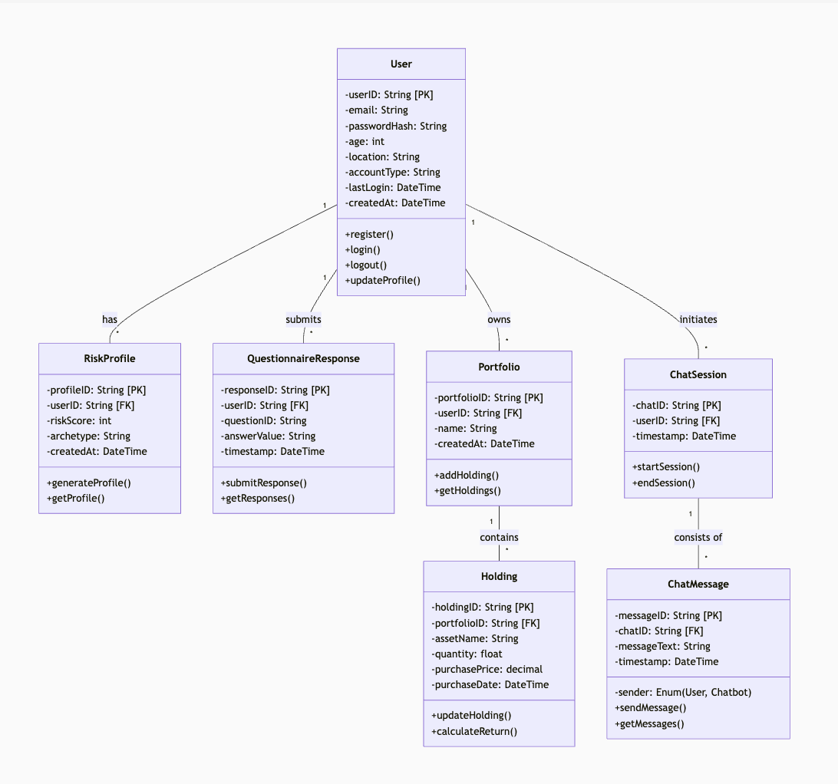

Figure 4.4 Class Diagram(remove the has, submits e.t.c add the cardinality)

4.4.5 Activity Diagram
Figure 4-5 illustrates the workflow of the system from start to end. The investor first registers an account and logs in by entering their credentials, which are authenticated by the system. Once logged in, the investor is redirected to the dashboard, where they can choose to complete the risk profiling questionnaire or manage their portfolios. When the investor submits their survey responses, the machine learning model processes the data, generates the risk profile, and stores it in the database. The investor can then interact with the chatbot, which retrieves their stored profile and fetches live market data before providing personalized investment advice. Finally, the investor can log out of the system once they are done.

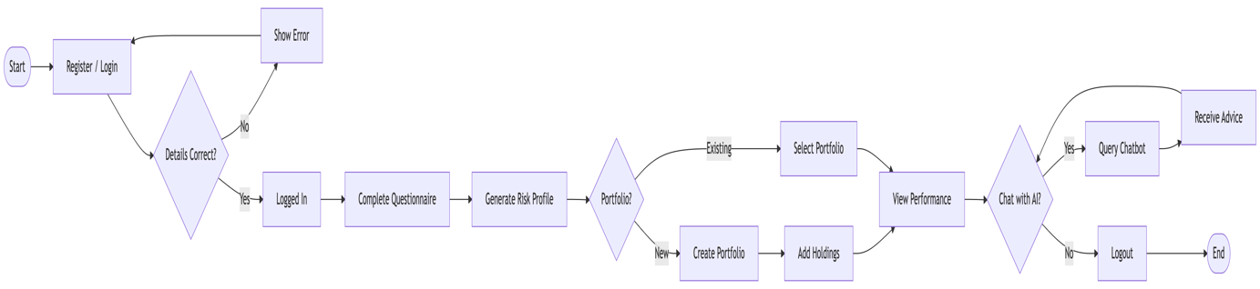

Figure 4.5 Activity Diagram

4.5 System Design Diagrams
This section presents the design models that demonstrate how the system satisfies the documented requirements. These include the database schema, wireframes of the main interfaces, and the overall system architecture. Each model illustrates how data is structured, how users interact with the system, and how the different components work together to deliver personalized investment advice.

4.5.1 Database Schema
Figure 4.512 illustrates the database schema used in Supabase. The database is relational, built on PostgreSQL, but incorporates JSON fields to handle flexible outputs such as archetype probabilities. The schema is organized around four main tables: Users, Profiles, Portfolios, and ChatSessions. The Users table stores unique identifiers and authentication details. The Profiles table is linked to each user and contains their risk score and archetype distribution. The Portfolios table records user investments, including asset symbol, quantity, and purchase details. The ChatSessions table stores conversation histories in JSON format for continuity in future sessions. These relationships ensure that all user data is properly linked and easily retrievable for real-time personalization.
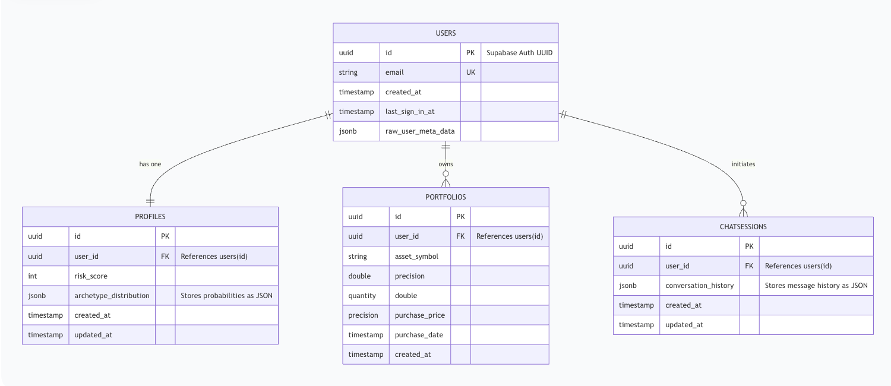
Figure 4.5.1 Database Schema (redo it make it better change userid to investor id)

4.5.2 Wireframes
The wireframes illustrate the appearance and interaction flow of the main system interfaces.
i. Landing, Login and Registration Pages
Figure 4.5.2 – 4.5.4illustrates the login and registration screens. New users register by providing their email and password, while existing users log in with the same details. Supabase authentication verifies credentials before granting access.
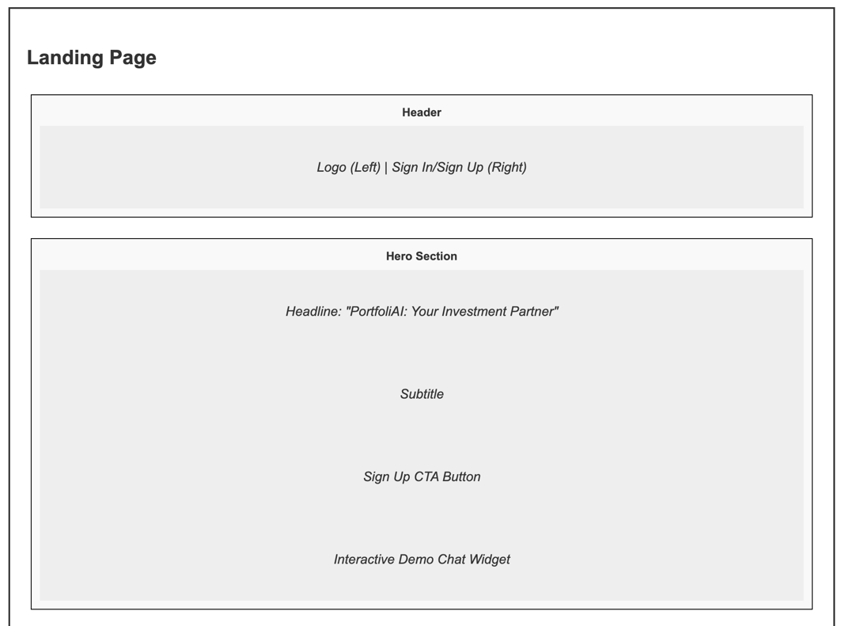

Figure 4.5.2 Landing page

ii. Onboarding Questionnaire
Figure 4-8 illustrates the onboarding questionnaire page. After logging in, users complete a guided survey capturing demographic and behavioral data. The responses are submitted to the machine learning service for profiling.
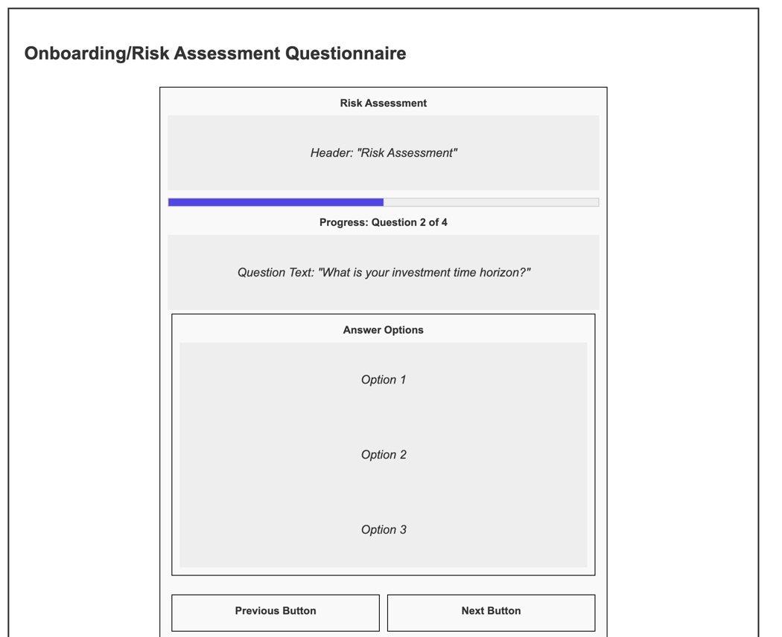

Figure 4.5.3 Onboarding/Risk Assessment Questionnaire

iii. Dashboard and Chatbot interface
Figures 4.5.4 illustrate the investor dashboard and chatbot interface. Once profiling is complete, the dashboard presents the investor’s risk score, archetype probabilities, and a summary of portfolio performance, serving as the central hub for accessing other functionalities. Complementing the dashboard, the chatbot interface allows users to interact in plain language, receiving personalized investment guidance based on stored profiles and live market data. Chat history is maintained to ensure continuity across sessions.

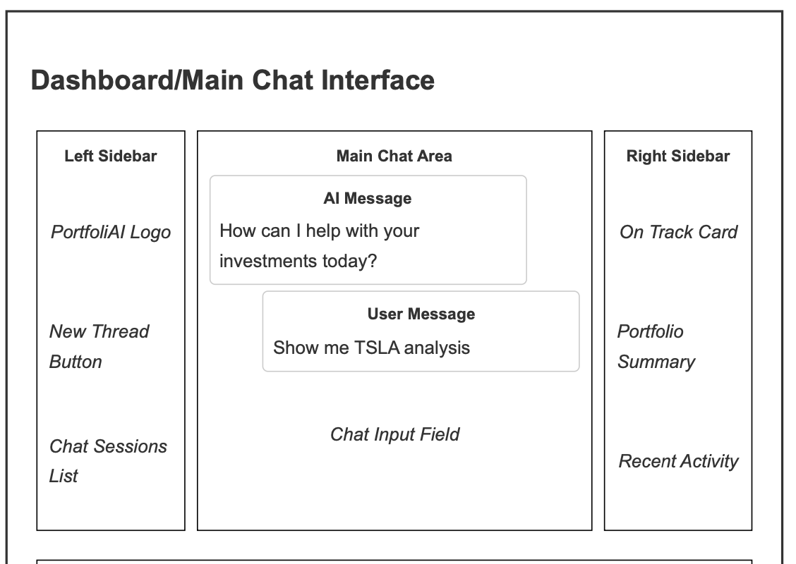

Figure 4.5.4 Dashboard/Main Chat Interface

iv.PortfolioPage
Figure 4-11 illustrates the portfolio tracker page. Investors can add assets by specifying details such as symbol, quantity, price, and date of purchase. The system automatically fetches live prices from the Finnhub API to compute performance. Historical data is stored to allow users to track progress over time.

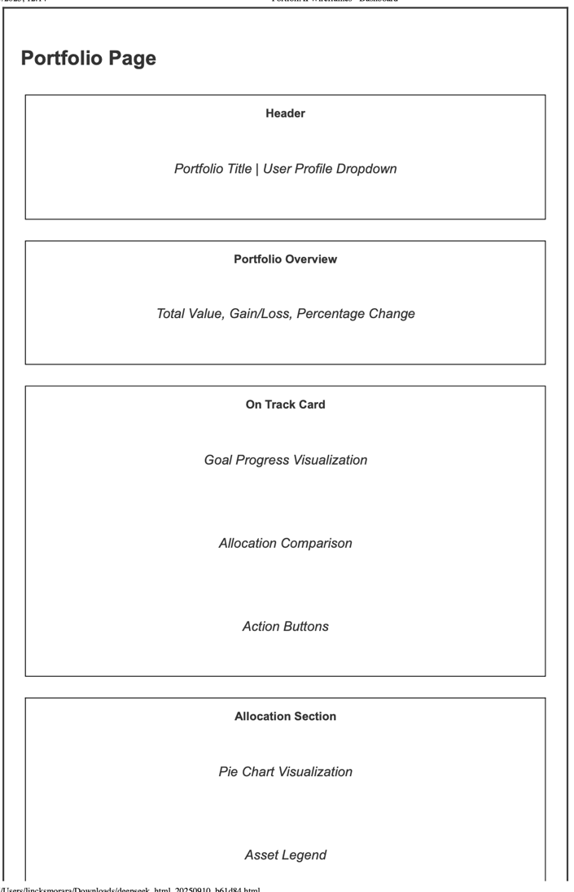

Figure 4.5.5 Portfolio Page

4.6 System Architecture
Figure 4-12 illustrates the overall architecture of the system and how its components interact. The frontend, developed in React and Next.js, handles the user interface, including survey input, dashboard, chatbot, and portfolio tracker. The backend is powered by Supabase, which provides authentication, database services, and real-time updates. The machine learning model is hosted as a serverless API that processes profiling data and returns risk scores and archetype probabilities. External APIs such as Finnhub are integrated to supply real-time financial data. Together, these layers ensure that user requests flow seamlessly from the interface through the backend and back, delivering accurate, secure, and personalized results.

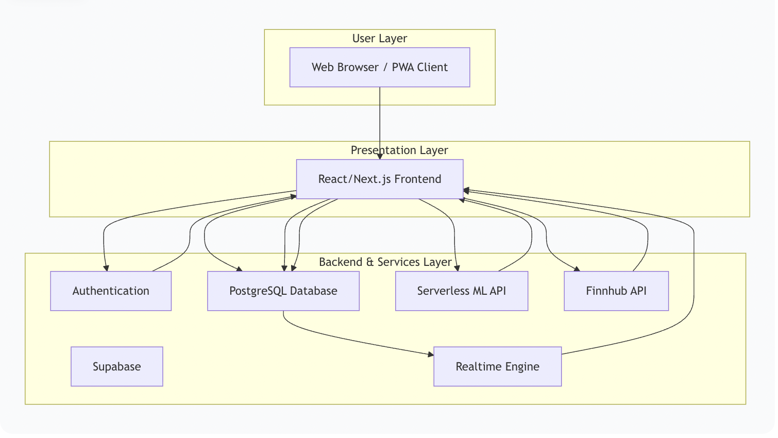

Figure 4.6 System Architecture (include all components including hardware, network, internet, apis, etc in a very visual way)
References
Amponsah, E., Ntim, L., & Mensah, M. (2025). Influence of Financial Risk Tolerance on Investment Decision-making: A Conceptual Analysis and Future Research Agenda. International Journal of Applied Research in Business and Management, 6. https://doi.org/10.51137/wrp.ijarbm.2025.eaia.45677
Ariwangsa, I., Putra P, K., & Laksmi P, K. W. (2024). The Impact of Financial Literacy on Investment Decisions: The Moderating Role of Financial Technology. UPI YPTK Journal of Business and Economics, 9, 16–22. https://doi.org/10.35134/jbe.v9i3.274
Guo, Y., Liu, Y., Pan, Z., & Bu, G. (2023). The Impact of Information Overload on Investment Decisions under the Information Disclosure System of STAR Market. Advances in Economics, Management and Political Sciences, 4, 174–184. https://doi.org/10.54254/2754-1169/4/20221051
Jain, N., & Kesari, B. (2022). THE IMPACT OF BEHAVIORAL BIASES ON FINANCIAL RISK TOLERANCE OF INVESTORS AND THEIR DECISION MAKING.
Julius, F., Morgan, A., Ayoex, S., & Hoover, R. (2023). Evaluating the Impact of AI Tutors on Student Performance in Online Learning Platforms Author.
Kabaiku, P. (2018). Savings and Credit Cooperative Societies (SACCOs) in Kenya. Jumuga Journal of Education, Oral Studies, and Human Sciences (JJEOSHS), 1. https://doi.org/10.35544/jjeoshs.v1i1.3
Lusardi, A., & Mitchell, O. S. (2014). The Economic Importance of Financial Literacy: Theory and Evidence. Journal of Economic Literature, 52(1), 5–44. https://doi.org/10.1257/jel.52.1.5
Ndung’u, N. (2021). A Digital Financial Services Revolution in Kenya: The M-Pesa Case Study.
Nguyen, L., Gallery, G., & Newton, C. (2016). The Influence of Financial Risk Tolerance on Investment Decision-Making in a Financial Advice Context. Australasian Accounting, Business and Finance Journal, 10, 3–22. https://doi.org/10.14453/aabfj.v10i3.2
Riar, E., & Kumar, A. (2022a). Personality Traits (Big-Five Model) and Investment Behaviour of Individuals: Analysis of Socio-Demographic Factors (pp. 126–138).
Riar, E., & Kumar, A. (2022b). Personality Traits (Big-Five Model) and Investment Behaviour of Individuals: Analysis of Socio-Demographic Factors (pp. 126–138).
Tabot, S. (2024). Investing in the long-term: An empirical approach. International Journal of Research in Business and Social Science (2147- 4478), 13, 537–541. https://doi.org/10.20525/ijrbs.v13i4.3276
Tariq, M., Maryam, S. Z., & Shaheen, W. A. (2024). Cognitive factors and actual usage of Fintech innovation: Exploring the UTAUT framework for digital banking. Heliyon, 10(15), e35582. https://doi.org/10.1016/j.heliyon.2024.e35582
WANJIRU, C., & WAWERU, F. (2025). Liquidity and Financial Performance in SACCOs: Evidence from Kiambu County, Kenya. Asian Journal of Economics, Finance and Management, 7, 123–137. https://doi.org/10.56557/ajefm/2025/v7i1259

