ASSIGNMENT 4

Lincoln Brown

2021-07-17

# Markdown Basics

## Favorite Foods

1. Lamb
2. Sushi
3. Steak

## Images

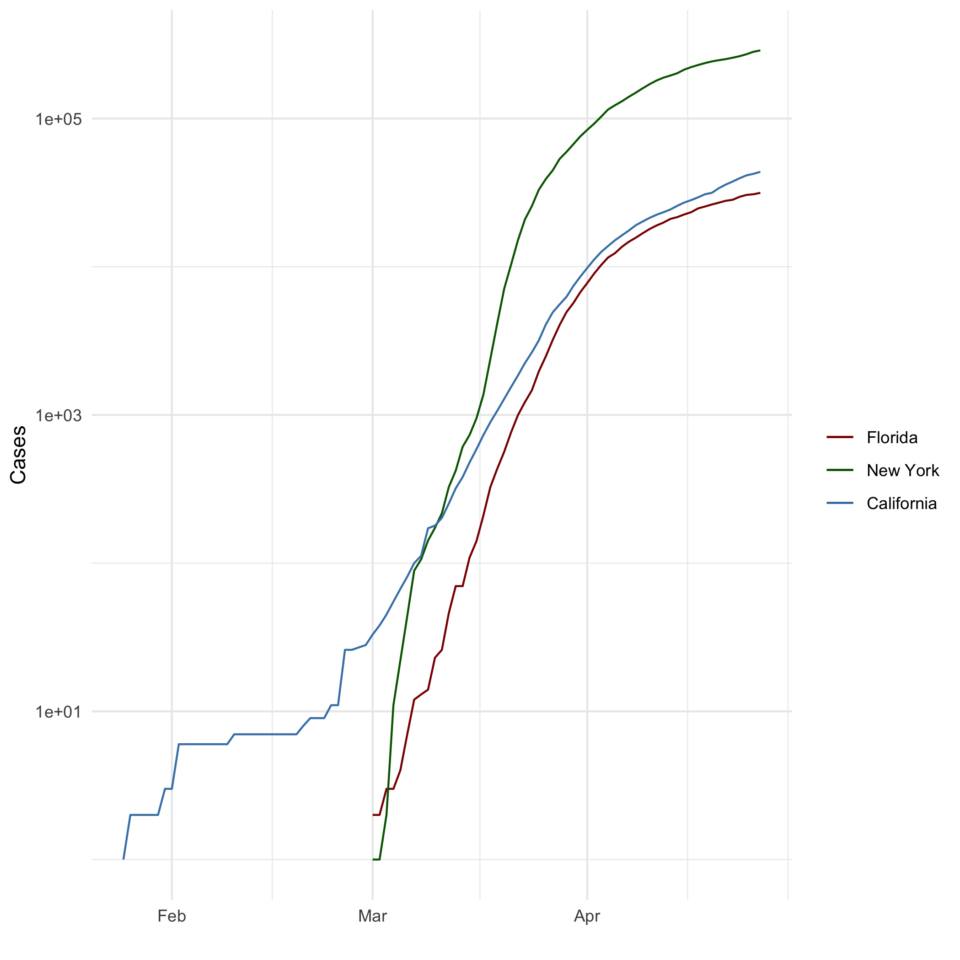

All cases

## Add a Quote

A nod to the Lord of the Rings table in our assignment:

“I wish it need not have happened in my time,” said Frodo. “So do I,” said Gandalf, “and so do all who live to see such times. But that is not for them to decide. All we have to decide is what to do with the time that is given us.” ― J.R.R. Tolkien, The Fellowship of the Ring

## Add an Equation

### Standard Score

$z=(X−μ)/σ$

## Add a Footnote

This is a footnote.[1]

## Add Citations

* R for Everyone (Lander 2014).
* Discovering Statistics Using R (Field, Miles, and Field 2012).

# Inline Code

## NY Times COVID-19 Data

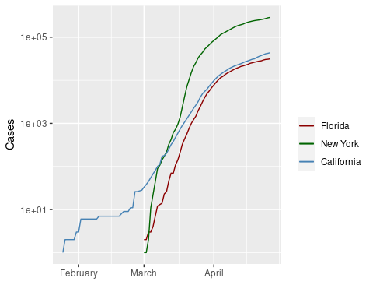

## R4DS Height vs Earnings

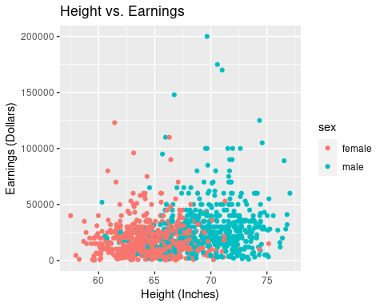

# Tables

name <- c("Aragon", "Bilbo", "Frodo", "Galadriel", "Sam", "Gandalf", "Legolas", "Sauron", "Gollum")  
race <- c("Men", "Hobbit", "Hobbit", "Elf", "Hobbit", "Maia", "Elf", "Maia", "Hobbit")  
in_fellowship <- c(TRUE, FALSE, TRUE, FALSE, TRUE, TRUE, TRUE, FALSE, FALSE)  
ring_bearer <- c(FALSE, TRUE, TRUE, FALSE, TRUE, TRUE, FALSE, TRUE, TRUE)  
age <- c(88, 129, 51, 7000, 36, 2019, 2931, 7052, 589)  
  
characters_df <- data.frame(name, race, in_fellowship, ring_bearer, age)

## Knitr Table with Kable

library(knitr)  
knitr::kable(characters_df, col.names = c("Name", "Race", "In Fellowship?", "Is Ring Bearer?", "Age"), caption='One Ring to Rule Them All.')

One Ring to Rule Them All.

|  |  |  |  |  |
| --- | --- | --- | --- | --- |
| Name | Race | In Fellowship? | Is Ring Bearer? | Age |
| Aragon | Men | TRUE | FALSE | 88 |
| Bilbo | Hobbit | FALSE | TRUE | 129 |
| Frodo | Hobbit | TRUE | TRUE | 51 |
| Galadriel | Elf | FALSE | FALSE | 7000 |
| Sam | Hobbit | TRUE | TRUE | 36 |
| Gandalf | Maia | TRUE | TRUE | 2019 |
| Legolas | Elf | TRUE | FALSE | 2931 |
| Sauron | Maia | FALSE | TRUE | 7052 |
| Gollum | Hobbit | FALSE | TRUE | 589 |

## Pandoc Table

library(pander)  
library(Rcpp)  
pannames <- c("Aragon", "Bilbo", "Frodo", "Sam", "Sauron")  
panrace <- c("Men", "Hobbit", "Hobbit", "Hobbit", "Maia")  
panfellow <- c("Yes", "No", "Yes", "Yes", "No")  
panring <- c("No", "Yes", "Yes", "Yes", "Yes")  
panage <- c(88, 129, 51, 36, 7052)  
  
pantable_df <- data.frame(pannames, panrace, panfellow, panring, panage)  
  
pandoc.table(pantable_df, style='grid')

##   
##   
## +----------+---------+-----------+---------+--------+  
## | pannames | panrace | panfellow | panring | panage |  
## +==========+=========+===========+=========+========+  
## | Aragon | Men | Yes | No | 88 |  
## +----------+---------+-----------+---------+--------+  
## | Bilbo | Hobbit | No | Yes | 129 |  
## +----------+---------+-----------+---------+--------+  
## | Frodo | Hobbit | Yes | Yes | 51 |  
## +----------+---------+-----------+---------+--------+  
## | Sam | Hobbit | Yes | Yes | 36 |  
## +----------+---------+-----------+---------+--------+  
## | Sauron | Maia | No | Yes | 7052 |  
## +----------+---------+-----------+---------+--------+

# References

Field, A., J. Miles, and Z. Field. 2012. *Discovering Statistics Using r*. SAGE Publications. <https://books.google.com/books?id=wd2K2zC3swIC>.

Lander, J. P. 2014. *R for Everyone: Advanced Analytics and Graphics*. Addison-Wesley Data and Analytics Series. Addison-Wesley. <https://books.google.com/books?id=3eBVAgAAQBAJ>.

1. This is what the footnote looks like.