An open source search revealed the following details.

query: kevinrose  
url: http://www.youtube.com/kevinrose  
user: kevinrose

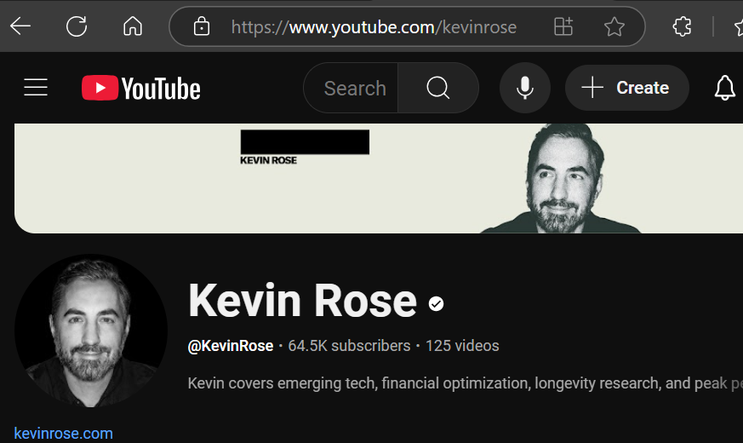

query: kevinrose  
url: https://instagram.com/kevinrose/  
user: kevinrose

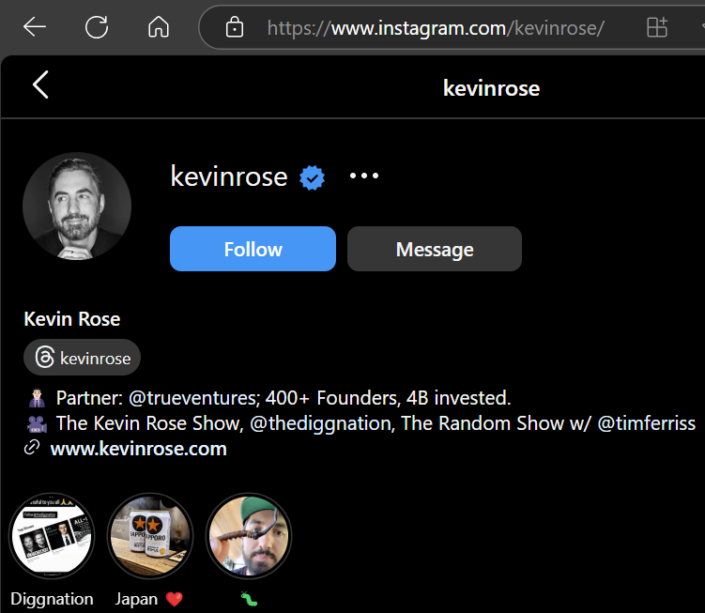

query: kevinrose  
url: http://www.pinterest.com/kevinrose/  
note: I invest in startups. http://about.me/kevinrose

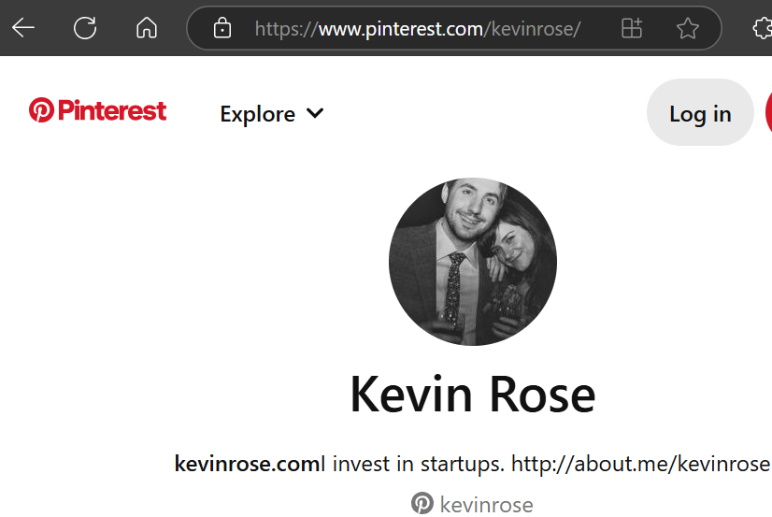

query: kevinrose  
url: http://disqus.com/kevinrose  
user: kevinrose

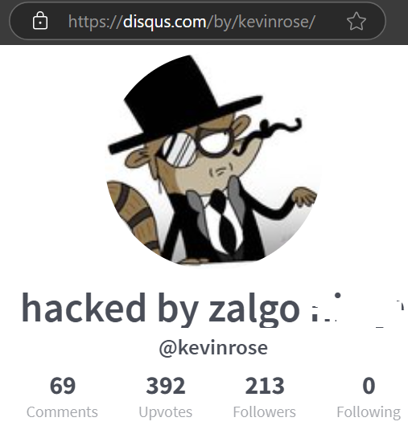

query: kevinrose  
url: https://venmo.com/u/kevinrose  
user: kevinrose

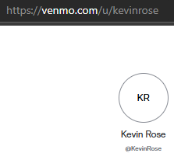

query: craig@craigslist.org  
url: https://thatsthem.com/email/craig@craigslist.org  
email: craig@craigslist.org

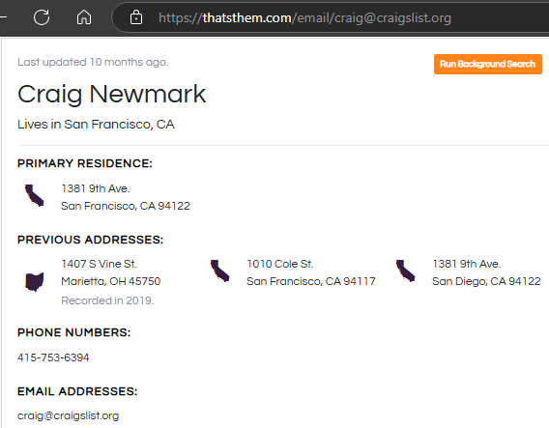

query: 92.20.236.78  
url: https://www.geodatatool.com/en/?IP=92.20.236.78  
ip: 92.20.236.78  
city: Sutton Bridge  
country: United Kingdom

query: 77.15.67.232  
url: https://resolve.rs/ip/geolocation.html?ip=77.15.67.232  
ip: 77.15.67.232  
city: Korb  
state: Baden-Wurttemberg  
zip: 74255  
country: Germany

query: kevinrose  
url: http://tiktok.com/@kevinrose?  
user: kevinrose

query: kevinrose  
url: https://whatsmyname.app/  
user: kevinrose

query: 77.15.67.232  
url: https://whatismyipaddress.com/ip/77.15.67.232  
ip: 77.15.67.232

query: 92.20.236.78  
url: https://www.ip-adress.com/whois/92.20.236.78  
ip: 92.20.236.78

query: kevinrose  
url: http://open.spotify.com/user/kevinrose

query: kevinrose@gmail.com  
url: https://x.com/users/email_available?email=kevinrose@gmail.com  
email: kevinrose@gmail.com

query: kevinrose  
url: http://profiles.wordpress.org/kevinrose/  
user: kevinrose