# 1 Mysql

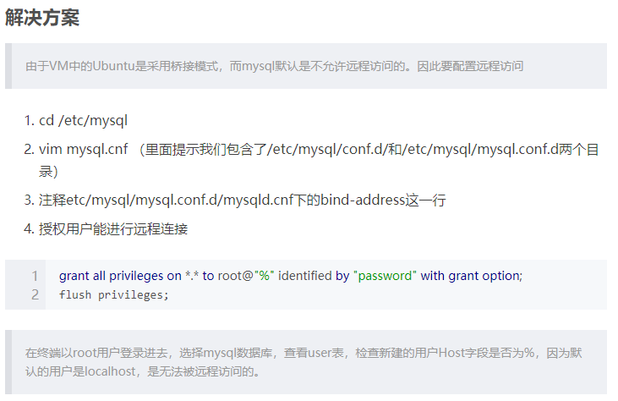

# 2 Mysql常规索引测试

|  |  |  |  |
| --- | --- | --- | --- |
| 编号 | 在name上建索引查询 | Name上无索引 | 主键 |
| 1 | 6.072957515716553 | 39.62403130531311 | 5.98876690864563 |