1. consider the following cases:

FootPrint is a internet company that provides statistical data for their customer( or other internet company). They need to record the user behavior on most of the social media websites so that their customer could make better strategic decision based on these data. For each website model , they need to record the visiting frequency of the user, intervals, average spent time, time spent on watching ads, possibility that user willing to buy their service. Usually the number of users can be immense, it would be intricate and inconvenient to use relational database in this case.

1. a. the ERD is shown below:summary:

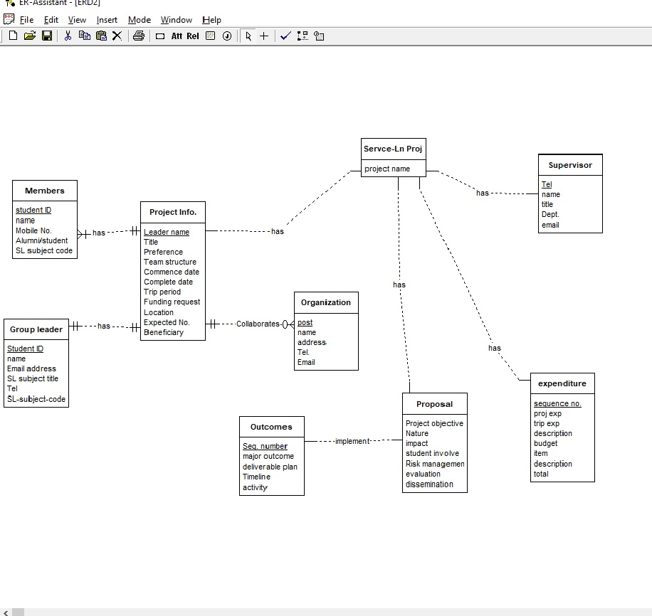

Entities

Project Info. : REGULAR ENTITY

Title : ATTRIBUTE Type:CHAR Length=20

Preference : ATTRIBUTE Type:CHAR Length=20

Leader name : [PK] ATTRIBUTE Type:CHAR Length=20

Team structure : ATTRIBUTE Type:CLOB Length=100

Commence date : ATTRIBUTE Type:TIME

Complete date : ATTRIBUTE Type:TIME

Trip period : ATTRIBUTE Type:TIME

Funding request : ATTRIBUTE Type:NUMERIC Length=100 Width=100

Location : ATTRIBUTE Type:NCHAR VARYING Length=20

Expected No. : ATTRIBUTE Type:NUMERIC Length=20 Width=

Beneficiary : ATTRIBUTE Type:NCHAR VARYING Length=20

Group leader : REGULAR ENTITY

name : ATTRIBUTE Type:CHAR Length=20

Student ID : [PK] ATTRIBUTE Type:NUMERIC Length=20 Width=10

Email address : ATTRIBUTE Type:VARCHAR Length=50

SL subject title : ATTRIBUTE Type:CHAR Length=20

Tel : ATTRIBUTE Type:NUMERIC Length=20 Width=10

SL-subject-code : ATTRIBUTE Type:NUMERIC Length=20 Width=10

Members : REGULAR ENTITY

name : ATTRIBUTE Type:CHAR Length=20

student ID : [PK] ATTRIBUTE Type:NUMERIC Length=20 Width=20

Mobile No. : ATTRIBUTE Type:NUMERIC Length=20 Width=10

Alumni/student : ATTRIBUTE Type:BOOLEAN

SL subject code : ATTRIBUTE Type:NUMERIC Length=20 Width=10

Organization : REGULAR ENTITY

name : ATTRIBUTE Type:VARCHAR Length=20

address : ATTRIBUTE Type:VARCHAR Length=20

post : [PK] ATTRIBUTE Type:NUMERIC Length=20 Width=

Tel. : ATTRIBUTE Type:NUMERIC Length=20 Width=

Email : ATTRIBUTE Type:VARCHAR Length=20

Proposal : REGULAR ENTITY

Project objective : ATTRIBUTE Type:VARCHAR Length=50

Nature : ATTRIBUTE Type:VARCHAR Length=50

impact : ATTRIBUTE Type:VARCHAR Length=50

student involve : ATTRIBUTE Type:BOOLEAN

Risk management : ATTRIBUTE Type:VARCHAR Length=50

evaluation : ATTRIBUTE Type:VARCHAR Length=

dissemination : ATTRIBUTE Type:VARCHAR Length=50

Outcomes : REGULAR ENTITY

major outcome : ATTRIBUTE Type:VARCHAR Length=50

deliverable plan : ATTRIBUTE Type:VARCHAR Length=50

Timeline : ATTRIBUTE Type:TIMESTAMP

activity : ATTRIBUTE Type:VARCHAR Length=20

Seq. number : [PK] ATTRIBUTE Type:NUMERIC Length= Width=

expenditure : REGULAR ENTITY

proj exp : ATTRIBUTE Type:NUMERIC Length=20 Width=

trip exp : ATTRIBUTE Type:VARCHAR Length=20

description : ATTRIBUTE Type:VARCHAR Length=20

budget : ATTRIBUTE Type:NUMERIC Length=20 Width=

sequence no. : [PK] ATTRIBUTE Type:NUMERIC Length=10 Width=

item : ATTRIBUTE Type:VARCHAR Length=20

description : ATTRIBUTE Type:VARCHAR Length=20

total : ATTRIBUTE Type:NUMERIC Length=20 Width=

Supervisor : REGULAR ENTITY

name : ATTRIBUTE Type:VARCHAR Length=20

title : ATTRIBUTE Type:VARCHAR Length=20

Dept. : ATTRIBUTE Type:VARCHAR Length=20

Tel : [PK] ATTRIBUTE Type:NUMERIC Length=20 Width=

email : ATTRIBUTE Type:VARCHAR Length=20

Servce-Ln Proj. : REGULAR ENTITY

project name : ATTRIBUTE Type:NO DATATYPE

Relationships

has : REGULAR RELATIONSHIP Project Info. ONE MANDATORY to Group leader ONE MANDATORY

has : REGULAR RELATIONSHIP Project Info. ONE MANDATORY to Members MANY MANDATORY

Collaborates : REGULAR RELATIONSHIP Organization MANY OPTIONAL to Project Info. ONE MANDATORY

implement : REGULAR RELATIONSHIP Proposal to Outcomes

has : REGULAR RELATIONSHIP Servce-Ln Proj. to Project Info.

has : REGULAR RELATIONSHIP Servce-Ln Proj. to Proposal

has : REGULAR RELATIONSHIP Servce-Ln Proj. to expenditure

has : REGULAR RELATIONSHIP Servce-Ln Proj. to Supervisor

2b:

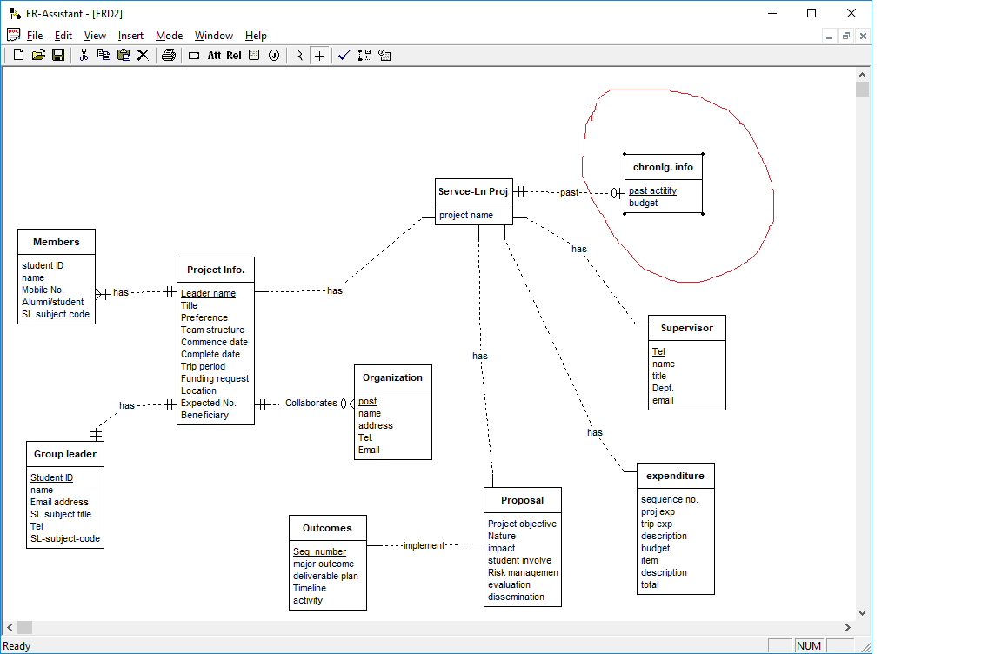

The original ERD file can be accessed here:

3. a.

Explanation: first we use the product function to match different employees, then select the employee name1 not equals enmploy name2 but from the same department. Finally select the department column.

b. this query can not be written in relational algebra if count function is not allowed.

c. $∏name\left(Employee\right)-\prod{Emp1.name1(}σ(Emp1.salary1<Emp2.salary2(ρ\left(Emp1\right) ✖ρ（Emp2）)）$

Explanation: Use the product function to match different employee within one table. Find the employee who has less salary than others, select the name column. Select the original all the employee names then minus the employee whose salary is less , thus we got the highest salary employee.

4.

5.

|  |  |
| --- | --- |
| TABLE A | |
| 1 | 500 |
| 2 | 500 |
| 3 | 800 |

|  |  |
| --- | --- |
| TABLE B | |
| 500 | 4 |
| 500 | 5 |