**SCA CLOUD APPLICATION**

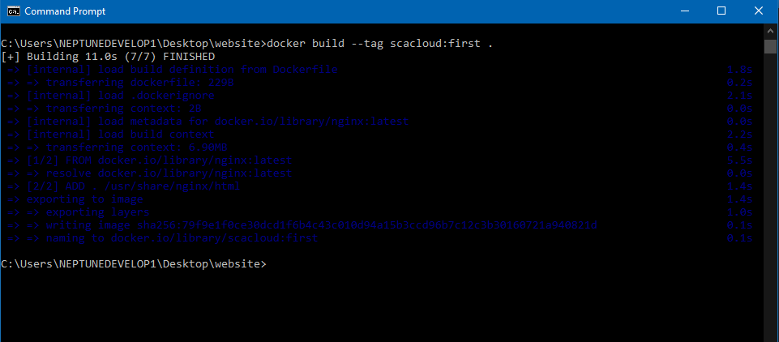

1. BUILDING THE FIRST IMAGE: The image above shows the building of the Image with name “scacloud” and tag as “first”. The running process shows that the Dockerfile contains 2 instructions. First is to pull from the base image named “nginx:latest” and secondly to add the content of the location to the image volume path.

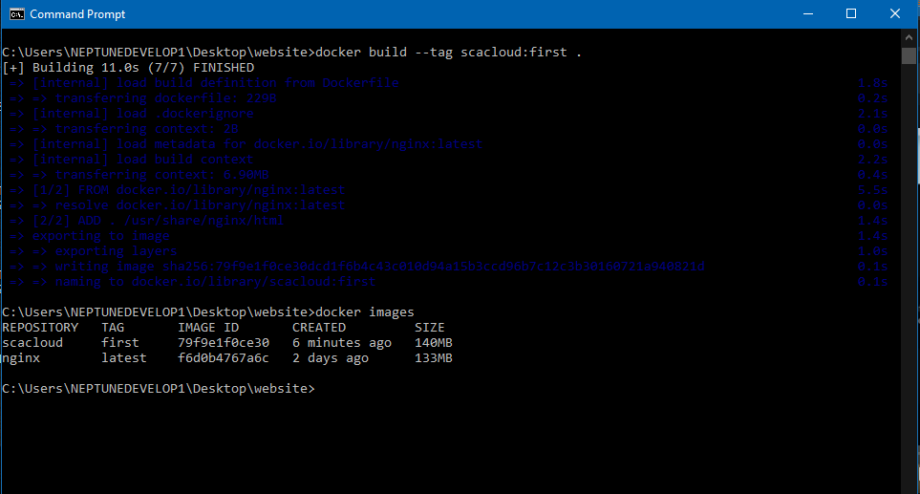

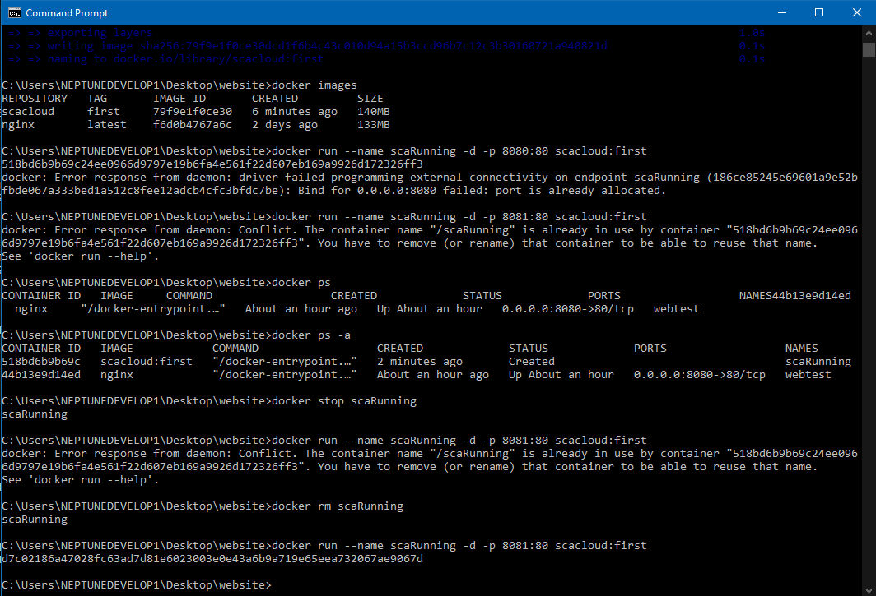

1. RUNNING THE CONTAINER: After building the image, the next step was to check for images on the host using “docker images” command. Which includes the scacloud image built. I tried running the container named it “scaRunning” but the port specified was already in use as seen above. This was resolved by stopping the container running on that port and also re running the container on port 8081.



1. TESTING THE APPLICATION: the image above shows the application running in port 8081 as specified.