1. For request GET were requirements:

* Response code mustn’t contain such errors like 404, 302, 400;
* Size for full response must be less than 1030 bytes;
* Load time must be less than 100ms.

Result:

31.67 % of responses are errors. Almost all errors were cause of Size assertion and 2 of them became errors cause of Duration assertion. All responses passed Response assertion.

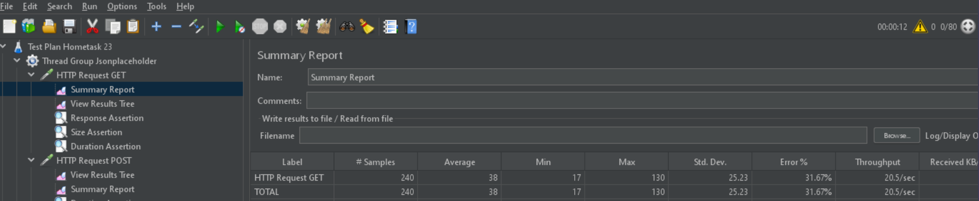

1. For request POST were requirements:

* Response message contains “Created”;
* Size for full response must be more than 1280 bytes;
* Load time must be less than 250 ms.

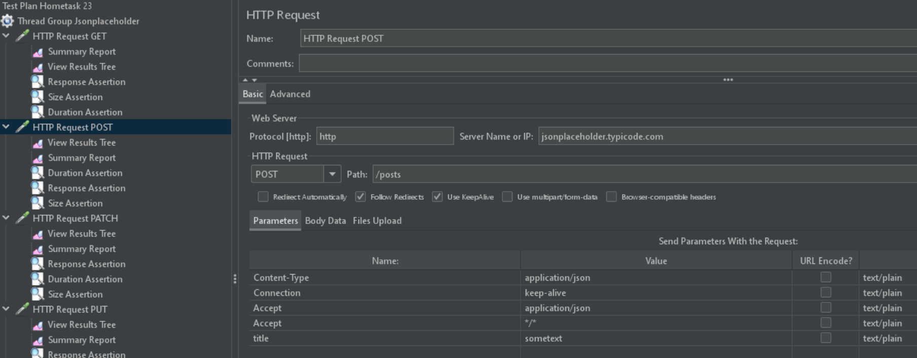

Result:

17.92 % of responses are errors. Almost all errors were cause of Size assertion and 6 of them became errors cause of Duration assertion. All responses passed Response assertion.

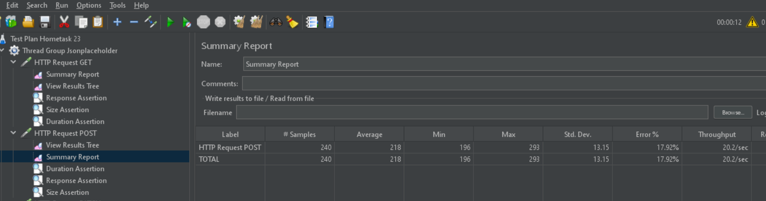

1. For request PATCH were requirements:

* Response message contains “OK”;
* Size for full response must be less than 2000 bytes;
* Load time must be less than 250 ms.

Result:

1.25 % of responses are errors. All errors were cause of Duration assertion. All responses passed Response assertion and Size assertion.

1. For request PUT were requirements:

* Response message mustn’t contain such errors like 404, 302, 505 ;
* Size for full response must be less than 2000 bytes;
* Load time must be less than 250 ms.

Result:

1.6 % of responses are errors. All errors were cause of Duration assertion. All responses passed Response assertion and Size assertion.

1. For request DELETE were requirements:

* Response message mustn’t contain such errors like 404, 302, 505 ;
* Size for full response must be less than 2000 bytes;
* Load time must be less than 250 ms.

Result:

1.25 % of responses are errors. All errors were cause of Duration assertion. All responses passed Response assertion and Size assertion.

General result: All responses for all request passed Response assertion. We received 129 responses with errors, 8 of them were cause of Duration assertion ( for requests GET and POST).