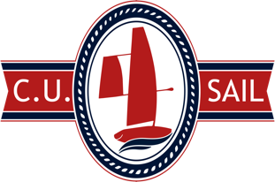

**CU Sail**

**Fall 2018 Freshman Application**

**DUE: Monday, October 1, 2018, 11:59 PM**

**Instructions:**

* Save your application as a pdf with the file name in the format FirstnameLastname_CUSail_App.pdf
* Email the pdf to [gae27@cornell.edu](mailto:gae27@cornell.edu) with CU Sail Application plus your full name as the subject line (ex: CU Sail Application John Doe)
* If you would like to submit a resume in addition to your application, include a pdf version of the resume in the email. A resume is not required.

**Full Name:**

**NetID:**

**Graduation Year:**

**Major:**

**Minor (if applicable):**

**Which sub-team are you interested in joining (Mechanical, Navigation, or Business)?**

**Tell us about yourself.**

**What are you involved with on campus or looking to get involved with?**

**Why do you want to join a project team?**

**Why are you interested in CU Sail?**

**List and describe any technical or relevant experience you have (ex: machining, CAD, graphic design, web design, PCB, etc.). Experience not required.**

**Do you have any sailing experience? Experience not required.**

**If you could have any super power, what would your super power be?**