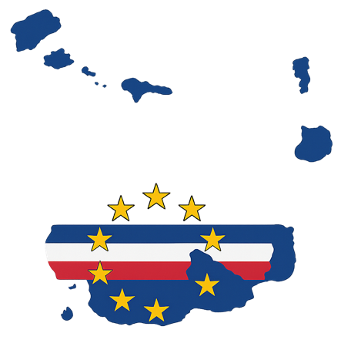
Country Factsheet: Cabo Verde

This country factsheet offers a summary of Cabo Verde’s plastic related policy frameworks and key data, drawing on findings from the AFRIPAC project and publicly accessible data sources. Detailed reports can be found on the AFRIPAC Data Hub¹.

National Overview

Demographic Details:
Area (2019) | 4,033 km² | UN Data²
Total population (2024) | 600,000 | UN Data²
Population density (2024) | 149 per km² | UN Data²
Urban Population (2018) | 66 % | UN Data²
Population projection (2050) | 700,000 | UN Data²
GDP (2024) | US$ 2,315,000,000 | UN Data²

Plastics Trade Data

HS codes are often too broad for detailed monitoring as many plastic products are not clearly identified, and trade data can be incomplete or inconsistent due to fragmented reporting. Despite these challenges, HS-based statistics still provide a reliable high-level view of plastic trade flows and use, helping to inform and support regulatory design.

Overall, trade data shows Cabo Verde has a product-heavy, net import market, resulting in an ever-increasing quantity of plastics that accumulate in Cabo Verde. Cabo Growth is modest with smaller volumes in comparison to other countries in the West African region, although there are clear discrepancies regarding tonnage and value reported. By application, packaging, textiles, and tubes/pipes/hoses indicate some of the highest import volumes, while vehicle-related plastics indicate some of the fastest growth.

Data | Trends | Source
General trade trends in West Africa
General import and export trends in West Africa (2005-2022) | Import volume increased by 459%  - Primary forms: ↑ 556%.  - Intermediate forms: ↑ 1,890%.  - Final manufactured goods: ↑ 1,946%.  - Plastic waste: ↑ 67% (peaked in 2014).  Exports volume increased by 265%  - Growth mainly in intermediate and final manufactured products.  - Plastic waste exports grew from 0 to 40,000 tonnes (2005-2022). | UNCTAD³
General trade trends in Cabo Verde
Imports of primary, product, and waste forms of plastic | - Imports have shown a slight increase from 10,300 to 12,200 tonnes/year (2017-2021).  - Most imports by volume were plastic products, followed by plastics in primary form.  - Primary forms between 2017-2021 by volume were mostly: other (72%), HDPE (8%), LDPE and PVC (7% each), PS (3%), and polyester (2%).  - Product forms between 2017-2021 by volume were mostly: PP (19%), polyester (15%), LDPE (16%), HDPE and PVC (13% each), PET (8%) PS and synthetic rubber (6% each).  - Plastic waste imports were on average 0.4 tonnes/year between 2017 and 2021.  - Between 2011-2022 imports by volume were 24% of plastics in primary form, 76% products, and 0.01% waste.  - Between 2011-2022 imports by value were 14% plastics in primary form, 86% products, and 0.01% waste.  - Waste under HS code 3915: highest volume was in 2020 (1.3 tonnes), which decreased to 0.6 tonnes in 2022 following the Basal Convention amendments.  - Imports have slightly increased over the years reported, estimated at 9,000 tonnes in 2005 and 13,000 tonnes in 2022.  - The value of packaging imported has increased from US$ 2,902,000 in 2005 to 10,666,000 in 2023.  - The value of textiles imported has increased from US$ 1,158,000 in 2005 to 2,343,000 in 2023. | UNEP-IUCN Hotspotting tool⁴
Imports of primary, product, and waste forms of plastic |  | UN Comtrade⁵
Imports of primary, product, and waste forms of plastic |  | UNCTAD³
Exports of primary and product forms of plastic | - Exports have remained stable at around 200 tonnes/year, except for a huge increase to 8,000 tonnes in 2019 (2017-2021).  - Most exports by volume were plastic products, followed by plastics in primary form.  - Primary forms between 2017-2021 by volume were mostly: PP (22%), other (21%), HDPE (17%), PVC (15%), PS (14%), LDPE (8%), and PET (3%).  - Product forms between 2017-2021 by volume were mostly: polyester (60%), LDPE (11%), PP (10%), HDPE (7%), PVC (5%), and PS (3%).  - Plastic waste was only exported in 2019 (4.2 tonnes).  - Between 2011-2022 exports by volume were 31% plastics in primary form, 60% products, and 9% waste.  - Between 2011-2022 exports by value were 22.94% plastics in primary form, 75% products, and 2% waste.  - Waste: ~4,085 tonnes/year (2017-2021).  - Exports have been reported as 0 tonnes (in thousands) between 2005 and 2022.  - The value of packaging exported has increased from US$ 59,000 in 2005 to 79,000 in 2023.  - The value of textiles exported has fluctuated, with a peak value of US$ 3,232,000 in 2005, decreasing to US$ 868,000 in 2023. | UNEP-IUCN Hotspotting tool⁴
Exports of primary and product forms of plastic |  | UN Comtrade⁵
Exports of primary and product forms of plastic |  | UNCTAD³
Imports by application (top use cases) | - Plastic tubes, pipes, and hoses were on average the highest import by volume, followed by different types of bottles (2017-2021).  - The strongest increase in annual imports by volume can be seen in vehicles, which saw an almost 5-fold increase (2017-2021).  - Plastics in clothes saw a decrease by almost 50% (2017-2021). | UNEP-IUCN Hotspotting tool⁴
Problematic & avoidable plastics (PAP) (2013-2022) | This section provides a brief overview of trade data on plastics that are being discussed as part of the draft Plastics Treaty negotiations, specifically a proposal submitted by Georgia, Peru, Rwanda, Switzerland, and Thailand⁶.  Highest import volumes:  - HS Code 392329: Plastics; sacks and bags (including cones), for the conveyance or packing of goods, of plastics other than ethylene polymers).  - HS Code 392390: Plastics, articles for the conveyance or packaging of goods.  - HS Code 390410: Vinyl chloride, other halogenated olefin polymers; polyvinyl chloride (not mixed with any other substances), in primary forms.  - HS Code 392049: Plates, Sheets, film, foil and strip of polymers of vinyl chloride, not reinforced/laminated/combined with other materials, others).  - By value these are ranked 392329, 392390, 392049, 392111 (Plastics; plates, sheets, film, foil and strip, of polymers of styrene, cellular). | UN Comtrade⁵

Note: UNCTAD functionally categorises plastic trade (primary to final forms, including waste) offering a strategic, lifecycle-oriented view, though less precise than UN COMTRADE data and the UNEP-IUCN Hotspotting tool as it overlooks many final plastic products, including filled packaging and embedded plastics. It is important to note that both UNCTAD and UNEP-IUCN data includes synthetic textiles and rubber into plastic categories and excludes electrical products.

Waste Management and Emissions Data

The table compiles some of the most recent waste management and plastic leakage figures from reported data and models. Simplified material flow analysis (MFA) diagrams compare reported data with 2020 model estimates⁷, using key lifecycle indicators and contemporaneous trade data from the UNCTAD (experimental) database³ and the UNEP-IUCN Hotspotting tool⁴ to provide broader context.

Data | Value | Unit | Source
Waste management data
Per capita municipal solid waste (MSW) generation (no date) | 0.71 | kg/person/day | World Bank (2023)⁸
Total MSW generation (no date) | 132,495 | tonnes/year | World Bank (2023)⁸
Waste accumulation in landfill from MSW (2015) | 145,900 | tonnes/year | UNSD (2023)⁹
Waste accumulation in landfill (2015) | 170,640 | tonnes/year | UNSD (2023)⁹
Per capita plastic waste generation (2010) | 0.07 | kg/person/day | Jambeck et al. (2015)¹⁰
Total municipal plastic waste generation (no date) | 16,790 | tonnes/year | World Bank (2023)⁸
Plastic composition of waste (no date) [SDG Indicator 11.6.1] | 13 | % | World Bank (2023)⁸
MSW collection coverage (2018) | 79 | % | Governo De Cabo Verde (2018)¹¹
MSW collection coverage in urban areas (2018) | 97 | % | Governo De Cabo Verde (2018)¹¹
Emissions data
Beach litter (2018) [SDG 14.1.1b] | 1,649,256 | items per km² | Global Plastics Hub¹²

Simple Material Flow Analysis combining trade data with a) data based on sources between 2018-2021 and b) modelled data for 2020

a)
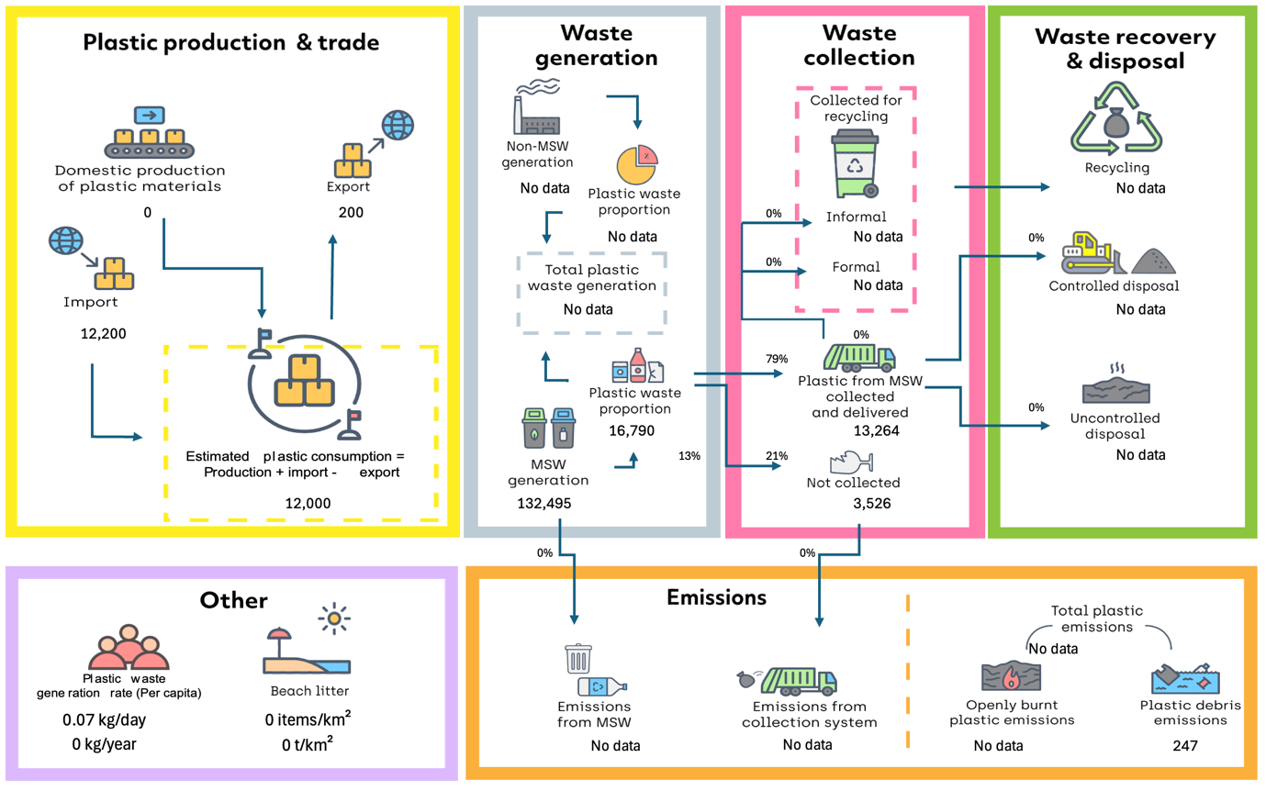

b)
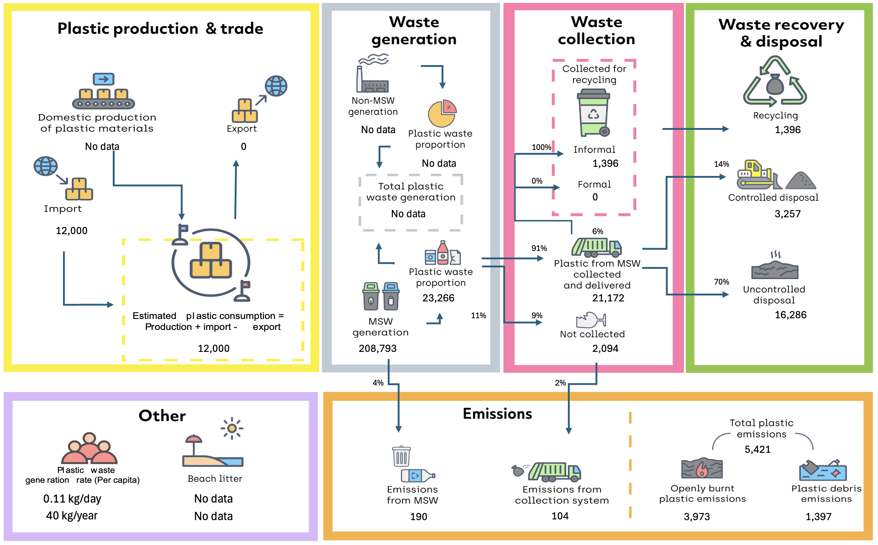
Values are in metric tonnes per year unless stated otherwise. Modelled data excludes e-waste, textiles, and rubber.

Relevant Governance, Policy and Legislation

Theme | Policy and Legislation
National coordination bodies | Decree-Law No. 57/2021¹³  - Ministry of Agriculture and Environment (MAA)  - National Directorate for Environment (DNA)  - The Environmental Impact Prevention and Assessment Services  - The Environmental Quality Information and Monitoring Service  - The Nature Conservation Service  - Environmental Sanitation Service  Resolution 35/2023¹⁴  - National Council for the Environment and Climate Change (CNAAC)  - Competent Authorities and Services of the State and Local Authorities  Law No. 45/VIII/2013¹⁵  - The National Water and Sanitation Council (CNAS)  - Competent Authorities and Services of the State and Local Authorities  Law No. 46/VIII/2013¹⁶  - The National Water and Sanitation Agency (ANAS)  Decree-Law No. 59/2020¹⁷  - The Environmental Fund (public institute)  Law No. 134/IV/95¹⁸  - Municipalities and ANAS  Legislative Decree No. 1/2010¹⁹  - The General Directorate of Customs (DGA)  Decree-Law No. 38/2018²⁰  - The Maritime and Port Institute (IMP)
Plastic production and trade | Legal Regime for the Commercialisation, Import, Distribution and Production of Single-Use Plastic (Law No. 22/X/2023)²¹  - Establishes a legal framework and applies to all sectors of economic and industrial activity and to all economic agents who engage in both wholesale and retail trade, whether formal or informal, and to all stages of the manufacture, processing and distribution of single-use plastic materials and objects, with the exception of the health, cosmetics and personal hygiene areas.  - Prohibits the production, import and placing on the market of packaging and other single-use plastic objects that do not meet general safety requirements and comply with good manufacturing practices, labelling, traceability and composition.  - Bans non-recyclable, oxo-biodegradable or oxo-degradable plastics, among others, with the exception of those in the areas of health, cosmetics and personal hygiene.  - An initiative under this regime bans the sale of plastic bottles smaller than 500ml and regulates the use of post-consumer recycled plastics. The initiative focuses on scaling up the production and distribution of reusable 19-litre bottles, which can be refilled up to 50 times, thus replacing a significant portion of the bottled water market. The project aims to prevent up to 170 tonnes of plastic waste from ending up in landfills and dumps every year, as well as achieving a 100% recycling rate for 19L bottles used by 2035.  Eco-tax Legal Regime (Law No. 17/VIII/2012)²²  - Makes many plastic-based products subject to the eco-tax, namely: (i) plastic transport or packaging articles, stoppers, lids, capsules and other devices for closing plastic containers (PET and derivatives); (ii) plastic egg pallets; and (iv) disposable cups and plastic foil rolls.  - In these terms, collaboration and coordination between the public bodies responsible for importing and taxing products subject to ecological taxation and waste management is crucial, especially the DGA, ANAS, the Environment Fund and the municipalities.  - The eco-tax varies from 2 to 100 Cape Verdean escudos per item, depending on the quantity or weight of the products.  - Industry and tax/environmental bodies must establish data collection systems and allow for harmonisation with the provisions of the eco-tax implemented by the tax-customs department of the Ministry of Finance.
Plastic waste management | The Legal Regime for Urban Waste management Services (Decree-Law No. 26/2020)²³  - Approves legal framework and applies to municipal and inter-municipal urban waste management systems.  - Has made the management model for municipal systems more flexible, enabling new forms of relationship between the state and municipalities, either directly or through associations of municipalities, while respecting their autonomy and own competences.  - The municipal urban waste management services covered by the law include, in whole or in part, the management of municipal systems for the collection, transport, storage, sorting, treatment, recovery and disposal of urban waste, as well as soil decontamination operations and the monitoring of disposal sites after the closure of the respective facilities.  - Both public and private initiatives for waste collection and management coexist in Cape Verde. Partnerships can be established between business and the state, municipalities, or associations of municipalities for the operation and management of municipal urban waste management systems, under terms that will be defined in specific legislation.  - ANAS is assigned the role of national waste authority and is responsible for ensuring compliance with the obligations of management entities, with the aim of promoting the efficiency and quality of the service provided to users and the economic and financial sustainability of the provision of these services, contributing to the general development of the sector.  - This theoretically resolves the possibility of a conflict between ANAS and the municipalities regarding the management of solid urban waste in Cape Verde.  - Tariffs are implemented to generate revenue to support this, with a variety of payment options, although they are not applied in all municipalities, and collection is sometimes poor and challenging.  - In Santiago, Praia is the only municipality that has applied both regulations and tariffs for waste management, with revenues covering only 19% of total costs.
Non-plastic specific policies | The Constitution of the Republic of Cabo Verde²⁴  - Highlights environmental issues, enshrining the right to a healthy and ecologically balanced environment and the duty to defend it.  - Assigns the public authorities with the duty to draw up and implement appropriate land-use planning policies.  - It can be concluded that the defence of environmental components against pollution, including by plastic waste, is primarily a state task.  Basic Law on Environmental Policy (Law No. 86/IV/93)²⁵  - The purpose is to optimise and guarantee the continued use of natural resources, both qualitatively and quantitatively, as a basic prerequisite for self-sustaining development  - Establishes guidelines for the promotion of environmental quality, such as the creation of protected areas, places, sites and classified objects, strategic environmental and social assessments and environmental impact studies of plans, projects, works and actions, strict liability for environmental damage, and the duty of citizens and private individuals to collaborate in the creation of a healthy and ecologically balanced environment.  - The government is obliged to submit an annual report to the National Assembly on the state of the environment for the previous year.  Legal Framework for Environmental Impact Assessment (EIA) (Decree-Law No. 27/2020)²⁶  - Approves the legal framework for the EIA of public and private projects likely to have significant effects on the environment.  National Biodiversity Strategy and Action Plan (2014-2030)²⁷  - Sets out 15 achievable and monitorable targets and 7 national priorities.  - These are divided into 5 Strategic Objectives aligned with the Convention on Biological Diversity.  - Considering national priority 7, fund mobilisation, currently the majority of resources for the environment and biodiversity conservation are directed through multilateral funds, bilateral cooperation and international non-government organisations (NGOs).  - Strategic Objective A sets the following targets:  - By 2030, society will be aware of the importance and values of biodiversity and the measures needed to conserve and utilise it sustainably;  - By 2025, the ecological, economic and social values of Biodiversity will have been integrated into national and local planning and poverty reduction strategies and processes, and duly incorporated into national and national accounts;  - By 2025, government, business and civil society implement plans and measures to ensure sustainable production and consumption, keeping the impacts of the use of natural resources within safe ecological limits.  National Action Plan for the Implementation of the Persistent Organic Pollutants Management System (PAN-POP) (2011)²⁸  - Through Resolution No. 18/2011 Cabo Verde approved the PAN-POP to support implementation of the Stockholm Convention.  - Financed by the Global Environment Facility (GEF).  - Provides for a set of activities to be carried out over a five-year period.  - Activities involve setting up an institutional and administrative framework and establishing a set of measures and policies that will support the implementation of the Plan.
Regional conventions | Bamako Convention on the Ban of the Import into Africa and the Control of Transboundary Movement and Management of Hazardous Wastes within Africa²⁹  - Prohibits the import of hazardous waste into Africa and promotes sound management of hazardous waste within African countries.  - Cabo Verde has not signed the Convention.  Abidjan Convention for Cooperation in the Protection and Development of the Maritime Environment and the Coastal Zone of the West African Region³⁰  - Part of a network of Regional Seas Conventions and Action Plans, aiming to prevent, reduce, and combat pollution in the marine environment and inland waters, while ensuring the environmentally sound management of natural resources using the most appropriate means available within a State’s capabilities.  - Established obligations to prevent, reduce, and combat pollution from ships, aircraft, land-based sources, airborne sources, and activities related to exploitation of the seabed.  - Cabo Verde ratified the Convention in 2019.  Economic Community of West African States (ECOWAS) Environmental Policy (2008) and Regulation (C/REG.17/12/23)³¹  - ECOWAS includes 15 countries and was established in 1975, with revisions in 1993 that were ratified by Cabo Verde in 1996.  - Provides a regional environmental governance framework and Environmental Action Plan (2020-2026) for ECOWAS Member States to support implementation of regional and international commitments.  - Establishes conditions for the prohibition and authorisation of plastic bags (<60μm), packaging, single-use or disposable products and waste.  - Establishes structures and mechanisms for cooperation in the control of the production and marketing of plastic containers and other articles, plastic product harmonisation, and the environmentally sound management of plastic waste.  - Facilitates the creation of a circular economy through market, economy, and policy instruments (taxes on imports of plastic products, conditions for authorization by the competent authorities for placing biodegradable or special-purpose plastic articles or packaging on the market, eco-design standards, financial incentives, DRS for plastic bottles, mandatory take-back programs for used plastic products for marketers and distributors, mandatory marking of plastic products, EPR systems that cover the costs of processing and cleaning up waste from plastic products, establishment of national entity for plastic waste logistics, mandatory curb side recycling targets under EPR).  - Restrictions on landfilling of plastic waste, ban on open burning and incineration of plastics, and penalties for illegal dumping.  - Cabo Verde’s current legislation on plastics falls short of the ECOWAS Regulation and should be revised.  Libreville Declaration on Health and Environment in Africa (2008)³²  - Signed by Cabo Verde in 2008, the declaration commits governments to address public health challenges linked to environmental factors through intersectoral collaboration, capacity building, surveillance, and policy integration.  Ouagadougou Declaration on Primary Health Care and Health Systems in Africa (2008)³³  - Signed by Cabo Verde in 2008, the declaration calls for an integrated, multisectoral approach to health, recognizing that social, economic, environmental, and governance factors are deeply linked to health outcomes.  - Highlights climate change and environmental sustainability as key health determinants, reinforcing the need to link environmental action (e.g., plastic pollution control) with health strategies.
International conventions | The Rio Declaration on Environment and Development (1992)³⁴  - While not a treaty requiring ratification, over 175 countries (including Cabo Verde) have signed this declaration, which outlines 27 principles that have subsequently been incorporated into international agreements and national laws. Key principles include:  - Human centred development, promoting sustainable production and consumption, with integration of environmental protection into development policies;  - States have the right to exploit their resources, but also the responsibility to prevent damage to the environment, including beyond their national jurisdiction;  - The precautionary and polluter pays principles, and the need for environmental impact assessments;  - States should cooperate to protect ecosystems and biodiversity, with environmental standards harmonised internationally;  - Recognises various national capacities in addressing environmental damage;  - Citizens and the use of traditional knowledge should be involved in environmental decision making;  - Development should meet the needs of both present and future generations;  - International and national laws should be further developed to address environmental damage and liability.  Basel Convention on Transboundary Waste³⁵  - Controls transboundary movements of hazardous wastes and their disposal. It also covers ‘other wastes’ requiring special attention including household waste, incinerator ash, and plastic waste.  - Cabo Verde ratified the Convention in 1999 but there is no detailed domestic legislation that implements the Conventions obligations.  - An amendment in 1995, which entered into force in 2019, formally prohibits the export of hazardous waste for final disposal and recycling from Annex VII countries (European Union, OECD, and Liechtenstein) to developing countries, which has not been ratified by Cabo Verde.  - In 1999 an Additional Protocol established a comprehensive regime of liability, adequate and prompt compensation for damage resulting from transboundary movement and disposal of hazardous wastes and other wastes, including illicit traffic in such wastes.  - In 2021 amendments on plastic waste became effective for all Parties that had not submitted a notification of non-acceptance:  - Annex II (Y48) – Plastic waste requiring special consideration: This includes mixed, contaminated, or difficult-to-recycle plastics.  - Annex VIII (A3210) – Hazardous plastic waste: Plastics that are hazardous due to contamination with chemicals or other toxic components.  - Annex IX (B3011) – Non-hazardous plastic waste that can be traded more freely: This includes clean, sorted, and recyclable plastic waste intended for environmentally sound recycling.  - Plastic wastes that fall under Annex II or VIII now require Prior Informed Consent (PIC) procedure expansion.  - In 2022, new technical directives and guidelines on the environmentally sound management of waste, including plastic waste, were adopted.  - Information from open-sources did not reveal how Cabo Verde implements its obligations at a national level.  Rotterdam Convention on Hazardous Chemicals³⁶  - Ratified by Cabo Verde in 2006, the Convention promotes shared responsibilities in relation to the trade of hazardous chemicals and pesticides through a PIC procedure.  - Information from open-sources did not reveal how Cabo Verde implements its obligations at a national level.  Stockholm Convention on Persistent Organic Pollutants (POPs)³⁷  - Ratified by Cabo Verde in 2006, aiming to eliminate or restrict the production and use of POPs.  - The Convention lists a number of plastic additives to eliminate.  - Cabo Verde does not yet have internal legislation that domesticates the Convention.  Minamata Convention on Mercury³⁸  - Protects human health and the environment from emissions and releases of mercury and mercury compounds, aiming to ban use and reduce emissions.  - Not ratified by Cabo Verde.  United Nations Convention on the Law of the Sea (UNCLOS)³⁹  - Ratified by Cabo Verde in 1987, it establishes a comprehensive legal framework governing all activities on oceans and seas, including marine environmental protection. resource management, and measures to prevent, reduce, and control marine pollution.  - UNCLOS directs the responsibility for regulation the protection of the marine environment to Member States, but appears to be one of the most viable ways of materialising the control of conduct that pollutes the marine environment.  International Convention for the Prevention of Pollution from Ships (MARPOL) (1973)  - Cabo Verde ratified MARPOL Annex V in 2016, which strictly prohibits the discharge of plastics into the sea and mandates responsible shipboard waste management, including storage, segregation, and disposal at designated port reception facilities.  - The International Maritime Organisation (IMO) have also established a general Action Plan to address marine litter from ships.  Agreement on Biodiversity Beyond National Jurisdiction (BBNJ) (2023)  - The Agreement on Biodiversity Beyond National Jurisdiction (BBNJ) ensures the conservation and sustainable use of marine biodiversity in areas beyond national jurisdiction, covering marine genetic resources, area-based management tools, environmental impact assessments, and capacity building. The BBNJ was signed by Cabo Verde in 2023 but not yet ratified.  - Information from open-sources did not reveal how Cabo Verde implements its obligations at a national level.  The London Convention (1972)⁴⁰ and London Protocol (1996)⁴¹  - Prohibits the incineration and dumping of certain types of wastes and substances contained in the list set out.  - Ratified by Cabo Verde in 1977.  International Convention for the Safety of Life at Sea (SOLAS)⁴²  - Ensures maritime safety but indirectly supports marine environmental protection by requiring safe waste handling practices aboard ships, including plastics.  - Not ratified by Cabo Verde.  Convention on Biological Diversity (CBD)⁴³  - Ratified by Cabo Verde in 1995, the Convention promotes the conservation of biological diversity, sustainable use of its components, and fair and equitable sharing of benefits.  - Target 7 of the Kunming-Montreal Global Biodiversity Framework (2021) emphasises the importance of reducing pollution, with a specific focus on plastic pollution.  - Cabo Verde also ratified the Cartagena Protocol on Biosafety in 2006, but has not signed the Nagoya Protocol on Access and Benefit-sharing or the Nagoya-Kuala Lumpur Supplementary Protocol on Liability and Redress.  - Cabo Verde implemented its first National Biodiversity and Action Plan in 2000, with an additional 2014-2030 Action Plan.  The Sustainable Development Goals (SDGs)⁴⁴  - All United Nations Member States adopted the 17 SDGs as part of the 2030 Agenda for Sustainable Development in 2015.  - Aiming to transform societies and economies to become more sustainable, balancing economic growth, social development, and environmental protection.  - Includes suggested indicators for monitoring each goal.  - Emphasizes the importance of reaching the most vulnerable and marginalised populations.  - Requires partnerships and collaborations between governments, the private sector, civil society and individuals.  - The most relevant goals for plastic policies include SDG 1: No poverty, SDG 3: Good health and well-being, SGD 6: Clean water and sanitation, SDG 8: Decent work and economic growth, SDG 11: Sustainable cities and communities, SDG 12: Responsible consumption and production, SDG 13: Climate action, SDG 14: Life below water, SDG 15~: Life on land, and SDG 17: Partnerships for the goals.  Paris Agreement under the United Nations Framework Convention on Climate Change (UNFCCC)⁴⁵  - The UNFCC was ratified in 1995 and the Paris Agreement in 2017 by Cabo Verde, which aims to limit global warming to below 1.5°C through nationally determined contributions (NDCs) and global efforts to reduce greenhouse gas (GHG) emissions.  - The Paris Agreement makes no reference to fossil fuels or their petrochemical derivatives. Even if fully implemented, State’s NDCs remain inadequate to limit warming to 1.5°C.  - Cabo Verde updated its NDC in 2020, in which it commits to adopting measures to reduce GHG.  - The document provides for 14 specific contributions that must be implemented by 2030 (5 for Mitigation and 9 for Adaptation), resulting in a reduction of emissions by at least 20 %, i.e. from 200,000 to 280,000 tCO2eq annually.  - More than 100 measures have been identified, with impacts to be felt across food, water and energy security, and the resilience of economic and social sectors.  World Trade Organization Policies and Practices⁴⁶  - Cabo Verde has been a member of the WTO since 2008, which establishes global trade rules, including agreements that affect goods and services, and addresses trade-related aspects of environmental measures, promoting sustainable development.

Key Gaps and Recommendations

Category | Identified Gaps | Recommendations
Legislative and regulatory framework | - Lack of a comprehensive legal regime covering the full life cycle of plastics, including marine plastics.  - Undefined responsibilities for monitoring and enforcement of plastic laws.  - Lack of substantive legal measures on plastic classification (e.g., avoidable, problematic, exempted). | - Adopt a new or expanded legal regime for all types of plastics throughout their lifecycle, including specific rules for marine plastics.  - Define supervisory responsibilities clearly and empower relevant entities for effective enforcement.  - Create an updateable list of plastic categories (e.g., permitted, avoidable, prohibited) based on best practices.
Institutional framework and intersectoral coordination | - No clear mechanism for collaboration between ANAS and other key institutions.  - Limited coordination in plastic product import and commercialisation oversight.  - Oversight of plastics in the marine environment. | - Define institutional roles and collaboration mechanisms, and consider creating a formal consultation forum.  - Establish focal points and notification protocols among relevant agencies for coordinated plastic regulation.  - Provide for types of plastic that are outside the scope of application (e.g. plastics in the marine environment, sanitary, and industrial use).
Implementation tools | - Insufficient mechanisms for public participation in environmental decision-making.  - Weak systems for documenting and disclosing permissive acts and decisions.  - Lack of monitoring of compliance with legal standards. | - Enable public consultation and participation in plastic-related decisions through transparent procedures.  - Maintain an up-to-date public register of regulatory decisions and relevant administrative acts.  - Define the competence of each entity to monitor the implementation of the legal framework applicable to the sector.
Financing and economic incentives | - Lack of identified financial levers to support a transition to a circular plastics economy. | - Develop economic tools such as extended producer responsibility or pollution taxes to fund circular economy actions.
Human and technical capacities | - Limited public awareness and stakeholder engagement due to weak environmental education and outreach. | - Strengthen public education, awareness campaigns, and stakeholder training to enhance engagement, which can be implemented by the MAA in collaboration with the Environment Fund.

