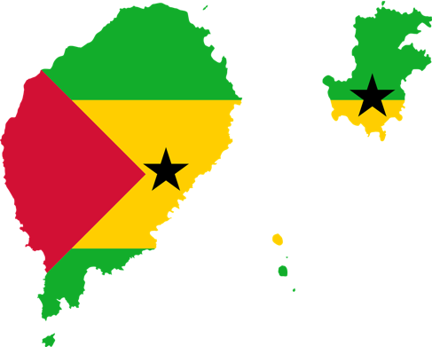
Country Factsheet: São Tomé and Príncipe

This country factsheet offers a summary of São Tomé and Príncipe’s (STP) plastic related policy frameworks and key data, drawing on findings from the AFRIPAC project and publicly accessible data sources. Detailed reports can be found on the AFRIPAC Data Hub¹.

National Overview

Demographic Details:
Area (2019) | 964 km² | UN Data²
Total population (2024) | 236,000 | UN Data²
Population density (2024) | 207 per km² | UN Data²
Urban Population (2018) | 73 % | UN Data²
Population increase (2050) | 400,000 | UN Data²
GDP (2024) | US$ 547,000,000 | UN Data²

Plastics Trade Data

HS codes are often too broad for detailed monitoring as many plastic products are not clearly identified, and trade data can be incomplete or inconsistent due to fragmented reporting. Despite these challenges, HS-based statistics still provide a reliable high-level view of plastic trade flows and use, helping to inform and support regulatory design.

Overall, trade data show STP has a product-dominated (packaging heavy), net-import market. In comparison to the region, STP’s volumes are very small with modest growth.

Data | Value | Source
General trade trends in West Africa

General import and export trends in West Africa (2005-2022) | Import volume increased by 459%  - Primary forms: ↑ 556%.  - Intermediate forms: ↑ 1,890%.  - Final manufactured goods: ↑ 1,946%.  - Plastic waste: ↑ 67% (peaked in 2014).  Exports volume increased by 265%  - Growth mainly in intermediate and final manufactured products.  - Plastic waste exports grew from 0 to 40,000 tonnes (2005-2022). | UNCTAD³
General trade trends in São Tomé and Príncipe

Imports of primary and product forms of plastic | - Imports on average 2,910 tonnes/year (2017-2021).  - Most imports are in product form (96%), with the rest consisting of primary form (4%).  - Plastic waste imports only reported in 2017 (0.3 tonnes).  - Primary forms between 2017-2021 by volume mostly: other (62%), PP (18%), synthetic rubber (14%), and polyester (1%).  - Product form between 2017-2021 by volume mostly: polyester (26%), LDPE (20%), PP (17%), HDPE (11%), PVC (11%), PET (6%), PS (5%), and synthetic rubber (4%).  - Between 2014-2018, by volume, 5% of plastic imports were in primary form, 95% were products, and 0.1% was waste.  - Between 2014-2018, by value, 4% were plastic imports in primary form, 96% were products, and 0.04% was waste.  - Import of total plastics estimated to have increased from 1,000 to 2,000 tonnes/year over the last 20 years. | UNEP-IUCN Hotspotting tool⁴
Imports of primary and product forms of plastic |  | UN Comtrade⁵
Imports of primary and product forms of plastic |  | UNCTAD³
Exports of primary and product forms of plastic | - Export volumes remained relatively stable between 2017-2021 at ~142 tonnes/year.  - Most exports were primary forms (85%), followed by plastic products (15%).  - Primary forms exported by volume between 2017-2021 mostly: LDPE (52%), PP (28%), and HDPE (20%).  - Product forms exported by volume between 2017-2021 mostly: PP (25%), LDPE (18%), polyester (17%), HDPE (14%), PET (9%), PS and PVC (8% each), and synthetic rubber (2%).  - There were no exports of plastic waste reported between 2018-2021.  - Between 2014-2018 plastics exported by volume were 99% plastic products, 0.5% plastics in primary form, and 0.1% waste.  - Export of total plastics only estimated as 0.5 over the last 20 years. | UNEP-IUCN Hotspotting tool⁴
Exports of primary and product forms of plastic |  | UN Comtrade⁵
Exports of primary and product forms of plastic |  | UNCTAD³
Imports by application (top use cases 2017-2021) | - Plastics in clothes and drinks bottles were on average the item with the highest import volume, followed by plastics in tubes, pipes, and hoses.  - The annual increase in plastic bottles showed a very large increase in 2020.  - The strongest increase in imports can be observed for plastic tubes, pipes and hoses, which increased 2.3 times between 2017-2021. | UNEP-IUCN Hotspotting tool⁴
Problematic & avoidable plastics (PAP) 2013-2022 | This section provides a brief overview of trade data on plastics that are being discussed as part of the draft Plastics Treaty negotiations, specifically a proposal submitted by Georgia, Peru, Rwanda, Switzerland, and Thailand⁶.  Highest import volumes and values:  - HS Code PVC packaging (392329): plastics; sacks and bags (including cones).  - HS Code PVC packaging (392390): Plastics; articles for the conveyance or packing of goods.  - Import values are very similar to import volumes.  - An estimated 20% of the total import volume may include plastics identified as PAPs.  Highest export volumes:  - HS Code PVC (392049): Plates, sheets, films, foil and strip not reinforced, laminated or combined with other materials.  - HS Code PVC (392390): Plastics, articles for the conveyance or packaging of goods.  - HS Code PVC (392329 ): Plastics; sacks and bags (including cones) for the conveyance or packaging of goods, of plastics other than ethylene polymers.  - By value these are ranked 392390, 392049, and 392329.  - An estimated 71% of the total export volume may include plastics identified as PAPs. | UN Comtrade⁵
Note: UNCTAD functionally categorises plastic trade (primary to final forms, including waste) offering a strategic, lifecycle-oriented view, though less precise than UN COMTRADE data and the UNEP-IUCN Hotspotting tool as it overlooks many final plastic products, including filled packaging and embedded plastics. It is important to note that both UNCTAD and UNEP-IUCN data includes synthetic textiles and rubber into plastic categories and excludes electrical products.

Waste Management and Emissions Data

The table compiles some of the most recent waste management and plastic leakage figures from reported data and models. Simplified material flow analysis (MFA) diagrams compare reported data with 2020 model estimates⁷, using key lifecycle indicators and contemporaneous trade data from the UNCTAD (experimental) database³ and the UNEP-IUCN Hotspotting tool⁴ to provide broader context.

Data | Value | Unit |  | Source
Waste management data
Per capita municipal solid waste (MSW) generation (2014) | 0.4 | kg/person/day | Dias (2014)⁸
Total MSW generation (2014) | 25,587 | tonnes/year
Total MSW generation (2015) urban only | 24,249 | tonnes/year | General Directorate of the Environment (2018)⁹
Per capita plastic waste generation (2010) | 0.1 | kg/person/day | Jambeck et al. (2015)¹⁰
Total municipal plastic waste generation (no date) | 6,114 | tonnes/year | World Bank (2023)¹¹
Plastic composition of waste (2016) [SDG Indicator 11.6.1] | 3.6 | %
MSW collection coverage (no date) | 19 | %
MSW collection coverage in urban areas (2015) | 60 | % | General Directorate of the Environment (2018)⁹
Emissions data
Beach litter (2016) [SDG 14.1.1b] | 53,107 | items per km² | Global Plastics Hub¹²

Simple Material Flow Analysis combining trade data with a) data based on sources between 2014-2021 and b) modelled data for 2020

a)
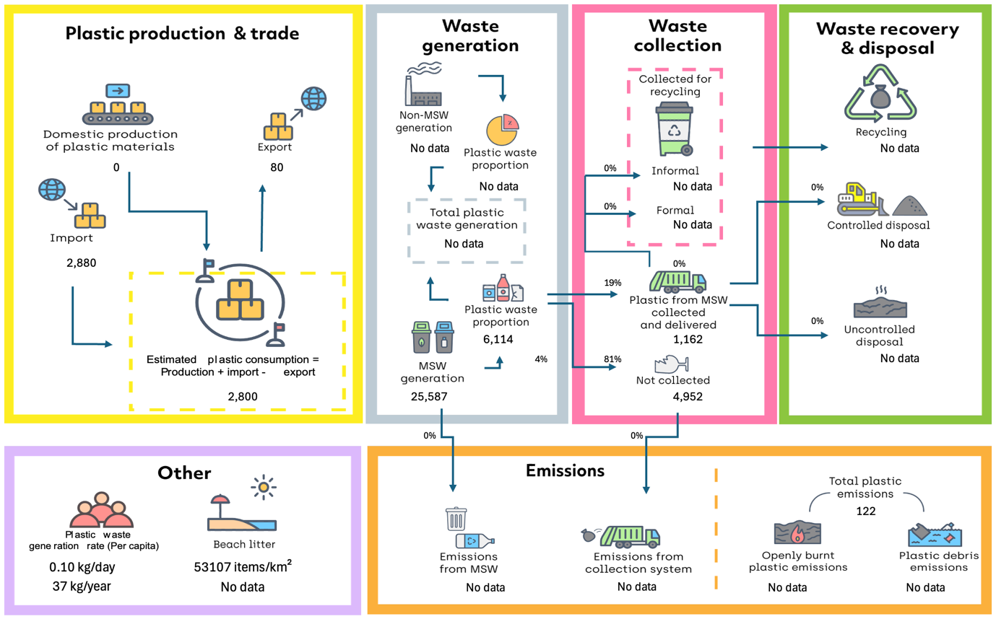

b)
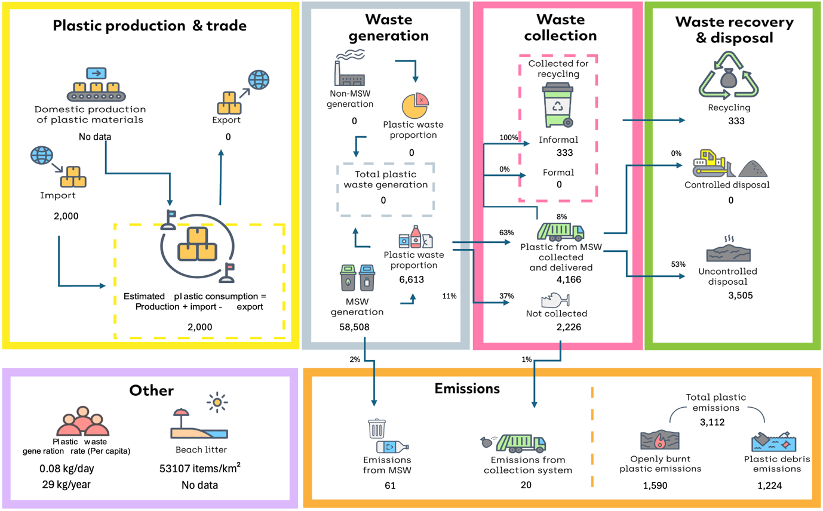
Values are in metric tonnes per year unless stated otherwise. Modelled data excludes e-waste, textiles, and rubber.

Relevant Governance, Policy and Legislation

Theme | Policy and Legislation
National coordination bodies | The Constitution of the Republic of São Tomé and Príncipe (CRSTP) (Law No. 1/2003¹³; Decree-Law No. 02/2025¹⁴)  - The Ministry of Environment, Youth, and Sustainable Tourism  - The Directorate-General for the Environment and Climate Action (DGA)  Basic Environmental Law (Law No. 10/1999)¹⁵  - The National Environment Commission  - The Technical Environmental Commission  Plastic Bag Regulation (Law No. 8/2020)¹⁶  - Local Authorities (Districts)  - General Customs Authority (AGA)  - Directorate for the Regulation and Control of Economic Activities  Basic Law on Maritime Safety and Prevention of Pollution at Sea (Law No. 13/2007¹⁷; Decree-Law No. 32/2007¹⁸)  - Maritime and Port Institute São Tomé and Príncipe (IMAP-SP)  - Ministry of Infrastructure, Natural Resources and the Environment (MIRN)  - Directorate-General for Natural Resources and Energy (DGRNE)  - Series of sectors and Ministries for e.g. Agriculture, Health, Education, Tourism, Industry, and Commerce.  - Chemical Products Management Committee (CNGPQ)
Plastic production and trade | Plastic Bag Regulation (Law No. 8/2020)¹⁶  - Aims to ban production, import, marketing and distribution of non-biodegradable plastic bags.  - Increases customs duty on imports and penalises illegal production, with various fines and/or the closure of the establishment.  - Encourages import and production of alternative products, although unclear if these include polymer-based plastics.  - Excludes plastic films for packaging fish, meat, chicken or their fresh products, fruit, vegetables, and ice.  - Plastic bags used in sectors such as health, industry, and construction are not referred to.  - Provides for awareness-raising actions for alternative solutions and to reduce the use of plastic bags.  Plastic Bag Regulation (Law No. 8/2020¹⁶; Decree-Law No. 09/2024¹⁹)  - Gives the AGA power to interdict and collaborate in banning imports, among other measures that can be adopted to combat plastic pollution under the terms of Law No. 8/2020.  - Assigned the AGA the mission of participating in the process of drawing up the legal texts necessary for the exercise of its powers, to supervise and exercise fiscal control of the area under customs jurisdiction, to carry out searches in sales establishments, warehouses, dwellings, vessels or any other premises when there are well-founded grounds for suspecting a customs offence, as well as to "seize illicit goods, narcotics, weapons, instruments, merchandise, means of transport, documents and any other goods that have been used to commit a customs offence or that are the subject of a tax offence”.  - The AGA can participate in other collegiate bodies or multi-institutional organisations responsible for coordinating and monitoring national policies that are of interest or have an impact on its duties.  Environmental Impact Fee (TIA) (Decree-Law No. 64/2013)²⁰  - Establishes the TIA with the aim of introducing the “principle of the extended responsibility (EPR) of the producer of goods for the production of waste" into the legal system.  - All economic agents importing packaging, products and articles, as set out in the list annexed to the law, are obliged to pay the TIA, depending on the impact of the product introduced onto the market, the proceeds of which are earmarked for financing the management of solid waste.  - The TIA has never been effectively collected due to the challenges encountered in its implementation and the lack of records on its applicability by the AGA.
Plastic waste management | Plastic Bag Regulation (Law No. 8/2020)¹⁶  - Encourages local authorities to implement the selective collection of plastic material and waste.  - Ban on recycling conventional plastic bags due to inadequate recycling practises.  Waste Regime (Decree No. 36/99)²¹  - Defines competences in waste management.  - Selective collection of plastic and waste materials.  - Tax benefits for companies that invest in the recovery and recycling of waste.  - Regulation on the disposal of waste in landfills.  - Prohibition of dumping at sea.  - Provision of sanctions for illegal dumping.  Comprehensive Waste Management Plan (2024)²²  - Aims to minimise the production of municipal solid waste (MSW), improve the management and handling of MSW, reduce MSW disposal in landfills and dumps, reduce the risk of dangerous exposure to human health and the environment, improve compliance with regulations, improve capacities, contribute to the transparency of the sector’s authorities, and build partnerships.  - There are a number of funding and technical assistance organisations that support these efforts, mostly external.  National Health Service Waste Management Plan²³  - The competent national authorities have opted to apply a policy of incinerating hazardous waste, as well as non-recyclable and non-biodegradable MSW, in compliance with the Stockholm Convention.  - An incinerator was purchased with a gas treatment device (in accordance with European Directive 2000/76/EC). These devices are expensive and limited to large-scale incinerators, it will therefore be necessary to maximise its use in order to justify its investment and operating costs.
Non-plastic specific policies | Basic Environmental Law (Law No. 10/1999)¹⁵  - Establishes principles and duties for environmental protection and sustainable use of resources.  - Lays foundations for combatting plastic pollution such as, the precautionary principle, the principle of respect for the carrying capacity of ecosystems, the principle of appropriate management and reuse of natural resources, the principle of participation, the principle of access to information, the principle of responsibility, the principle of recovery, the user-pays principle, the polluter-pays principle, and the principle of international cooperation.  - Makes the emission, transport and final destination of waste and effluents subject to prior authorisation, duly covered by a transport document stating its origin and destination.  - Requires waste or effluents to be collected, stored, transported, disposed of or reused in such a way that they do not constitute an immediate or potential danger to human health or harm the environment.  - Makes the discharge of waste and effluents at specific locations subject to prior authorisation.  - Prohibits the disposal of radioactive, hazardous, or harmful substances and substances containing micro-organisms into the environment that could damage or degrade its components.  - Currently a proposal for an eco-tax in the 2025 State Budget.  Environmental Impact Assessment Process (Decree-Law No. 37/99)²⁴  - Applies to all activities that, due to their nature, size or location, are likely to have a significant impact on the environment.  - Can directly or indirectly deal with pollution and waste management.  Basic Law on Maritime Safety and Prevention of Pollution at Sea (Law No. 13/2007¹⁷; Decree-Law No. 32/2007)¹⁸  - Relates to the safety of vessels and the people onboard, as well as the prevention of pollution from ships and environmental protection.  - IMAP-SP authorises the entry and exit of ships and can monitor their cargo manifest.  - IMAP-SP is responsible for implementing some of the international conventions in the field of maritime safety and preventing pollution from ships, and can prepare regulations for related activities.  - IMAP-SP is tasked to clean up the entire seafront, including pollution from land and sea.  The Constitution of the Republic of São Tomé and Príncipe (CRSTP) (Law No. 1/2003)¹³  - States that "everyone has the right to housing and to a human environment, and the duty to defend it".  - A primary objective is to “harmonise the balance of nature and the environment".  - Enables for the creation of legislative, political and administrative measures aimed at preventing and combating plastic pollution, including in the marine environment.
Regional conventions | Bamako Convention on the Ban of the Import into Africa and the Control of Transboundary Movement and Management of Hazardous Wastes within Africa²⁵  - Prohibits the import of hazardous waste into Africa and promotes sound management of hazardous waste within African countries.  - STP has signed but not ratified the Convention.  Abidjan Convention for Cooperation in the Protection and Development of the Maritime Environment and the Coastal Zone of the West African Region²⁶  - Part of a network of Regional Seas Conventions and Action Plans, aiming to prevent, reduce, and combat pollution in the marine environment and inland waters, while ensuring the environmentally sound management of natural resources using the most appropriate means available within a State’s capabilities.  - Established obligations to prevent, reduce, and combat pollution from ships, aircraft, land-based sources, airborne sources, and activities related to exploitation of the seabed.  - STP has not signed the Convention.  Libreville Declaration on Health and Environment in Africa (2008)²⁷  - Signed by STP in 2008, the declaration commits governments to address public health challenges linked to environmental factors through intersectoral collaboration, capacity building, surveillance, and policy integration.  Ouagadougou Declaration on Primary Health Care and Health Systems in Africa (2008)²⁸  - Signed by STP in 2008, the declaration calls for an integrated, multisectoral approach to health, recognizing that social, economic, environmental, and governance factors are deeply linked to health outcomes.  - Highlights climate change and environmental sustainability as key health determinants, reinforcing the need to link environmental action (e.g., plastic pollution control) with health strategies.
International conventions | The Rio Declaration on Environment and Development (1992)²⁹  - While not a treaty requiring ratification, over 175 countries (including São Tomé and Príncipe) have signed this declaration, which outlines 27 principles that have subsequently been incorporated into international agreements and national laws. Key principles include:  - Human centred development, promoting sustainable production and consumption, with integration of environmental protection into development policies;  - States have the right to exploit their resources, but also the responsibility to prevent damage to the environment, including beyond their national jurisdiction;  - The precautionary and polluter pays principles, and the need for environmental impact assessments;  - States should cooperate to protect ecosystems and biodiversity, with environmental standards harmonised internationally;  - Recognises various national capacities in addressing environmental damage;  - Citizens and the use of traditional knowledge should be involved in environmental decision making;  - Development should meet the needs of both present and future generations;  - International and national laws should be further developed to address environmental damage and liability.  Basel Convention on Transboundary Waste³⁰  - Ratified by STP in 2013, the Convention controls transboundary movements of hazardous wastes and their disposal. It also covers ‘other wastes’ requiring special attention including household waste, incinerator ash, and plastic waste.  - An amendment in 1995, which entered into force in 2019, formally prohibits the export of hazardous waste for final disposal and recycling from Annex VII countries (European Union, OECD, and Liechtenstein) to developing countries, which has not been ratified by São Tomé and Príncipe.  - In 1999 an Additional Protocol established a comprehensive regime of liability, adequate and prompt compensation for damage resulting from transboundary movement and disposal of hazardous wastes and other wastes, including illicit traffic in such wastes.  - In 2021 amendments on plastic waste became effective for all Parties that had not submitted a notification of non-acceptance:  - Annex II (Y48) – Plastic waste requiring special consideration: This includes mixed, contaminated, or difficult-to-recycle plastics.  - Annex VIII (A3210) – Hazardous plastic waste: Plastics that are hazardous due to contamination with chemicals or other toxic components.  - Annex IX (B3011) – Non-hazardous plastic waste that can be traded more freely: This includes clean, sorted, and recyclable plastic waste intended for environmentally sound recycling.  - Plastic wastes that fall under Annex II or VIII now require Prior Informed Consent (PIC) procedure expansion.  - In 2022, new technical directives and guidelines on the environmentally sound management of waste, including plastic waste, were adopted.  - No information is available on how STP has implemented the Convention’s obligations.  Rotterdam Convention on Hazardous Chemicals³¹  - Ratified by STP in 2013, it promotes shared responsibilities in relation to the trade of hazardous chemicals and pesticides through a PIC procedure.  - No information is available on how STP has implemented the Convention’s obligations.  Stockholm Convention on Persistent Organic Pollutants (POPs)³²  - Ratified by STP in 2006, aiming to eliminate or restrict the production and use of POPs.  - The Convention lists a number of plastic additives to eliminate.  - STP drew up and adopted its National Implementation Plan in 2010, with specific objectives:  - Improve knowledge about POPs so as to be able to eliminate/reduce their local sources and quantities of waste;  - Adapt national legislation specifically targeting POPs and enforce it;  - Strengthen the capacities of key partners in the ecologically rational management of POPs and coordinate their activities;  - Ensure the exchange of information on implementation measures and participate in international co-operation in the fight against POPs.  Minamata Convention on Mercury³³  - Protects human health and the environment from emissions and releases of mercury and mercury compounds, aiming to ban the use and reduce emissions.  - Ratified by STP in 2018.  United Nations Convention on the Law of the Sea (UNCLOS)³⁴  - Ratified by STP in 1987, it establishes a comprehensive legal framework governing all activities on oceans and seas, including marine environmental protection. resource management, and measures to prevent, reduce, and control marine pollution.  International Convention for the Prevention of Pollution from Ships (MARPOL) (1973)  - STP ratified MARPOL Annex V in 2002, which strictly prohibits the discharge of plastics into the sea and mandates responsible shipboard waste management, including storage, segregation, and disposal at designated port reception facilities.  - The International Maritime Organisation (IMO) have established a general Action Plan to address marine litter from ships.  Agreement on Biodiversity Beyond National Jurisdiction (BBNJ) (2023)  - The Agreement on Biodiversity Beyond National Jurisdiction (BBNJ) ensures the conservation and sustainable use of marine biodiversity in areas beyond national jurisdiction, covering marine genetic resources, area-based management tools, environmental impact assessments, and capacity building. The BBNJ was signed by STP in 2024 but has not yet ratified.  The London Convention (1972)³⁵ and London Protocol (1996)³⁶  - Prohibits the incineration and dumping of certain types of wastes and substances contained in the list set out.  - Not ratified by STP.  International Convention for the Safety of Life at Sea (SOLAS)³⁷  - Ensures maritime safety but indirectly supports marine environmental protection by requiring safe waste handling practices aboard ships, including plastics.  - Ratified by STP in 1998.  Convention on Biological Diversity (CBD)³⁸  - Ratified by STP in 1999, the Convention promotes the conservation of biological diversity, sustainable use of its components, and fair and equitable sharing of benefits.  - Target 7 of the Kunming-Montreal Global Biodiversity Framework (2021) emphasises the importance of reducing pollution, with a specific focus on plastic pollution.  - STP adopted an Implementation Plan in 2004, establishing the main priority actions for the conservation and management of biodiversity, through an "enabling activity grant" that began in 2000. Its development has filled several gaps identified in the issue of conservation and sustainable utilisation of natural resources and biodiversity.  - The Implementation Plan establishes the following goals:  - An analysis of the country's different ecosystems, covering the main species that make them up and the situation experienced by each;  - A description of the national strategy, detailing the goals that have been agreed to solve the problems identified;  - Annexes with proposals for programmes and action plans and lists of the species that make up national biodiversity.  - STP also ratified the Nagoya Protocol on Access and Benefit-sharing in 2017, but is not a party to the Cartagena Protocol on Biosafety or the Nagoya-Kuala Lumpur Supplementary Protocol on Liability and Redress.  The Sustainable Development Goals (SDGs)³⁹  - All United Nations Member States adopted the 17 SDGs as part of the 2030 Agenda for Sustainable Development in 2015.  - Aiming to transform societies and economies to become more sustainable, balancing economic growth, social development, and environmental protection.  - Includes suggested indicators for monitoring each goal.  - Emphasizes the importance of reaching the most vulnerable and marginalised populations.  - Requires partnerships and collaborations between governments, the private sector, civil society and individuals.  - The most relevant goals for plastic policies include SDG 1: No poverty, SDG 3: Good health and well-being, SGD 6: Clean water and sanitation, SDG 8: Decent work and economic growth, SDG 11: Sustainable cities and communities, SDG 12: Responsible consumption and production, SDG 13: Climate action, SDG 14: Life below water, SDG 15~: Life on land, and SDG 17: Partnerships for the goals.  Paris Agreement under the United Nations Framework Convention on Climate Change (UNFCCC)⁴⁰  - Ratified by STP in 2016, the Convention aims to limit global warming to below 1.5°C through nationally determined contributions (NDCs) and global efforts to reduce greenhouse gas emissions.  - The Paris Agreement makes no reference to fossil fuels or their petrochemical derivatives. Even if fully implemented, State’s NDCs remain inadequate to limit warming to 1.5°C.  - STP has adopted a national NDC plan, updated in 2021.  - STP's updated NDC is significantly more ambitious than the 2015 version, nearly doubling its GHG reduction target from 57 to 109 ktCO₂eq (~27% total reduction by 2030 with an estimated cost of US$ 150 million), expanding mitigation, adaptation, and cross-cutting measures from a total of 18 to 29, aiming to boost renewable energy capacity from 26 MW to 47 MW along with improved energy efficiency.  - The number of sectors covered has increased and now covers energy, transport, civil protection, fisheries, agriculture, livestock, forestry, water and waste.  - A mitigation component is planned to increase the share of renewable energy in its energy production matrix, reduce network losses and improve energy efficiency, and reduce the carbon intensity of mobility.  World Trade Organization Policies and Practices⁴¹  - Establishes global trade rules, including agreements that affect goods and services, and addresses trade-related aspects of environmental measures, promoting sustainable development.  - STP established a Working Party in 2005 but has not yet met.

Key Gaps and Recommendations

Category | Identified Gaps | Recommendations
Legislative and regulatory framework | - No comprehensive legal regime covering the full life cycle of plastic products.  - Lack of plastic and alternative product definitions.  - Unclear supervisory authority powers.  - Conflicting provisions on import bans and tax increases.  - Lack of provision for the final destination of prohibited or apprehended goods and the responsibility of the importer/breacher. | - Establish a comprehensive legal framework addressing the full plastic lifecycle.  - Create and maintain an updated register of permissive administrative acts issued.  - Define types of avoidable, problematic, permitted and non-permitted plastics and alternative products that can be updated.  - Provide a process for apprehended goods.  - Provide for types of plastic that are outside the scope of application e.g. for sanitary and industrial use.  - Grant explicit enforcement powers.  - Consider outright bans on harmful imports.
Institutional framework and intersectoral coordination | - Lack of structured collaboration between agencies on plastic import, trade, and inspection.  - Unclear institutional responsibilities. | - Establish clear roles and coordination mechanisms among regulatory bodies.  - Support exchange of information between trade members and key sectors.  - Create designated focal points and require prior opinion.
Implementation tools | - Lack of clarity and applicability of laws.  - Limited mechanisms for public access to information and participation in decision-making and compliance.  - Uncertainty around recycling ban considering innovative recycling methods. | - Implement penalties for offenders.  - Ensure public access to regulatory information and enable public consultation.  - Support innovation in plastic treatment and recycling methods e.g. construction of paving blocks or tiles using plastic waste.
Financing and economic incentives | - Absence of clear financial instruments or incentives to support a circular economy and plastic waste reduction. | - Further develop financial levers such as extended producer/importer responsibility, plastic taxes, TIA, and support for circular economy solutions.
Human and technical capacities | - Weak institutional capacity in terms of technical skills, material resources, and financial support for effective implementation.  - Lack of alternatives to plastic. | - Invest in training, infrastructure, and financial support to strengthen institutional capacity for regulation and enforcement.  - Support technology transfer for waste management, recycling, and viable alternatives to plastic.

