3/13/2017

Typing Spelling Educational Game (app)

Psuedocoders

Project Proposal

COMP315 C++ game programming

Introduction

Skills is one of the required self-developed neglected equipment. As we are living in the modern information age were everything is occupied by the technology, it is an honour to form a team which develop a game which will encourage student to learn interactively, interestingly while simultaneously improving their typing and spelling skills. We live in the days dominated by social media were everything is being simplified and shortened to the atomic no sense text and negative impact our society when it comes to formal presentation.

That is why we are developing this game which train and improve typing skills, comprehensive, spelling skills also easy pronunciation of the word(sound) in every different subject in the scope of the current curriculum.

Literature Review

All the games which we are going to mention below are well designed, and solves the problems of spelling and improving typing. They are also somehow educational and have the levels of difficulty which increase the more you play the game.

These games found here https:\\lay.google.com\store\apps\

* Typing Lessons
* Learn to Type / Learn English Word For Kids
* Ultimate English Spelling Quiz
* Mavis Beacon
* Etc.

However, judging from the one which we are going to create, they do not focus on the current curriculum(CAPS) or specific grade which is grade 4 to grade 7. They also do not support concurrent multiplayer where students can test themselves how well are they improving. Our solution will be improving, relating to students current curriculum. This will be achieved by allowing the teacher to preload new words for spelling,

The biggest difference is the fact that although such games exist, none is which is created using c++ and openGL.

Objectives

1. Improving typing skills
2. Improving spelling skills
3. Improving memory skills and Listening skills (hear and see)
4. To enhance collaboration and conquering competitive skills
5. Comprehensive and
6. Mathematic**

Methodology

Typing skills - user will be required to type a word displayed on the screen as a picture format and pronounced by an audio.

Spelling skill - to get the maximum points, the user will be required to spell the word correctly as they give it in the spelling input.

Memory skills – it is difficult to forget what you seeing / saw before, hence picture triggers the memory to remember the spelling of the word.

Listening skill – the user interface will come with the feature of an audio icon/ button to retrieve an audio as many times as you can, hence even the blind person can play this game.

Collaboration skill - besides challenging each other, but there will be a time were players required to reach a certain level both in combination.

Mathematics – there will be a part were mathematic questions will pop up and it will require a player to provide an answer in a give time.

UML Class Diagram

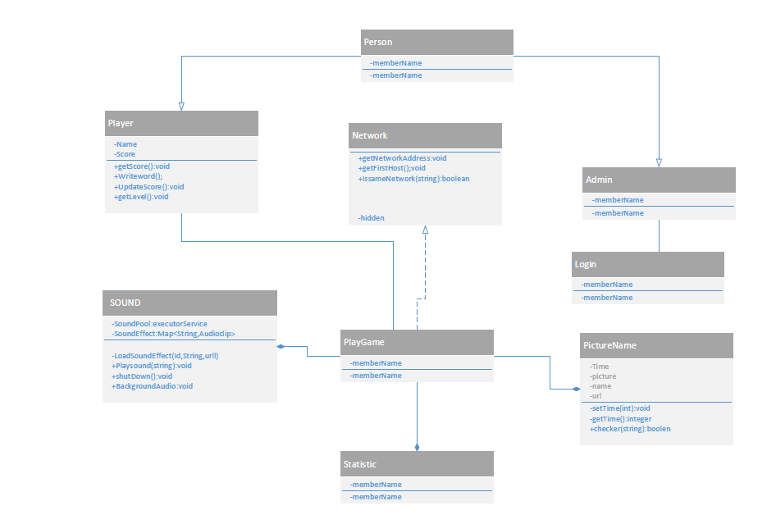

Conclusion

In summary, we believe that our development will indeed improve the educational system of our country. By offering learners with fun iterative game but still improving their basic skills that will sharpen them for the real world.

References

<https://www.microsoft.com/en-za/download/details.aspx?id=10121> // sound

<http://doc.qt.io/qt-5/qtnetwork-module.html> //Network

[http://www.macmillan.co.za/catalogue/resources/dictionaries/274 //](http://www.macmillan.co.za/catalogue/resources/dictionaries/274%20//) words

<https://www.google.co.za/search?q=pictures+grade+4+dictionary+words&espv=2&source=lnms&tbm=isch&sa=X&sqi=2&ved=0ahUKEwjD_dOuttPSAhXJLcAKHU1DDMUQ_AUIBigB&biw=994&bih=622> //dictionary words

<http://www.englishforeveryone.org/Topics/Word-Definition.htm> /words

<http://www.mavisbeaconfree.com/> // mavis beacon

<https://play.google.com/store/search?q=typing%20skills%20games&c=apps&hl=en> // games

Group Members

Senzosenkosi Shezi 215024323

Mfundo Sithole 215037601

Nothando Mkhwanazi 214516138

Nkosenhle Duma 215023375

Wendy Sibiya 214582055

Luyanda Mgabhi 215030119

Lindani Mabaso 215016957 (Group Leader)