5/15/2017

Group 10

DYNAMIC SYSTEMS PRACTITIONERS

UKZN OPTOMETRY EYE-CARE CLINIC INFORMATION MANAGEMENT SYSTEM

UKZN Westville Campus Block E

Tel: 031 260 7294

Administrator (Ms Priscilla)

Group Members

1. 213530876- Zanele Nkosi
2. 214516138- Nothando Mkhwanazi
3. 214523369- Candice Gumede
4. 215016957- Lindani Mabaso
5. 215024323- Senzosenkosi Shezi
6. 215079932- Njabulo Hlophe

Table of Contents

CLIENT BACKGROUND 2

CURRENT SYSTEM OVERVIEW & PROBLEM IDENTIFICATION 2

DATA FLOW DIAGRAM 3

MAJOR SYSTEM’S REQUIREMENTS 4

ENTITY RELATIONSHIP DIAGRAM 5

BENEFITS OF THE SYSTEM 6

USER STORY APPLICATION SUMMARY 6

# CLIENT BACKGROUND

* University of KwaZulu Natal Discipline of Optometry
* Westville Block E5
* Offers Comprehensive Vision Assessment to the Community and internal stuff and students
* Administrator: Priscillar Sewamber
* Telephone Number: 031 260 7294

# CURRENT SYSTEM OVERVIEW & PROBLEM IDENTIFICATION

* The Eye-Care clinic uses a manual system to record appointment bookings, registering patients and keeping records for patients.
* Manual patient data management is labour demanding and time consuming.
* There is limited space to update patient information using manual record card.
* Patent files may be lost due to natural hazards.
* Using manual filling system exposes patient data to high security issues.

# DATA FLOW DIAGRAM

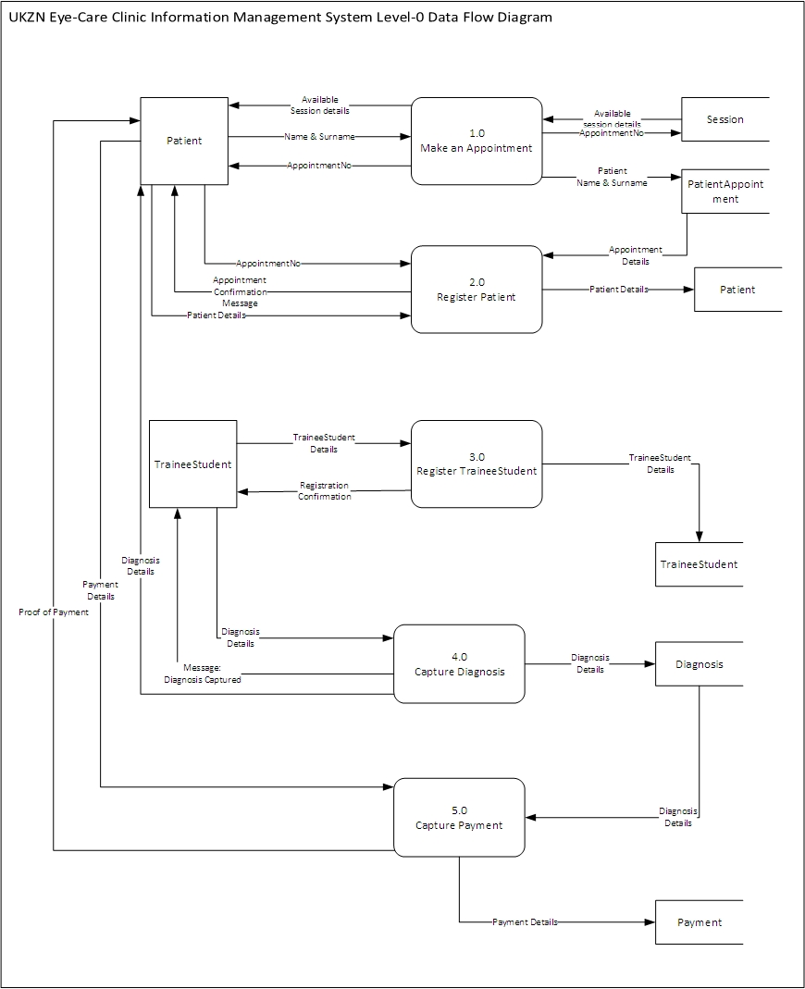

# MAJOR SYSTEM’S REQUIREMENTS

The UKZN Eye-Care Clinic Information is required to do the following:

* Make appointment Booking
* Register patient
* Register Trainee Student
* Capture Diagnosis Details
* Capture Payment

# ENTITY RELATIONSHIP DIAGRAM

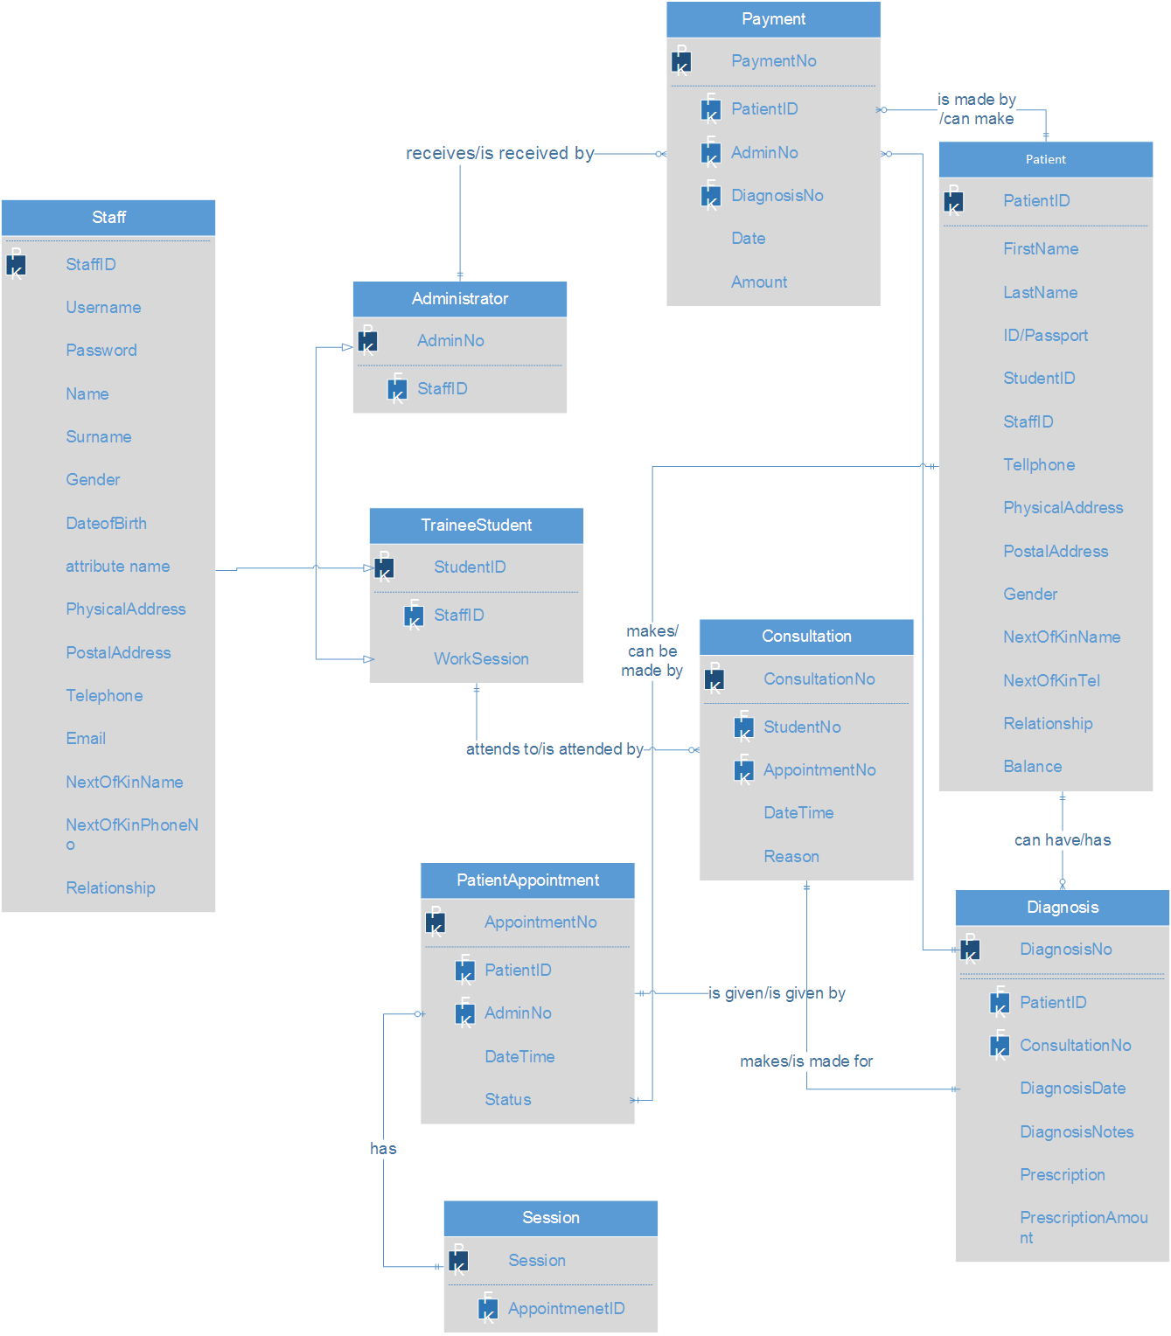

# BENEFITS OF THE SYSTEM

* Improve patient data security
* Change manual patient record filling to an information system
* Advance patient record keeping
* Improve decision making
* Improve patient statistics capturing
* Advance patient booking system

# PROJECT HIGHLIGHTS AND ACHIEVEMENTS

* Team work: Communication, listening and understanding brings about a successful project.
* Achieving our main system goal is to eliminate manual systems.
* Priscillar the administrator is impressed about the whole system.
* Combining everything we learnt from ISTN211 , ISTN212 with our third year ISTN modules in order to achieve a working system.
* All members learnt the basics of coding.
* Project was developed and carried out in a truly collaborative manner.

# PROJECT LOWLIGHTS AND LESSONS LEARNT

* Lack of time management
* Project scope was too big which forced us to review our actual plan and design
* Lack of proper planning

# USER STORY APPLICATION SUMMARY

|  |  |  |  |  |  |  |  |
| --- | --- | --- | --- | --- | --- | --- | --- |
| * **User story number** | **User story title** | **User Role** | **User story description** | **User story start date** | **User story end ate** | **User story status** | **User story priority** |
| 11 | Check available Appointment Session | Administrator | As an administrator, I want to search for available appointment session | 2017-03-28 | 2017-04-03 | Complete | High |
| 12 | Add New Appointment | Administrator | As an administrator I want to add a new appointment so that a patient can be allocated an appointment session | 2017-03-28 | 2017-04-05 | Complete | Medium |
| 13 | Read Appointment details | Administrator | As an administrator I want to read up appointment details so that an appointment can be verified | 2017-03-28 | 2017-04-07 | Complete | Medium |
| 15 | Register a new patient | Administrator | As an administrator I want to add new patient details so that a patient can be registered | 2017-03-28 | 2017-04-07 | Complete | Medium |
| 16 | Create diagnosis | Trainee Student | As a trainee student I want to add diagnosis details for a patient so that a diagnosis can be created | 2017-03-28 | 2017-04-15 | Complete | High |
| 17 | Read Diagnosis details | Administrator | As an administrator, I want to read the diagnosis details so that prescription details can be generated | 2017-03-28 | 2017-04-15 | Complete | Medium |
| 18 | Capture Payment | Administrator | As an administrator | 2017-03-28 | 2017-04-20 | In-progress | High |
| 19 | Generate Payments Report | Administrator | As an administrator, I want to generate payments reports so that payment details can be viewed for decision making | 2017-03-28 | 2017-04-25 | In-progress | High |
| 20 | Register Trainee Student | Administrator | As an administrator, I want to register a trainee student so that they can have access to the system. | 2017-03-28 | 2017-04-27 | Complete | High |

|  |  |  |  |
| --- | --- | --- | --- |
| **User Story Number** | **User Story Title** | **Group Member 1** | **Completed (Y/N)** |
| 11 | Check available Appointment Session | |  | | --- | | 1 | | Y |
| 12 | Add New Appointment | 1 | Y |
| 13 | Read Appointment details | 3 | Y |
| 15 | Register a new patient | 5 | Y |
| 16 | Create diagnosis | 6 | Y |
| 17 | Read Diagnosis details | 6 | y |
| 18 | Capture Payment | 7 | N |
| 19 | Generate Payments Report | 7 | N |
| 20 | Register Trainee Student | 8 | Y |