AUTOMATED CATTLE WEIGHING SYSTEM

Objectives
1. Uniquely identify each cow, through cow tags
2. Automatically weigh the cow, and record the weight
3. Collect recorded weights and upload to an online server with a database. Each weight is tagged with the corresponding cow unique tag as well as the date that day.
4. Have a web application for the owner to browse uploaded data.
5. The web application should have export functionality, for the owner to export recorded data as an Excel/Spreadsheet or PDF.
6. (Optional) Web application should analyze and plot recorded data, for simpler data analyses, so that the owner can see area to improve.

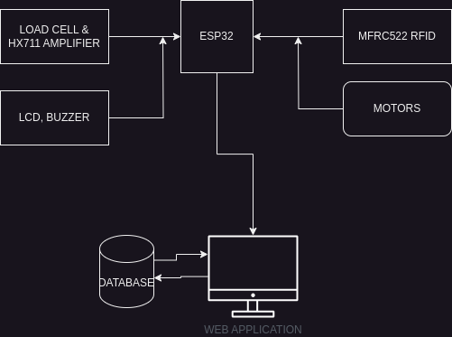

Suggested Components
1. ESP-32 Dev Board (should have WiFi capabilities)
2. MFRC522 RFID (for uniquely identifying each cow)
3. Load Cell and HX711 Amplifier (for weighing)
3.1 LCD for display, Buzzer for alert sounds
4. Motors to drive control gates when confining the cow for measurements
5. Remote Server with MySQL Database and Excel/PDF processing capabilities
6. Web Application UI to access, analyze, plot and browse the recorded data

Scenario
The farmer will register each cow RFID tag in the system remote database, unknown tags will be rejected. Each cow will have data like, sex, color, breed etc (having this data will be useful for analysis, etc. farmer can determine which breed is performing best...).
A cow enters the weighting system and is confined by two gates in-front and behind. Below is the load cell sensor. In-front of the cow, there is an RFID tag reader. The reader will detect the RFID tag of the cow from its ear, display the ID on an LCD, then verify if the cow is a valid tag and is available in the system. If the tag is valid and in the database, the weight is record and is sent to the remote server, the server saves the weight, date and RFID ID.
Once the server acknowledges that the data was saved successfully, the front motor opens, the cow gets out and the process repeats.

System Strict Limitation:
- no two cows can share the same RFID ID (should be unique)
- only weigh cows with valid tag, if the RFID is not in the system cow will not be weighed
- only one weight per day, if a multiple measurements are made, the system will overwrite the old data
- ADD MORE HERE

Pricing
- I’ll charge you 900 for esp32, connections, circuit and Arduino code
- The server and web application is way too much work, you could use ThinkSpeak (but I doubt you’ll get the excel processing and data validation). I can design a web application, database, excel integration and deploy to an online server, but it will be too much work, so I’ll charge 1200
- discount, final price you can pay is 1,400 and send a deposit as soon as you can

References
1. https://randomnerdtutorials.com/esp32-load-cell-hx711/
2. https://randomnerdtutorials.com/security-access-using-mfrc522-rfid-reader-with-arduino/

