Gruppmedlemmar
William Lindholm (a22willi)
Lili Tran (a21liltr)
Victor Adamson (a20vicad)
DSA rapport
IT405G – Datastrukturer och Algoritmer

Problem 1 - Sorting

Task 1.1 - Pseudo code
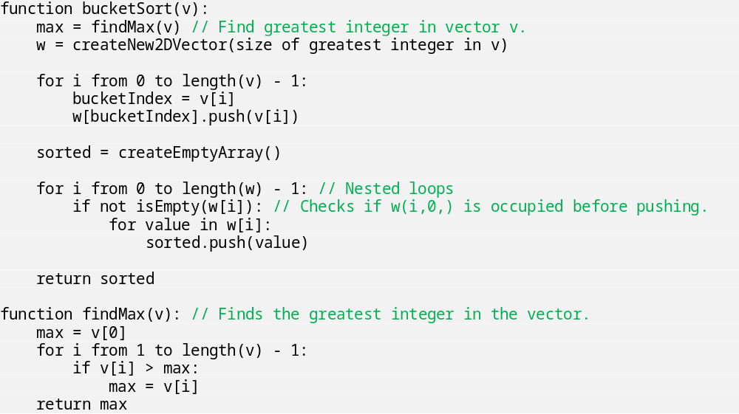

Task 1.2 - Time Complexity
T(n) = O(n²) This is because in the function bucketSort() we have nested loops, both of which will iterate n-times (n x n = n²). The complexity of n² will ‘overrule’ any tasks with the complexity of n or any constant.
Best-case scenario:
Worst case scenario: The worst-case scenario is if n w
Dominant factor:

Task 1.3 - Disadvantages
One of the problems with this implementation has to do with size, specifically the size of the number that is the greatest in the unsorted vector. If one of the elements in the unsorted vector v is an enormous number, then the size of vector w will also be gigantic and could consist of many empty spaces, as the size of vector w is dependent on the greatest number of the unsorted vector v.
Another problem is that since the size of the vector is determined based on the greatest integer in the vector, and the values of the vector are pushed into its corresponding index; it can only handle vectors which are built up of natural numbers. Thus, it can neither handle negative numbers since the vectors index starts at 0, nor can it handle decimals numbers. These issues can be solved, for handling negative numbers, the vector could be set to the size of the number furthest from 0, and then doubled, and then set to start at the vectors size divided by 2.

Task 1.4 - Insertion sort
The time complexity for insertion sort in the worst-case scenario is T(n) = O(n²). The loop that iterates through the vector, will run n-times. The inner loop that compares the current value to the “already sorted” part of the vector will also run through every position in the vector (n-times). I.e. O(n²).

Problem 2 – Social Network

Description of Algorithm
The graph is represented through a directed adjacency matrix. The graph traverses the shortest path using a breadth-first search starting at a source and finishing at a destination. When the shortest path is known, it is determined by the two provided rules whether or not the two are adversaries or friends. The rules are as follows: “An adversary of my adversary is my friend”, and “An adversary of my friend is my adversary”.

Pseudo Code
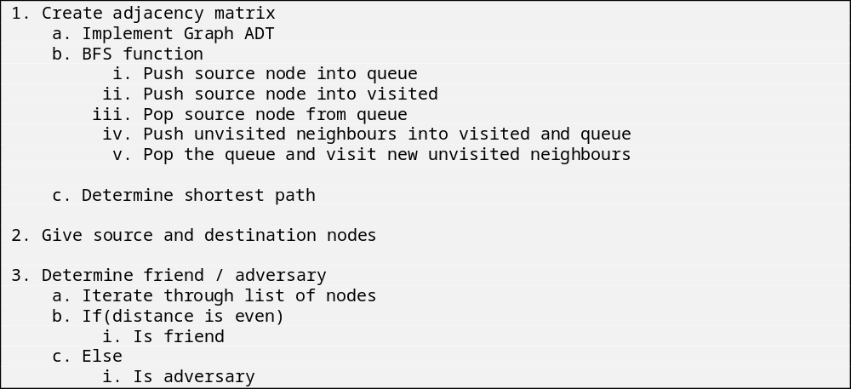
- Create adjacency matrix
  - Implement Graph ADT
  - BFS function
    - Push source node into queue
    - Push source node into visited
    - Pop source node from queue
    - Push unvisited neighbours into visited and queue
    - Pop the queue and visit new unvisited neighbours
  - Determine shortest path

- Give source and destination nodes
- Determine friend/adversary
  - Iterate through list of nodes
  - If (distance is even)
    - Is friend
  - Else
    - Is adversary

Time Complexity

C++ Code

Problem 3 – Huffman Coding

Description of algorithm
The goal of Huffman encoding is to reduce the space complexity of data, in this case text. To achieve this an algorithm is used to reduce the number of bits required to represent each character. Normally, in ASCII, each character is represented by one byte (8 bits). Through Huffman coding, this can be decreased depending on the number of characters in the string that needs to be encoded.
To achieve this the algorithm first creates several tree nodes, without any parents or children, each one containing a character, and its frequency; referred to as its weight. This weight is equivalent to the number of times this character is used in the text that is to be encoded. Thereafter all nodes are placed in a priority queue, where each nodes weight is used to determine its priority, the lowest frequency gets the highest priority. Then a recursive function grabs the two nodes with the highest priority and creates a parent node for them. This node does not contain a character but does hold the combined weight of its child nodes. This algorithm runs until there is only one root node, which means a binary tree has been built which contains the paths, ergo the codes each letter has received.

Pseudo code
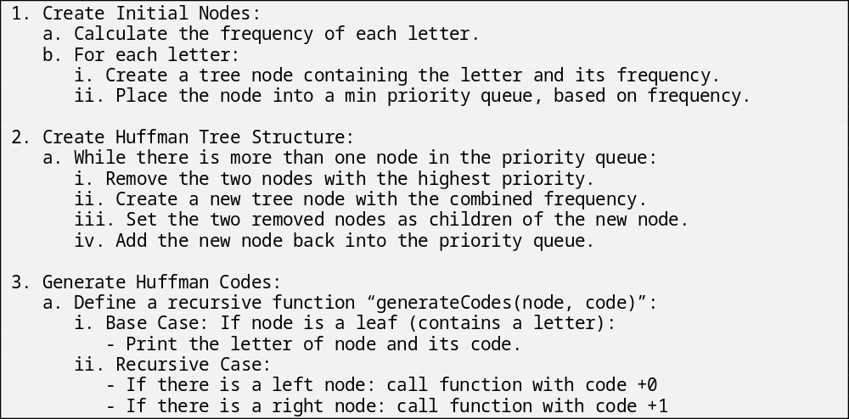

Time Complexity

Problem 4 – Time Complexity

Task 4.1
Design a trivial (the most obvious solution) recursive algorithm that calculates T (n) in the expression (2). Implement the algorithm in C / C ++ code.
The following parts should be included in the report:
- Intuitive description of the algorithm
The algorithm serves as a formula for determining the time complexity of algorithms, depicting how execution time scales with input size. It handles each input item and smaller, partial problems at the same time. It's like breaking a big problem into smaller ones and solving them separately.
This mirrors the divide-and-conquer strategy, an algorithm design approach where a problem is divided into smaller, related sub-problems, independently solved, and their results combined.
This recursive process keeps going until it reaches a case where (T(1) = 1). Then, the time complexity becomes a fixed number, no longer dependent on the input size.
- Abstract algorithm in pseudo code
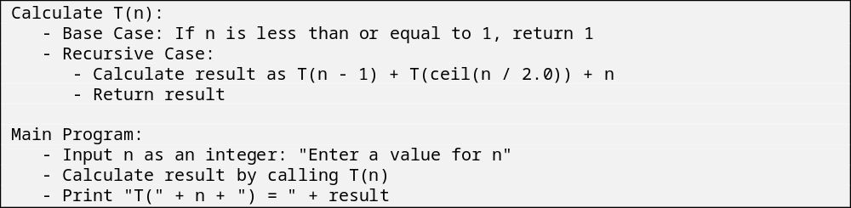
Figure 1 Pseudo code
- C/C++ code
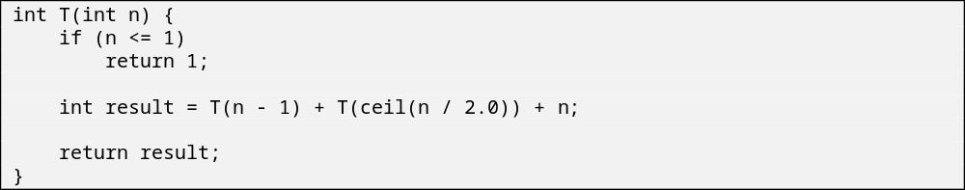
Figure 2 C++ code

4.2
Design an algorithm based on the design principles of dynamic programming, which calculates T (n) in expression (2).
The following parts must be included in the report:
- Intuitive description of the algorithm.
This code is implementing a top-down dynamic programming approach using memorization. It optimizes the computation of the algorithm sequence T(n) by avoiding redundant calculations and storing the results of subproblems in a map.
The memorization uses a map to store the previously computed results and before calculating T(n), it checks whether the results for n is already in the storage. If it is, the stored result is returned immediately without re-calculating. This is a key concept in dynamic programming, and it helps optimizing the time complexity by reusing previously calculated values instead of doing the calculation process all over again.
- Abstract algorithm in pseudo-code.
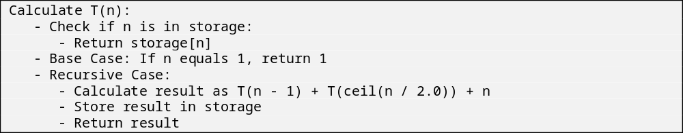
Figure 3 Pseudo code for algorithm using dynamic programming principles.
- Time complexity analysis with O(·)-notation.
WIP.
- C/C++ code
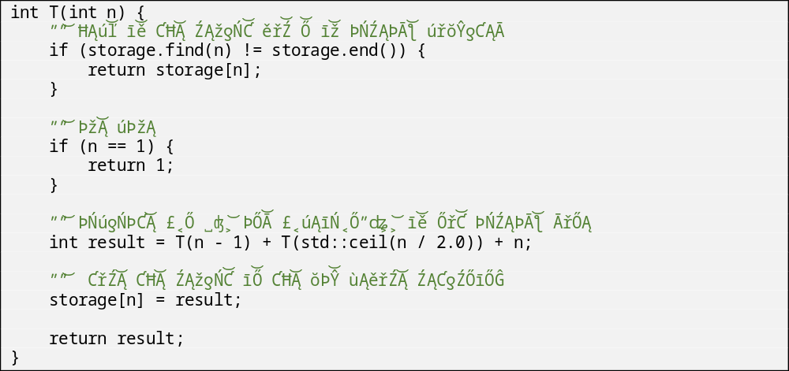
Figure 4 C++ code using dynamic programming principles.

Appendix

