Lindokuhle Ginindza | 2092154
FINE7079A: Blockchain and Cryptocurrency
Assignment 1: Blockchain Solution Design and Smart Contract Development
Due: 27 Aug 2026

Required Links

Item | Link
GitHub Repository | https://github.com/Lindo-123/FINE7079A-Assignment
GitHub Commit History | https://github.com/Lindo-123/FINE7079A-Assignment/activity
YouTube Video Link | https://youtu.be/kuEnuikpLKw

Table of Contents
1. Part A: Problem Analysis (20%) 3
2. Part B: System Design (25%) 5
3. Part C: Smart Contract Implementation (35%) 8
4. Part D: Critical reflection (20%) 9

Student declaration to be submitted alongside research proposals/reports/dissertations/written assignments

Declaration of Original Work

I, (Name and surname) _______Lindokuhle Ginindza_________________________________,

Student number: ____________________2092154__________________________________,

Understand and agree that:
- Plagiarism, i.e., to use another’s work and to present it as one's own, is dishonest.
- Copying the output from generative AI is akin to plagiarism and is therefore dishonest.
- Using generative AI to analyse my data amounts to outsourcing my work, which is not permitted in SEF.

Please confirm the following (write YES in each of the boxes provided):
YES | I declare that the assignment/proposal/research report/dissertation entitled  ____________________2092154 Assignment1 FINE7079A___________________  and handed in on the date below is my own work.
YES | I have acknowledged and referenced all direct quotations and paraphrased ideas using the appropriate house style.
NO | I have provided a complete, alphabetised reference list, if required, with DOI/web links for each reference, and have checked that each reference is accurate.
YES | I have not shared my work with anyone, and I have not allowed and will not allow anyone to copy my work with the intention of passing it off as their own work.
YES | I have not directly copied or paraphrased the output from any generative AI programme and presented this as my own writing or argumentation.
YES | Where relevant, I have not used generative AI to analyse statistics, or to solve any mathematical problems.
YES | I understand that the University of the Witwatersrand will take disciplinary action against me if evidence suggests that this is not my own unaided work, or if I failed to acknowledge the source of the ideas or words in my writing.

Please complete the two sections below:
I used generative AI to improve the readability and language of work that I have written.
Yes No
If yes, provide the name of AI tool/platform used:
Chat GPT, Claude
I used generative AI to assist in the data code that I have written.
Yes No
If yes, provide the name of AI tool/platform used:
Chat GPT, Claude

Signed: ___L.Ginindza_______________ Date: ______27 Aug 2026___________

Course code: ___FINE7079A______ Lecturer/Tutor/Supervisor:___Julien Kanjere____________

Part A: Problem Analysis (20%)
The current Monitoring, Reporting and Verification (MRV) process is mostly manual. It depends on multiple individuals to collect, calculate and combine emissions data. The current process has been split into the four phases mentioned below:
Phase 1: Greenhouse gas emissions are measured by sensors which are attached to plant equipment. Sometimes, authorised personnel will take readings by hand.
Phase 2: Authorised staff physically collect the sensor readings and record them into spreadsheets. They add up the totals from different sensors and then consolidate different spreadsheets as well as perform further manual calculations to produce one company-wide emissions report.
Phase 3: An internal auditor checks the consolidated figures against to confirm that reported measurements are complete and accurate. The auditor makes any corrections that are needed, and thereafter, the final report is submitted to the environmental regulator.
Phase 4: External auditors are appointed to independently verify the reported figures. At this point, the manufacturer has to provide evidence of data lineage.
The table below shows the stakeholders in the current process and where and how shortcomings could arise.
Stakeholder | Role in the process | Shortcomings
Sensors and authorised personnel | Measure emissions at source. | Sensors drift out of calibration, fail, or stop reporting. Manual readings can be misread. No automatic record proves a sensor was working correctly at the time of the reading.
Data collectors | Record sensor readings, consolidate them, and prepare the first draft of the emissions report. | Manual typing into spreadsheets causes human error. Records can be overwritten or deleted by mistake and there would be no record of the original records.
Manufacturer management | Owns the systems and approves the final report before submission. | They have a direct financial incentive to under-report because a lower emission could mean lower carbon tax liabilities. They also control the only complete copy of the records.
Internal auditor | Confirms the report is complete and accurate before submission. | They review records held and controlled by the same company that employs them therefore, they cannot prove to outsiders that the records were not changed.
Environmental regulator | Receives the report and checks compliance with environmental regulations. | Sees only the final submitted figure. Has no independent view of the underlying readings and has no choice but to trust what was submitted.
External auditor or verifier | Independently verifies the accuracy and integrity of reported emissions. | Must reconstruct data lineage by hand, months after the event. They cannot tell whether a spreadsheet was edited, when, or by whom.

The Trust, Transparency, and Coordination Problem
The current process has no shared, tamper-evident source of truth. This is essentially what creates a trust, transparency, and coordination problem. The manufacturer controls the primary records, and everyone else has to trust what the manufacturer reports.
- The trust problem: The manufacturer has an incentive to report a low greenhouse gas emission number, and it is also the one that controls the records. Regulators and verifiers cannot independently confirm whether the figures reported are actually true or are from the sensors. Therefore, trust is placed with the manufacturer whose interests conflict with accurate reporting.
- The transparency problem: Spreadsheets and manual reports can be edited without an audit trail. If a figure is corrected or changed, there is no way of knowing for certain who made the change, when it was made, or what the original record was.
- The coordination problem: The manufacturer, the regulator and the external verifier each work off their own copy of the data which is usually stored in their own systems and updated at different times. This means that there is no shared record of what has been submitted, what has been reviewed, and what is still outstanding. This results in slow reconciliation and disputes over which record is correct.
Evaluation of Blockchain Suitability
A blockchain would be suitable because data is stored by multiple parties whereby the manufacturer, internal auditors, the regulator and external verifiers all add records or approvals to the process. Moreover, there is no one third party that can be trusted as the regulator has no mandate to take control and operate the manufacturer’s data systems meaning that there is no neutral operator that exists. A blockchain would also be suitable because not all the stakeholders trust each other as the manufacturer has a financial reason to under-report. Because Emissions data is commercially sensitive, it does not need to be seen or accessed by the public, hence the suitable blockchain would be a private (consortium) blockchain.
A blockchain-based solution would ensure that there is evidence of any tampering to any records. Once a reading is read to the ledger, it cannot be changed without leaving a trace. This gives every party a record they can rely on without trusting the manufacturer. Moreover, blockchain will address the coordination problem by ensuring that there is shared visibility amongst stakeholders as they would all be able to see the same submission and verification history, timestamped and linked in order. A blockchain will also allow an external verifier to be able to trace a submitted record back to origination automatically. This reduces audit time and reduces disputes. Using a blockchain will also help in distributing trust because there is no single controller of records. Smart contracts would be most suitable because they can automate the workflow therefore enforcing who is allowed to submit, and reporting submitted report statuses, as well as handling any errors.
Why a conventional database is not sufficient.
A traditional database would be sufficient if a neutral, trusted party operated it. If the regulator hosted the system, most of the benefit of a blockchain would fall away. However, this is not the case. There is no neutral operator, the parties have conflicting financial incentives, and each keeps a separate copy of the data. A traditional database could allow records and audit logs to be modified or altered and demonstrating that historical records were not changed could be difficult. Although controls such as backups, access restrictions, and audit trails can mitigate this, they still do not eliminate the need to trust the manufacturer as the owner of the records.

Part B: System Design (25%)
Because the manufacturer currently controls the only set of records, the system will be designed as a four nodes Proof of Stake (PoS) consortium whereby every node representative of each stakeholder (i.e., the manufacturer, internal auditor, regulator, and external verifier) will put in an equal amount of stake. This means that no single party can change records on its own. Because alterations to records currently leave no trace, each report is hashed and anchored to the chain, and every action is written to an append-only event log. If anyone alters the off-chain report, the hash will no longer match, and the system will be able to detect that the record has been tampered with. In the current process each party has been working from its own copy of the data, all parties will now read the same ledger state and the same verification status, so that there is no manual reconciliation done. For a complete audit trail, the system will be designed in a way that it contains a timestamped chain that runs from submission, through internal sign-off, to external verification.

Architecture Diagram
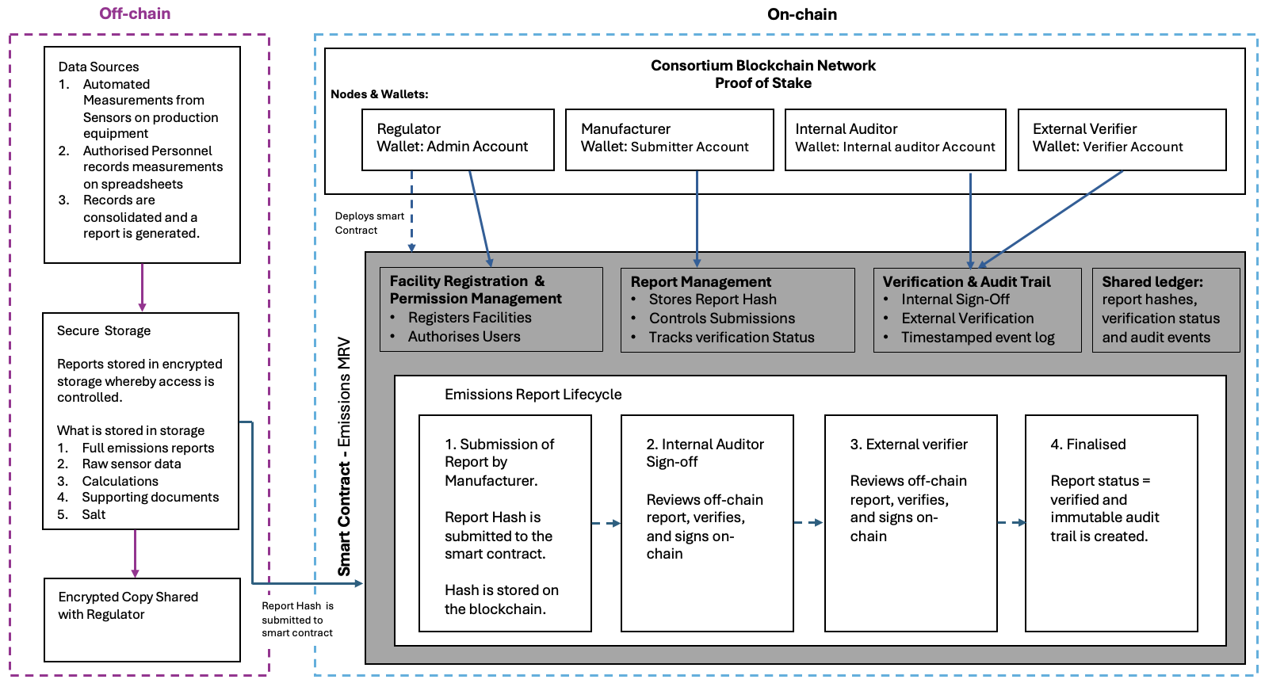
Blockchain type
The proposed system is a consortium blockchain because greenhouse gas emissions are commercially sensitive and if made available to the public, competitors would be able to decipher production volumes. A fully private blockchain would not be suitable because it would have to be run by the manufacturer and would not address the trust problem as they would be controlling the blockchain.
Consensus Mechanism
The most suitable consensus mechanism for the system is Proof of Stake (PoS) because:
Energy: Proof of Work (PoW) consumes a huge amount of electricity (gas) hence using it would increase carbon emissions. Running an energy-intensive consensus mechanism in order to report greenhouse gas emissions is self-defeating. PoS on the other hand, uses very little energy.
Security: PoW security assumes that there is no participant who can command a majority of hash power. This does hold in public blockchains with many independent miners, however because this system only has four validators PoW is not the best because a manufacturer can attain enough computing power to attack the network and rewrite history if they are facing large carbon tax liability. PoS is most suitable because each member puts in an equal stake so that none can reach the two-thirds threshold alone, and a validator signing false blocks is slashed. An attacker would need to own two-thirds of the total money locked in the system, which the rules prevent.
Filing Safety: PoW only gives probabilistic safety. This means that a filed report could still be cancelled or changed by accident. PoS gives exact, guaranteed finality within a fixed time, which is necessary for legal filing.
Punishment: If someone is dishonest in PoW, they only lose the electricity or gas they used. In PoS, cheating has a financial penalty whereby, the system takes away the attacker's locked money.
Smart Contracts
The contract keeps a register of facilities, and it keeps a record of the emissions reports filed for those facilities. When a company files a report, the contract does not store the report itself. It stores a digital fingerprint of it which is produced by hashing the report. This is so the actual emissions records stay off the ledger and remain confidential.
Once the report hash is written it stays the same and only the verification status is added alongside it. If anything in the report is later changed, the hash will no longer match, and this will show to the network that a change happened. An auditor holding the original document and the salt can run that check themselves without having to ask the company for any information because the data sits on the network.
The contract also controls who is allowed to do what. Only accounts approved for a specific facility can submit records for that facility. This prevents staff members from different plants to record emissions for plants they’re not placed at. Only approved auditors can sign a report off, and nobody can sign off on their own submission. External verifiers cannot be the same person who gave internal sign-off. Moreover, there can only be one report open per facility per year. This prevents a company from filing several competing versions and later choosing the most favourable one. Where a figure genuinely has to be restated, the contract writes a new record and links it to the old one with a stated reason rather than editing anything.
Wallets
Every action on the ledger is identified by a wallet which is a digital account with a unique address and a private key. When someone submits a report or signs a record off, the smart contract records their wallet address alongside the action they performed. This is done so that there is always a permanent on-chain record of who did what and when. The contract has four types of accounts. These are:
- The admin account (the regulator): deploys the contract, and it is the only account allowed to register facilities, authorise submitters, auditors and verifiers. The regulator controls permissions and access, not record content or history.
- The submitter accounts (the manufacturer): accounts the approved by the admin for a specific facility. Approval at one facility does not carry over to another. This ensures that a data collector at one plant cannot file on behalf of a different one.
- The internal auditors’ account: can approve records from a specific facility but cannot approve their own submissions.
- The verifier accounts: can approve any records from any facilities except their own.
On-chain/Off-chain data
The contract stores a hash (digital fingerprint) of each emissions report and not the report itself. The actual report has raw sensor readings, and calculations, that will be kept in a secure off-chain storage system that only authorised parties can access. This is one so that the emission data is kept confidential. A salt is generated per report and is disclosed to the internal auditor and external verifier at submission. An encrypted copy of the report is lodged with the regulator the moment the hash is anchored.
Every member of the consortium can read the ledger, and anything written on-chain is visible to all of them. Putting raw emissions figures there would expose commercially sensitive production information to competitors. Storing report hashes is also done because blockchains are not naturally designed to hold large files, and storing only a fingerprint keeps the cost of each transaction constant regardless of how long the report is.
On-chain | Off-chain
Report hash, facility ID, reporting period | Raw sensor readings and time series
Submitter address, block timestamp, verification status | Full emissions report and calculation workbooks
Auditor and verifier addresses, role mappings | Sensor calibration certificates and methodology
Events forming the complete audit trail | Salt values and supporting evidence

Part C: Smart Contract Implementation (35%)
Please see links on cover page.
Smart contract code can be found on the GitHub repository.

Part D: Critical reflection (20%)
Security and access control.
The smart contract has relatively strong security and access control. Firstly, it has three modifiers that limit permissions. These are:
- onlyCreator which restricts registration and authorisation to the regulator
- onlySubmitter which restricts filing to accounts approved for one specific facility
- onlyVerifier which restricts sign-off to approved auditors.
Secondly, Submitter rights are scoped per facility rather than granted globally. This prevents a data collector at one facility from filing for another. Thirdly, separation of duties is enforced by the check that no account can verify or reject its own submission. Lastly, the report hash is written once and can never by reassigned. This means that only the verification status can change after submission, and every authorisation change and state transition emits an indexed event.
However, the smart contract does have limitations related to security and access control. These are:
- One report per year can be misused: because only one record may be open per facility per year, a compromised submitter can occupy that slot with an invalid or meaningless hash and block legitimate filing until a verifier rejects it. This would delay the process.
- Centralised administration: because only the regulator can register facilities and authorise submitters and verifiers and that regulators responsibilities cannot be transferred, if the regulators private key is lost no facility can be registered. If the key is stolen, this allows an attacker to authorise submitters, and verifiers, and produce a report that looks like it has been properly signed off.
Privacy of commercially sensitive emissions data.
Privacy works by keeping the actual emission report off-chain and putting only a salted hash on the ledger. The salt is important because Emissions figures fall in a narrow, guessable range, so without a salt a competitor could simply hash likely tonnage values until one matched and read the number straight off the chain. Each report therefore needs its own random salt, shared with the auditors through a secure channel outside the ledger.
However, one weakness is that computeHash and checkRecord take the report and the salt as inputs. If they are called locally as view functions they reveal nothing, but if either is ever sent as a transaction, or run through an outside node provider, the report itself becomes visible and in the transaction, case stays on the chain permanently.
Gas costs and scalability.
Gas costs
One facility going through a full year of reporting does three transactions being submitting the record, the internal sign-off, and the external verification. Together these cost about 319,000 gas the first time, and about 304,000 gas every year after that. The first submission is more costly because writing to an empty slot on the blockchain uses about 20000 of gas, while changing a slot that already contains data only costs 2 900 of gas. The cost does not change with the size of the report. This is because the contract only stores a 32-byte hash, no matter how long the report is.
Scalability
The total cost grows with the number of reports filed, not with the amount of emissions data collected. This matters because sensors produce new readings all the time, but reports are only filed once a year. The sensor data can be recorded as many times as possible without making the blockchain more expensive. The weakest function for scalability is getRecordForYear. It searches backwards through all of a facility's records one by one until it finds the right year. There is no limit on how many records it might have to check.
Limitations and recommendations for production deployment.
The one problem the ledger does not solve is sensor accuracy. The contract removes the ability to alter a record silently. It gives the regulator and the external verifier the same view of the same history and makes lineage checkable a bit faster than by hand.
The blockchain can only guarantee that a number was recorded faithfully, not that the sensor measured emissions correctly. This means that a wrong reading becomes immutable. This can be mitigated outside the ledger by keeping sensor keys in a hardware security module, anchoring calibration certificates on-chain, and keeping the internal auditors as a human in the loop check. The internal auditor can check whether reported emissions align with production volumes, and fuel consumption data to confirm that the reported numbers are plausible. A related limit is that the system anchors the final report and not the steps that produced it. This means that manual consolidations can be altered until the data collection is automated.

