Results
The study examined family-formation readiness and perceptions of family-support initiatives among Emirati and non-Emirati students and employees within Khalifa University’s Abu Dhabi community. The analysis included 700 synthetic questionnaire records covering demographic characteristics, personal preparedness, social circumstances and programme-related perceptions. Descriptive analyses compared nationality and university-role groups. The primary readiness analysis was restricted to single or engaged respondents, while the broader sample was retained for support-initiative descriptions where individual items were applicable.
Figure 1 presents the distribution of the 700 synthetic questionnaire records across the analytical samples. Of these, 416 were Emirati, 275 were non-Emirati, and nine did not report their nationality. The support-initiative analysis included 691 respondents with known nationality, of whom 651 recognised at least one family-support programme. Separately, 265 respondents reported eligibility for their selected programme. The primary readiness analysis was restricted to 407 single or engaged respondents, comprising 297 Emiratis and 110 non-Emiratis. These samples provided the basis for examining family-formation readiness and support-programme awareness and eligibility across the two nationality groups.
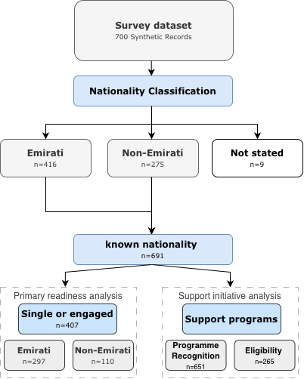
Fig. 1. Distribution of synthetic questionnaire records by nationality and analytical sample. The primary readiness analysis included 407 single or engaged respondents, while the support-initiative analysis included 691 respondents with known nationality. Programme recognition (n = 651) and self-reported eligibility (n = 265) represent distinct indicators; eligibility was not independently verified.

Table 1 summarises respondent characteristics by nationality. Emirati records were more frequently aged 18–25 years, female and single; non-Emirati records more frequently represented older and married individuals. Nationality therefore coincided with differences in age and household circumstances, limiting the interpretation of unadjusted comparisons.
Table 1. Characteristics of respondents by nationality, n (%). Percentages use the nationality-group denominator; 1–4 observations are shown as <5. “Both” is reported separately here and assigned to students only for the role-specific readiness comparison.
Characteristic | Emirati (n = 416) | Non-Emirati (n = 275)
Gender
Female | 235 (56%) | 102 (37%)
Male | 178 (43%) | 172 (63%)
Not stated | <5 | <5
Age group
18–25 | 279 (67%) | 64 (23%)
26–30 | 43 (10%) | 53 (19%)
31–40 | 46 (11%) | 83 (30%)
41 or older | 41 (10%) | 70 (25%)
Not stated | 7 (2%) | 5 (2%)
Marital status
Single | 269 (65%) | 104 (38%)
Engaged | 28 (7%) | 6 (2%)
Married | 103 (25%) | 135 (49%)
Divorced or widowed | <5 | 21 (8%)
Not stated | 12 (3%) | 9 (3%)
University role
Student | 289 (69%) | 118 (43%)
Employee | 123 (30%) | 144 (52%)
Both | <5 | 13 (5%)
Questionnaire language
Arabic | 171 (41%) | 31 (11%)
English | 245 (59%) | 244 (89%)
Among Emirati records, 269 respondents (65%) reported Abu Dhabi as their emirate, 135 (32%) reported another emirate and 12 (3%) did not specify an emirate. The unreported-emirate group was retained in the overall Emirati totals but excluded from regional programme comparisons.
Figure 2 presents the distribution of overall family-formation readiness (B10) among the 407 single or engaged respondents. The middle response category was the most frequently selected across all four subgroups. Agreement or strong agreement was highest among Emirati employees (63%), followed by Emirati students (40%), non-Emirati employees (38%), and non-Emirati students (20%). These findings indicate differences in self-reported readiness across nationality and university-role groups, with higher proportions of agreement among employees than students in both nationality groups.
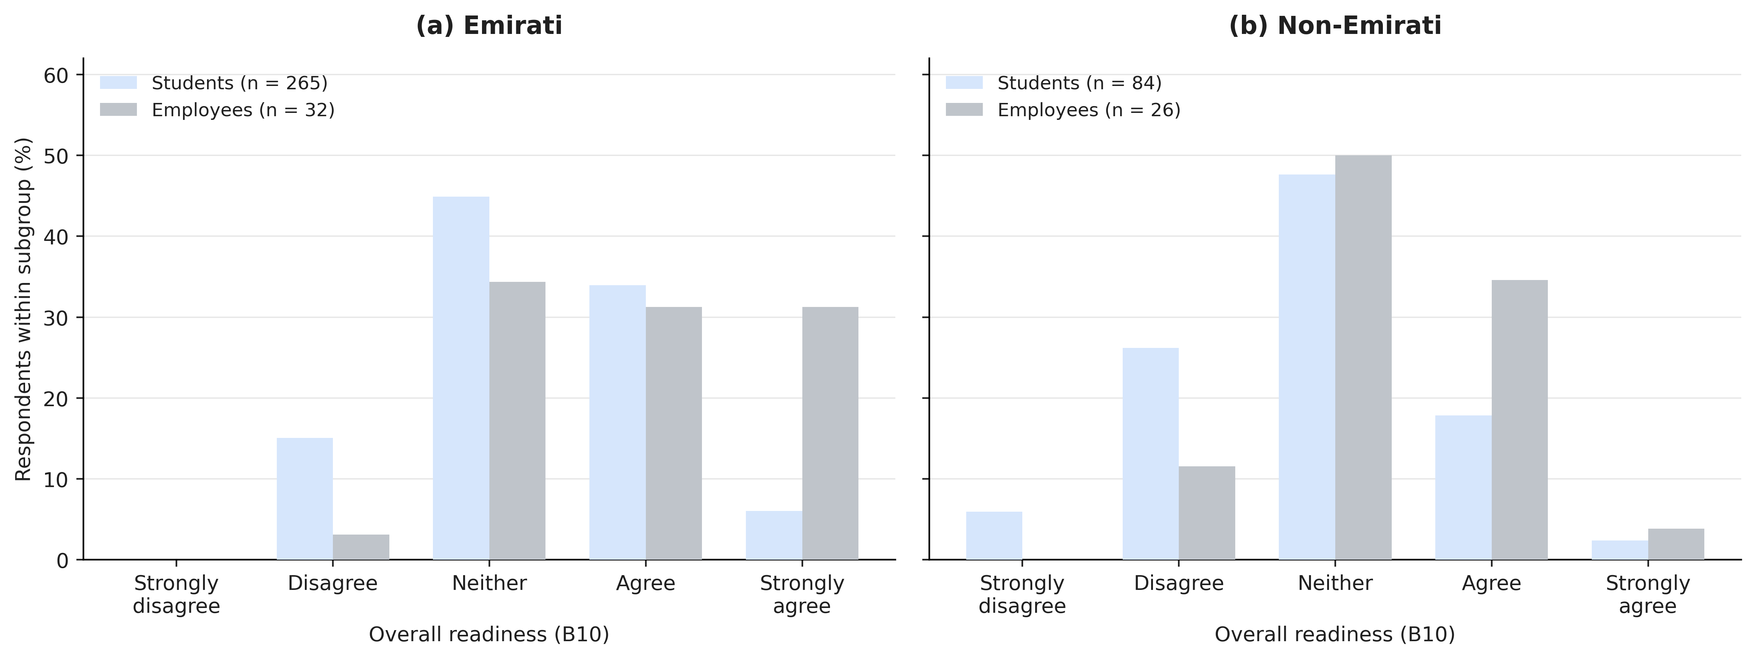
Fig. 2. Distribution of overall family-formation readiness (B10) among single or engaged respondents: (a) Emirati and (b) non-Emirati, stratified by student and employee role. Bars show percentages within each displayed subgroup; n values are given in the legends. Dual-role respondents were classified as students.
The comparisons in Fig. 2 represent unadjusted differences in self-reported readiness across nationality and university-role groups. These differences should be interpreted alongside the variation in demographic characteristics presented in Table 1, particularly age and marital circumstances. The relatively small employee subgroups also limit the precision of the descriptive comparisons.
Among single or engaged respondents who reported low overall readiness (B10 ≤ 2, n = 71), the reasons for not feeling ready differed between the two nationality groups. Continuing education was the most frequently reported reason among Emirati respondents, whereas financial preparedness was the leading concern among non-Emirati respondents. These findings describe the principal barriers identified by respondents expressing low readiness within the synthetic sample.
Figure 3 presents a comparative analysis of four family-support initiatives: the federal Marriage Grant, Medeem, Abu Dhabi Housing Support, and Federal Housing Support. Three indicators were examined for each initiative: programme recognition, self-reported understanding, and willingness to consider its use if eligible. The federal Marriage Grant showed the highest recognition among Emirati respondents, with approximately 90% reporting awareness across both regional groups, compared with 27% of non-Emirati respondents. Recognition of Medeem and Abu Dhabi Housing Support was higher among Emiratis from Abu Dhabi than among those from other emirates, whereas the opposite pattern was observed for Federal Housing Support. The indicators were assessed independently and did not represent sequential stages of programme engagement. Twelve Emirati respondents who did not specify their emirate were excluded from the regional comparisons but retained in the overall Emirati sample (n = 416).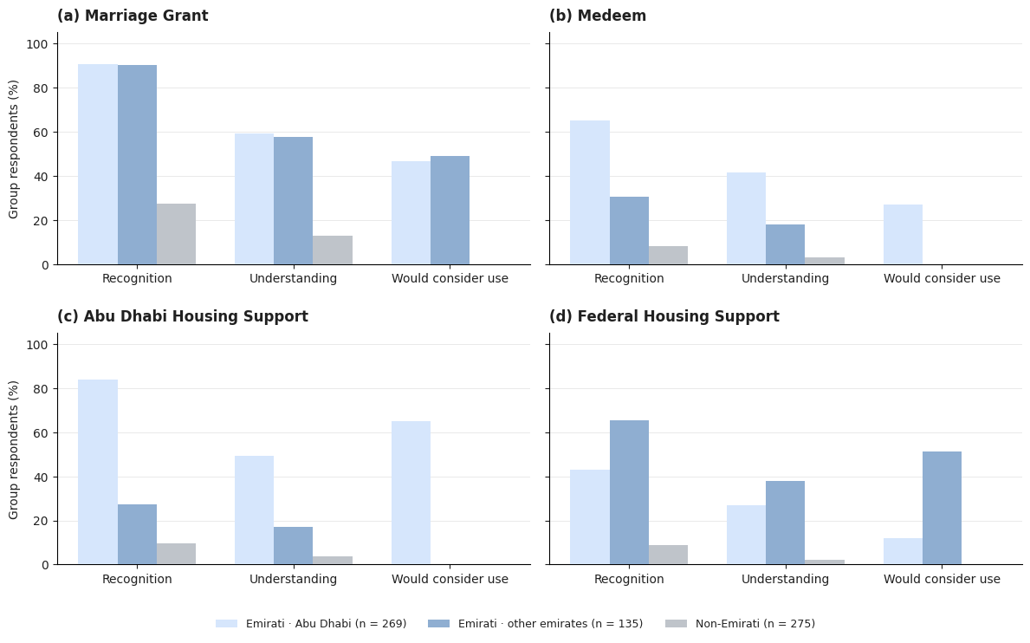
Fig. 3. Recognition, self-reported understanding and stated willingness to consider use of (a) Marriage Grant, (b) Medeem, (c) Abu Dhabi Housing Support and (d) Federal Housing Support. Each bar represents a separate multiple-response indicator as a percentage of the indicated nationality/regional group. The sample sizes are 269 Emiratis from Abu Dhabi, 135 Emiratis from other specified emirates, and 275 non-Emiratis. Lack of selection is not equivalent to verified ineligibility; indicators are not stages of a measured pathway.
Table 2 summarises self-reported eligibility for the family-support initiative identified by each respondent as most relevant to their circumstances. Eligibility responses were classified as eligible, ineligible, unsure, or not assessed where no applicable response was available. Uncertainty regarding eligibility was particularly evident among Emirati respondents, with 128 of 269 respondents from Abu Dhabi (48%) and 78 of 135 respondents from other specified emirates (58%) reporting that they were unsure of their eligibility. Among non-Emirati respondents, 104 of 275 (38%) did not identify a relevant programme and therefore had no applicable eligibility assessment. These findings indicate differences in reported eligibility uncertainty and programme applicability across nationality and regional groups. Eligibility responses reflect respondents’ own assessments rather than independent verification against official programme criteria.
Table 2. Self-reported eligibility for the initiative identified as most relevant (D13), n (% of group). “Not assessed” denotes a missing or inapplicable response; eligibility was self-reported, not independently validated. The 12 Emiratis with unstated emirate are shown separately.
Group | Total n | Yes | No | Unsure | Not assessed
Emirati · Abu Dhabi | 269 | 126 (47%) | 15 (6%) | 128 (48%) | 0 (0%)
Emirati · other emirates | 135 | 46 (34%) | 11 (8%) | 78 (58%) | 0 (0%)
Emirati · emirate unstated | 12 | 2 (17%) | 1 (8%) | 9 (75%) | 0 (0%)
Non-Emirati | 275 | 91 (33%) | 21 (8%) | 59 (21%) | 104 (38%)

Table 3 presents respondents’ broader perceptions of the family-support environment, including trust in programme information, perceived fairness, accessibility, and willingness to use available initiatives. Unlike the programme-specific eligibility assessment in Table 2, this analysis examined general attitudes towards family-support initiatives using a five-point agreement scale. The analysis included 416 Emirati respondents and 127 non-Emirati respondents who provided valid ratings. The smaller non-Emirati sample reflects the exclusion of respondents unable to assess the initiatives, limiting direct comparisons between nationality groups. Among Emirati respondents, agreement was highest for trust in programme information (79%) and willingness to use initiatives if eligible (76%). In contrast, agreement was lower for understanding eligibility requirements (49%) and perceiving application procedures as straightforward (22%). These findings indicate a gap between favourable perceptions of family-support initiatives and perceived clarity of eligibility requirements and application procedures.
Table 3. Agreement with statements concerning family-support initiatives among Emirati and non-Emirati respondents (% agree or strongly agree). Percentages were calculated from valid responses on the five-point agreement scale.

Statement | Emirati (n=416) | Non-Emirati (n=127)
Trust in information | 79% | 52%
Fair implementation | 74% | 50%
Would use if eligible | 76% | 24%
Would recommend | 70% | 39%
Initiatives increase confidence | 63% | 49%
Know reliable information sources | 62% | 39%
Information easy to understand | 58% | 27%
Understand eligibility | 49% | 20%
Application straightforward | 22% | 10%

Figure 4 illustrates the distribution of reported barriers to accessing and using family-support initiatives among Emirati and non-Emirati respondents. Difficult application procedures and unclear eligibility requirements were the most frequently identified barriers among Emiratis, suggesting that procedural complexity and uncertainty regarding programme requirements were prominent concerns. Among non-Emiratis, unclear eligibility requirements, limited awareness of available initiatives, and perceived lack of programme relevance were more frequently reported. These findings reveal distinct patterns in perceived barriers across the two nationality groups, with procedural difficulties more prominent among Emiratis and programme awareness and relevance emerging as additional concerns among non-Emiratis. Responses classified as “Other” were retained as a separate category, while optional written comments provided supplementary context to the reported barriers.

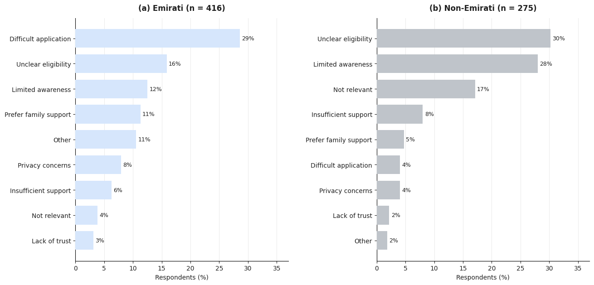
Fig. 4. Main perceived reasons for non-use of support initiatives (D10), (a) Emirati and (b) non-Emirati respondents. Percentages use the full nationality-group denominator (n = 416 and n = 275, respectively). Mutually exclusive survey response categories are preserved; categories below 2% are omitted from the plot but remain in the data.
Dataset generation and analysis documentation
The dataset comprised 700 synthetic questionnaire records covering demographic characteristics, family-formation readiness, economic preparedness, family-support initiatives, social influences, and family aspirations. Nationality, marital status, and university role were used to define the analytical groups, as illustrated in Fig. 1. Table 4 summarises the dataset structure, processing procedures, and reproducibility information, distinguishing characteristics verified from the synthetic records from generation parameters requiring the original simulation specifications.
Table 4. Reproducibility record for the supplied synthetic dataset. “Requires source” identifies generation details not verifiable from the delivered CSV.
Component | Verified from dataset | Provenance status
Records | 700; IDs SYN0001–SYN0700 | Verified
Data status | Explicitly labelled synthetic | Verified
Survey variables | 136 columns; Sections A–H plus metadata | Verified
Nationality coding | Yes / No / Prefer not to answer | Verified
Readiness selection | Known nationality + single/engaged | Verified
Dual-role convention | Both assigned to Student for role comparison | Analysis rule documented
Support indicators | Distinct multi-select fields D1/D2/D4 | Verified
Eligibility responses | D13: Yes / No / Unsure / missing | Verified
Generation probabilities and dependencies | Not embedded in CSV | Requires generator code
Random seed / software version | Not embedded in CSV | Requires generator code

The findings are based on synthetic questionnaire data and should be interpreted within the assumptions of the simulation. Differences in demographic composition, questionnaire language, and programme applicability may affect comparisons between Emirati and non-Emirati respondents. In addition, the relatively small employee subgroups limit the precision of the descriptive estimates. Although the results reveal differences in self-reported readiness, programme awareness, and perceived accessibility, they do not establish measurement equivalence between groups or causal relationships between family-support initiatives and readiness. The findings therefore provide a basis for evaluating the analytical framework rather than drawing conclusions about the wider Abu Dhabi population.

