

SCHOOL OF COMPUTING AND INFORMATICS
DEPARTMENT OF INFORMATION TECHNOLOGY

TITLE: SKILL EXCHANGE

STUDENT: Lindsey Chepkemoi
REG NO: BIT/2024/39880

FIGURE 1:INSTALLATION PROCESS
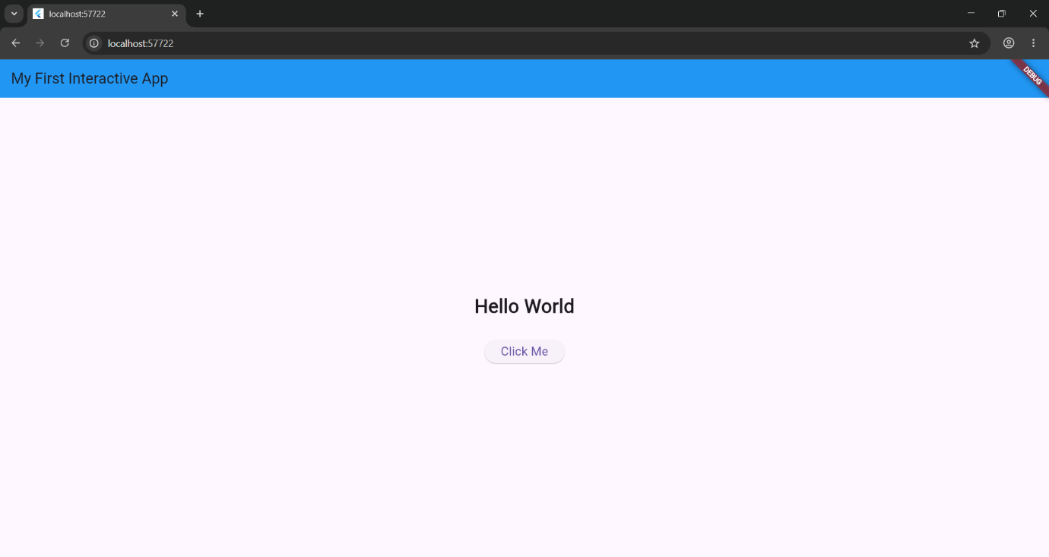

FIG 2: TERMINAL: set the folder structure

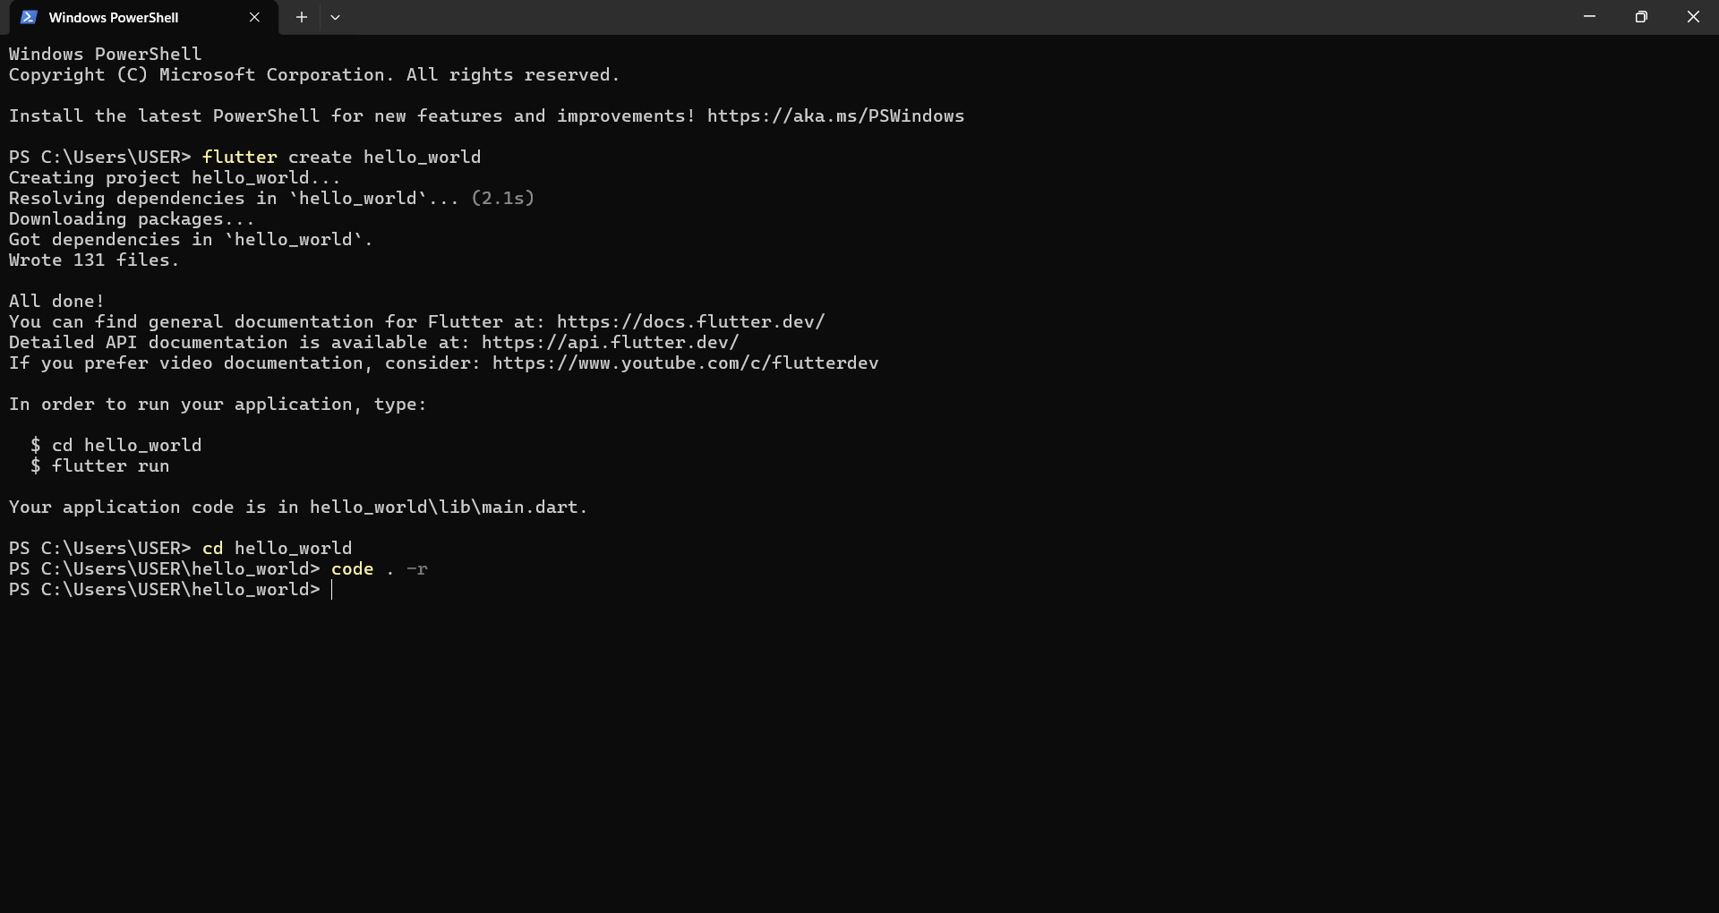
FIG 3: CODES
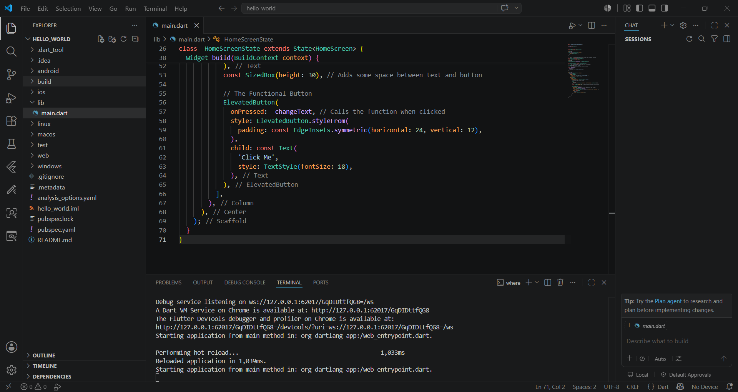

FIG 4:FIRST_APP: display
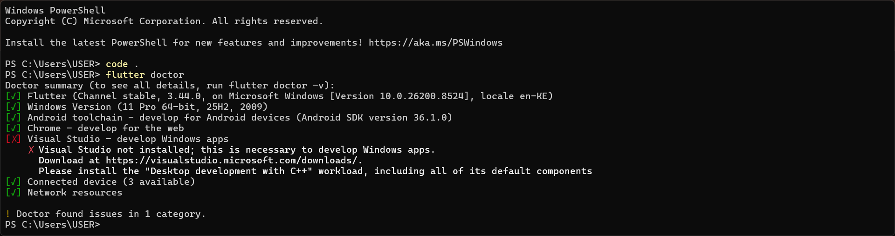
FIG 5:
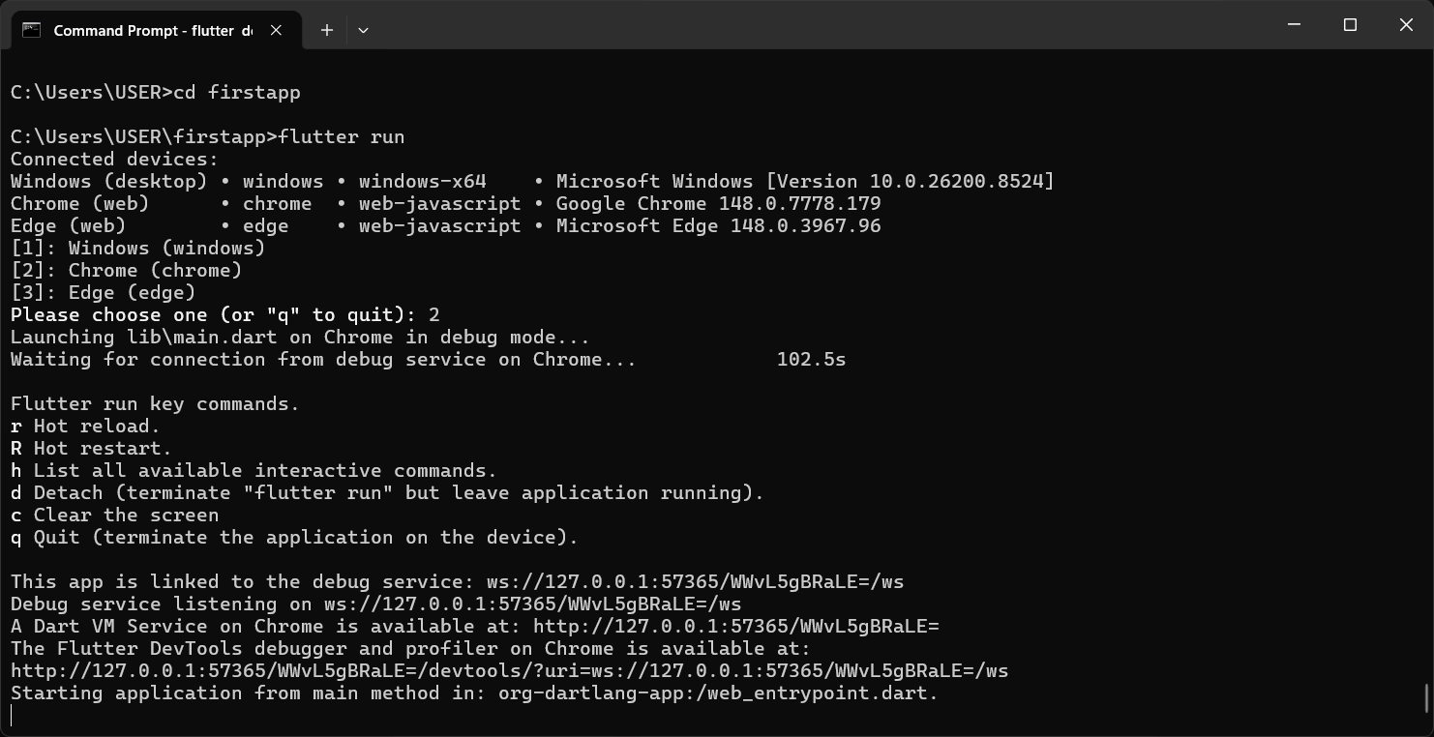
WEEK 2-3. Starting with Building the APP

AgriLink

Home screen
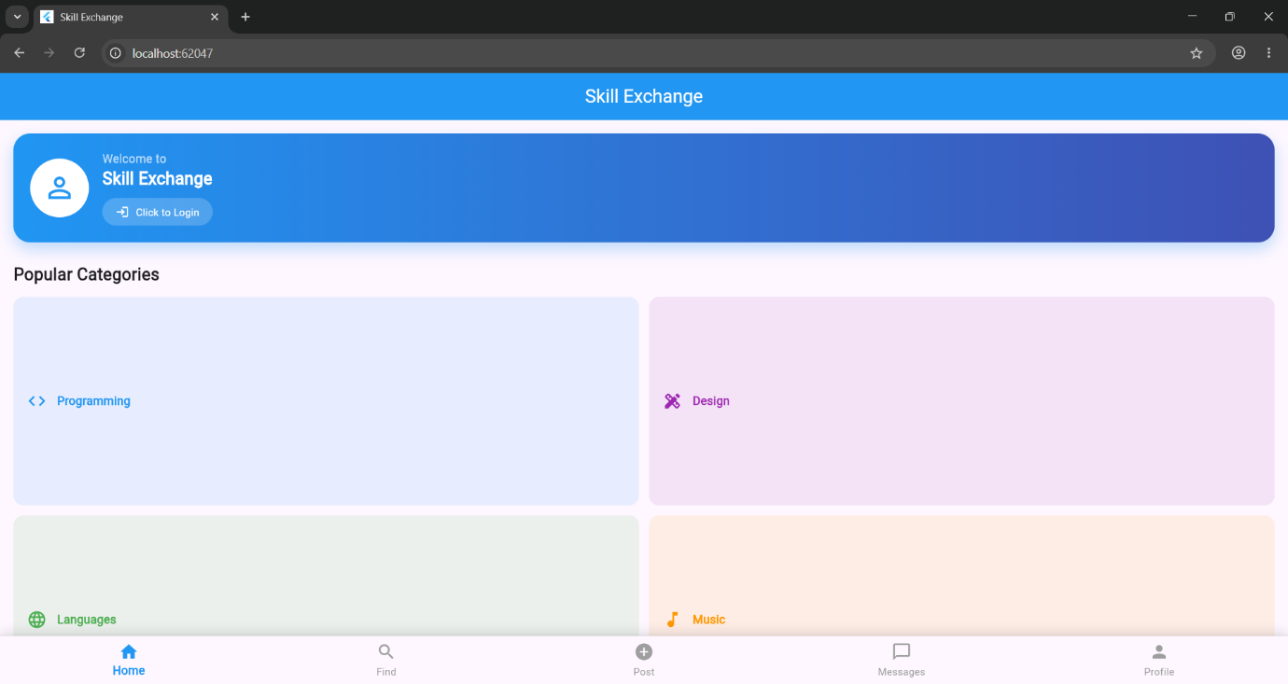

Registration Screen
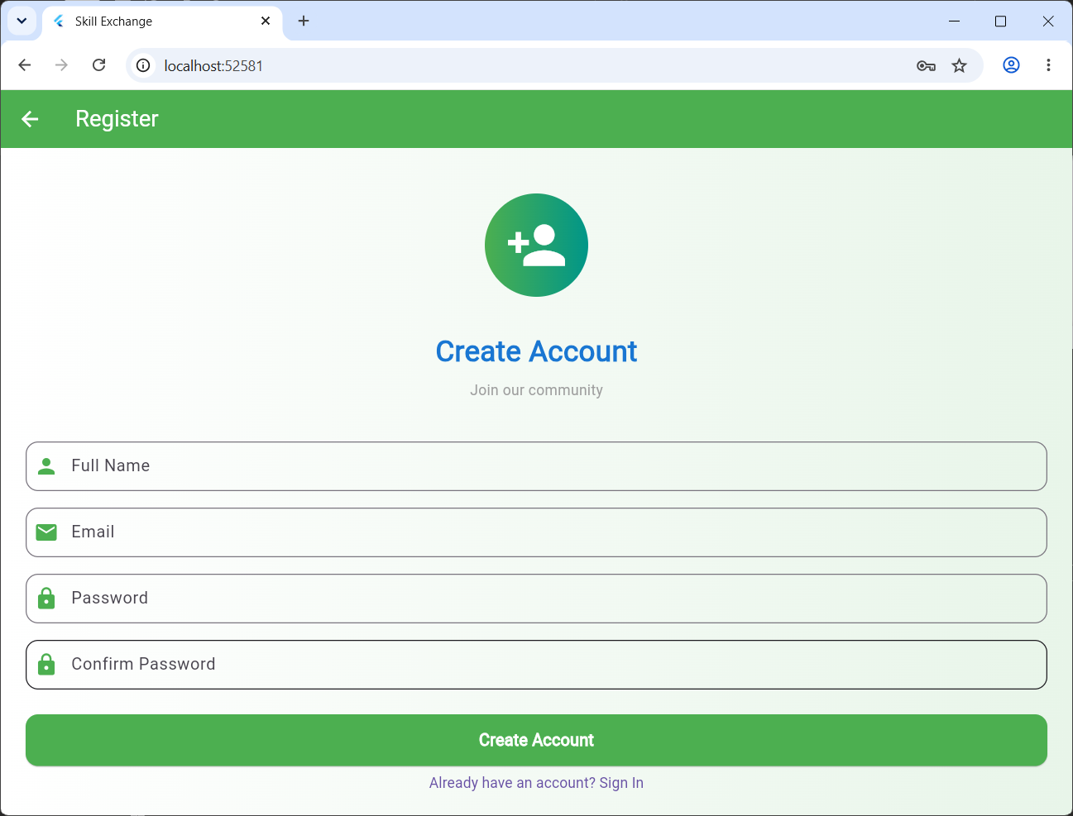

Login Screen
