**Home page:**

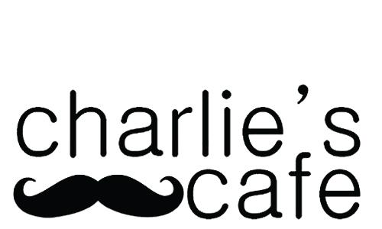

With locations in the heart of ASU, Charlie’s cafe provides delicious, high quality drinks and food for the ASU community. Stop by to fuel your next study session!

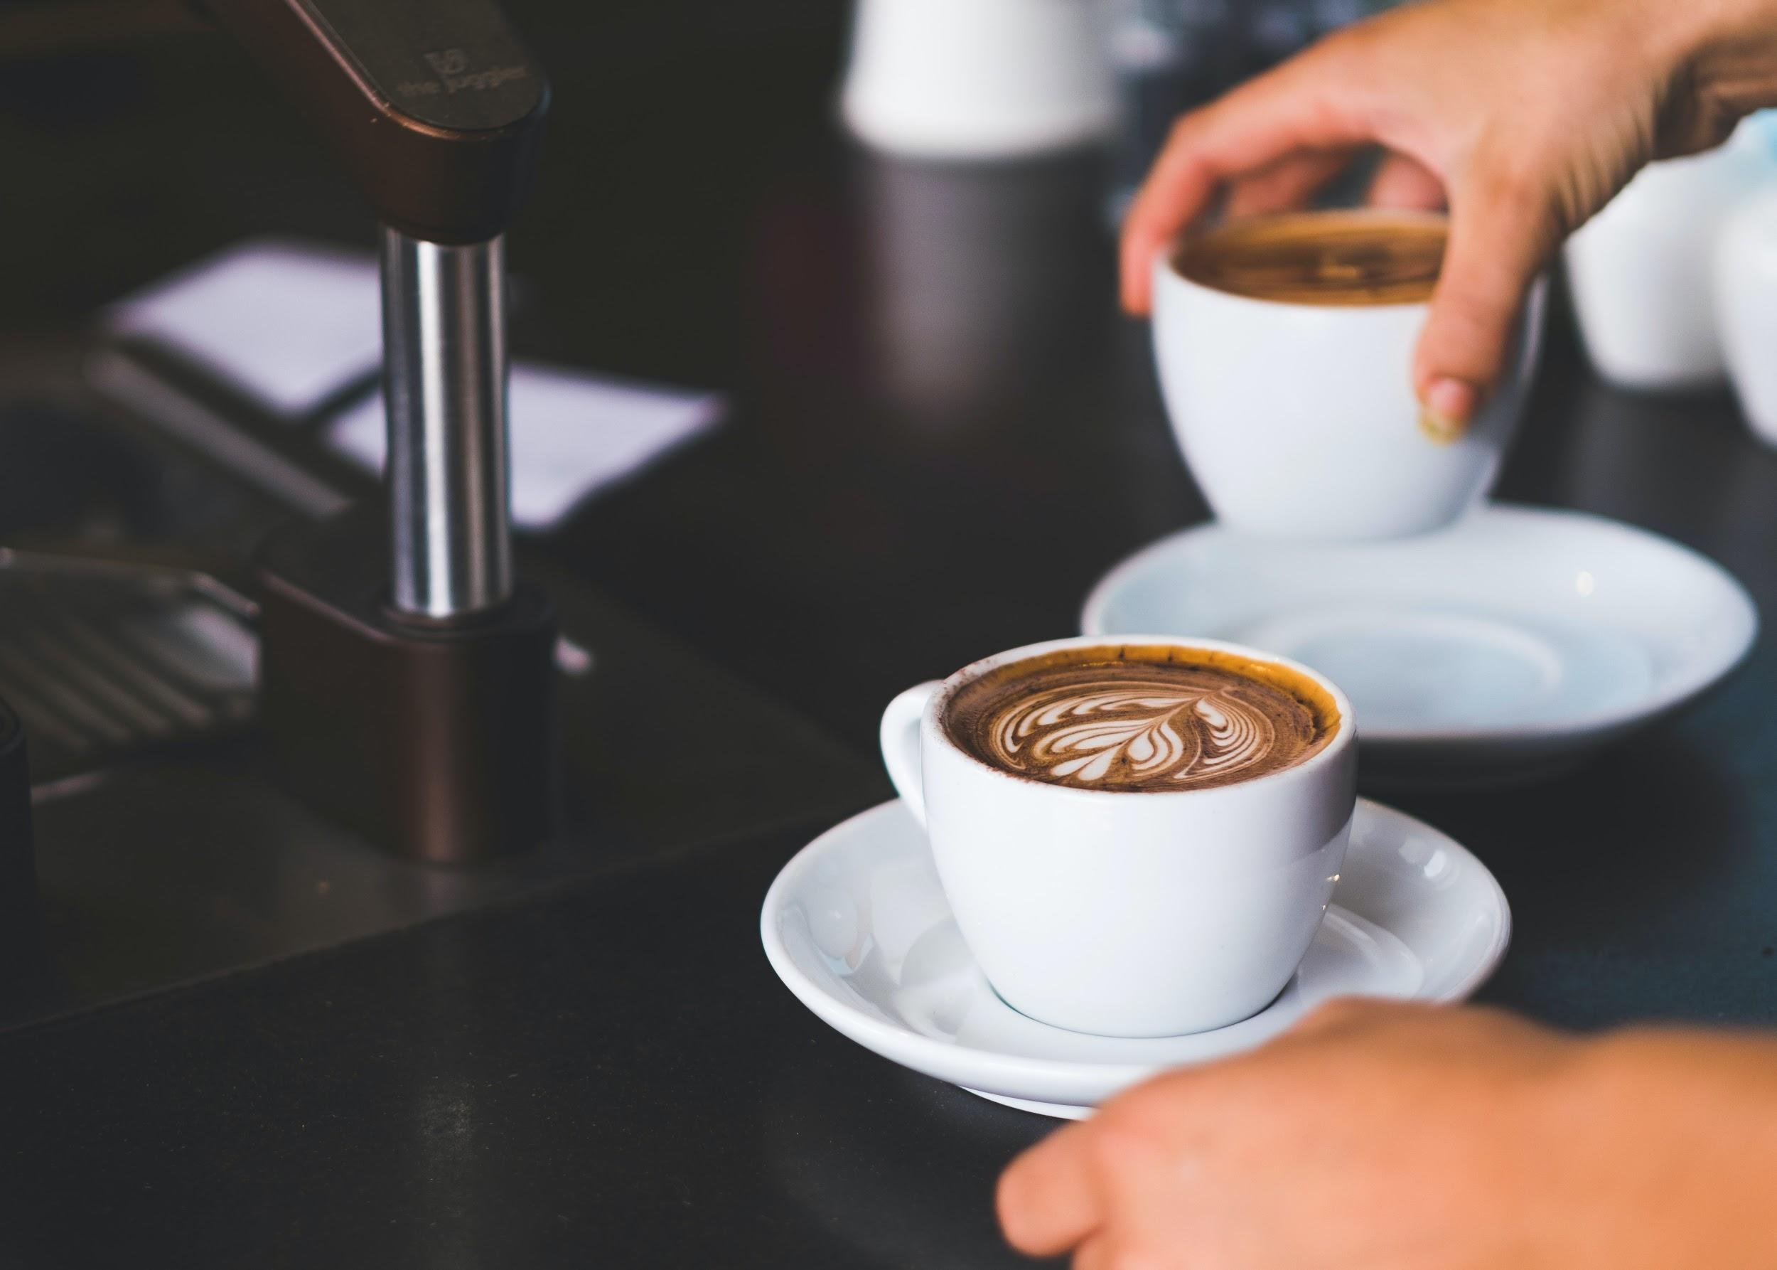

Experience an italian classic since 1895 <caption>

Lavazza Italian espresso <text on image>



Charlie's Café, one of Sun Devil Dining’s local restaurant partners, brings the taste of Europe to ASU! Proudly serving Lavazza Italian espresso and featuring fresh European sandwiches and baked goods. Come experience the difference! With three locations on campus, there is always a Charlie's Cafe near! Charlie’s Café is located at the Hayden Library, Bio Design B Building and the College of Design.

Explore our drink menu! <link to menu>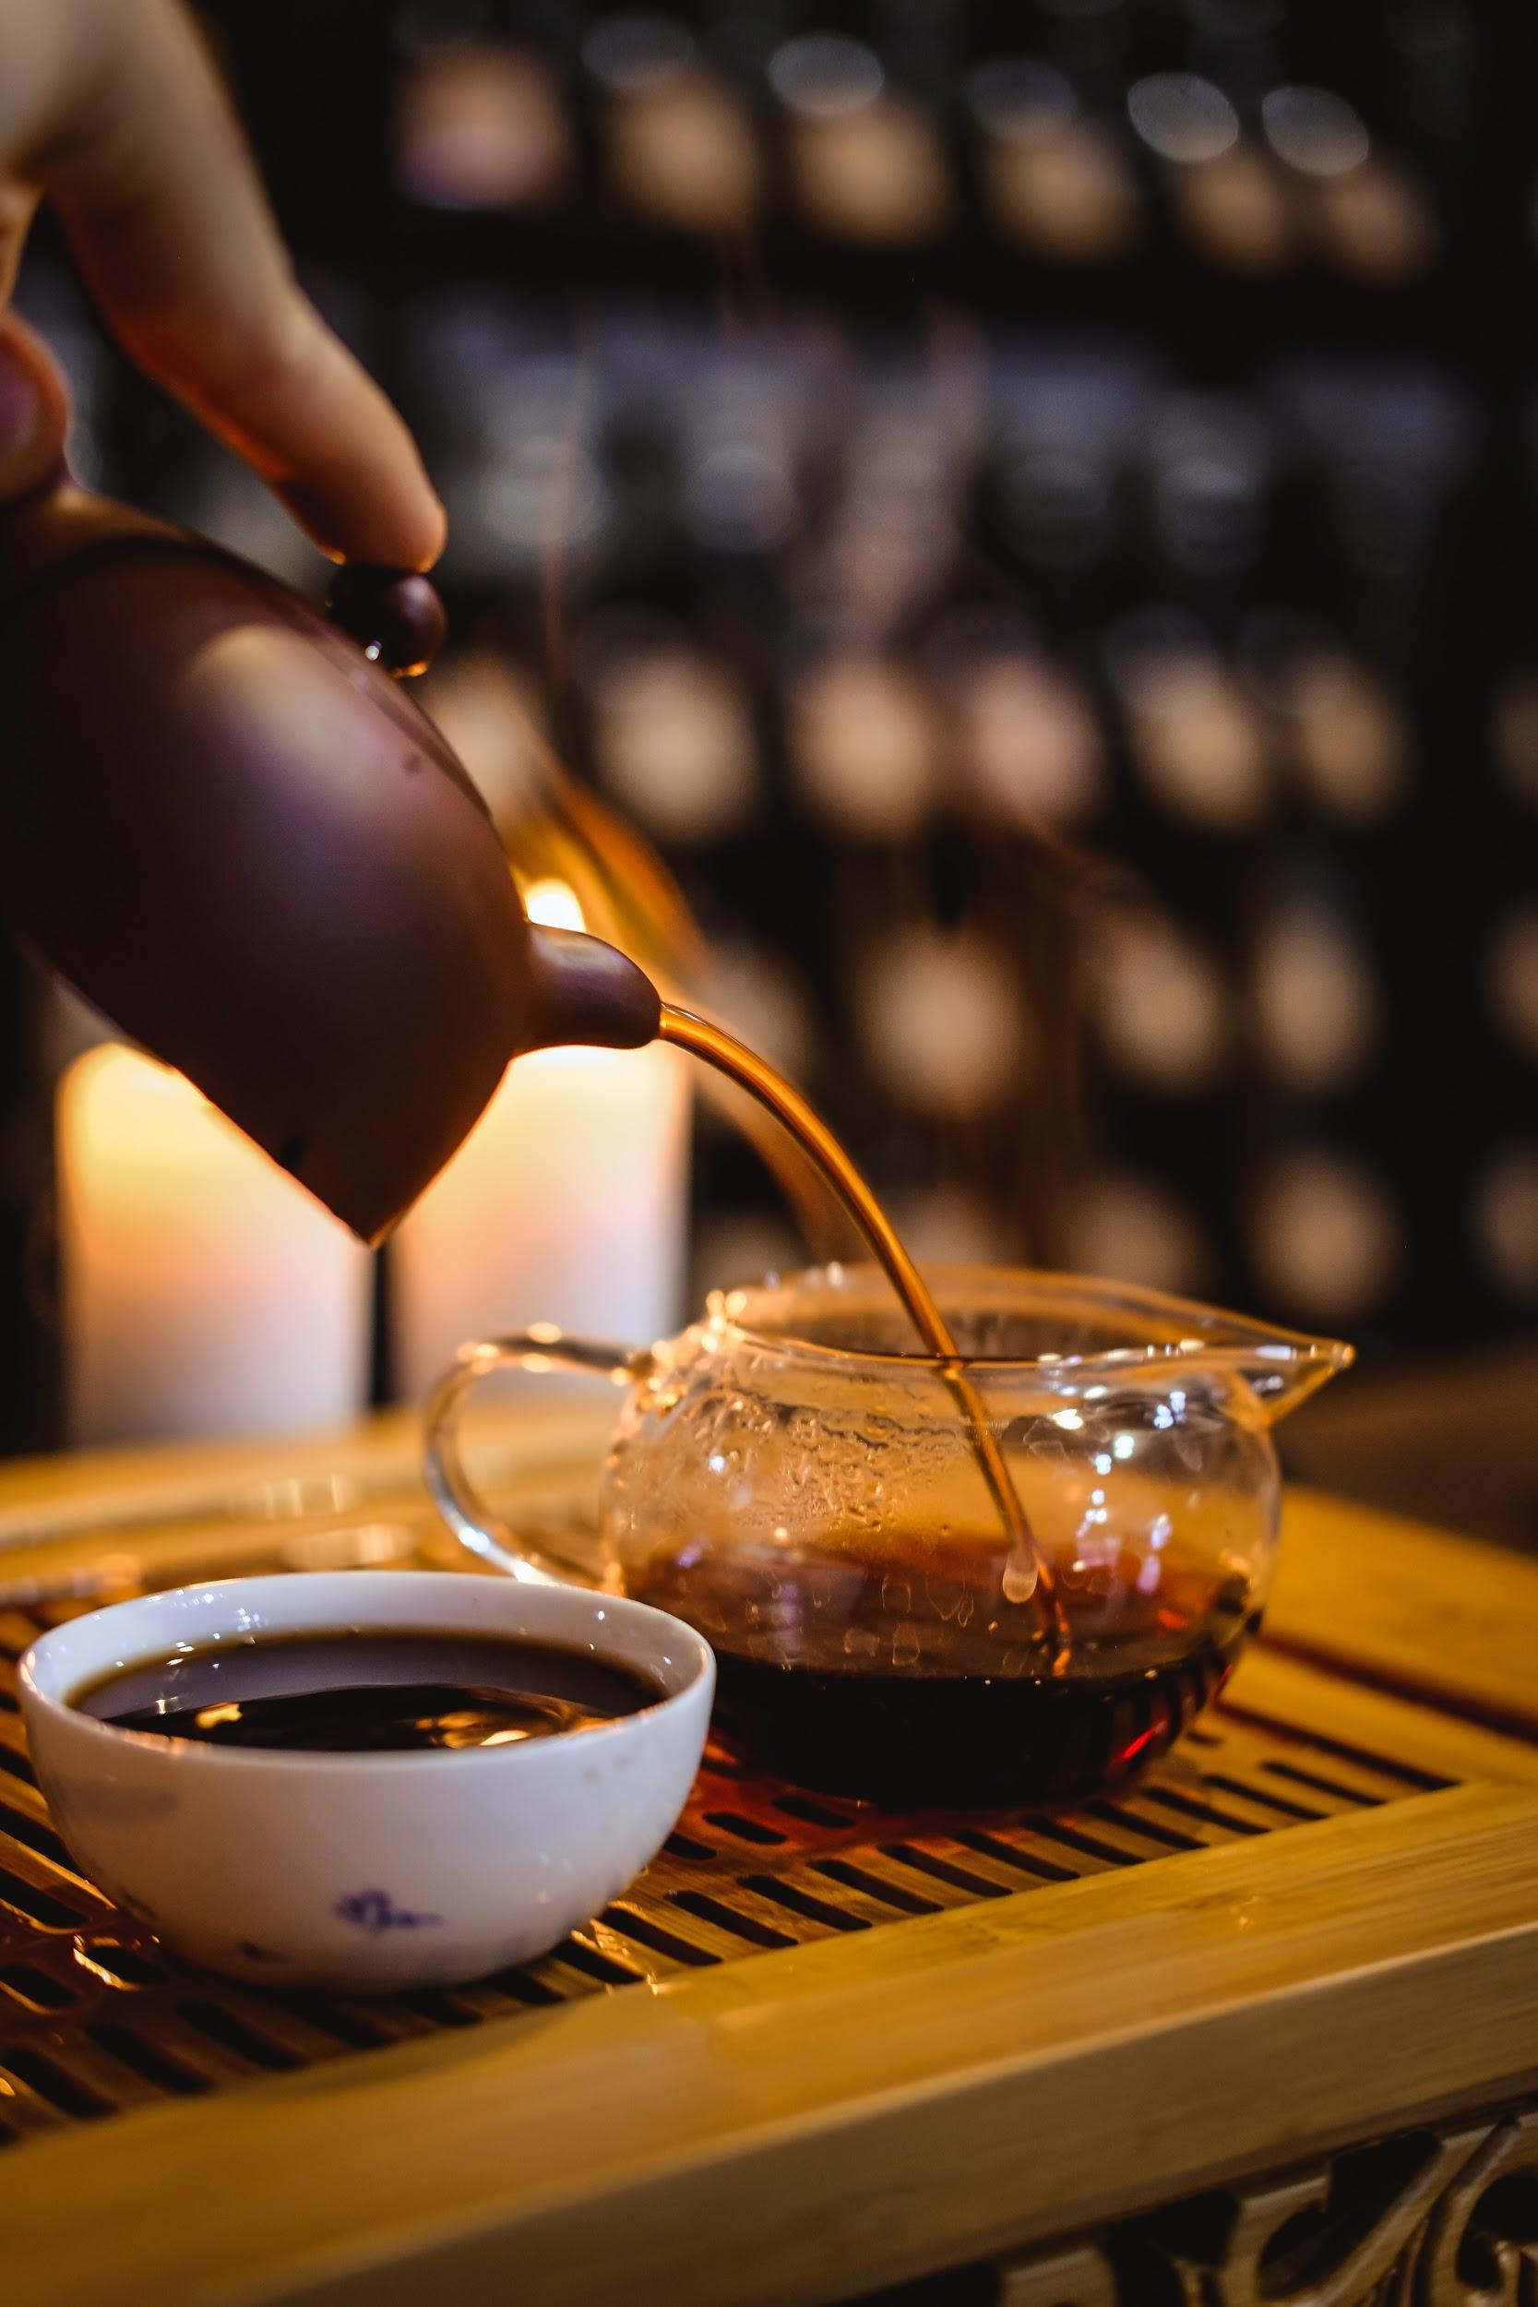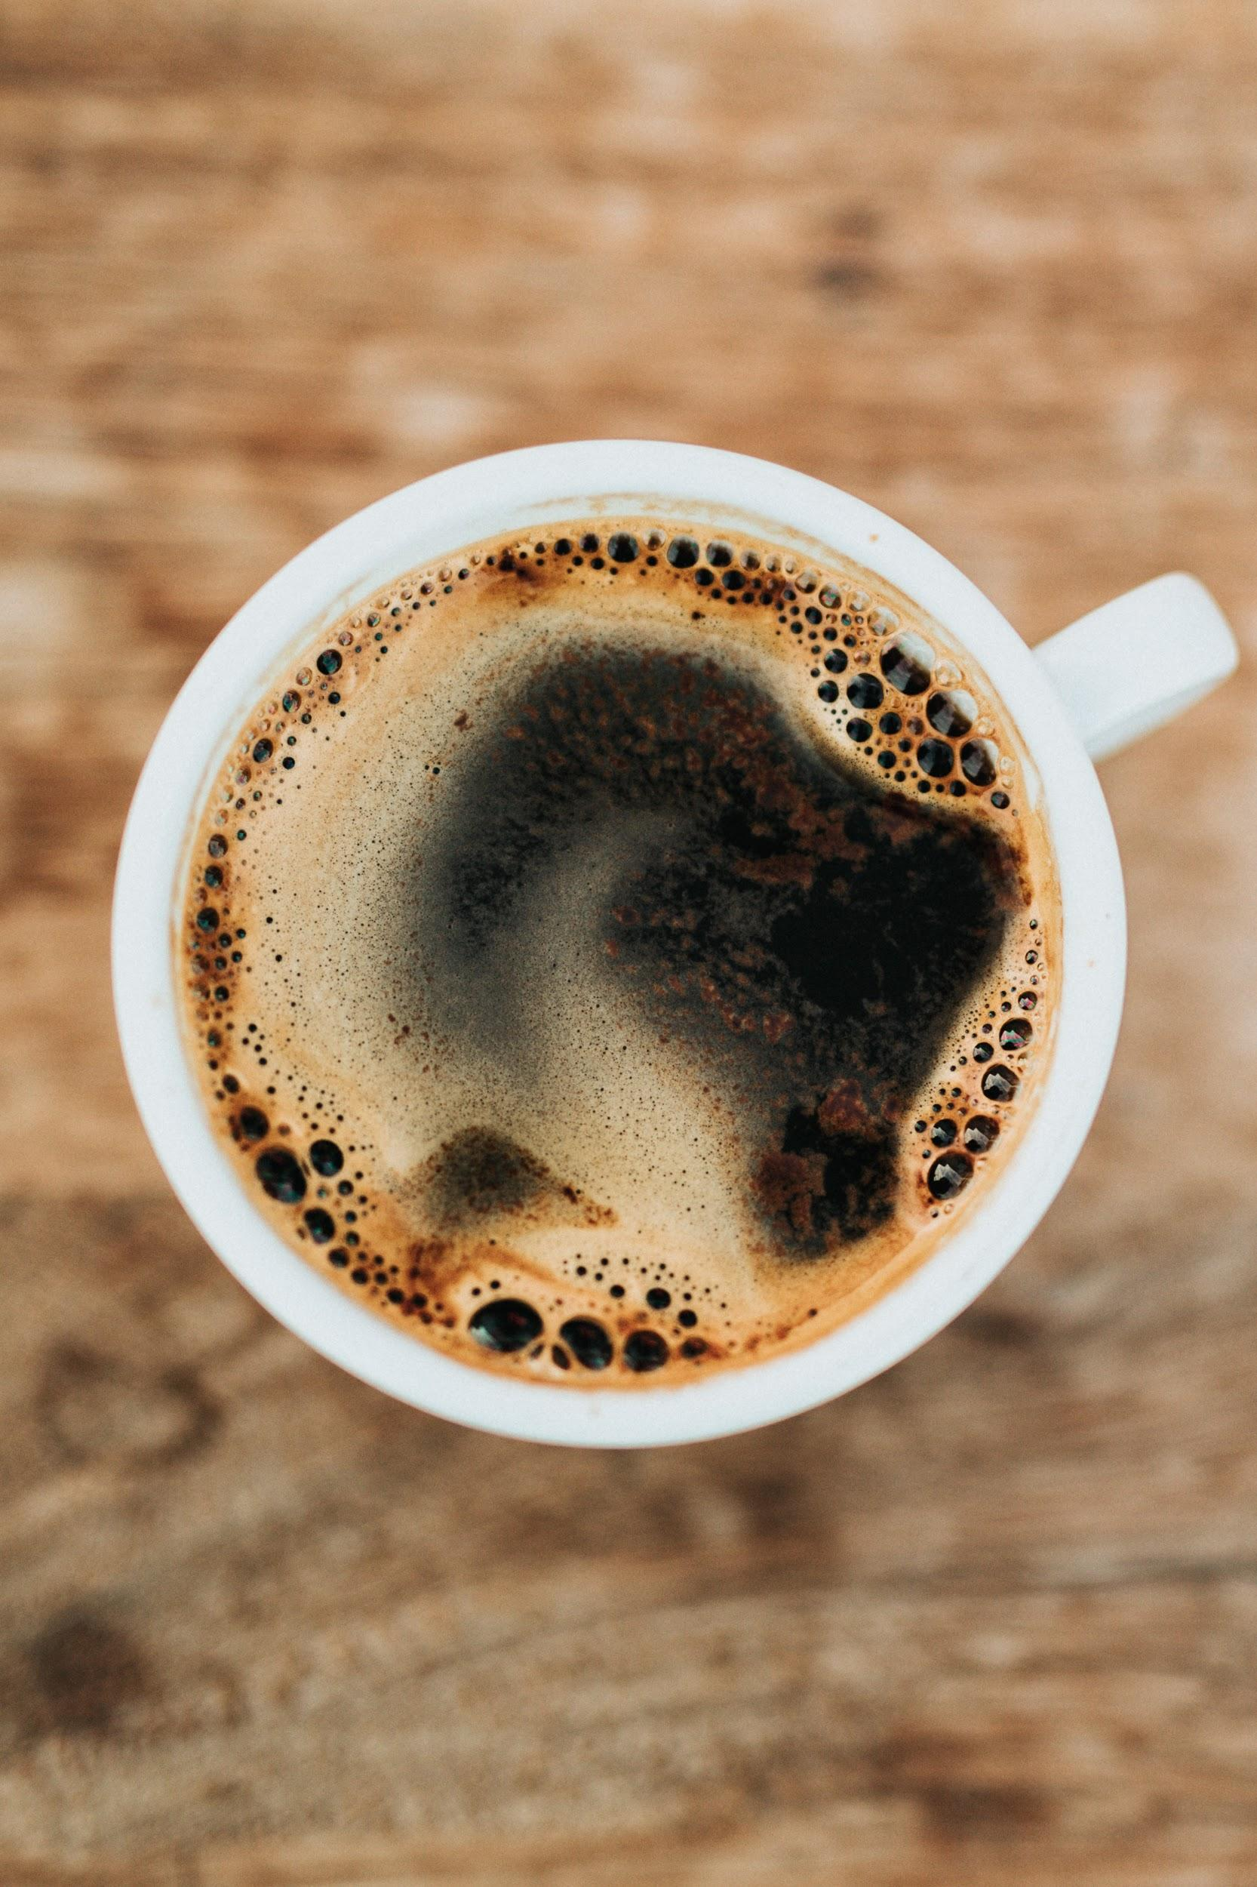

Travel to a store near you to experience Charlie’s Cafe! <Link text/image to location page>

**Our Story:**

Here at Charlie’s Cafe we understand not only the importance of quality beverages, but also the importance of community. We strive to create a positive experience for all of our customers by creating genuine connections with our guests, timely service, and providing a community space for all of our customers to collaborate and create. Charlie’s is more than coffee, we are a community. 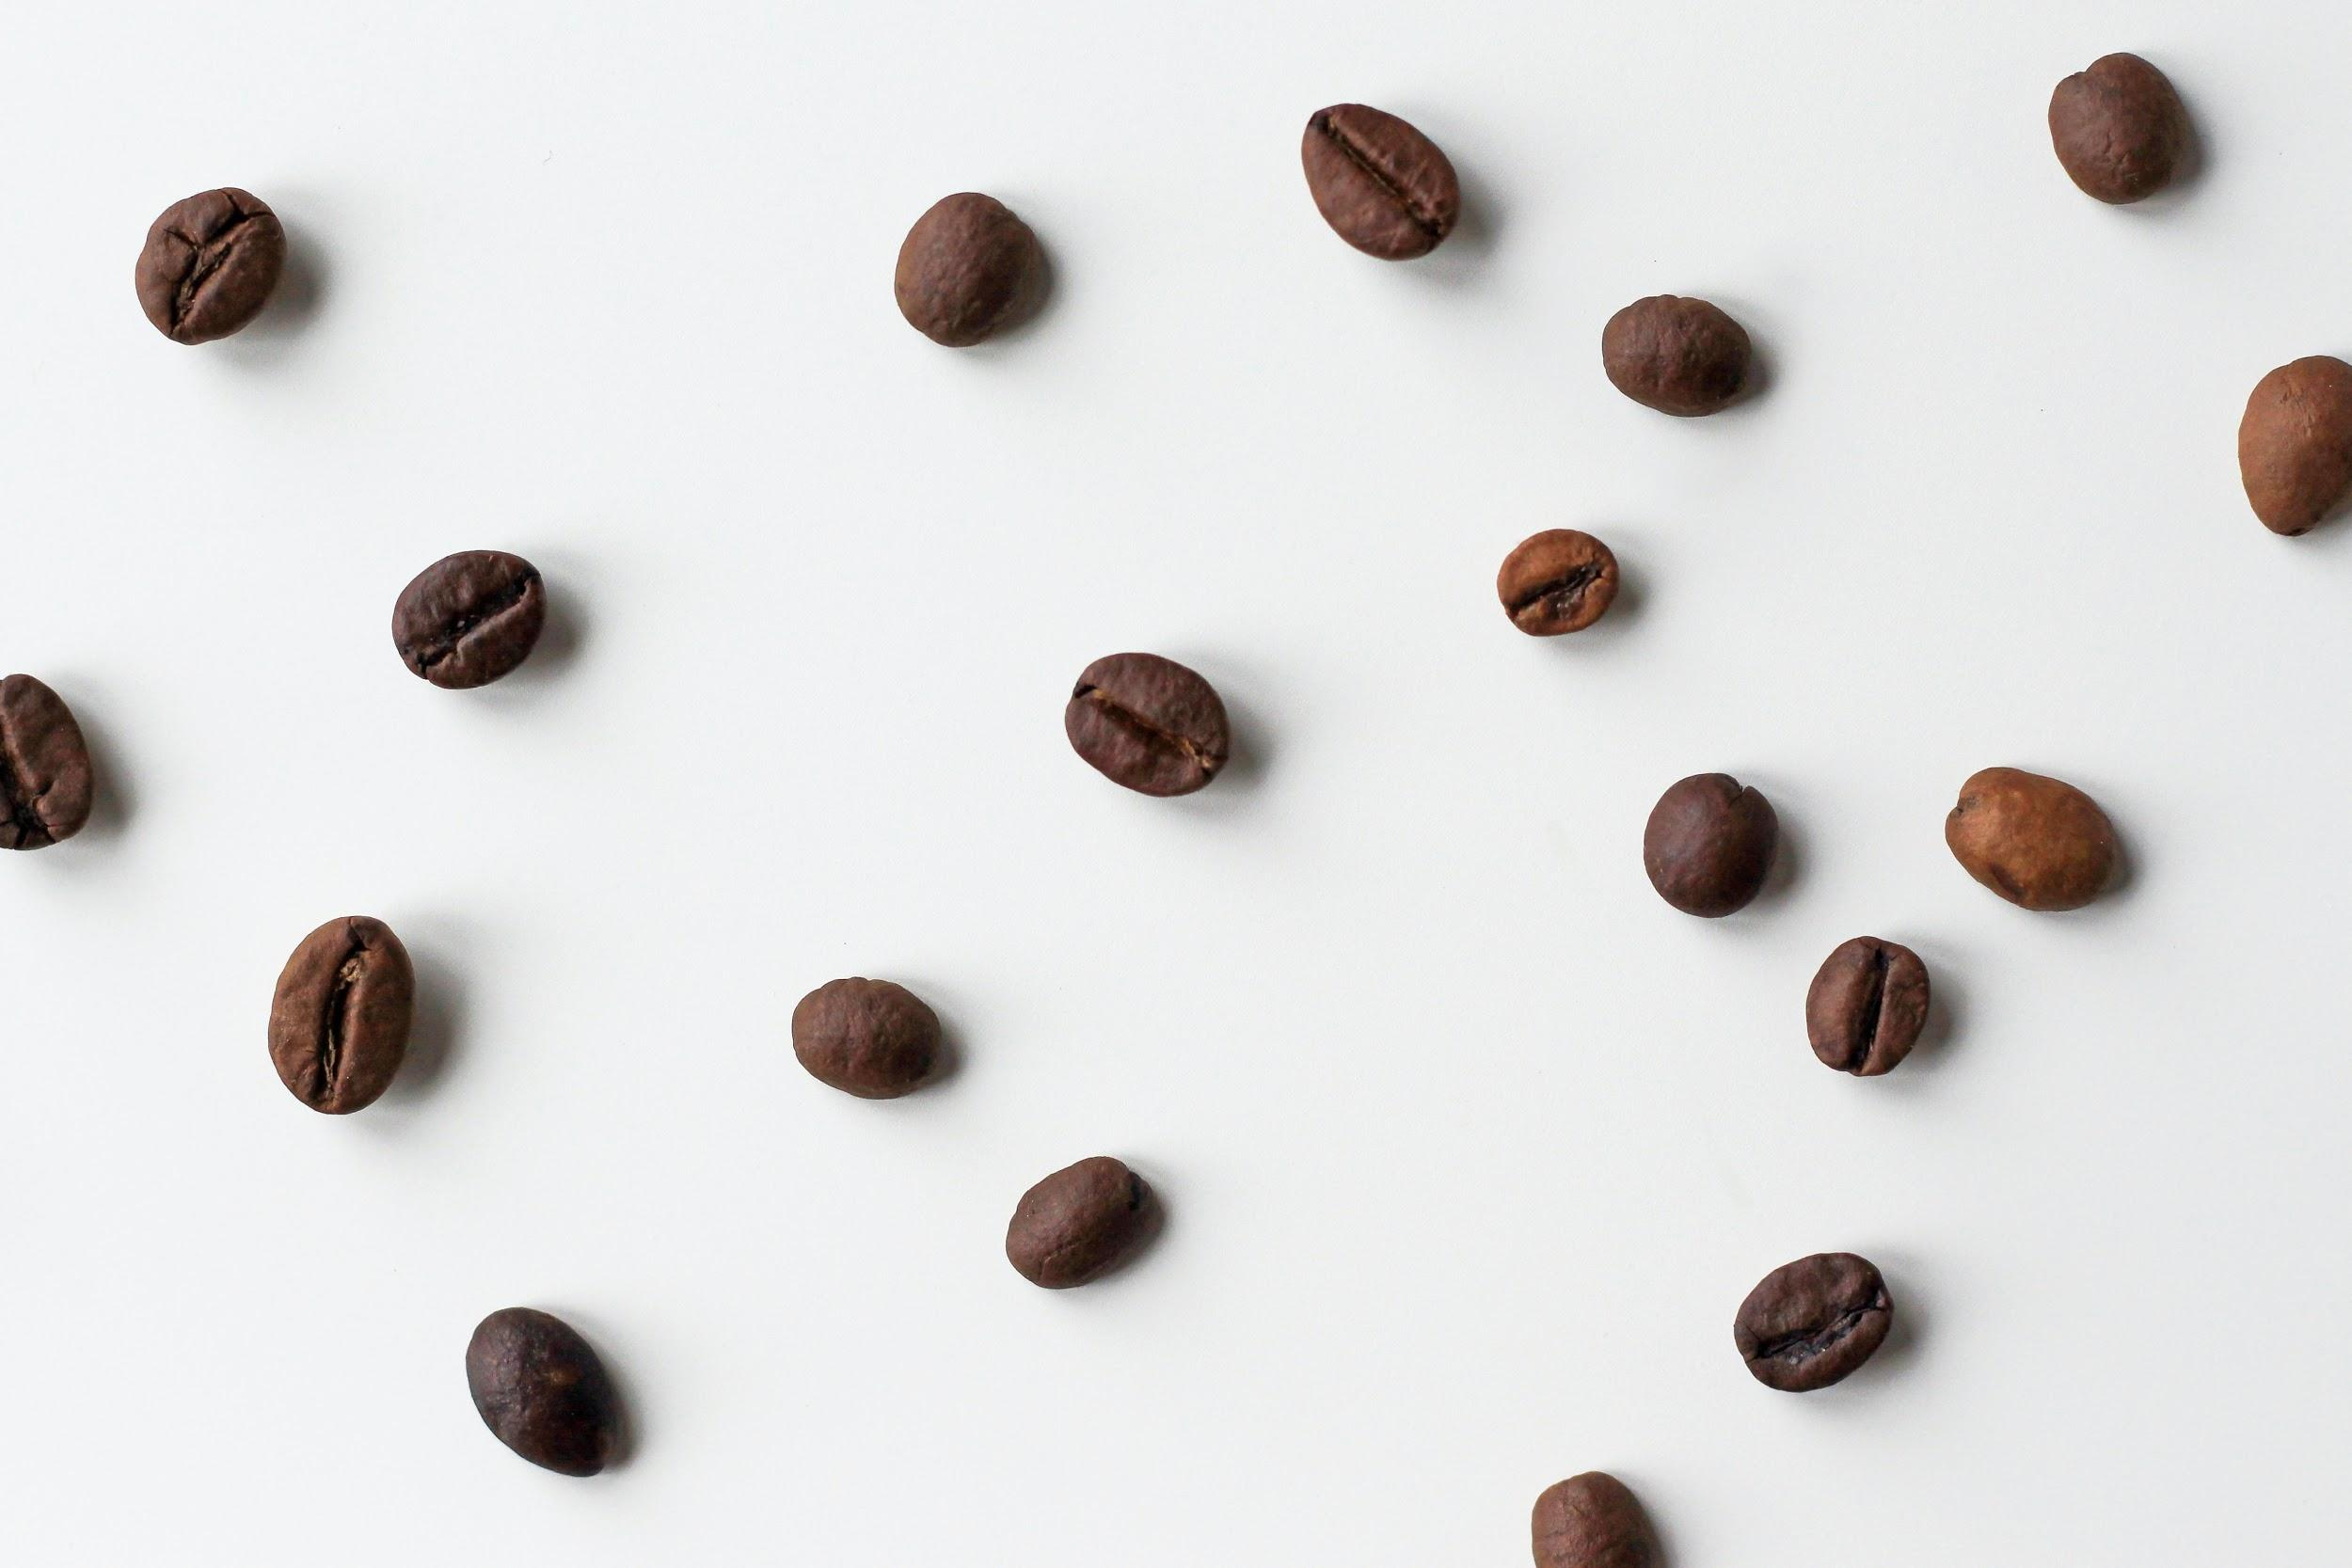

**Menu:**

Specials:

*All specials are either double or triple shots

Thai Iced Cappuccino

Channel your inner exotic spirit with a double shot of espresso finished with sweetened condensed milk

Joyous Almond Latte

Imagine drinking the candy bar…only better!!

Banana Nut Mocha

You’ll go bananas!! It’s so yum.. Yep, just yum!

Hot Teas

Black

Green

Earl grey

Jasmine

Raspberry Pomegranate

Chamomile

Lemon Ginger

Mint

English Breakfast Chai

Yerba Mate

*Add emergen C +$1

-orange or raspberry

Iced Drinks

$1 refills on iced teas and iced coffees when you keep your cup!

small reg large

Coffee …. 2.75 ….

Americano 2.00 2.50 3.25

Latte 3.55 3.95 4.75

Mocha 3.75 4.25 5.00

Chai 3.25 3.95 4.25

Mocha Frappe …. 4.50 5.50

Thai Cappuccino …. 4.25 ….

Thai Tea …. 3.25 ….

Iced Tea …. 2.50 2.75

Green Morrocan Mint

Black Passion fruit

Cucumber Mint Lemonade

Hot Drinks

Drip Coffee . . . . . . . 2.15 2.50 2.75

Espresso 2.25 2.75 3.25

Macchiato 2.35 2.85 3.35

Americano 2.00 2.50 3.25

Cappuccino 2.95 3.50 4.25

Caffe Latte 3.55 3.95 4.75

Caffe Mocha 3.75 4.25 5.00

Caramel Macchiato 3.95 4.45 5.05

Hot Chocolate 3.25 3.75 4.25

Chai 3.25 3.95 4.25

Organic Tea 2.50 …. ….

Black

Green

Earl grey

Jasmine

Raspberry Pomegranate

Chamomile

Lemon Ginger

Mint

English Breakfast Chai

Yerba Mate

*Add emergen C +$1

-orange or raspberry

Milk Alternatives:

Almond milk + .75

Soy milk +.50

*** Food menu on location only

**Locations:**

Inside ASU Biodesign Institute

727 E Tyler St, Tempe, AZ 85281

+14809653515

Hours:

Monday-Thursday: 7AM-4PM

Friday: 7AM-2PM

Saturday-Sunday: CLOSED

Inside ASU Hayden Library

300 Orange Mall, Tempe, AZ 85281

+14809653605

Hours:

Monday-Friday: 7AM-3PM

Saturday-Sunday: CLOSED

Inside ASU Design North

810 S Forest Mall, Tempe, AZ 85281

+14807273463

Hours:

Monday-Thursday: 7AM-7PM

Friday: 7AM-4PM

Saturday-Sunday: CLOSED

**Webpage Footer**



Find a Charlie’s near you! <link to locations page>

Contact us! <form bar>

© 2020, Charlie’s CafeAll Rights Reserved