

Contents

[**RULES AND CONCEPTS *Rev9.5*** 3](#_Toc148049060)

[GAME SETUP 3](#_Toc148049061)

[BASIC GAMEPLAY 4](#_Toc148049062)

[MOVEMENT 4](#_Toc148049063)

[SUSTENANCE 5](#_Toc148049064)

[SHOOTING 5](#_Toc148049065)

[MELEE 6](#_Toc148049066)

[OVERWATCH 6](#_Toc148049067)

[FLANKING 7](#_Toc148049068)

[TERRAIN 7](#_Toc148049069)

[PROMOTION 7](#_Toc148049070)

[TRAUMA 8](#_Toc148049071)

[COVER 8](#_Toc148049072)

[GENERAL ENVIRONMENT 9](#_Toc148049073)

[EXPECTATIONS OF PLAYERS 9](#_Toc148049074)

[**SOLDIER SKILLS** 9](#_Toc148049075)

[WEAPON SKILLS 11](#_Toc148049077)

[SUPPORT SKILLS 11](#_Toc148049078)

[**GAME CALCULATIONS** 1](#_Toc148049079)

[SHOOTING 1](#_Toc148049080)

[MELEE 2](#_Toc148049081)

[JUMP/FALL FROM HEIGHT 2](#_Toc148049082)

[WEATHER 2](#_Toc148049083)

[TRAUMA 3](#_Toc148049084)

[DIPLOMACY/ELECTRONICS 3](#_Toc148049085)

[MOVEMENT 4](#_Toc148049086)

[STRUCTURAL COLLAPSE 4](#_Toc148049087)

[LEADERSHIP 5](#_Toc148049088)

[SIGHT RADIUS 5](#_Toc148049089)

[HEALING 5](#_Toc148049090)

[STEALTH/CAMOUFLAGE 5](#_Toc148049091)

[LOUD ACTIONS 6](#_Toc148049092)

[GRENADES 6](#_Toc148049093)

[DRUGS 7](#_Toc148049094)

[ABILITY UPGRADE 7](#_Toc148049095)

[POISONING 7](#_Toc148049096)

[LAST STAND 8](#_Toc148049097)

[RADIOS 8](#_Toc148049098)

[**ABILITY LIST** 9](#_Toc148049099)

[ITEM LIST 1](#_Toc148049100)

[Life Safety Items 1](#_Toc148049101)

[Habiliments 3](#_Toc148049102)

[Combat Items 4](#_Toc148049103)

[Tools 5](#_Toc148049104)

[SKILLS LIST 8](#_Toc148049106)

[XP TABLE 9](#_Toc148049107)

[DRUG REGISTER 9](#_Toc148049108)

[AP CHART 10](#_Toc148049109)

[WEAPON SPECIFICATIONS 11](#_Toc148049110)

# 

# RULES AND CONCEPTS *Rev9.6*

## GAME SETUP

* The Gamemaster is responsible for declaring all battlefield parameters with the assistance of the ‘Map Priefing Tool’ and ‘GM Task List’.
* Some soldiers must select a Prime specialty, some must select a Weapon specialty and some must select a Support specialty. The breakdown is as follows and also applies to the composition of the squad initially fielded:



* One Prime specialist from each team will assume the role of ‘Commander’. He will be the team’s Leadership specialist (who must always field on the first turn) and will be issued with thermal goggles which cannot be removed from him.
* All soldiers will be randomly allocated two additional skill points (to different skills) and a native terrain.
* All soldiers shall start with one randomly allocated ability.
* Specialties cannot be duplicated within a team and abilities cannot be duplicated within or between teams.
* Depending on the Gamemaster’s wishes, soldiers may deploy onto the battlefield with preselected gear.
* No soldier can be damaged by any means until they spend AP or the end of the first turn in which they are able to spend AP. The event which would have caused them damage still occurs.

## BASIC GAMEPLAY

* Every turn, Players may utilise up to 3AP for each of their soldiers- this may be increased via Leadership.
* Players may choose not to use all available AP.
* Players may choose to complete their soldiers’ turns in any order. A soldier may not perform any action once play has been passed to his ally or the Player has ended their turn.
* Players must not enter the command zone or otherwise glean game information during the Opponent's turn unless instructed by the Gamemaster.
* Once a decision is verbalised or a soldier has been moved, decisions and actions cannot be undone by the Player (at the discretion of the Gamemaster). Games can never be tied- there is always a winning team.

## MOVEMENT

Every turn, a soldier can move up to his maximum range for 3AP, alternatively, he may spend 2AP to move up to half his maximum range or 1AP to move up to 3cm. Only one Movement Action is permitted per soldier (though successful Leadership rolls each grant an additional MA).

If a soldier’s maximum range falls below 6cm, it shall only cost 2AP to perform a full move and 1AP to perform a half move. All soldiers capable of moving at all shall be able to move 3cm for 1AP.

* A soldier’s position (and movement) will be measured from his left foot.
* If possible, soldiers may elect to jump (or fall) from elevation (sometimes vaulting is required), they may then lose HP (see Calcs).
* Horizontal jumping up to 4cm is permitted provided a sensible landing is possible.
* As a general rule, the movement penalty to vault will be double the height of the vault obstacle or triple the height of the obstacle if the soldier’s arms are required to vault safely.
* Ducking under obstacles consumes as many cm of movement as the obstacle is shorter than the soldier’s height (min 1cm)- the soldier must be able to comfortably fit under the space and cannot end his turn there.
* Soldiers may move around ledges if there are appropriate handholds and there is enough ground purchase to comfortably cover the length of their foot.
* Soldiers may walk up or down inclines less than 20° in slope. Inclines greater than this can only be slid down (for free) as part of another movement action. Doors do not cost any AP to open but Players will consume 1cm of movement should they wish to open or close a door- doors will be left open if Players do not specify.
* When dragging a body (unless conscious, body will assume dragger’s C and F), soldiers may move as many cm as they have Str for 1AP- multiple such movements are possible up to their maximum AP and all other actions and regular movements are disabled. Dragging conscious enemies is only possible if controlling them in an engagement (broken when the dragging starts), the enemy must be dropped within 3cm of the dragger at the end of his turn.
* Soldiers can play dead for 0AP and will stay in that state until they use AP. Playdeaders appear as corpses but act as an unconscious bodies in all game calculations. Their L, Dip and Elec will be set to 0 (can be increased again).

Players are ultimately responsible for the positioning/orientation/profile of their soldiers. Even if the Gamemaster moves a soldier, it is the Player’s responsibility to ensure they are satisfied with the final position. Once a new command is made or the Player is dismissed, the actions of the previous turn shall be locked in. Given soldiers may have to be removed from the board between turns, Players must ensure that Gamemasters are clear on their desired positioning before they are dismissed.

Players may bend and balance their soldiers however they wish provided the soldier is in a standing position (with one or both feet on the ground and vertically in line with their shoulders) or is, at least, leaning against an object in an upright position. Soldiers will sit down with their body upright in Last Stand and lie down flat if Unconscious, killed or playing dead.

## SUSTENANCE

Soldiers must regularly eat or drink during the game. Going without sustenance for:

* 10 turns (Hungry) incurs a 20% movement penalty.
* 20 turns (Very Hungry) incurs a 50% movement and Weapon skill penalty when engaging in combat calcs. The soldier's HP will also be halved (rounded down).
* 30 turns (Starving) will render the soldier Unconscious.
* 40 turns will kill the soldier.

Soldiers may eat/drink in advance. Eating 3 meals during the first round secures a soldier penalty-free until round 41.

Eating or drinking after a penalty has been imposed will remove its effect once the appropriate sustenance has been achieved (starvation induced damage will be refunded).

## SHOOTING

* Shooting and suppressing are permitted if there is a LOS from the shooter’s eye to any part of a target’s body (excluding items/weapons).
* A missed shot can never scatter to hit the intended target or other soldiers engaged in melee with the target. Missed shots are resolved up to 5cm away from the centre of the target area the shooter can see.
* If a shot aimed at an engaged target is successful, it is equally likely to hit the target or any combatant engaged with the target.
* Suppressing a soldier will also suppress any combatants he is engaged with.
* To aim, a soldier must spend aiming AP before every shot- even when firing consecutively at a target.
* If an aimed shot probability is under 25%, a soldier will be given the option not to take the shot (shot AP will be refunded while aiming AP won’t).
* Pistols may be stowed in any slot. Other guns can only be stowed in backpack, BA or JA slots.

Shooting range brackets are defined as follows:



## MELEE

To engage in melee combat, soldiers must be able to see targets (teamsight enabled) with an effective SR>0. Melee attacks may still be performed with minor obstructions between the combatants (such as Poor cover) at the discretion of the Gamemaster. There are several cases in which the melee combat calculator does not need to be run (other special cases also apply):

* Stealth attacks (if the defending team cannot see the attacking soldier) kill instantly if the attacker’s F exceeds the defender’s ­M.
* Attacks on overwatchers kill instantly unless the defender’s M exceeds the attacker’s M.
* Attacks on Unconscious defenders or playdeaders kill instantly.

If nothing else prevents a melee attack then the damage calculation begins. Melee attacks cannot miss- though some may be blocked or countered. See Calcs for more information.

* Only the single best melee weapon held will be input into the calculator. The other weapon will be dropped.
* After an uncountered melee attack, melee engagements are ‘controlled’ by the soldier with the higher R. If R's are equal, then Str followed by M will determine the controller. If these are all equal, neither of them shall control the engagement.
* Engagements may be generated with the ‘attacker’ electing not to follow through with the melee attack (AP will still be lost but the enemy cannot counterattack).
* Engagements can only involve two opposing soldiers- although a soldier may be involved in multiple engagements.
* Unless they are controlling the engagement, engaged soldiers may not be interacted with.
* Soldiers involved in engagements they do not control can only attempt melee attacks or fire a handheld pistol or SMG (unaimed).
* Engagements will be broken if their controllers move, lose all sight, cancel the engagement, receive damage, fire guns (excluding unaimed pistols and SMG’s), take cover or perform any action requiring more than 1 AP. Engagement controllers may perform any other action without breaking engagements.

If the attacker’s turn does not begin within melee range (3cm) of his defender, melee attacks may be made for 0AP as part of a movement of any distance (with a damage penalty). If within an engagement, or the attacker is within 3cm of a seen enemy, it will cost 2AP to perform a ‘static’ melee attack.

## OVERWATCH

* While on overwatch, a soldier will take one aimed reaction shot (only during the Opponent’s turn) against a soldier he would otherwise be capable of detecting- this happens the moment he detects an enemy.
* Enemies already detected at the moment overwatch is entered will not be shot unless they move.
* Overwatch acts in a specified arc of 90° or less.
* If a soldier has been hit via an overwatch shot he must roll inv. R to complete his move, else he shall suffer ‘overwatch daze’ which stops him mid-move and removes his remaining AP.
* An overwatch shot can only be taken if the shooter personally sees the target (teamsight is disabled during overwatch).
* Receiving damage or starting a beginning new turn shall remove a soldier’s overwatch.

## FLANKING

Shooting:

* A target is flanked on 1 side if there is an enemy beyond 80° (relative to the target) of another enemy both of whom can see the target.
* A target is flanked on 2 sides if there is an enemy beyond 80° (relative to the target) either side of another enemy all three of whom can see the target.
* A target is flanked on 3 sides if the chain of 80° proximity is continued to include four separate enemies.
* It is not possible for a soldier to be flanked on more than 3 sides.
* Flanking may run in a clockwise or counterclockwise direction but not both.

For flanking to be valid during a shot, a flanker must see the target in his own right. There is no requirement to be able to shoot him also. Flanking ignores angle changes due to elevation.

Melee:

* A defender is flanked on 1 side if there are two enemies within melee range of him
* A defender is flanked on 2 sides if there are three enemies within melee range of him
* A defender is flanked on 3 sides if there are four enemies within melee range of him
* It is not possible for a defender to be flanked on more than 3 sides.

Nearby units must be within 3cm of the defender and able to make a melee attack (if they had enough AP) for melee flanking to be considered.

## TERRAIN

* There are four terrain types- Alpine, Desert, Jungle and Alpine.
* Urban is opposed by Jungle and Desert is opposed by Alpine.
* Soldiers not on native or opposite terrain will be considered to be in neutral terrain.
* While in native terrain, a soldier's C and F will increase by 1. Equivalent penalties apply for opposite terrain.
* Terrain also affects a soldier’s movement and shooting/melee performance.

## PROMOTION

* Once a soldier obtains enough experience, he shall be promoted according to the below table:



* Upon promotion, soldiers are awarded three skill points. One skill point is always assigned to his specialty, one is selected by the Player and one is randomly assigned (never to the specialty skill or the selected skill for that promotion).
* The selected skill point cannot be spent on the soldier's specialty or the same skill as the previous promotion’s selected skill.
* Upon achieving Captaincy, soldiers may attempt an Ability Upgrade (see Calcs).
* Players will be informed when they earn XP and how they have earned it.
* Players should consult the ‘XP Table’ for action vs XP relationships.

## TRAUMA

If a soldier sees a comrade die within his direct LOS (no teamsight), there is a chance he may be negatively affected (see Calcs).

There are five mental health states soldiers can assume:

* Committed🡪 No modifiers.
* Wavering🡪 10% movement penalty and weapon skill reduction when shooting.
* Shaken🡪 20% movement penalty and weapon skill reduction when shooting.
* Frozen🡪 Unless he is controlled in an engagement, the soldier immediately equips his gun and continually fires it unaimed (or aimed if unaimed shooting is impossible) at the nearest enemy (with a 40% Weapon skill reduction while shooting). If he cannot see any enemies, he shall fire at any cover the Player chooses (all for 0AP). Once the gun is empty (or if he had no gun to begin with) the Player will resume control of the soldier as normal with a 40% movement penalty added to the weapon skill penalty. Leadership is disabled.
* Broken🡪 The soldier will drop all items/weapons (excluding armours) then use his every AP making full movements (without trauma-related penalty) towards the tile he fielded from along the most AP-efficient path. Upon arriving at this tile (or as close as possible to it) he will be removed from the battlefield and be registered as a death on the tile he fled from. Leadership is disabled. Broken soldiers always act first within their teams and are not contained by melee engagements. Players resume control of Broken soldiers while they are in Last Stand.
* Desensitised🡪 Control of the soldier shall be returned to the Player with all trauma-related modifiers removed. Desensitised soldiers can never change trauma state. They function the same as Committed soldiers.

## COVER

Cover is divided into 4 gradations classified at the Gamemaster’s discretion. As a guide:

* No cover refers to features which offers no reasonable protection.
* Poor cover (over 20% coverage) refers to obstacles which a soldier could be largely concealed behind it if he were proned or otherwise reach his knees. Taller obstacles may also be considered Poor cover if they are of poor construction. Examples include soldier corpses, low parapets and ladders.
* Average cover (over 45% coverage) refers to obstacles which would completely conceal a proned soldier or otherwise reach between his upper thighs and navel. Taller obstacles may be considered Average cover if they have holes or weaknesses. Examples include goody boxes.
* Good cover (over 75% coverage) refers to obstacles which ordinarily reach between a soldier’s chest and neck. Examples include a full height side wall of sturdy construction or a sandbag wall of suitable height.
* Excellent cover (over 90% coverage) refers to purpose built shooting holes or features that serve as extremely comfortable shooting locations. Examples include the gothic holes in the iron walls.

If a soldier does not formally 'take cover', any LOS from a shooter allows a No cover shot to be made. When a soldier enters cover, he will be shielded by all cover elements within 3cm of his position- obstructions outside this radius offer no protection. The soldier’s cover level will depend on the degree to which valid obstructions block the shooter’s view. Soldiers will remain in cover until they move or perform a melee attack.

Destructible cover may be reduced or destroyed if struck by a bullet, explosive or significant impact. Cover will be reduced according to the power of the weapon that is firing upon it (as per the ‘cover damage’ weapon stat). Critical shots completely destroy destructible cover.

## GENERAL ENVIRONMENT

* There are many features (POI’s) in the physical environment which may be interacted with. These include goody boxes, dipelec terminals, drug cabinets, explosive barrels and doors.
* If an explosive barrel is shot it shall act as a detonating grenade.
* The contents of POI’s will be known once a soldier is within 3cm.
* Destroyed structures may create new vantage points and exposures.
* Corpses are always visible and act as Poor cover. Rubble can become a mixture of covers.
* All ‘loose’ items will remain visible as part of the environment at all times (no LOS required).

## EXPECTATIONS OF PLAYERS

It is the Player’s responsibility to record or otherwise remember (and remind the Gamemaster of):

* The locations and orientations of all their soldiers
* The effects of any ‘manual’ abilities and other game modifiers
* All their soldier’s statistics (Player’s will be informed every time there is a change)
* Current weapon ammo (AP for aiming will be lost if a shot is requested on an empty clip)

The Gamemaster might not remind Players of these considerations. If Players cannot provide accurate and timely recollections of the above, there may be negative consequences. Turns may be time-limited.

# SOLDIER SKILLS

Skills (or specialties) are divided into three categories- Prime, Weapon and Support. Prime skills develop essential soldiering capabilities, Weapon skills increase proficiency in a particular weapon category and Support skills enhance non-combat proficiencies.

### PRIME SKILLS

**LEADERSHIP (**L**)**

Impacts a soldier’s likelihood of receiving additional MA and AP as well as the quantity of both.

**HEALTH (**H**)**

A soldier’s maximum health. Whenever a soldier’s H changes, a corresponding HP change will be applied- the inverse is rarely true. In addition to active service, other states of health exist in the game:

* Stunned- When a soldier is stunned his SR, E, F, C and M reduce to 0, he will drop handheld items, and he cannot take any action. Multiple stun events upon a soldier do not stack and will be carried out concurrently.
* Last Stand- The soldier cannot move but otherwise performs his turn normally (various penalties will also apply). Once a soldier is in Last Stand, any increase in HP will return him to functional service.
* Unconsciousness- Unconscious soldiers incur stun penalties and act like corpses. If any damage is taken while a soldier is Unconscious, he shall die. Unconscious soldiers lose the use of their abilities. If a Player’s entire fielded team is Unconscious, the soldier who has been Unconscious the longest shall be killed off and a new deployment will occur. If the Player has no reinforcements remaining their Opponent shall win.

**RESILIENCE (**R**)**

A soldier’s ‘grit’ affecting dozens of in-game mechanics.

**SPEED (**S**)**

A soldier’s maximum movement range.

**EVASION (**E**)**

Impacts a soldier’s capacity to avoid gunfire.

**STEALTH (**F**)**

Reflects a soldier's capacity to conceal himself from an enemy during his own turn. No formal move is required to 'enter' stealth, it is constantly being compared against the P of all fielded enemies (see Calcs).

**PERCEPTIVENESS (**P**)**

Reflects a soldier’s skill at detecting items/weapons and hidden enemies- both moving and stationary.

**CAMOUFLAGE (**C**)**

Reflects a soldier's capacity to conceal himself from an enemy during that enemy's turn. No formal move is required to 'enter' camouflage, it is constantly being compared against the P of all fielded enemies (see Calcs).

**SIGHT RADIUS (**SR**)**

A radial measure of the distance a soldier can see around him in full visibility.

### WEAPON SKILLS

**RIFLE (**R**)**

Determines a soldier's capacity to effectively employ rifles in combat.

**ASSAULT RIFLE (**AR**)**

Determines a soldier's capacity to effectively employ assault rifles in combat.

**LIGHT MACHINE GUN (**LMG**)**

Determines a soldier's capacity to effectively employ machine guns in combat.

**SNIPER RIFLE (**Sn**)**

Determines a soldier's capacity to effectively employ sniper rifles in combat.

**SUB-MACHINE GUN (**SMG**)**

Determines a soldier's capacity to effectively employ sub-machine guns in combat.

**SHOTGUN (**Sh**)**

Determines a soldier's capacity to effectively employ shotguns in combat.

**MELEE (**M**)**

Determines a soldier's capacity to effectively attack and defend in hand-to-hand combat.

### 

### SUPPORT SKILLS

**DIPLOMACY (**Dip**)**

Influences how well a soldier can negotiate with terminals and radios to benefit him and his team. Each terminal in the game environment may be negotiated with once per soldier per game. A terminal will be destroyed if it takes any damage or if a soldier spends 3AP (within 3cm) to deactivate it. The soldier responsible for disabling it will be placed on 3HP (unless he is already below 3HP). Terminals may not be targeted by shooters.

**ELECTRONICS (**Elec**)**

Influences a soldier's capacity to hack terminals and radios to benefit him and his team. Each terminal in the game environment may be hacked once per soldier per game. A terminal will be destroyed if it takes any damage or if a soldier spends 3AP (within 3cm) to deactivate it. The soldier responsible for disabling it will be placed on 3HP (unless he is already below 3HP). Terminals may not be targeted by shooters.

**HEALING** **(**Heal**)**

Impacts a soldier’s ability to heal HP and reduce trauma in themselves and their allies.

**STRENGTH (**Str**)**

Increases a soldier’s grenade throwing range and slightly improves movement speed and melee performance.

# GAME CALCULATIONS

## SHOOTING

The probability of a shot hitting its mark is influenced by the calculation of a ‘base’ probability to which multiplicative modifiers are applied. The base probability is equal to:

* (Weapon accuracy at the relevant range)+10\*(shooter’s relevant Weapon skill)-12\*(ˀtarget’s E).
* Pistol skill is equal to the highest (non-melee) Weapon skill a soldier has.
* ˀ*Target Cover-* Poor cover is a 10% penalty. Average cover is a 34% penalty. Good cover is a 62% penalty and Excellent cover is an 88% penalty.
* *Visibility-* Good visibility is a 2% penalty, Moderate visibility is an 18% penalty, Poor visibility is a 26% penalty and Zero visibility is a 64% penalty.
* *Rain-* Moderate rain is a 2% penalty, Heavy rain is an 8% penalty and Torrential rain is an 18% penalty.
* *Oblique wind-* Light wind is a 2% penalty, Moderate wind is a 6% penalty and Strong wind is a 10% penalty. Oblique wind is considered if the line between shooter and target forms an angle of 22.5-67.5° with the wind direction.
* *Crosswind-* Light wind is a 6% penalty, Moderate wind is a 12% penalty and Strong wind is a 29% penalty. Crosswind is considered if the line between shooter and target forms an angle of 67.6-90° with the wind direction.
* *Shooter Health*- between Half and under Full H is a 6% penalty, under Half H is a 16% penalty and Last Stand is a 60% penalty.
* ˀ*Target Health*- between Half and under Full H is a 4% bonus, under Half H is a 14% bonus and Last Stand is a 40% bonus.
* *Shooter Terrain*- Native Terrain is a 4% bonus, Neutral terrain is a 6% penalty and Opposite terrain is an 12% penalty.
* ˀ*Target Terrain*- Native Terrain is a 16% penalty, Neutral terrain is a 2% bonus and Opposite terrain is an 8% bonus.
* *Shooter-to-Target Elevation*- Every cm of elevation is a 1% bonus and every cm of depression is a 1% penalty.
* ˀ*Shooter k/d ratio-* Percentage bonus/penalty is 2\*(Kills-Deaths)% using k/d from overall teams.
* ˀ*Shooter Overwatch-* Overwatch confers a 40% penalty.
* *Shooter Handicap-* Applies the Player Handicap as a percentage penalty.
* ˀ*Flanking against Target-* 1 flanker is a 20% bonus, 2 flankers is a 50% bonus and 3+ flankers is a 100% bonus.
* ˀ*Shooter Stealth-* If the target’s team cannot see the shooter the shot is taken with a 40% bonus.
* Suppression penalties are multiplied together then subtracted but will be ignored if inv. R is rolled.
* Critical shot chance equals ((shooter’s relevant Weapon skill)^2)\*((shot probability)/100)-(target’s E)
* Modifiers marked with “ ˀ ” are neutralised when shooting at cover.

## MELEE

* Melee attacks cannot miss but the outputted damage can vary greatly as per the following calculation:

Damage = [((attacker’s M)\*(starvation modifier)+(attacker’s weapon damage))\*(attacker’s melee modifiers)+(0.2\*attacker’s Str)] – [((defender’s M)\*(starvation modifier)+(defender’s weapon damage)+(charge modifier))\*(defender’s melee modifiers’)+(0.2\*defender’s Str)].

* See ‘Sustenance’ for starvation modifier and ‘Weapon Specifications’ for weapon damages.
* The charge modifier benefits the defender with a 1.9 add-on for half-full moves, a 1.4 add-on for half moves longer than 3cm and a 1.1 add-on for moves under 3cm.
* The damage outputted is rarely an integer- it shall round in favour of the soldier with the higher R. If the R values are equal the value shall round to the nearest whole number.
* ‘Negative’ damage is considered a counterattack with the negative amount applied back onto the attacker.

Attacker’s melee modifiers:

* *Attacker Health*- Half-Full H is a 6% penalty, under Half H is a 20% penalty and Last Stand is a 60% penalty.
* *Attacker Terrain*- Native Terrain is a 40% bonus and Opposite terrain is an 20% penalty.
* *Attacker k/d ratio-* Percentage bonus/penalty is 2\*(Kills-Deaths)% using k/d from overall teams.
* *Flanking against attacker-* 1 flanker is a 16% penalty, 2 flankers is a 46% penalty and 3+ flankers is an 80% penalty.
* *Suppression against combatants-* The suppressing weapons’ suppression values shall be multiplicatively applied as a penalty to all combatants in an engagement

Defender’s melee modifiers:

* *Flanking against defender-* 1 flanker is a 26% bonus, 2 flankers is a 56% bonus and 3+ flankers is an 86% bonus.
* *Defender Health*- Half-Full H is a 20% bonus, under Half H is a 40% bonus and Last Stand is an 80% bonus.
* *Defender Terrain*- Native Terrain is a 40% penalty and Opposite terrain is a 40% bonus.

## JUMP/FALL FROM HEIGHT

HP loss due to a jump or fall from elevation is calculated as ((‘cm of height difference’/4)^2)/2-R (rounded up).

## WEATHER

* *Visibility-* Every turn, if Full or Zero, there is a 50% chance the visibility will change- otherwise there is a 40% chance the visibility will change (split equally in either direction) by one increment.
* *Wind Speed-* Every turn, if Zero or Strong, there is a 50% chance the wind speed will change- otherwise there is a 40% chance the wind speed will change (split equally in either direction) by one increment.
* *Wind Direction-* Wind may blow in one of the 8 directions derived from the cardinal points of a compass. Every turn, there is a 33% chance that the wind will change direction (split equally in either direction) by one gradation.
* *Rain Intensity-* If Zero or Torrential, there is a 50% chance the rain intensity will change, otherwise there is a 40% chance the rain intensity will change (split equally in either direction) by one gradation.

## TRAUMA

* A soldier will take the ‘trauma test’ for every ally he sees die in his own LOS (no teamsight). Soldiers with R>5 are assumed to have passed.
* In order to pass the trauma test the soldier must roll inv. R at least once.

The number of rolls (or attempts) will be determined by the relative rank of the fallen ally and added to the number of rolls awarded due to the proximity:

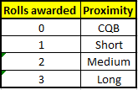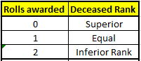

* If a soldier fails this test when the death is caused by a regular shot, starvation, poisoning, routing or a structural collapse he will accrue one trauma point. If a soldier fails this test when the death is caused by a critical shot, melee attack, deathroll or an explosive he will accrue two trauma points.
* Any soldier whose Commander dies while he is fielded will accrue a trauma point in addition to the above.
* Any soldier whose ally Lastandicides while he is fielded will accrue a trauma point in addition to the above.
* Trauma points convert to soldier states as per the below:

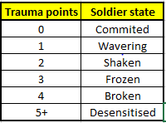

## DIPLOMACY/ELECTRONICS

* Diplomacy/Electronics may be accessed either at combined or dedicated negotiating/hacking terminals.
* Terminals include six levels of randomly generated rewards- the highest level always awards instant victory.
* Before the interaction begins, the Player must declare which reward level they are striving for and, if applicable, whether the interaction will be a hack or negotiation.
* A successful interaction will then award the rewards of that level and all levels below it.
* If the interaction is unsuccessful (the soldier does not achieve the level they were striving for) they shall not receive any rewards.
* The below table outlines the probability of achieving the required number of passes for each reward level given the soldier’s Dip/Elec:



## MOVEMENT

A soldier’s base movement is equal to his S minus the weights of all the items/weapons he is carrying. He shall also receive +1 in native terrain and -1 in opposite terrain (at the start of his move).

* Poor visibility reduces movement by 10%
* Zero visibility reduces movement by 50%
* Heavy rain reduces movement by 10%
* Torrential Downpour reduces movement by 20%
* 2\*(Kills-Deaths) is a percentage modifier to movement- using k/d from overall teams
* The Player Handicap is applied as a percentage penalty to movement
* Suppression reduces movement by the weapons’ suppression values (unless a soldier rolls inv. R).

After all modifiers have been considered (some special cases are not included above), the soldier’s Str value is added to calculate his final maximum movement.

## STRUCTURAL COLLAPSE

During a structural collapse:

* Survival requires an inv. R roll for each vertical 10cm of rubble section (starting after the first 10cm) falling on the soldier.
* This is measured from the soldier’s feet to the highest element of the game environment collapsing within 3cm of the soldier.
* Provided their armours still offer some protection, BA wearers shall have two roll chances per 10cm section and JA wearers shall have three chances.
* Survival places a soldier in their same position above the rubble pile whereas death has the soldier assume their natural place amongst the rubble and the soldier's corpse and equipment rendered inaccessible.
* Where a structural collapse requires a soldier to also suffer fall damage, the fall damage will be resolved first (from his previous elevation to his lowest elevation as though there was no structural collapse) and the structural collapse second (where the highest collapsing element is now taken from his lowest elevation).

## LEADERSHIP

* All soldiers perform an automated inv. L roll at the beginning of their turn.
* If the roll is successful, they are awarded an additional MA they roll again- if this second roll is a 1,2 or 3 then they shall earn +1AP for use, else they shall earn +2AP. Additional AP are then awarded with +1AP given for every 2L.
* Soldiers with more than 6L will perform a roll for each multiple of 6L, then attempt another roll sequence with their remaining L.

## SIGHT RADIUS

* A soldier’s base sight radius is 100cm. This radius will change according to the below visibility conditions:



* Each upgrade increment to a soldier’s SR skill will award 10cm beyond the above radii.
* Soldiers issued with thermal goggles always see with full visibility.
* Soldiers may fire at a target beyond their effective SR (teamsight) provided their effective SR>0, an ally can see the target and there is LOS from shooter to target.

## HEALING

* Medikits are required to heal soldiers, the amount of healing a medikit confers is equal to the medikit’s healing value added onto the soldier's Heal.
* Small medikits heal 1HP, Medium medikits heal 3HP and Large medikits heal to full H. All are consumed upon use.
* A soldier can only be healed up to his maximum H value.
* Medikit use will remove as many trauma points from the patient as the healer has ­Heal.
* If a soldier is Unconscious then a medikit is required to revive him. The use of any medikit will bring him back into Last Stand (neither his HP nor TP will change). Additional medikit use will take him out of Last Stand and award him the associated HP.

## STEALTH/CAMOUFLAGE

**STEALTH**

For general detection, a soldier will be revealed on his own turn if:

* He is beyond half of an enemy’s effective SR (but still within it) and his F fails to exceed twice the enemy’s P.
* He is between 3cm and half of an enemy’s effective SR and his F fails to exceed three times the enemy’s P.
* He is within 3cm of an enemy and his F fails to exceed four times the enemy’s P.

**CAMOUFLAGE**

For general detection, a soldier will be revealed on his Opponent’s turn if:

* He is beyond half of an enemy’s effective SR (but still within it) and his C fails to exceed the enemy’s P.
* He is between 3cm and half of an enemy’s effective SR and his C fails to exceed twice the enemy’s P.
* He is within 3cm of an enemy and his C fails to exceed three times the enemy’s P.

## 

## LOUD ACTIONS

If a soldier performs a loud action his C and F will be effectively zero:

* For 1 round if the loud action was beyond half of an enemy’s SR (but within his maximum SR).
* For 2 rounds if the loud action was between 3cm and half of an enemy’s SR.
* For 3 rounds if the loud action was within 3cm of an enemy.

Multiple loud actions apply concurrently and do not stack.

## GRENADES

**GRENADE ACCURACY AND FLIGHT**

* A soldier's grenade throwing range will equal 10\*Str (cm).
* If Inv. Str is rolled then the grenade is accurate. Else, cm off target will equal Diceroll\*Str/2 (rounded down). If the grenade is inaccurate it will miss its target in a direction randomly determined by the game engine.
* Thrown grenades obey similar physics to a baseball. Grenades detonated on a soldier’s person are always accurate.

**FRAG GRENADE EFFECT**

* Soldiers within 3cm of the grenade will receive 8 damage.
* Soldiers within 3-8cm will receive 4 damage.
* Soldiers within 8-15cm will receive 2 damage.
* For damage to apply, there must be LOS or suitably destructible cover between the grenade and the victim.
* Soldiers within 15cm with LOS to the grenade at the instant of detonation must roll Inv. R to avoid being stunned for one round.
* All items/weapons within 3cm of the blast are destroyed.

**FLASHBANG GRENADE EFFECT**

* A flashbang shall not affect a soldier unless it has LOS to his head (body and equipment are see-through).
* If the hit is direct the victim will suffer damage equal to Diceroll-R.
* Soldiers within 3cm of the grenade will be stunned for 4 turns.
* Soldiers within 3-8cm will be stunned for 3 turns.
* Soldiers within 8-15cm will be stunned for 2 turns.
* All stun values shall have the victim’s R subtracted from the original value.

**SMOKE GRENADE EFFECT**

* Provided there is a path for smoke to travel, smoke grenades fill the space within 20cm of their detonation point. Direct LOS is not required for a point within this space to be smoked.
* Smoke lasts for 1.5 turns- that is, it shall clear at the start of the enemy’s second turn after detonation.
* The space within 5cm of the grenade is known as the ‘blind zone’.
* Soldiers in the blind zone without thermal goggles shall have +6E and SR set to 0.
* Soldiers in the blind zone will (on their first turn within smoke) have the option to lie prone until it clears.
* External observers must have thermal goggles to see through or within the blind zone.
* If a soldier starts his turn in the blind zone he will be unable to move more than 3cm.
* If a soldier moves into the blind zone his movement will end the moment he enters it.
* The space within 5-20cm of the grenade is known as the ‘defence zone’.
* Soldiers within the defence zone shall have +3E -70SR -2P and suffer a 40% movement and aim penalty.

**TABUN GRENADE EFFECT**

* Tabun gas spreads and lingers in the same way smoke does.
* Affected soldiers within 5cm of the grenade will have -4E, -80SR and suffer an 80% movement and aim penalty.
* Affected soldiers between 5-20cm will suffer -2E, -40SR, a 40% movement and aim penalty and shall have F, C and P set to 0.
* The above penalties will be halved if inv. Heal or inv. R are rolled upon initial exposure (if both are rolled the soldier is immune).
* Once the gas dissipates or a soldier has exited the gas cloud he must roll inv. R (with as many attempts as he has R+Heal) or he shall accrue a trauma point.

## DRUGS

* Soldiers may administer drugs (via syringes) to themselves or others
* Soldiers already affected by drugs will be poisoned if additional different drugs are administered to them (unless the above are administered by an allied Medic)
* Soldiers already affected by drugs will die instantly if additional doses of the same drugs are administered to them (this will be no effect if administered by an allied Medic)
* Drugs administered by Medics never confer any side effects
* When a drug is administered by a non-Medic there is a 10% chance that it will have no effect and a 10% chance that only the side effect will be applied
* Refer to the ‘Drug Register’ for drug effects

## ABILITY UPGRADE

Upon reaching the rank of Captain, a soldier may attempt an Ability Upgrade, the soldier will then be issued one of the following four, equally likely, rewards:

* Nothing
* One additional random ability
* A choice of 1 of 4 additional random abilities
* Ability Upgrade

If the soldier decides not to attempt the upgrade, he shall be awarded a choice of 1 of 4 additional random abilities.

## 

## POISONING

* A soldier will be poisoned if he ingests poisoned food, water, syringes or medikits or has these administered to him (administration will cost the original item’s AP cost).
* A poisoned soldier will lose 2HP at the end of every turn until he dies- although soldiers can heal, the poisoning process cannot be stopped.
* Poison is harmless if inv. R is rolled.

## LAST STAND

* Upon being reduced to 3HP, a soldier shall enter Last Stand if he fails to roll inv. R (he shall have R chances to do this).
* Upon being reduced to 2HP, a soldier shall enter Last Stand if he fails to roll inv. R (he shall have one chance to do this).
* Upon being reduced to 1HP, a soldier shall enter Last Stand and must roll inv. R to avoid entering Unconsciousness. If a Player’s team are all Unconscious, the game shall end.
* If a soldier or his armour take damage while in Last Stand. He must roll inv. R to avoid entering Unconsciousness.
* A soldier may Lastandicide for 1AP.

## RADIOS

* ULF radio use will be successful if the soldier rolls inv. (average of Dip and Elec (rounded up))
* UHF radio use first calculates a ‘radio score’ as per the *Score Table*. This score is then input into the *Reward Table* to determine the strike’s parameters. Roll/s are then completed with the best attempt determining the strike’s accuracy as per the *Roll Table*.
* Inaccurate strikes will miss in a random direction.
* Damage inflicted beyond half radius will be halved (rounded in favour of an inv. R roll).
* 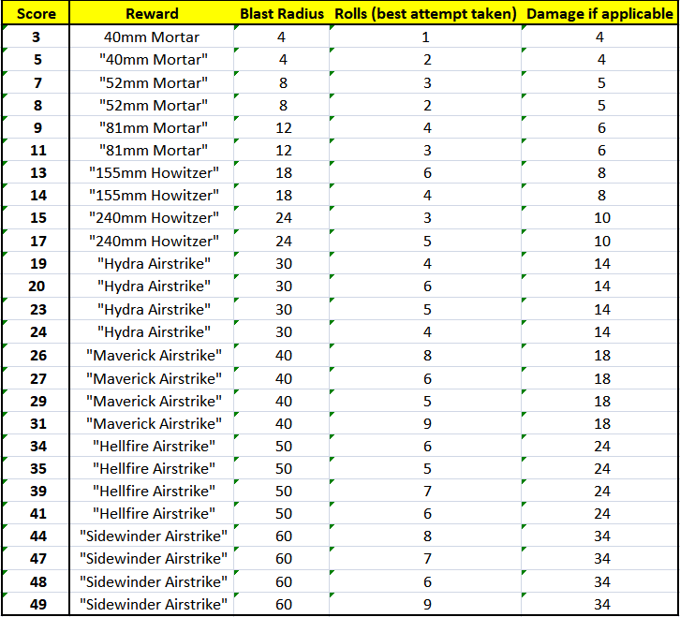Victim soldiers’ R will be subtracted from the damage value.

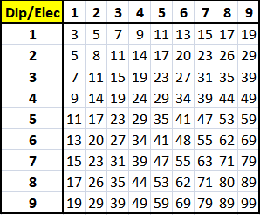

+

*Reward Table*

*Roll Table*

*Score Table*

# ABILITY LIST

*Upgraded Abilities not yet incorporated into game engine*

1.)

**Adept:**

-Binoculars/thermal cameras now see in a 15cm strip.

-All item use including pickups, configures, drops and swaps cost 1AP less (min 1).

**Aficionado:**

-Item usage, pickup, configuration, dropping and swapping cost 0AP.

-Binoculars/thermal camera see in a 25cm strip and his E-tool grants Excellent cover in all terrains.

-Can rerun all item calculations/rolls once if desired.

-Given an armour and weapon of his choice as a one-time bonus.

-All item weights are reduced to 1.

2.)

**Avenger:**

-Can retry (once) a missed shot (not overwatch) against any enemy that has killed an ally if he has enough ammo.

**Exactor:**

-Negative k/d differential acts as the corresponding positive k/d differential.

-As many times as he has R, the Exactor can retry a missed shot against any enemy that has killed an ally (he must have enough ammo and once a shot hits he cannot reshoot).

-When attacking an enemy that has killed an ally, the Exactor shall have the relevant Weapon skill multiplied by the number of allies the enemy target has slain (min x2). 1 shall be added to this final number.

3.)

**Bloodletter:**

-Once per turn, can sacrifice 1H (0AP) to deal double damage in his next successful melee attack. This sacrifice also permanently grants +3S.

-Using multiple times will stack the +3S but not the damage bonus (which is removed after any melee attack).

**Masochist:**

-Melee attacks grant +3AP if the enemy is killed.

-Once per game (decided the previous turn), can opt to take two full turn cycles with all incoming damage reduced to 1 and all Weapon skills multiplied by 10. His HP will then be reduced to 1 (no Unconsciousness or Last Stand).

-All melee 'damage' dealt to him will instead heal him by the same amount.

-All critical shots dealt to him will instead heal him by the full 'damage' value.

4.)

**Bull:**

-All guns and ammo carried by the Bull shall have their weight reduced to 1.

**Colossus:**

-All items/weapons are weightless.

-If he performs a full move, the Colossus can smash through destructible cover/objects as though they weren't there.

-If the Colossus’ move destroys any cover, he shall have his AP and MA refunded (once).

-Immune to critical shots (takes no damage), structural collapse and melee damage.

5.)

**Calculator:**

-Wind and rain work one gradation in the Calculator’s favour (either as shooter or target).

-Receives +1Elec when hacking terminals.

**Supercomputer:**

-Wind and rain are at their most advantageous for the Supercomputer (either as shooter or target).

-All actions cost only 1AP (excluding movements and 0AP actions).

-Receives +2Elec when hacking terminals.

-Immune to counterattacks.

6.)

**Daredevil:**

-If the Daredevil has no handheld items/weapons, he can scale all buildings (and other features) and enter them through any opening large enough to fit him. He will be able to move his regular distance in cm and can access inaccessible areas. He can stop mid-movement while scaling but can be shot at.

-He is able to stand and have turns regularly if on a slope of less than 20°. The daredevil may stow guns without having slots free.

**Spider:**

-Can scale all buildings with items/weapons handheld- while scaling, he cannot shoot or be shot at mid-climb (unless his time off regularly trafficable ground exceeds 2.5 turns- though he still cannot shoot).

-If the Spider is in Poor or Average cover it will be considered Good cover.

-Instantly traverses staircases, chains and ladders.

-Immune to fall damage.

7.)

**Dissuader:**

-All enemies the Dissuader sees (in his own right) at any point during his turn will lose 1AP on their next turn.

**Omen of Death:**

-All enemies that the Omen of Death can see must roll inv. R (every turn) or they shall miss their turn.

-Has the option to direct his deathly aura, for example, if he can see multiple enemies he may wish to spare one and make another pass the test twice. These decisions must be made at the start of a turn before any AP is used.

-All enemies that the Omen of Death can see shall have their L set to 0.

-If the Omen of Death is killed he places a curse on his killer preventing them from having (or continuing) their turn until they roll inv. R (this is attempted every turn). This curse begins the moment he dies (someone is always responsible).

-If the Omen of Death is killed, all fielded and unfielded enemy soldiers must roll inv. R, those who fail must then pass a deathroll.

8.)

**Experimentalist:**

-Will always know the next turn's weather.

-Immune to drug side effects.

-Suffers only half penalties from tabun gas.

**Chemist:**

-Immune to poison, tabun gas and drug side effects.

-Knows the entire weather forecast.

-Can see through smoke grenades.

-All poison administered by the Chemist is immediately fatal.

-Shall gain +1HP for each food pack he consumes and for each sip of a water canteen.

-If desired (decision must be made prior to throw), the Chemist’s frag grenades deal double damage, his flashbangs stun for twice as long, his smoke grenades confer double the usual E bonus and his tabun grenades inflict double the usual E penalty.

-If desired (decision must be made prior to throw), all grenades enjoy a scaled doubling of their effective radii and smoke and tabun grenades may linger for up to 3.5 turns.

-Permanently restored to full sustenance.

-When using medikits, maximum HP is not bound by H (a Chemist with full HP may heal to increase H).

9.)

**Fighter:**

-Static melee attacks cost 1AP.

-Permanently gains +5SR and +3S following each successful (any damage done) melee attack.

-If the Fighter performs a melee kill he shall receive 3AP and have one MA refunded (if used during kill).

**Pugilist:**

-All melee attacks cost 0AP- as do movements ending in melee attacks (movement AP is refunded).

-No melee penalty when attacking as part of a movement.

-Instant melee kills if there is any damage dealt via a melee attack.

-Cannot ever be killed, rendered Unconscious or put into Last Stand via melee (will instead remain on 1HP).

-Has his counterattack damage output multiplied by Diceroll (min will be x2).

-Permanently gains +5SR and +3S following each successful melee attack.

-Current trauma state cannot change for the rest of the game.

-Shall always control melee engagements.

10.)

**Guardsman:**

-Can instantly retry a missed overwatch shot once per miss (must have sufficient ammo).

-Suffers only half the usual penalty when firing from overwatch.

-Gains +1P while on overwatch and can overwatch up to an 180° arc.

-Immune to overwatch daze.

**Sentinel:**

-Immediately receives a full one-time repair to any armour he is wearing.

-Can retry missed overwatch shots as many times as he has R (there must be sufficient ammo in his clip).

-Suffers no aim penalty when firing from overwatch. Gains +4P while on overwatch.

-When firing from overwatch, the Sentinel will gain +Diceroll extra skill points in the weapon class firing the shot. The Sentinel can never be melee killed while on overwatch and is immune to overwatch daze.

-Has unlimited overwatch uses each turn. Can overwatch up to a 360° arc and can use teamsight during overwatch.

11.)

**Gunner:**

-Can reload and aim all weapons for 1AP.

-Reduces suppression ammo cost by 1.

-Max clip size and current clip ammo increase by 50% (min 1, rounded down) for any gun he picks up (once per gun).

**Cannoneer:**

-Can reload and aim all weapons for 0AP.

-Can suppress for 0AP.

-Max clip size and current ammo triple for any gun he picks up or is holding during his upgrade (min 2, once per gun).

12.)

**Illusionist:**

-During or after a move, if an enemy sees him by any means, he may redo the move once (previous move never happened). Does not apply if the enemy could see him (by any means) at the start of the move. The decision to redo the move must be made before any further AP is spent.

**Ghost:**

-Immune to all overwatch shots (at least one shot per overwatcher must still be attempted).

-Can redo any turn anytime (once per turn and will also be told if the enemy see or glimpse him by any means).

-Does not activate or appear on any items.

-When shot, the first attempt will miss and force a second attempt.

13.)

**Informer:**

-Whenever the Informer is attacked or damaged by an enemy, he shall obtain a snapshot providing full data (except locations) about the soldier (even if the attack kills him).

**Double Agent:**

-Reveals full data about all fielded enemy soldiers and their actions each turn (except their locations). This data is constantly updated even if the Double Agent dies.

14.)

**Inspirer:**

-All allies who can see the Inspirer in their own right (at the start of that Player’s turn) gain:

* +1 in their specialty if they have a Prime specialty.
* +5% accuracy in their specialty weapon when shooting (or +0.5M when melee attacking) if they have a Weapon specialty.
* +1AP if they have a Support specialty.

These are all temporary bonuses which last until that Player’s next turn begins.

**Galvaniser:**

-All allies who see the Galvaniser shall permanently gain: +10% accuracy when shooting, +20% movement, trauma immunity, existing trauma points removed and +1 in their specialty skill. Negative k/d ratios do not apply for these allies and their misses may be reshot once if inv. R is rolled and they have enough ammo.

-The Galvaniser guarantees successful Leadership rolls for allies that can seem him at the start of that Player’s turn.

15.)

**Insulator:**

-Takes only half damage (rounded down) from damage events if he rolls inv. R.

**Absorber:**

-Takes only half damage from damage events.

-Is never Unconscious or in Last Stand (he will still have the qualifying HP).

-If the Absorber attacks a soldier that has damaged him, he returns whatever damage he ‘absorbed’ (in addition to the regular attack damage).

-Once per game, if the Absorber is 'killed' he shall be placed on 1HP and shall continue on.

16.)

**Jammer:**

-Cannot be shot by an enemy using teamsight (shotcalc will not run).

**Corrupter:**

-While the Corrupter lives, no ally can be shot by an enemy using teamsight.

-Upon becoming a Corrupter, he and his allies (fielded and unfielded) shall receive +3E permanently.

17.)

**Learner:**

-Receives +50% XP (rounded up) for all non-combat actions.

**Mastermind:**

-All incoming XP is multiplied by Diceroll when it is gained (min x2).

-Receives an immediate and permanent increase of three gradations in his specialty skill.

18.)

**Locater:**

-Learns the contents of goody boxes and drug cabinets the moment his team can see them.

-Receives +1Elec when using radios.

**Logistician:**

-Learns everything about all POI’s.

- Permanently restored to full sustenance.

-Upon accessing a POI, the logistician can access/interact with equivalent POI’s anywhere on the map.

-Twice per game, the Logistician can move a POI to any other location on the map for 0AP.

-Receives +2Elec when using radios.

19.)

**Patriot:**

-If in his native terrain at the start of his turn, he shall receive +12S for the duration of the turn.

**Zealot:**

-If in his native terrain at the start of his turn, he shall gain +3AP, have his S doubled and receive +1 to all skills except H, S and SR.

-Upon becoming a Zealot he shall be given a (one time only) max HP restoration when he next enters his native terrain- this is instant if he is there currently.

20.)

**Planner:**

-Whenever the Planner picks up a gun (once per gun) it shall have Diceroll rounds added to its clip (up to max).

-If the Planner chooses not to move for a turn, he may donate 50% of his maximum movement to his nearest ally.

**Prophet:**

-Every weapon the Prophet picks up shall have its clip filled.

-Every weapon the Prophet puts down will have its ammo destroyed at the end of that Player's turn.

-During an enemy grenade throw, the Prophet has the option to move as many cm as he has R (at the exact instant of detonation) in any direction to escape (he is told where the grenade is).

-If the Prophet is shot at and is within R cm from superior cover, he has the option to move into that cover with the shot taken as though he were originally there.

-Will be told if enemies are behind walls and doors that are within R\*.1SR.

-Will return double damage during a counterattack.

-Will be told of all enemy shotcalc probabilities.

-Shall gain +1AP (on his next turn) for each allied shot (excluding his own) he correctly predicts the outcome of.

21.)

**Politician:**

-Upon request, the Gamemaster will provide low-level advice to the Player once per round.

-Receives +1Dip when using radios.

**Master’s Ally:**

-Once per game, the Master’s Ally can nominate any enemy he can see for immediate execution (2TP).

-Receives +2Dip when using radios.

-Upon request, the Gamemaster will provide medium-level advice to the Player once per turn.

22.)

**Revoker:**

-No abilities work directly for or against the Revoker (He will still receive the effects of additional abilities earned).

**Pacifier:**

-No abilities work directly for or against the Pacifier.

-Once an enemy has been seen by the Pacifier (in his own right) at any point (including while he was a Revoker) his abilities will be permanently disabled and he cannot earn new ones.

23.)

**Shadow:**

-Whichever is the Shadow’s lowest skill out of C, F and P shall assume the value of the highest of these stats. If his two lowest skills are equal, the precedence shall be F🡪P🡪C.

**Shapeshifter:**

-Undetectable (except by binoculars/cameras) unless he performs a loud action (he is re-concealed as per usual).

-No enemy can hide from him via Camouflage or Stealth.

-Will die if he receives any damage at all.

24.)

**Sharpshooter:**

-Accuracy for all weapons is increased by 5%.

**Deadeye:**

-Accuracy for all weapons is increased by 55%.

-Critical shot chance is tripled.

25.)

**Spotter:**

-If an enemy performs an action heard by the Spotter, the Spotter’s team shall have a live feed on him until the Spotter uses AP or takes damage. When the feed is lost, the ability resets ready for the next enemy loud action.

-The live feed applies to one soldier at a time and only to the last unrevealed enemy who takes action on their turn.

**Tracker:**

-Once an enemy is seen or heard by the Tracker at any point (including while they were a Spotter), his movements and actions will be known for the entire game (even if the Tracker dies).

26.)

**Sprinter:**

-All movement costs 1AP less (min 1).

**Olympian:**

-Uninterrupted straight line movement greater than 4cm (of any line width) costs only 4cm of movement provided it doesn’t involve vaulting or elevation changes. It is possible to combine these straight dashes with regular curving paths under a single ‘movement’. Only one movement can be made per turn (Leadership grants additional uses).

-Permanently restored to full sustenance.

27.)

**Tactician:**

-Immune to all flanking effects when acting as the target or defender.

-Receives +1Dip when negotiating with terminals.

-When the Tactician fires at enemy, flanking shall consider 20° arcs.

**Creator:**

-Immune to all flanking effects.

-When the Creator attacks an enemy, Diceroll/2 sides (rounded down) (min 1) will be added to the flanking calculation. Diceroll\*4cm will be added to his elevation value while shooting.

-Receives +2Dip when negotiating with terminals.

-All allies the Creator can see will share these bonuses.

28.)

**Tranquiliser:**

-Stuns enemies for one turn after dealing damage via a shot/melee/counterattack if the enemy fails to roll inv. R.

**Anaesthetist:**

-The Anaesthetist stuns enemies for:

* 2 turns after any attempted shot/melee/counterattack.
* 3 turns if the enemy fails to roll inv. R
* 4 turns if he rolls inv. R and the enemy fails to roll inv. R.

29.)

**Vaulter:**

-Can vault over and under vaultable obstacles as though they weren’t there (that is, no cm of movement are consumed during the vault). The Vaulter appears to move over obstacles normally to external observers and cannot finish his move inside an obstacle. If the movement path is efficient, cm of movement which would normally be consumed during the vault are instead awarded as additional movement.

-Traverses vertical elements for 1cm less (once per move).

**Acrobat:**

-Can move through any obstacle up to 4cm thick (horizontally only) as though it wasn’t there. The Acrobat appears to teleport through these obstacles but cannot finish his move inside an obstacle.

-Instantly traverses staircases, chains and ladders.

-Rolling a 6 before a melee attack or defence will instantly kill the enemy. He has R chances to do this.

-Getting into cover costs 0AP.

-Immune to fall damage and structural collapse.

30.)

**Witness:**

-Must use the ability (or abilities) of the enemy that last attacked or damaged him. This active ability is immediately replaced with each attack/damage he receives.

-The Witness shall have +2P until he is attacked or damaged (or until he becomes a Hypnotist).

**Hypnotist:**

-Can use the ability of any enemy that has been seen by an ally (and is not currently in use by an ally). He must choose the ability he wants to use one turn in advance (else he loses the option to have an ability).

-The Hypnotist retains memory of the abilities he was exposed to as a Witness.

-The Hypnotist is awarded +2P permanently.

# ITEM LIST

Throwable items (denoted with ‘^’) may be thrown like a grenade

Fragile items (denoted with ‘\*’) will break if dropped from higher than 8cm unless there is an ally within 3cm of the landing site.

These items (including all guns) will break if they receive any damage.

Other items (not BA, GA, JA or Riot Shields) will break if they receive 5 damage from any single event.

All soldiers field with a left and right leg slot, back hole, fullbody slot, shoulder slot, posterior slot, lateral slot and two hand slots.

### Life Safety Items

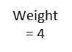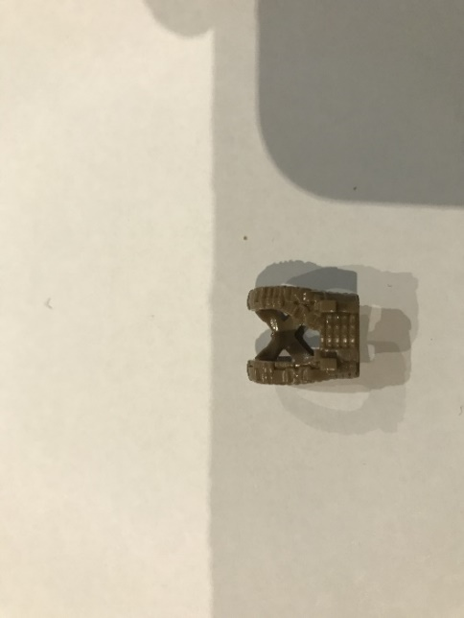Body armour: (worn on shoulder slot)

Can take 4 damage, adds two additional slots and reduces F and C by 1. Can be worn but not carried.

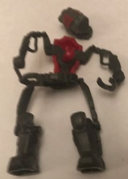

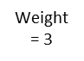Exo Armour: (worn on fullbody slot and removes back hole, lateral, posterior and brace slots)

* Removes 3H during fitting and may only be removed from a soldier once he has died.
* Persistently triples Str and sets F to 0.
* Where the environment permits, allows the soldier to jump (loud within 10cm) vertically as high as they please for 1AP. If this jump reaches within 3cm of interactable terrain on another elevation they can then end their jump on that terrain.
* Instantly kills enemies if any damage is dealt via melee attack. Can be worn but not carried.
* Allows for regular melee attack against JA wearers.
* Grants a 50% chance to ignore damage for each incoming shot that would otherwise hit.

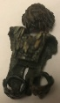

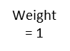Ghillie Armour: (worn on fullbody slot and removes shoulder, posterior and leg slots)

Increases C and F by 4. Can be worn but not carried.

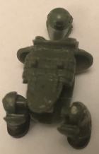

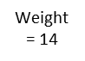Juggernaut Armour: (worn on fullbody slot and removes posterior and shoulder slots)

* Can take 18 damage.
* Adds four additional slots but prevents soldiers from taking cover and playing dead.
* Renders soldiers immune to damage from grenades and melee attacks.
* Causes unconsciousness during structural collapse where other soldiers would die.
* Sets F and C set to 0, reduces P by 2.
* Confers a -1 Weapon skill reduction when shooting or melee attacking.
* Render soldiers immune to Last Stand or being dragged. Can be worn but not carried.
* Limits item use to only weapons, grenades and riot shields.

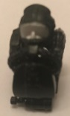

Stimulant Armour: (worn on fullbody slot and removes shoulder slot)

* Reduces incoming damage by 2 and may only be removed from a soldier once he has died.
* Confers a +2 Weapon skill increase when shooting.
* Restores and maintains full sustenance.
* Grants immunity to all drug and tabun effects- including any previously applied.
* Cannot be carried- only worn.

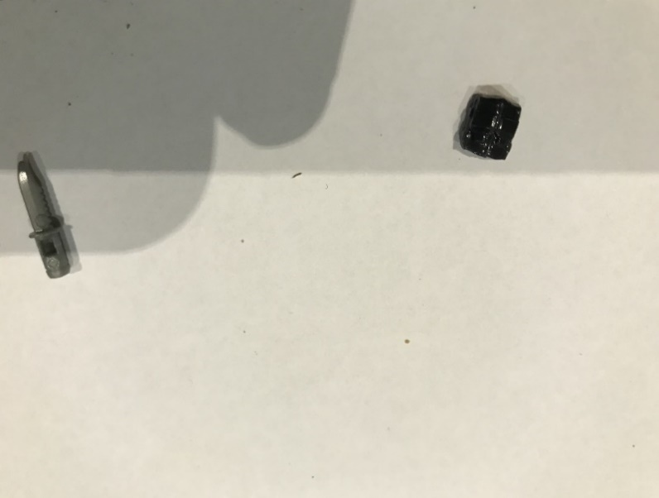

^Food pack: (any slot)

Provides sustenance for 10 turns once consumed.

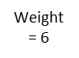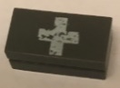Large medikit: (can only be handheld)

Heals soldier to full H. Will be consumed after use.

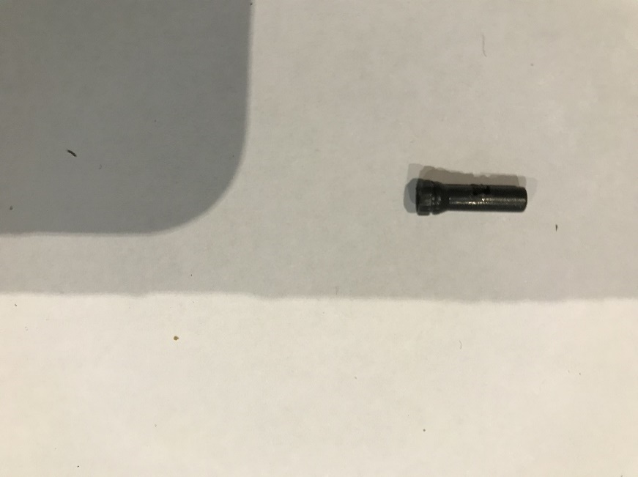^Poison satchel: (any slot excluding lateral slot)

Can be used to permanently contaminate food, water, syringes or medikits. Poisoned items do not perform any of their regular functions- they only confer poison. Soldiers may contaminate items within 3cm or on their person.

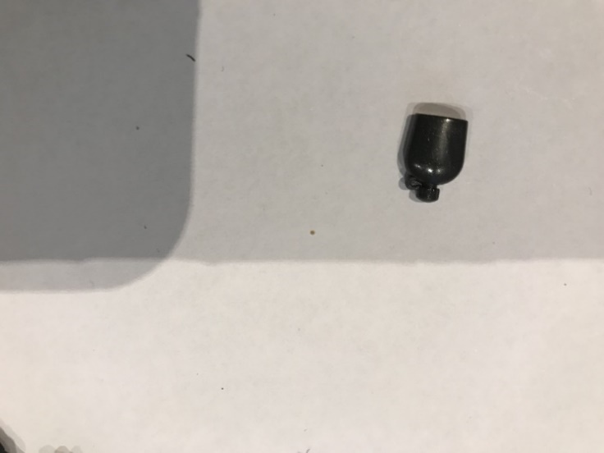

^Water canteen: (any slot)

May be drunk from four times until empty. Each sip provides sustenance for 5 turns and shall reduce its weight by 1.

### Habiliments

\*Ammo: (any slot)

External clips of ammo used to reload weapons. Soldiers can only determine the number of shots left in a clip if they are within 3cm of it. The type of ammo will be known as soon as it is within their sight radius:



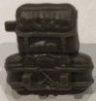

Backpack: (worn on back hole)

Adds three additional slots and contains 1 medium medikit and 1 small medikit.

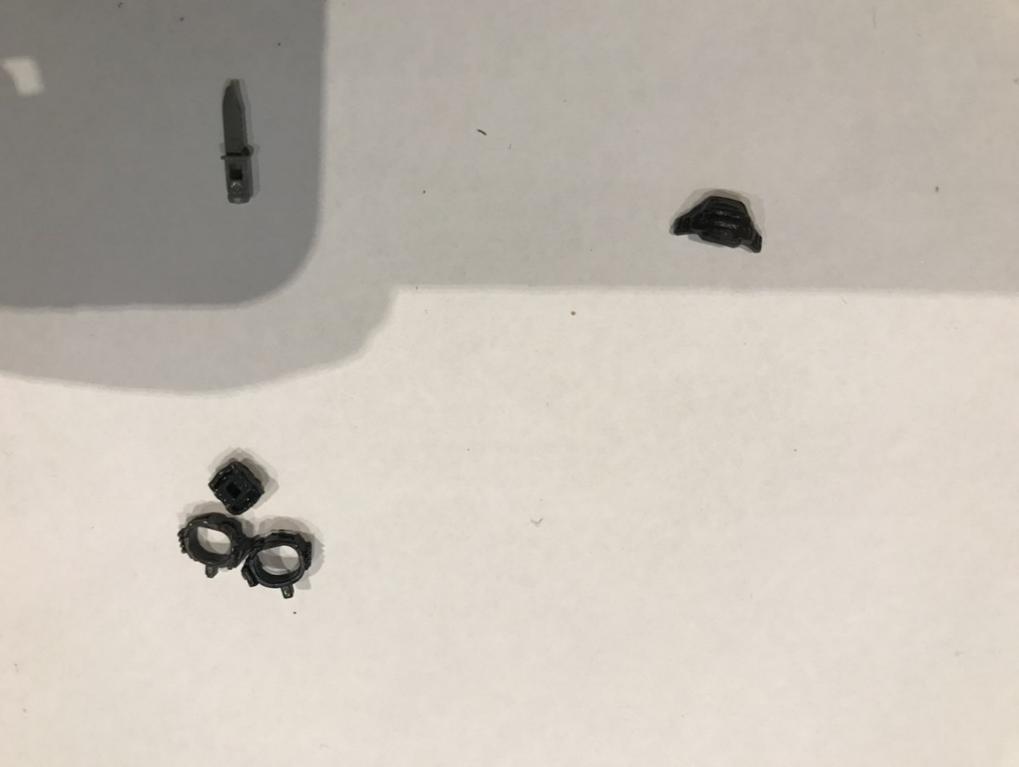

Bag: (posterior slot only)

Contains 1 medium medikit.

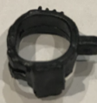

^Brace: (worn on leg slot)

Adds an additional slot to which an item may be fixed and contains 1 small medikit.

\*Logistics Belt: (posterior slot only)

Grants +1AP once per turn to the soldier who is wearing it.

C:\Users\h274059\AppData\Local\Microsoft\Windows\INetCacheContent.Word\IMG_0418.jpg

\*Syringe: (any slot excluding lateral slot)

Carry a single dose of a drug which confers benefits as well as side effects onto soldiers.

### Combat Items

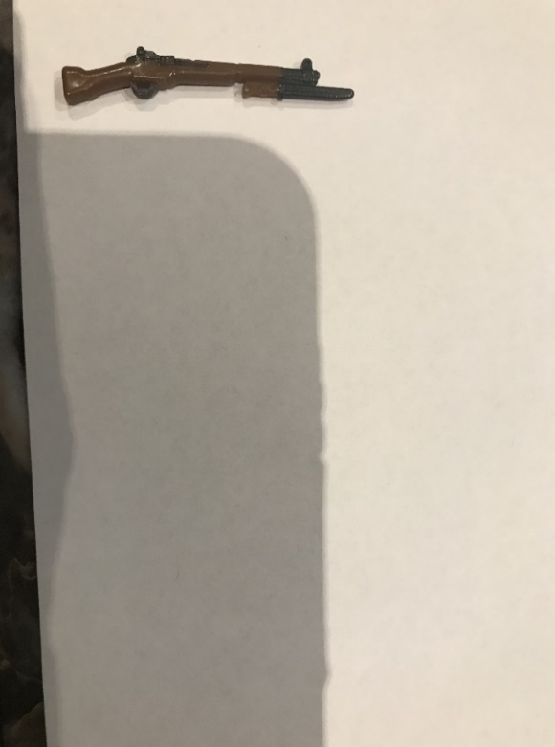Bayonet: (cannot be removed)

Bayonet fitted weapons (all rifles and only rifles) are effective melee weapons.

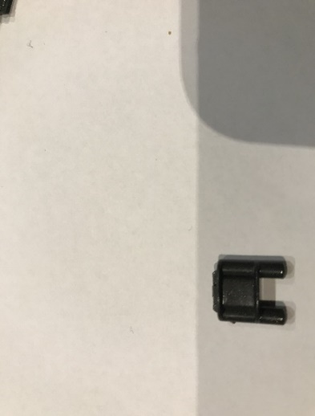

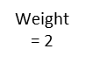\*Claymore: (any slot)

Will detonate if anyone passes within a 3cm 60° arc in front of it. It does not affect JA wearers or anything outside of this radius. It instantly kills all soldiers wearing, GA, SA or EA. BA wearers are brought into Last Stand on 1HP (if already in Last Stand, soldier shall die). All items/weapons (not BA or JA) will be destroyed. To detect a placed claymore, a soldier must be able to view it in his own right (no teamsight) and his P must exceed both the F and the C (at the time of placement) of the soldier who placed it. Claymores will detonate in a 3cm 360° dome if they receive explosive damage.

\*^Flashbang Grenade: (any slot)

A semi-lethal device capable of stunning soldiers within a radius of its landing spot. Flashbang grenades are brown/gold in colour. Will detonate if it receives any explosive damage.

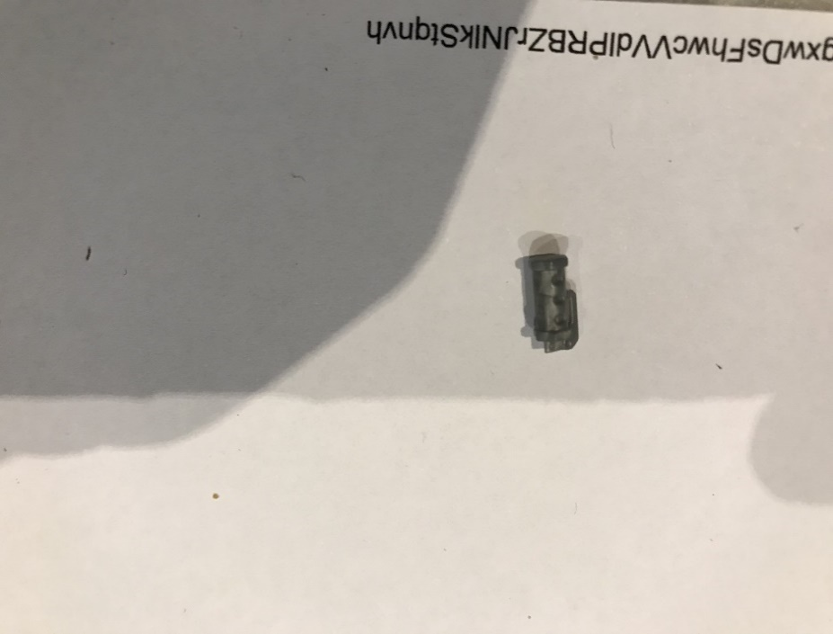\*^Fragmentation Grenade: (any slot)

A lethal device capable of damaging enemies within a radius of its landing spot. Frag grenades are silver in colour. Will detonate if it receives any explosive damage.

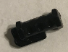\*^Smoke Grenade: (any slot)

A tactical device capable of filling a space with harmless smoke. Smoke grenades are black in colour. Will detonate if it receives any explosive damage.

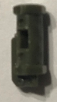

\*^Tabun Grenade: (any slot)

A toxic gas grenade which impacts units within its radius. Tabun grenades are dark green/khaki in colour. Will detonate if it receives any explosive damage.

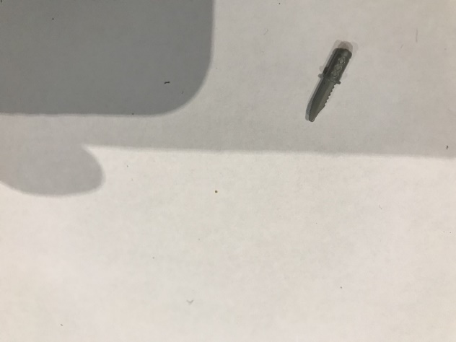

^Knife: (any slot)

A melee weapon.

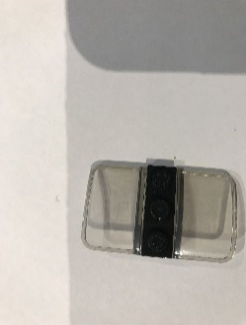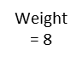Riot Shield: (can only be handheld)

Provides complete protection from gunfire across a 135° arc. Soldiers must be clear in what direction they face while moving and stationary. If not stated, their physical orientation will decide. The riot shield prevents all melee attacks to and from its wielder and zeroes the carrier’s F and C. If facing the blast direction, riot shields halve all explosive damage and grant stun immunity. Claymores will place riot shieldbearers in Last Stand on 1HP, if they have BA also, they will have their HP halved (rounded up). They are completely transparent.

### 

### Tools

\*Binoculars: (any slot)

Can be used in either ‘Recon’ or ‘Flash mode to look at any 5cm strip from the soldier’s position to the edge of the map (all z values included)- detections will resolve as per usual.

In Recon mode, soldiers will end their turn then:

* Remain looking through binoculars until they use AP (even through the Opponent’s turn).
* Swap handheld items to physically use binoculars (configuration/slot rules ignored).
* Temporarily increase their P by 1 for every full round they stay looking through binoculars.
* Have the option to shift their region of binocular focus once per turn (will end turn).
* Allow for teamsight shots where enemies are viewed through binoculars.

In Flash mode, soldiers will:

* Perform a single look with +4P through binoculars.
* Continue their turn as per usual immediately after the binocular use.

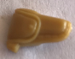^Deployment Beacon: (any slot except hand slot)

When placed, reinforcement soldiers may spawn on its location (usually without gear). Once placed, the enemy shall know the exact position of the beacon and can destroy it with any damage. If within 3cm, soldiers may spend 3AP to deactivate it.

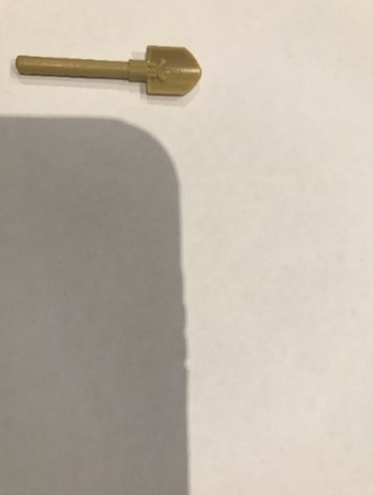E-tool: (posterior, hand, armour or backpack slots only)

As well as being a melee weapon, the e-tool can be used to improve cover on any terrain that is not urban (will be marked on map). Each use improves cover by one gradation (up to Excellent cover).

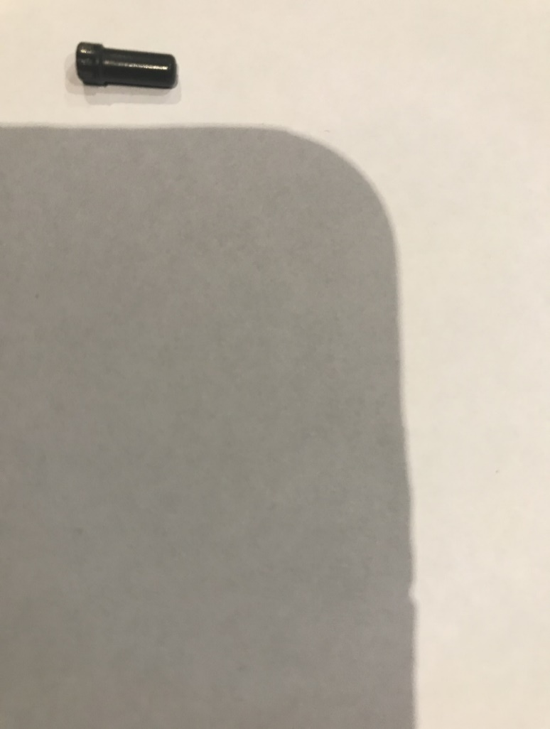^Suppressor: (can only be affixed to guns (excludes rifles)- cannot be carried)

Shooting with a suppressor is not considered a loud action if enemies are beyond 20cm of the shot.

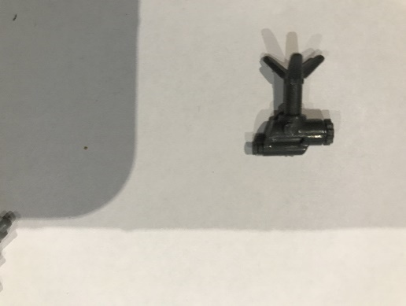

\*Thermal camera: (any slot)

When placed, provides a 3cm-wide viewing strip of infinite range (will not go through obstacles). Any enemy activity (regardless of F and C) at its planted elevation will be revealed to the planting Player.

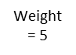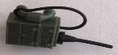\*ULF Radio: (worn on back hole)

Enables the Player to view their Opponent’s next turn (they cannot view the game screen). Alternatively, the operator may use it to jam all enemy ULF attempts on their Opponent’s next turn.



\*UHF Radio: (any slot except lateral slot)

Is used to call a vertical strike onto the battlefield, only one use per radio is possible.

# SKILLS LIST



# XP TABLE





# DRUG REGISTER



|  |  |  |
| --- | --- | --- |
| **Drug** | **Benefit** | **Side effect** |
| Amphetamine | Soldier specialty tripled (*once)* | All other skills (excluding H) reduced by two gradations (*permanent*) |
| Androstenedione | Incoming damage reduced by 1 (*permanent*) | S reduced by 12 (*once)* |
| Cannabinoid | Doubles P (on*ce*) | F and C set to 0 (*once*) |
| Danazol | Doubles HP (*once*) | L and R set to 0 (*once*) |
| Glucocorticoid | Grants 4 turns worth of AP and movement in the round after ingestion | The soldier cannot take any action for the rest of the game (*permanent*) |
| `Modafinil | Soldier is granted a turn upon his death | Removes 1HP upon administration |
| Shard | All weapon skills increased by 1 (once) | Deletes soldier's abilities (*once*) |
| Trenbolone | Soldier can see through obstacles in own effective SR (*permanent*) | Effective SR reduced by 60% (*permanent*) |

# AP CHART





|  |
| --- |
| \* Loud actions which may reveal a soldier |
| [] Loud within radius |
| ^ These actions end the soldier's turn |
| Handheld items/weapons can be dropped for 0AP [5] |
| Soldiers may only carry items/weapons if they physically fit and obey the slot conditions outlined in the ‘Item List’ section |
| If the only handheld item is a weapon, then items may be used directly from the inventory |
| If only one item is held in-hand (excluding weapons), then only that handheld item may be used |
| Weapons, riot shields and large medikits must be handheld and require two hands to be used in any capacity |
| In-hand Melee weapon/(pistol/SMG) combinations and duplications are the only items which may be used with both hands full  If two guns (SMG/pistol) are held, shooting will use both guns for 1AP (run as separate unaimed shots) and overwatch is disabled |
| Melee weapon/(pistol/SMG) combinations and duplications are considered a single weapon with respect to AP costs and inventory use |
| 'Configure' allows soldiers to access all allies and POI's within 3cm and fully rearrange inventories |
| Medikits, poison satchels and syringes are the only items which can be administered between allies |

# WEAPON SPECIFICATIONS



