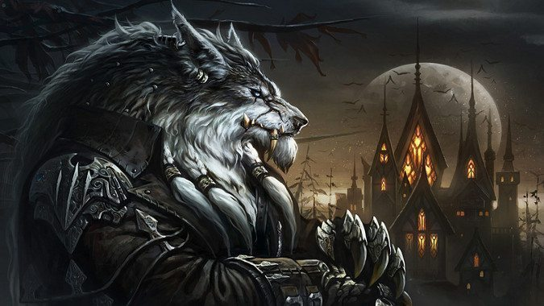

Night Flare

Game Design Document 1.15c

Contents

Minimum Value Product 3

Core Mechanics 3

Interface 7

# Minimum Value Product

Night Flare is a 2D top-down, wave-based survival game whose objective for the player is to survive wave after wave of enemies. Every new wave, enemies become progressively stronger, and that adds challenge to every new wave. It is important to note that our game has an end-game: to win the game, the player must survive 15 waves, with each new wave becoming more difficult from the previous.

Our end-quarter goal for the game is to have at least minimum value product, and this was determined based on the current experience level of our team.

## Core Mechanics

* **Player movement**
  + the player can move in infinitely many directions.
    - the direction is controlled by mouse-aim.
  + the player moves at a fixed speed.
  + the player can run and walk.
    - walking is normal, infinite movement in any direction; this is the default movement.
      * the player controls this by pressing the buttons to move.
    - running is faster movement limited by Adrenaline (explained in Player combat below).
      * the player controls this by pressing the button to run.
* **Player combat**
  + the player can attack enemies.
    - the player attacks are ranged, projectile-based.
      * the player attacks by pressing the button to attack.
      * ranged attacks are instant; require no animation nor charge time.
      * the player has infinite ammo; they can attack infinitely.
      * if any projectile hits an enemy, that enemy takes damage.
    - attacks occur in timed-intervals; the player cannot attack nonstop.
    - the player can attack by repeatedly pressing the fire button, or they can hold down the fire button.
  + the player can take damage.
    - the player has health.
      * enemies can damage the player.
        + running up to them and attacking the player inflicts damage.
        + landing successful projectile shots on the player inflicts damage.
        + the player running into any enemy causes them to take fixed “damage.”
      * if the player’s health drops to 0, they lose.
    - the player has adrenaline.
      * adrenaline acts as a limit for player movement.
        + when running, the player uses a fixed amount of adrenaline per second.
        + adrenaline regenerates at a fixed rate per second.
* **Enemy combat**
  + enemies can attack the player.
    - enemies attack automatically.
    - enemies attack the player using either melee or ranged-based attacks.
      * melee attacks occur in-between time intervals.
        + melee attacks are not instant; melee enemies must undergo an animation to attack.
        + a successful hit on the player inflicts damage on them.
      * ranged attacks are projectile-based and occur in-between time intervals.
        + ranged attacks are instant; require no animation nor charge time.
        + ranged enemies have a fixed range from which they start attacking.
        + a projectile hitting the player inflicts damage on them.
    - enemies can “attack” the player if they collide with them.
      * the “damage” inflicted on the player from this collision is fixed.
  + enemies can take damage.
    - enemies have health, but the health value varies.
      * the player can damage enemies with ranged projectiles.
        + if the any of the player’s projectiles hit an enemy, that enemy takes damage.
        + enemy health is not affected if they collide with the player.
    - if an enemy’s health drops to 0, they die.
* **Enemy movement**
  + enemies can move in infinite directions.
    - enemies always move in the direction of the player.
      * if the enemy uses ranged attacks, it will only move should the player be too far away from it.
        + they will move to face the player.
      * if the enemy uses melee attacks, it will attempt to close in on the player to attack.
        + they will always face the player to attack.
* **Wave system**
  + players start at Wave 1 whenever they begin the game or restart the game.
  + enemies grow stronger with every wave survived.
    - enemies gain the following boosts to their stats:
      * damage
      * health
  + when a wave ends, the player will have a 10-second intermission.
    - during the intermission, no enemies spawn and the player is free to move around the map and attack.
    - the player can “take a breather” during the intermission.
  + if the player dies during a wave, the player’s wave count does not reset.
    - the player returns to the current wave they are on and are given the opportunity to try beating it again.
    - the player has an infinite amount of tries at any wave, thereby has an infinite amount of lives.
  + wave progress is saved until the player completes the game or starts a new game (explained in Scenes below).
* **The End-Game**
  + for now, the player must finish 15 waves to complete the game.
    - upon surviving Wave 15, the player would have officially and successfully completed the game.
    - after reaching the end-game, the player can either restart the game, or return to the Main Menu screen (explained below under Scenes).

# Interface

For our game, we want our scenes to be simple and easily navigable for our players. We do not want any of our game scenes to be complex and difficult to read and use because that only creates frustration. For now, we will stick with the necessary interfaces that will run through our playtests to make sure that not only the game’s code works well, but that, as a player, we can find our way through the interface and easily understand how it works.

Illustrations will be drawn to provide an idea of how the scenes described below will appear in-game, as describing them here would be near-impossible.

Our game’s interface must abide by these central rules:

* Game scenes must have an aspect ratio of 16:9, with a resolution of 1280 x 720.
* Player movement and direction is guided by where the cursor is in-game.
  + the player controls the cursor through their mouse, thereby uses the mouse to control their movement.
* Player health should be visible.
* Enemy health should be visible on every enemy.
  + amount of health does not matter for interface appearance.

## Scenes

**Main Menu**

The Main Menu scene will be the screen shown to the player upon loading up and starting the game. From here, the player can start the game, adjust the game’s settings, or exit out of the game.

* **Buttons**
  + Start Game
    - starts the game; transitions to the Active Level scene (explained below).
  + Options
    - opens an options panel where the player can adjust certain settings incorporated into our game; stays on the Main Menu scene and blurs and darkens the background.
      * includes the following controls:
        + music: adjust dB level of music.

scroll-control

* + - * + sound: adjust dB level of in-game sounds and effects.

scroll-control

* + Credits
    - opens a panel that displays the names of the developers and/ or contributors to our game; stays on the Main Menu scene but removes all interface options.