

STUDENT NAME: LINET CHEPCHIRCHIR
ADM NO: BSCCS/2024/54961
COURSE: BACHELOR OF SCIENCE IN INFORMATION TECHNOLOGY
UNIT NAME: ADVANCED WEB DESIGN AND DEVELOPMENT
UNIT CODE: BIT3208
LECTURE: NYORO MICHEAL
SEMESTER: YEAR 3, SEMESTER 2
PPROJECT DETAILS:
PROJECT TITLE: SMART LIBRARY SYSTEM
SELECTED TECHNOLOGIES:
- HTML5
- CSS3
- JavaScript
- PHP
- MySQL
- Bootstrap 5
- XAMPP
GitHub Repository Link
https://github.com/Linet-19/smartlibrary/upload/main

TABLE OF CONTENTS

WEEK 1: Local Environment Setup............................. 3

WEEK 2: Wireframes and GUI Design .......................... 6

WEEK 3: JavaScript and PHP Basics.................................... 8

Week 4 – Server-Side Components (Login & Forms) ...................11

Week 5 – Database Components & CRUD Operations ................ 14

LIST OF FIGURE

Fig 1: Installation of XAMPP

Fig 2: Apache and MySQL Running

Fig 3: Localhost Test Page

Fig 4: Hello World Test

Fig 5: Database Connection Test

WEEK 1: Local Environment Setup

Title
Installation and Testing of Local Development Environment

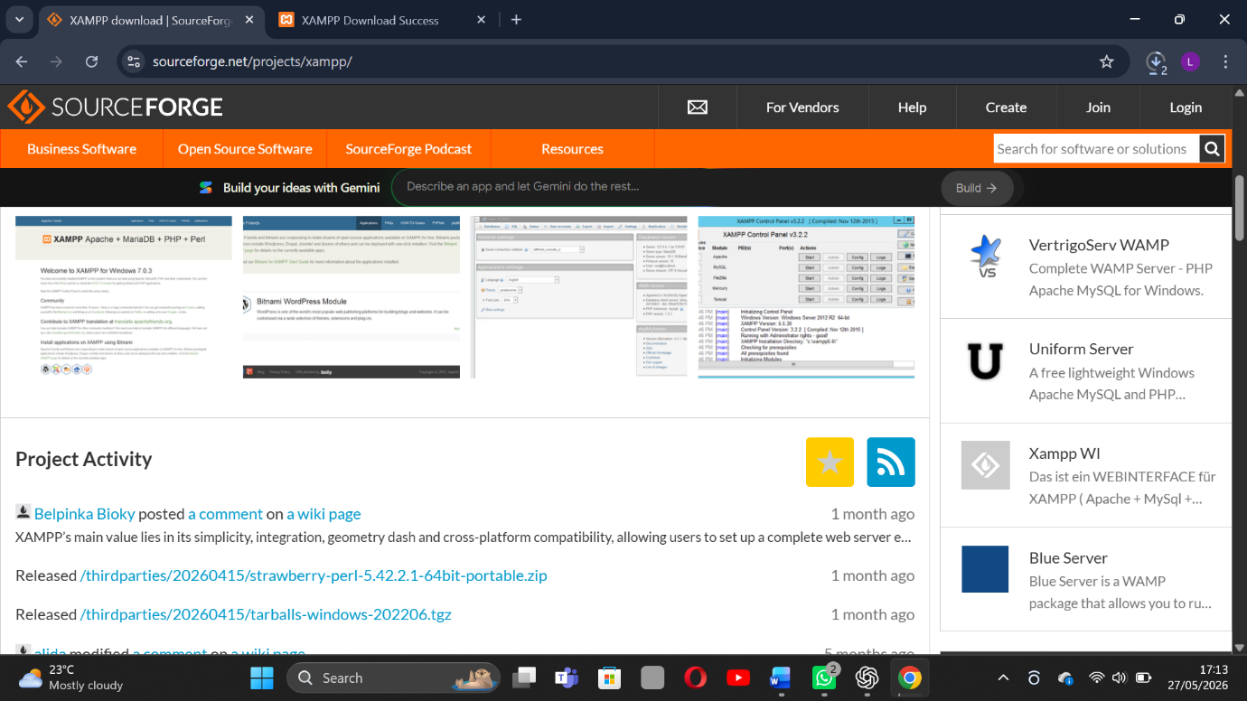

Fig 1: Installation of XAMPP
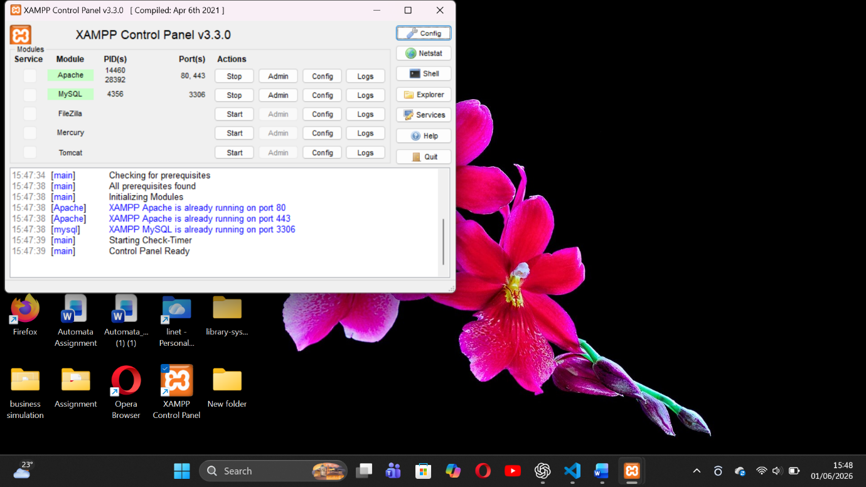

Fig 2: Apache and MySQL Running
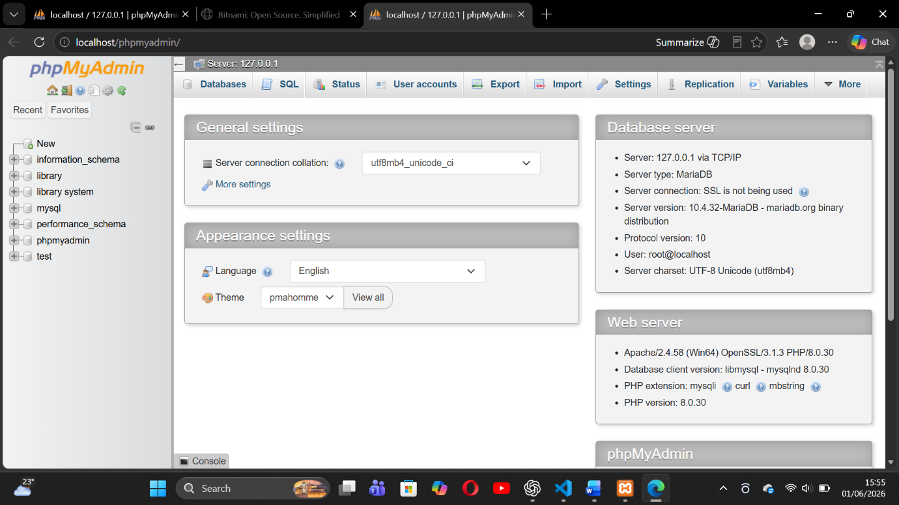

Fig 3: Localhost Test Page

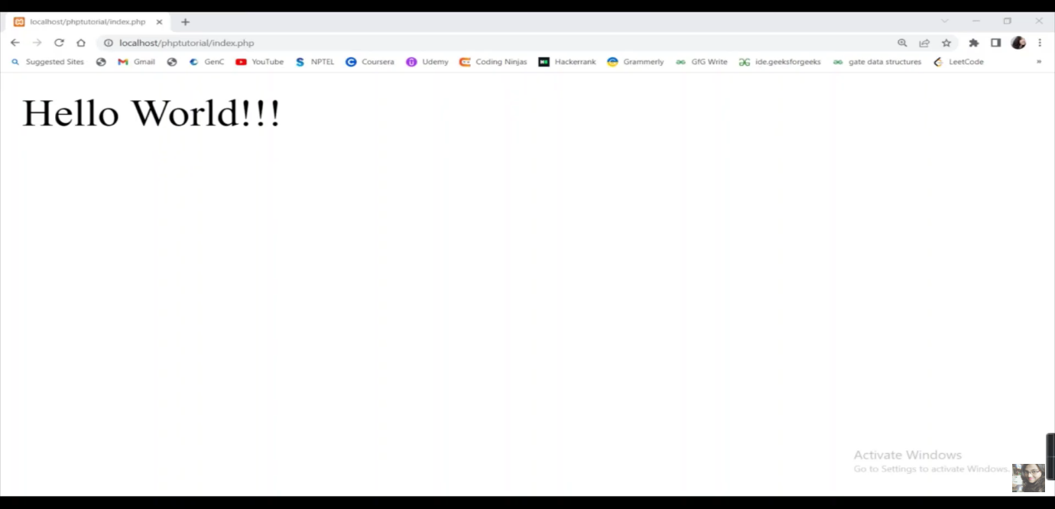

Fig 4: Hello World Test

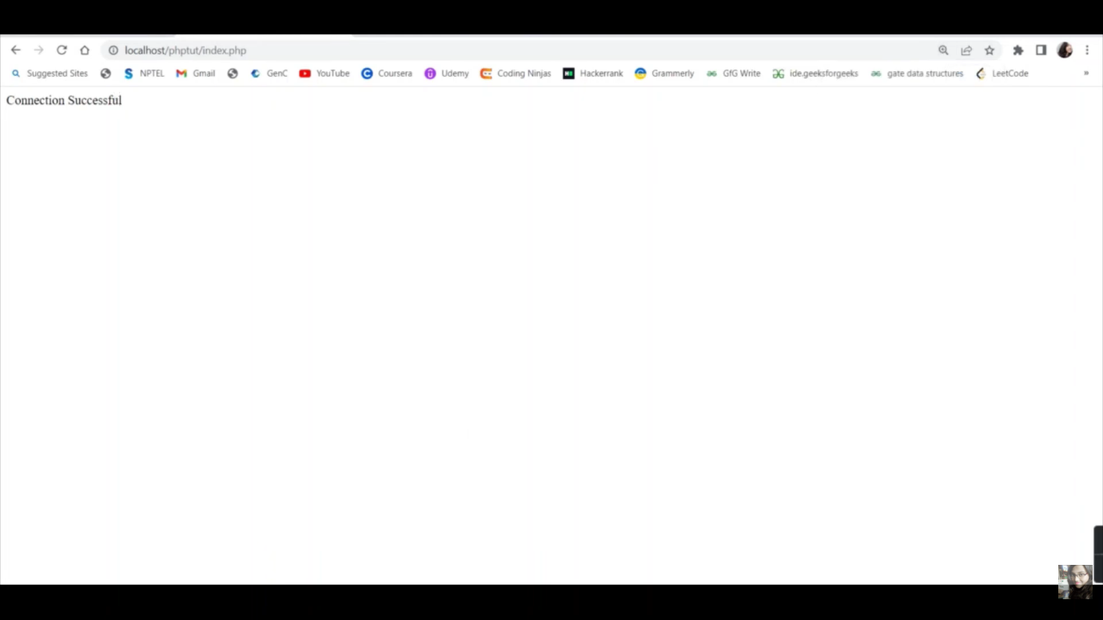

Fig 5: Database Connection Test

REFLECTION.
This week, I successfully set up my development environment using XAMPP and tested Apache and MySQL services. At first, I encountered issues with Apache not starting because of port conflicts, but after adjusting the settings, everything worked correctly. I created my first PHP page and verified that it could run through localhost. I also established a connection between PHP and MySQL, which helped me understand how web applications interact with databases. The screenshots provide evidence that the server, database, and local development environment were configured and functioning properly.

WEEK 2: Wireframes and GUI Design

Title

User Interface Planning and System Design
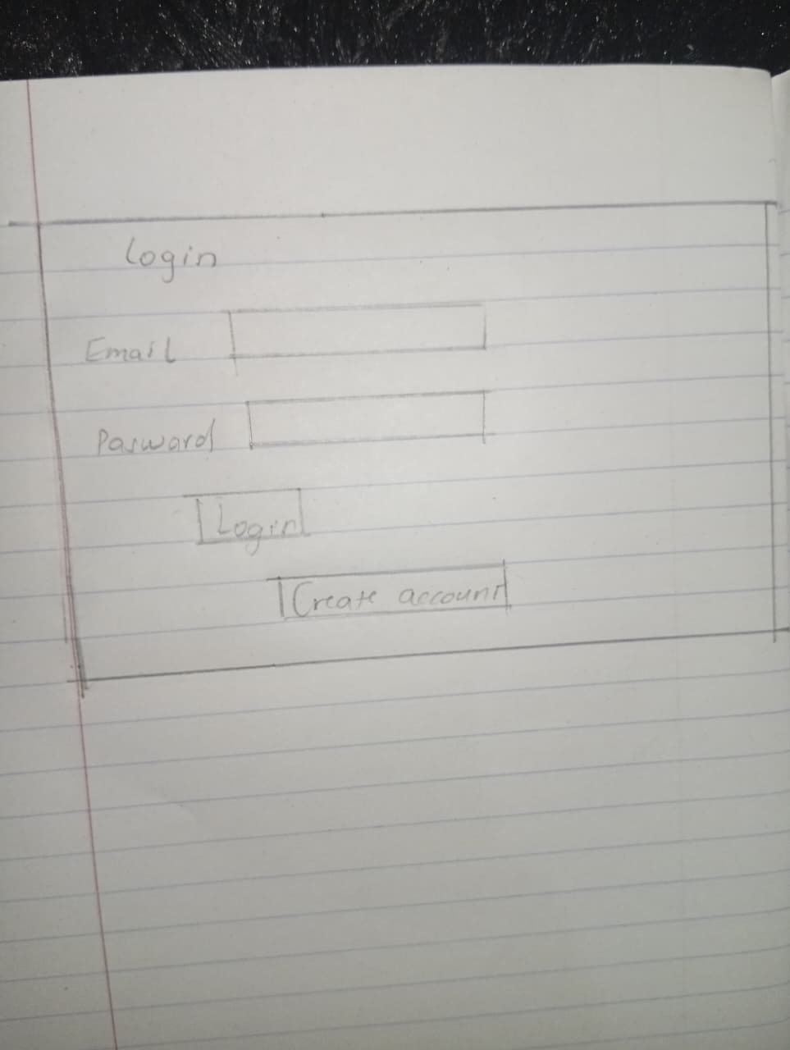

Fig 1: Hand-drawn Wireframe
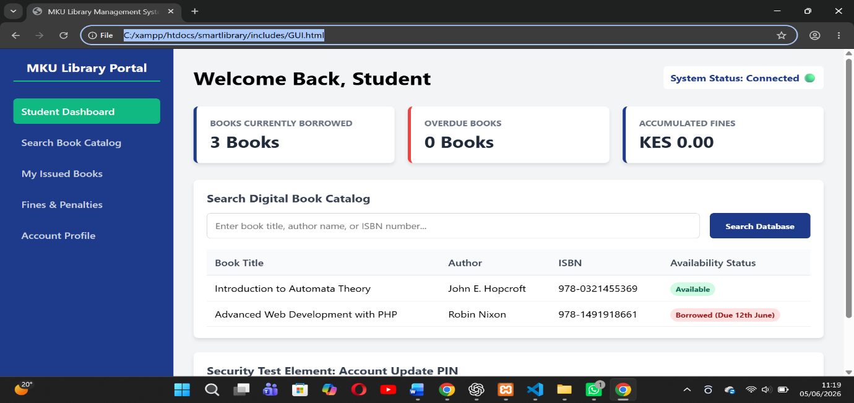

Student Reflection (100 words)
The dashboard layout (Fig 2.2) places navigation vertically on the left for easier scalability as more modules are added later. I chose dark navy (#2C3E50) for trust and professionalism, which suits a library environmen. Fig 2.3 ensures librarians can issue books from mobile devices without zooming. The primary user is the librarian; secondary users include library assistants. A key UX decision was placing the "Issue Book" button prominently on the dashboard to reduce click time. The Figma prototype (Fig 2.5) helped me visualize the complete user journey from login to returning books before writing any code.

WEEK 3: JavaScript and PHP Basics

Title

Frontend Interaction and Backend Foundations

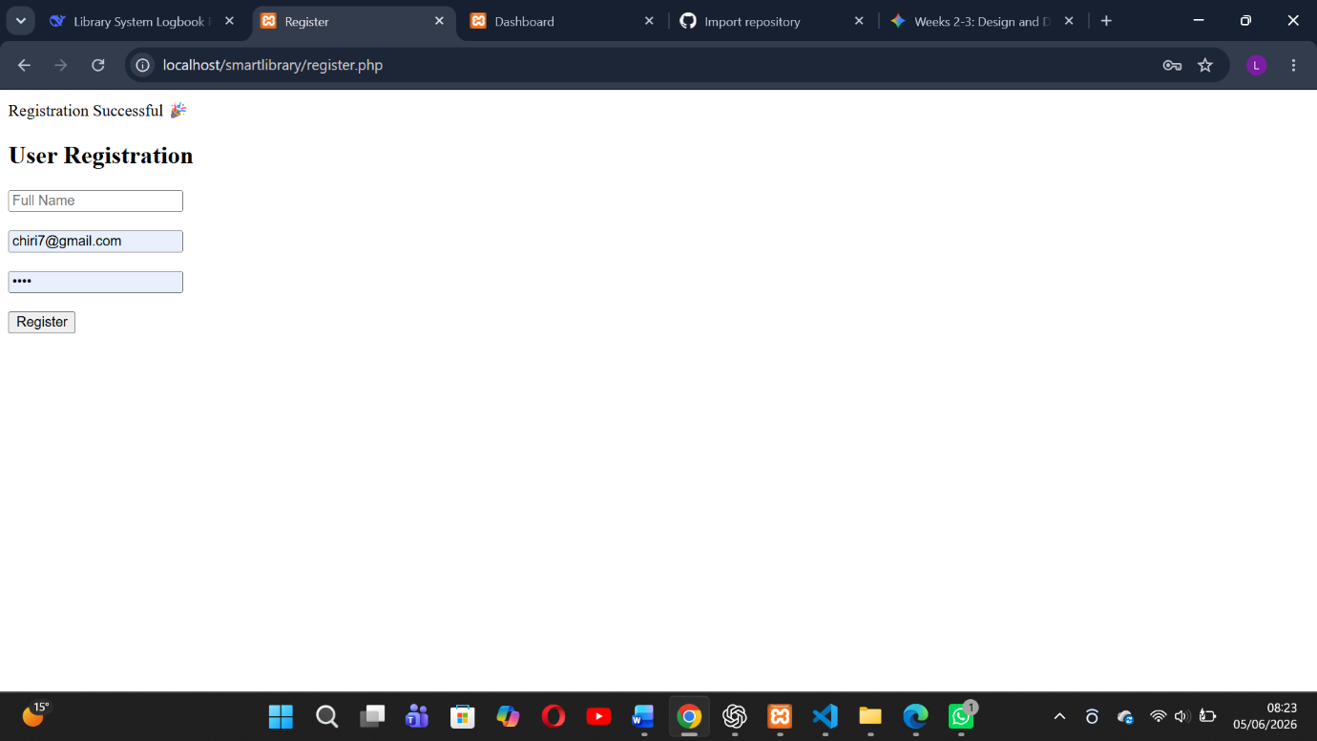

Fig 1: JavaScript Form Validation
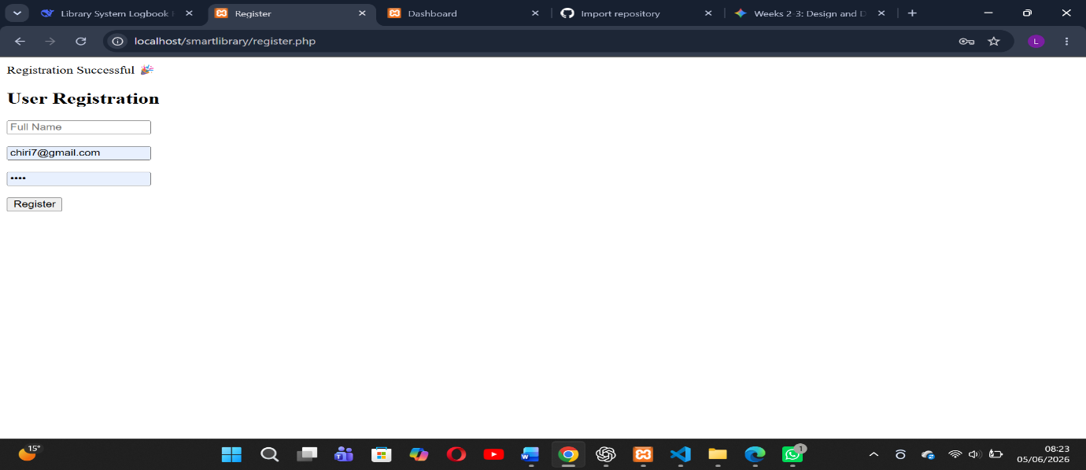

Fig 2: Password Strength Checker
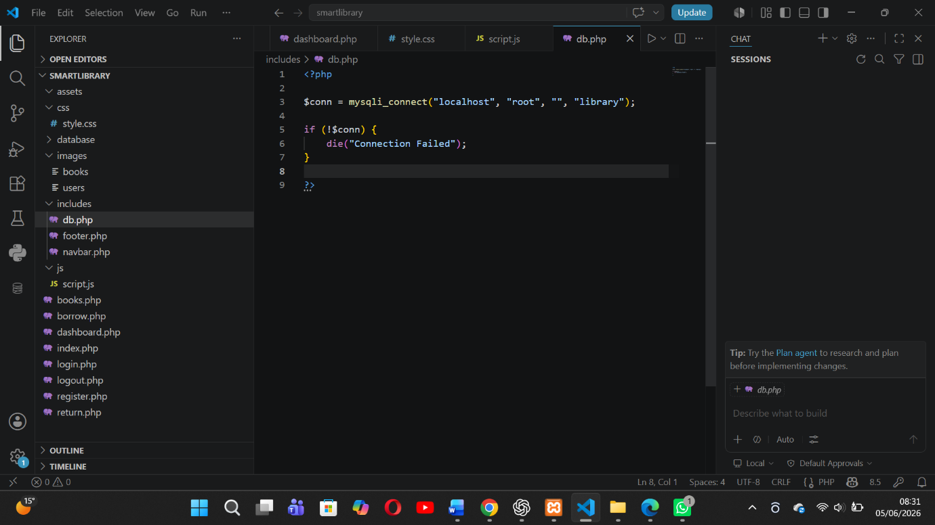

Fig 3: PHP Syntax Practice

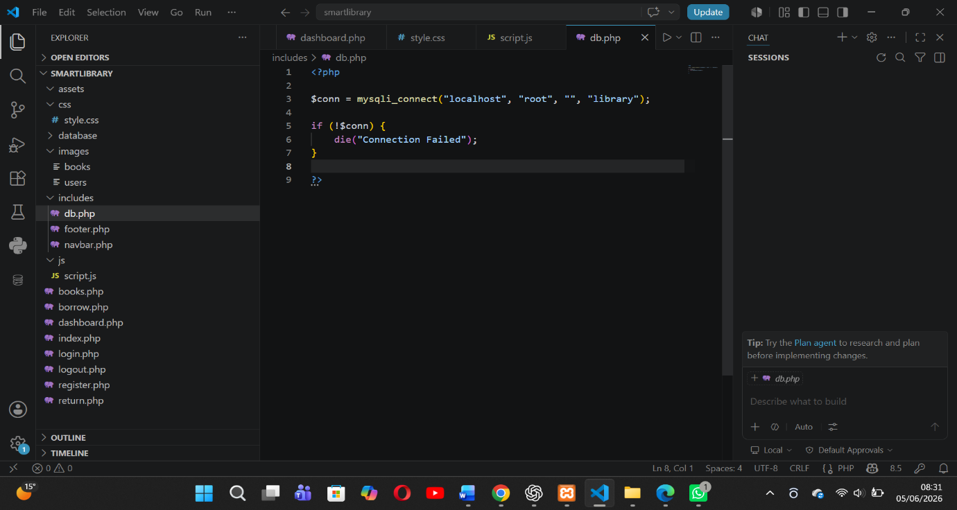

Fig 4: Database Connection Script

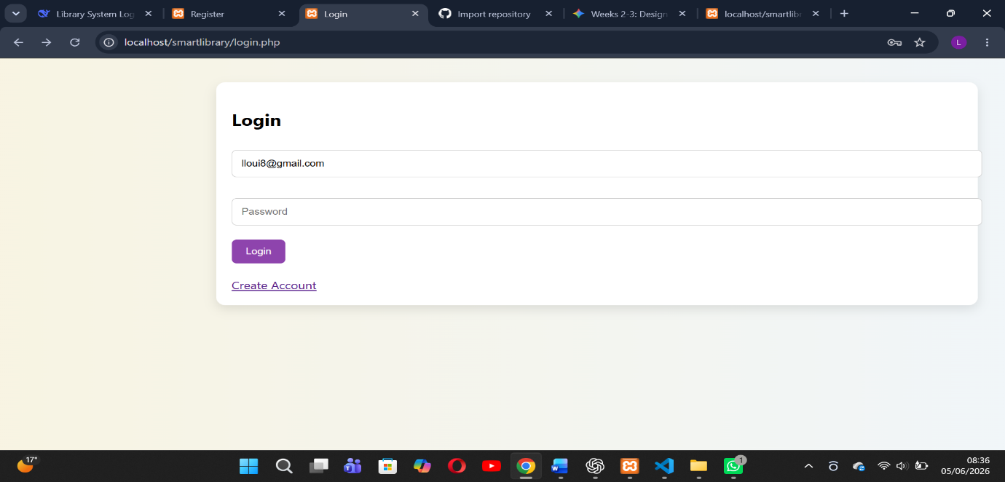

Fig 5: Dynamic User Input Handling

STUDENT REFLECTION
During Week 3, the frontend and backend components of the Smart Library Management System were integrated successfully. User authentication was implemented through login and registration modules connected to the MySQL database. Password hashing and validation mechanisms improved system security and reliability. This week enhanced my understanding of PHP sessions, database operations, and secure web development practices.

Week 4 – Server-Side Components (Login & Forms)

Introduction
During Week 4, the Smart Library Management System development focused on building the core foundation of the system. This included setting up the database, implementing authentication modules, and developing the basic functional structure of the library system using PHP, MySQL, HTML, CSS, and JavaScript.

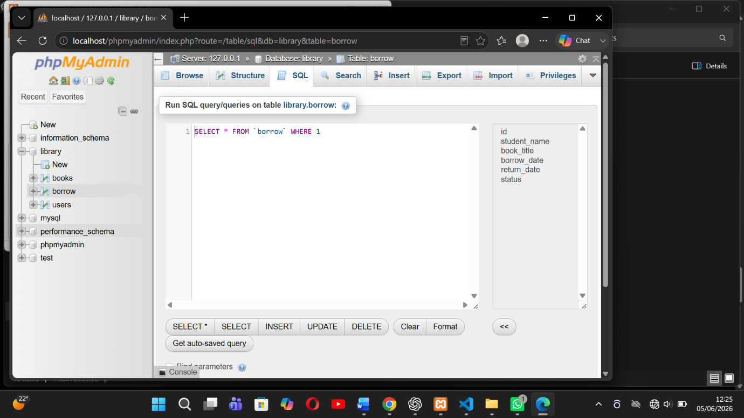

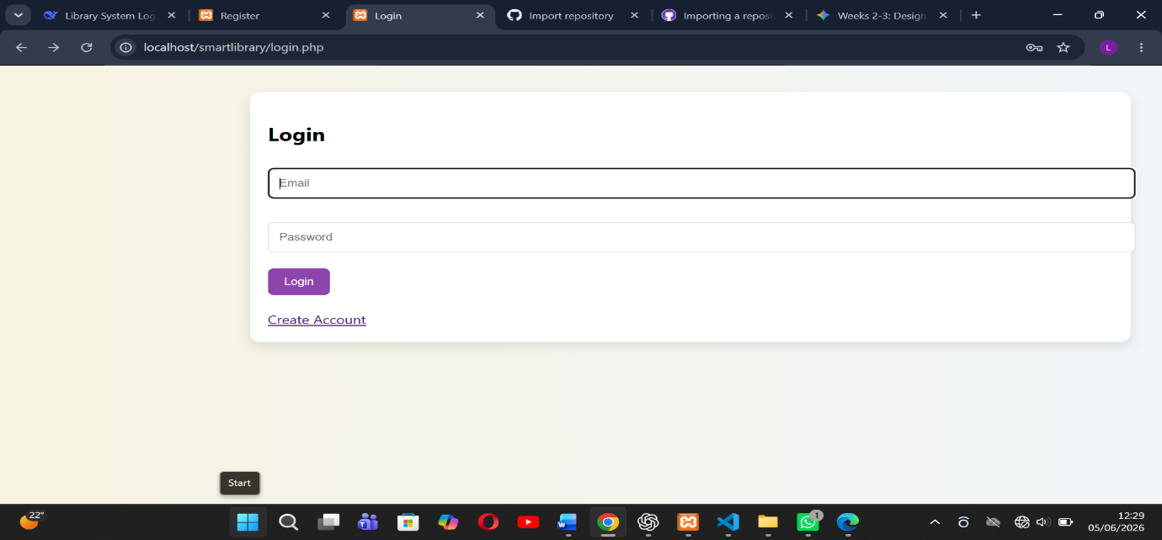

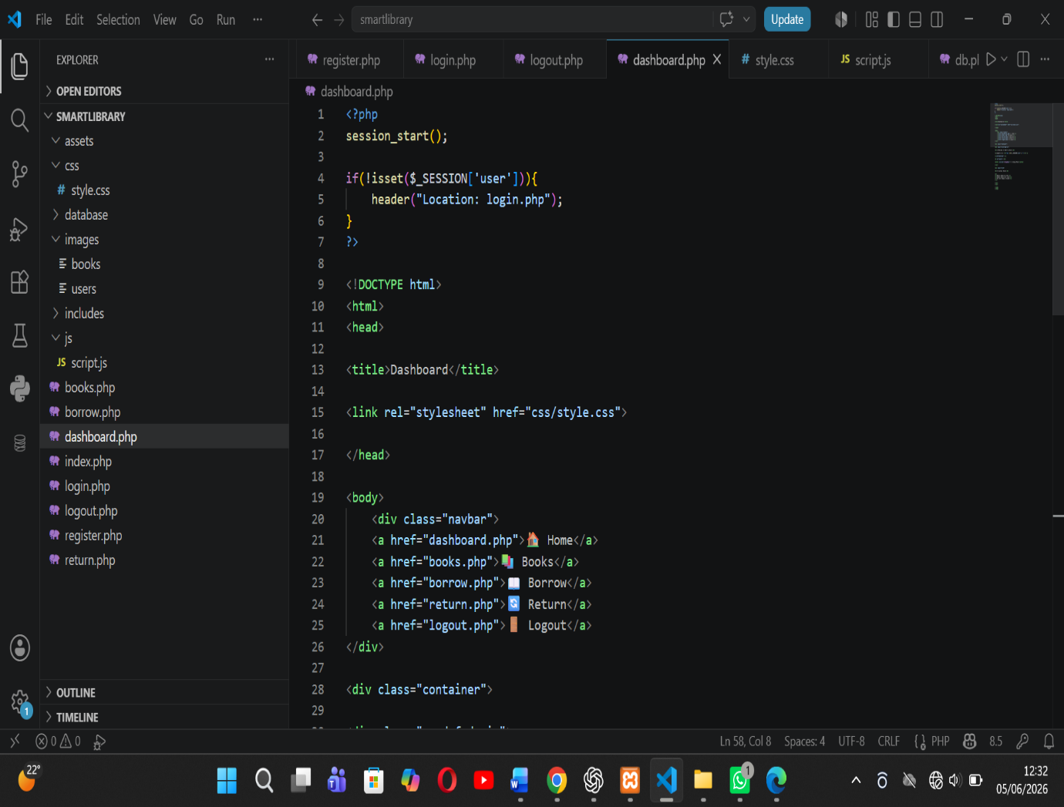

STUDENT REFLECTION
Week 4 marked the foundation phase of the SmartShelf Library System. The core system structure was successfully created, including authentication, database integration, and basic navigation. These components formed the backbone for further enhancements in Week 5.

WEEK 5 REPORT – SYSTEM ENHANCEMENT & UI IMPROVEMENT

1. Introduction
Week 5 focused on enhancing the SmartShelf Library Management System by improving the user interface, adding advanced features, and making the system more realistic and interactive. The goal was to transform the system from a basic functional prototype into a modern web-based library application.
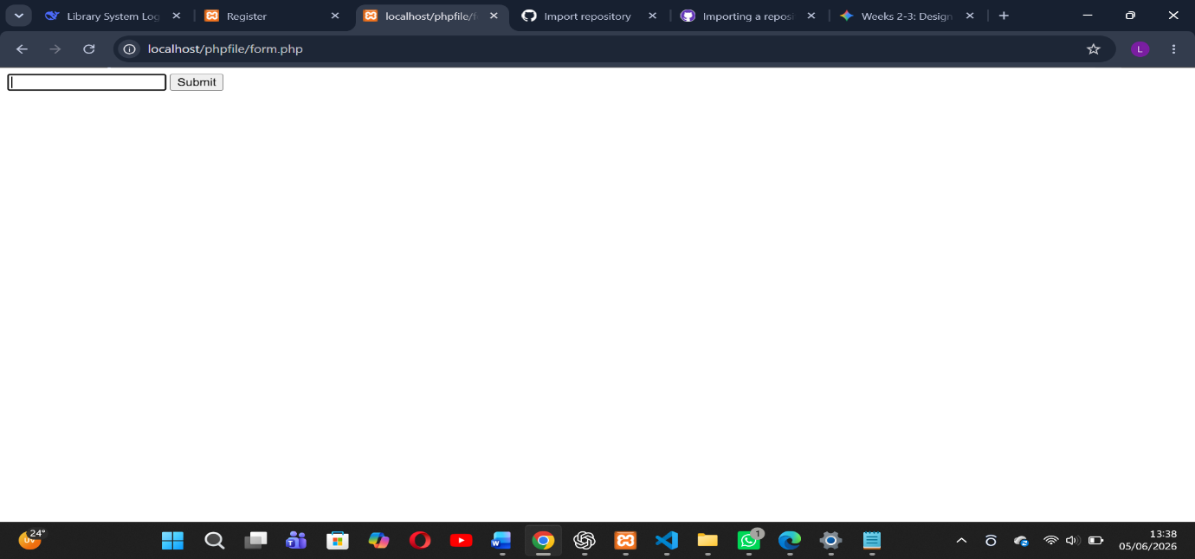
php forms handling

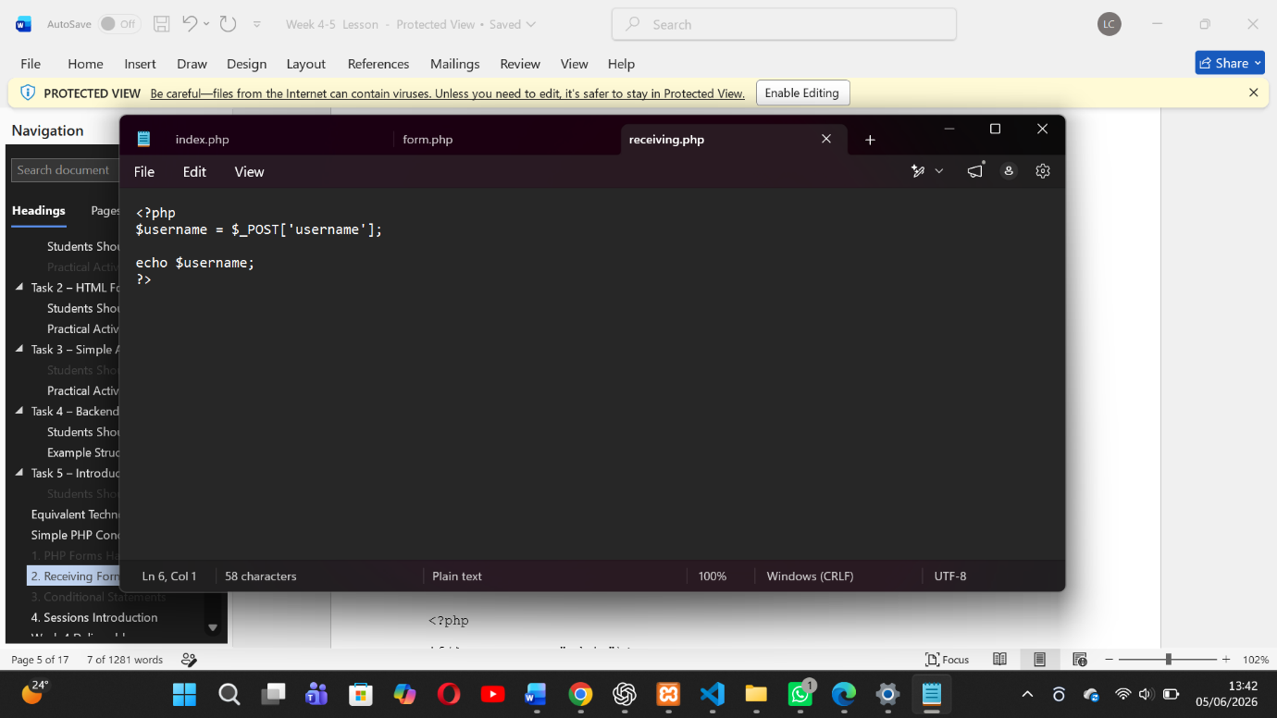
Receiving data

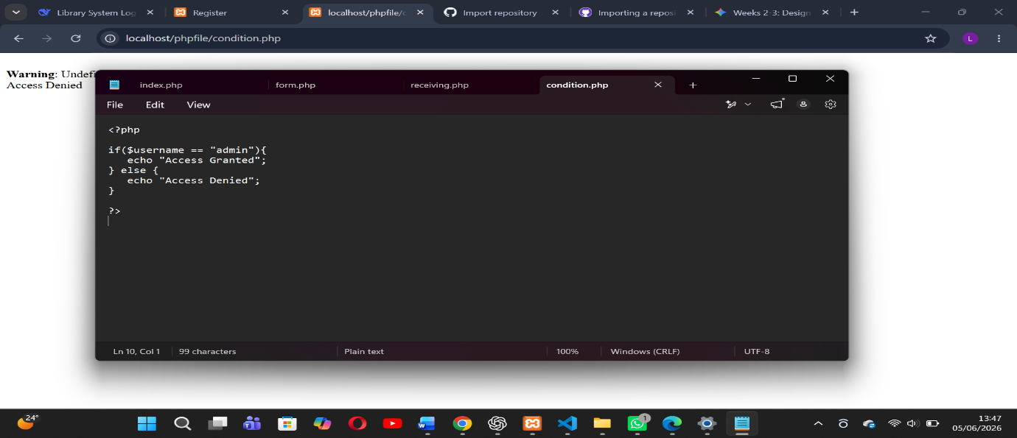
CONDITIONAL STATEMENT

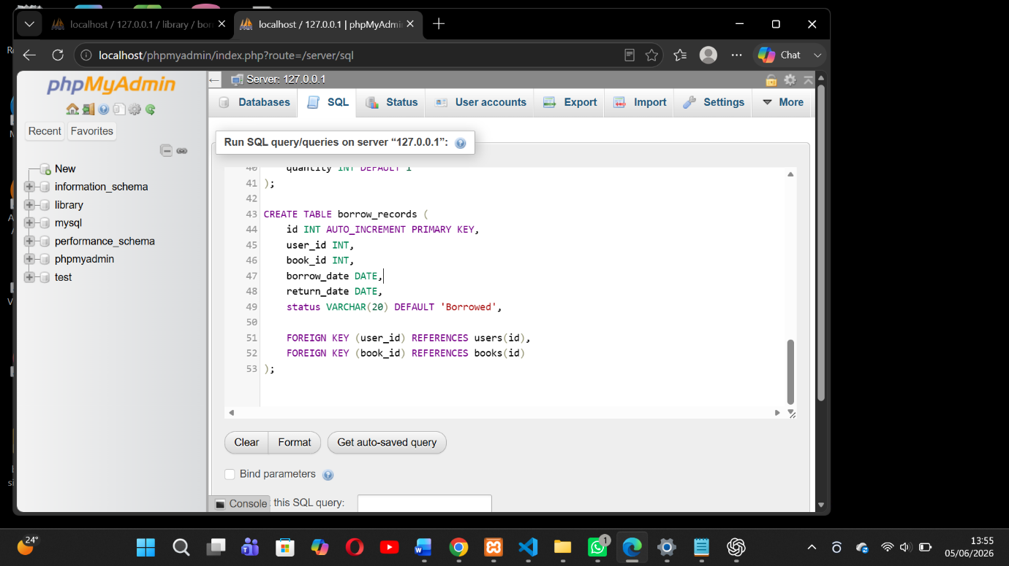

STUDENT REFLECTION
Week 5 significantly improved the SmartShelf Library System by enhancing its design, usability, and functionality. The system now resembles a real-world digital library platform with improved UI/UX, structured navigation, and interactive features.

