Set up computing environment for 3D content development

Instructions for installing Unity Hub and Unity Editor (version 2021.3.xx or higher) on the computer so the development environment is set up. Create a new Unity project. Add a game object to the new Unity project.

Estimated time is 1 – 2 hours. It may vary depending on your internet and/or computing capacity.

All downloads are directly from unity.com. These instructions are not intended to be exhaustive; they are representative instructions and could be brief. You are expected, as a graduate student, to find additional online resources to complete this pre-class assignment. It would not be acceptable to have incomplete pre-class assignment because “the instructions are too brief.”
- Create an account on unity.com to get student pricing (free!). unity.com/pricing#plans-student-and-hobbyist.
- Download Unity Hub. Unity Hub is a small program that manages all the versions Unity Editor you install as there has been numerous versions of Unity Editor since its public release. They update it on a biweekly basis. It is not necessary to update it every time a new version is released. Find it here. unity.com/download
- Install Unity Editor (version 2021.3.xx or higher).
  - How to install? Two installation options are outline below.
    - Option 1. You can install the Unity Editor by selecting the desired version in Unity Hub. Make sure you select “Installs” on the left hand side navigation option in order install. See Figure A1 and Figure A2 in Appendix for sample installation views.
    - Option 2. Go to unity.com/releases/editor/qa/lts-releases?version=2021.3 to find the version you want, and download and install it like you would for any other computer programs.
  - Does the version number matter? No, it should not as long as you use 2021.3.xx or higher. We use the LTS (long term support) versions, so even if Unity releases a 2023 version, they would still support / update the older version.
  - Why don’t we use the 2023 version? Unity 2023 is available as a beta testing version right now, which means it may or may not be stable. Unity 2022.x is also available and has LTS, but we have ensured stability and successful deployment on Unity 2021.3.xx.
  - I am a Windows (or Mac) user. Does it matter? No, it should not. I use both Windows and Mac machines. The deployment process (of transferring Unity project from computer to headset) may vary slightly. I would say my Mac laptop is more powerful than my Windows laptop, while my Windows GPU desktop is the most powerful one.
- Select and install the appropriate modules for Unity Editor. Check these boxes to install the useful modules for VR content development and deployment. The modules include: (1) Android Build Support (Open JDK, Android SDK & NDK Tools), iOS Build Support, Mac Build Support (IL2CPP), Windows Build Support (Mono). The screenshot below is an example; it is not the exhaustive list.
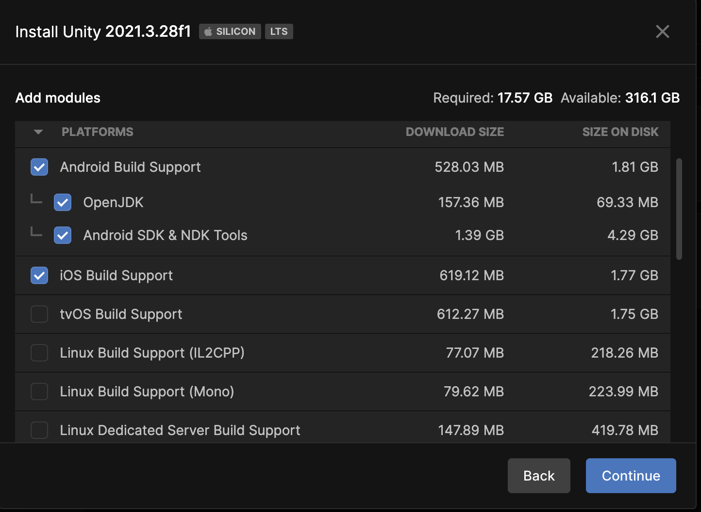
- Create a new unity project. Open up Unity Hub, select “Projects” on the left-hand side. You will be prompted to select the version of Unity Editor (version 2021.3.xx) and the type of project or template (3D, sometimes it says 3D Core), and asked to name the project and file path (where you want to save the project). See Figure A3 and Figure A4 in Appendix for sample installation views.
  - How big is the unity project file? Technically speaking, when you create a new unity project (blank), Unity Editor automatically creates a series of folders and file dependencies for you. When you name the project, you are actually naming the project folder name. Even simple projects can easily go above 5GB.
  - Since unity creates so many files and folders, how do I know what is the actual file that I should be working with? You should go to the new project folder that you just created (I put mine under Documents folder), and find SampleScene.unity file. This is a “.unity” file type. It is usually located in [main project folder] > [Assets] > [Scenes] > SampleScene.unity. In the example below, my main unity project (folder) is named Micro-MVRS.
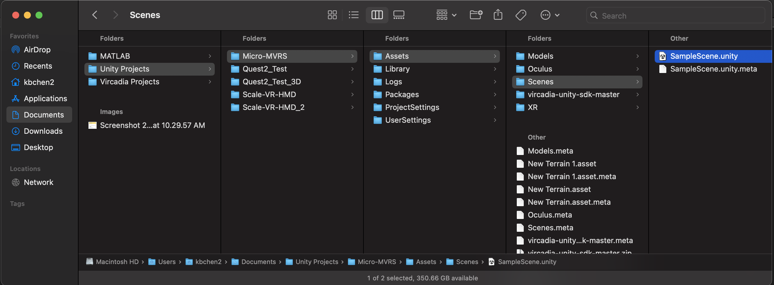
- Add a game object to your scene file (the .unity file). You can double click to open up SampleScene.unity file in Unity Editor. You may also locate that file through Unity Hub. See Figure A5 in Appendix for the expected view once you open up the .unity file. You can add a game object, such as a 3D cube, to the scene.

Sample additional resources. A starting place for you to look for additional resources.
- General link to tutorials: https://learn.unity.com/tutorials
- Get started in the Unity Editor: https://learn.unity.com/tutorial/get-started-in-the-unity-editor-1#
- https://learn.unity.com/tutorial/explore-the-unity-editor-1#
- A more in-depth tutorial (entirely optional): https://learn.unity.com/course/create-with-code
  - Unit 1, Unit 2, Unit 5 are more relevant.

Appendix

Figure A1. View of a Windows user installing Unity Editor using. Note: Your view might be slightly different given this was Unity Hub version 2.4.1, as well as your Windows color (dark or light) setting may impact the view.

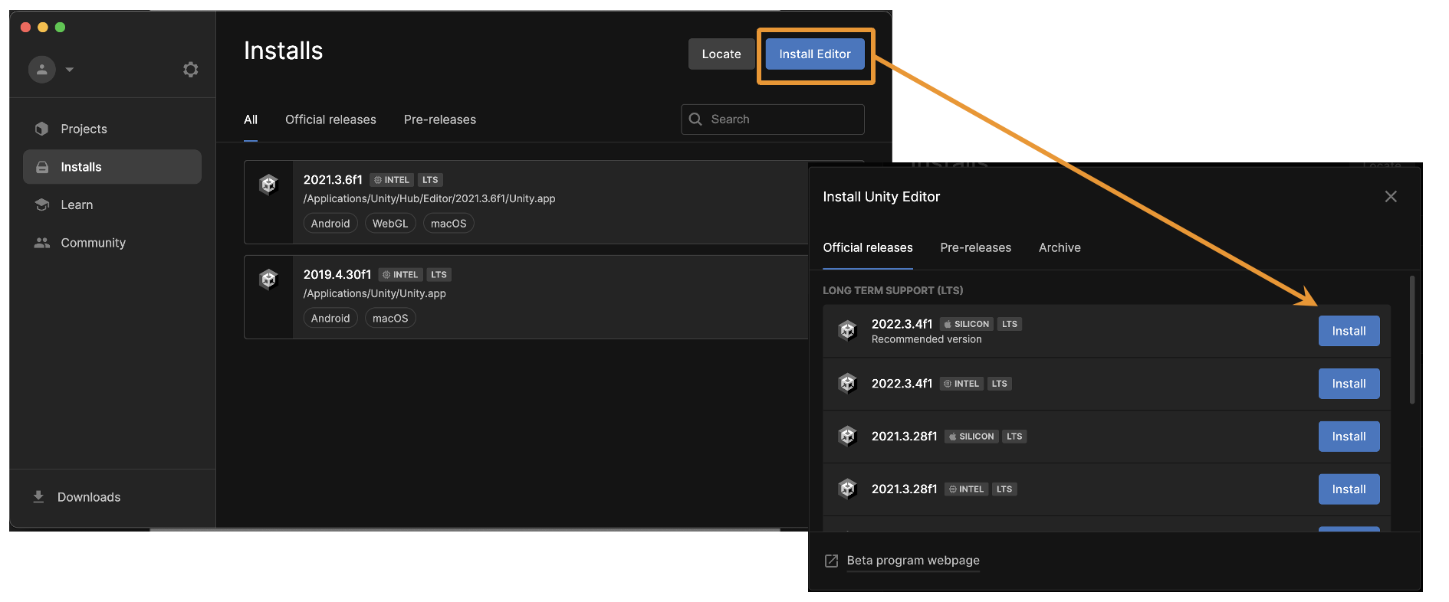
Figure A2. View of a Mac user installing Unity Editor using. Note: Your view might be slightly different given the version of Unity Hub, as well as your Mac color (dark or light) setting may impact the view.

Figure A3. View of a Windows user creating a new unity project. Once you click on “Projects” (the blue word on the left hand side), click on NEW at the upper right hand corner. In the pop-up screen, select 3D, name the project, and select the file-saving location. Note: Your view might be slightly different given this was Unity Hub version 2.4.1, as well as your Windows color (dark or light) setting may impact the view.

Figure A4. View of a Mac user creating a new unity project. Once you click on “Projects” (the blue word on the left hand side), click on NEW at the upper right hand corner. In the pop-up screen, select 3D, name the project, and select the file-saving location. Note: Your view might be slightly different given this was Unity Hub version 2.4.1, as well as your Windows color (dark or light) setting may impact the view.
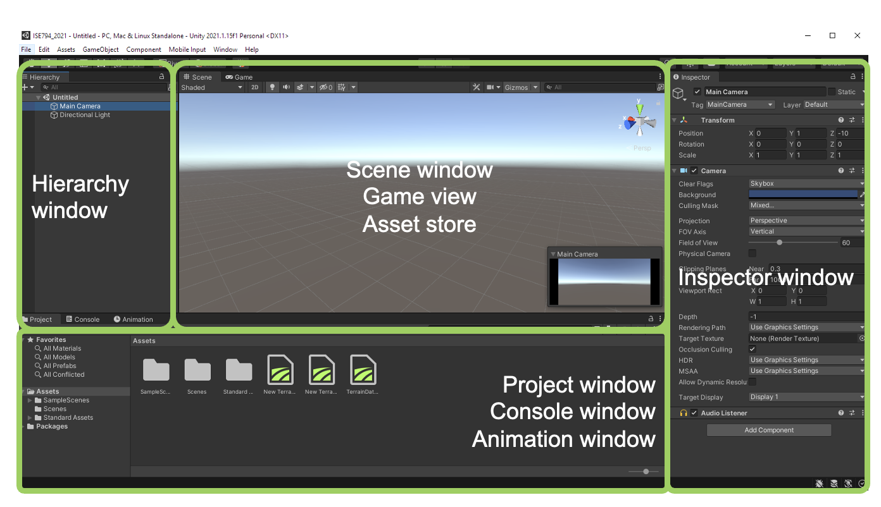
Figure A5. Unity Editor view when you open up the SampleScene.unity file. The window is generally divided into smaller windows or panels. You can right click in the Hierarchy window to add a 3D game object. (right click, select 3D Object > Cube).

