服务端:
public void doGet(HttpServletRequest request, HttpServletResponse response)
throws ServletException, IOException {
String id=request.getParameter("id");
ProductService productService=BasicFactory.getFactory().getInstance(ProductService.class);
try {
productService.deleteProdById(id);
//删除成功
response.getWriter().write("删除成功，1秒后自动跳转,如果没有跳转请点击此处:" +
"<a href='/back/BackProdListServlet'>商品管理</a>");
// response.getWriter().write("<a href='"+request.getServletContext().getAttribute("path")+"/back/manage.jsp'> manage </a>");
// response.getWriter().write("<a href='${path}/back/manage.jsp'> manage2 </a>");
// "<a href='${path}/back/BackProdListServlet'>商品管理</a>");
// response.setHeader("refresh", "1;url="+request.getContextPath()+"/back/BackProdListServlet");
} catch (MsgException e) {
//删除失败
response.getWriter().write("删除失败:"+e.getMessage()+";1秒后自动跳转,如果没有跳转请点击此处:" +
"<a href='${path}/back/BackProdListServlet'>商品管理</a>");
response.setHeader("refresh", "1;url="+request.getContextPath()+"/back/BackProdListServlet");
}
}

浏览器:

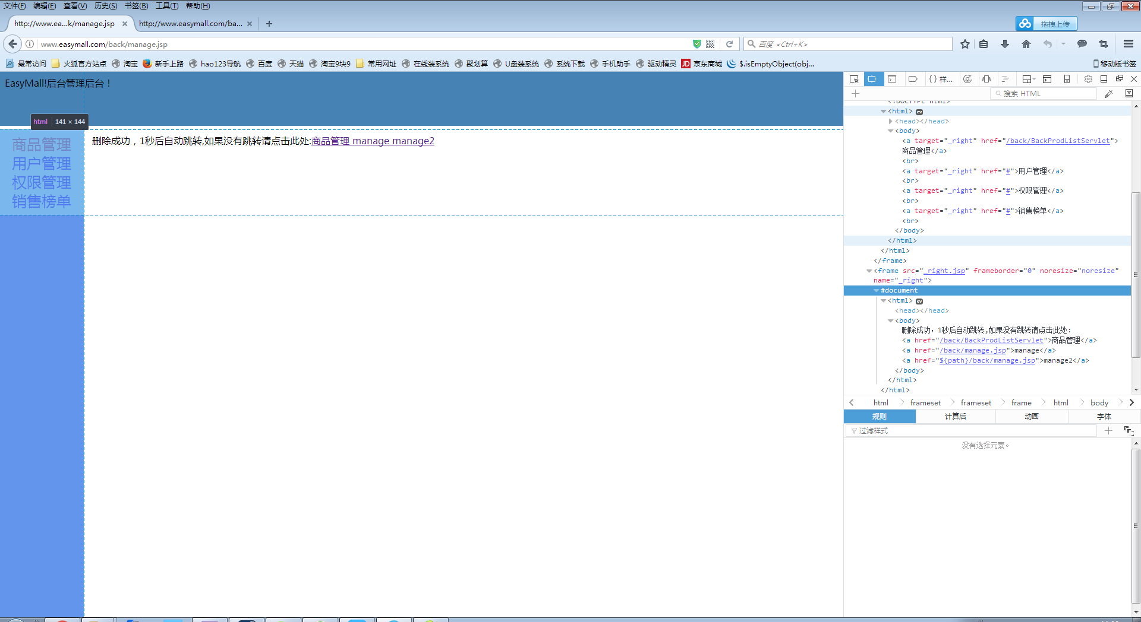
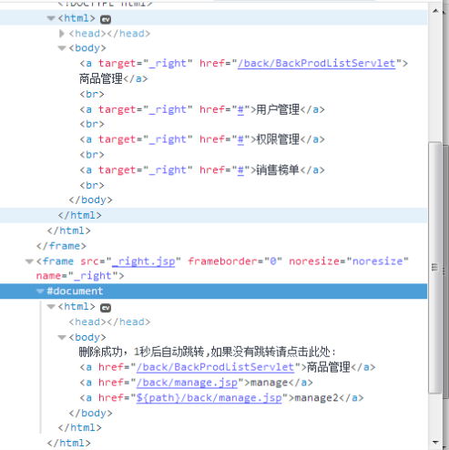
可以看到<a>标签中的el表达式并没有被解析
上面第一个商品管理是在jsp页面使用的${path}，在jsp解释为servlet的时候正常解析了el标签
而在servlet中以getwrite.write输出的el表达式未被正常解析

