1. 配送员配送速度：20km/h

参考文献：

Simoni M D, Winkenbach M. Crowdsourced on-demand food delivery: An order batching and assignment algorithm[J]. Transportation Research Part C: Emerging Technologies, 2023, 149: 104055.

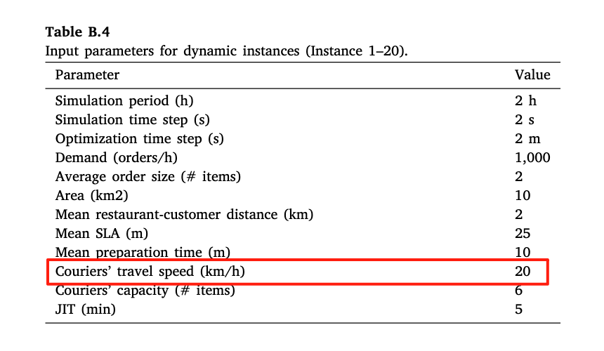

Zhang K, Ke J, Wang H, et al. Tactical operations of service region dimensioning, bundling, and matching for on-demand food delivery services[J]. Transportation Research Part C: Emerging Technologies, 2025, 174: 105069.

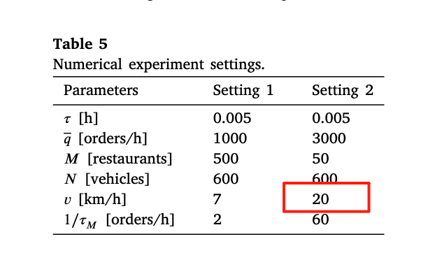

1. 平均空驶距离

空驶距离：本问题假设外卖员每次仅可携带一件订单，故空驶距离为——快递员前往餐厅取货的路径长度

$$平均每小时空驶距离=\frac{\sum_{所有外卖员}{空驶距离}}{\sum_{所有外卖员}{每个外卖员的工作时长}}$$

1. 超时率（1日）

$$超时率=\frac{超时到达的订单数量}{订单总数量}$$