Testing Document

1. Project’s idea: Raspberry Pi Image Recognition
2. System Block Diagram

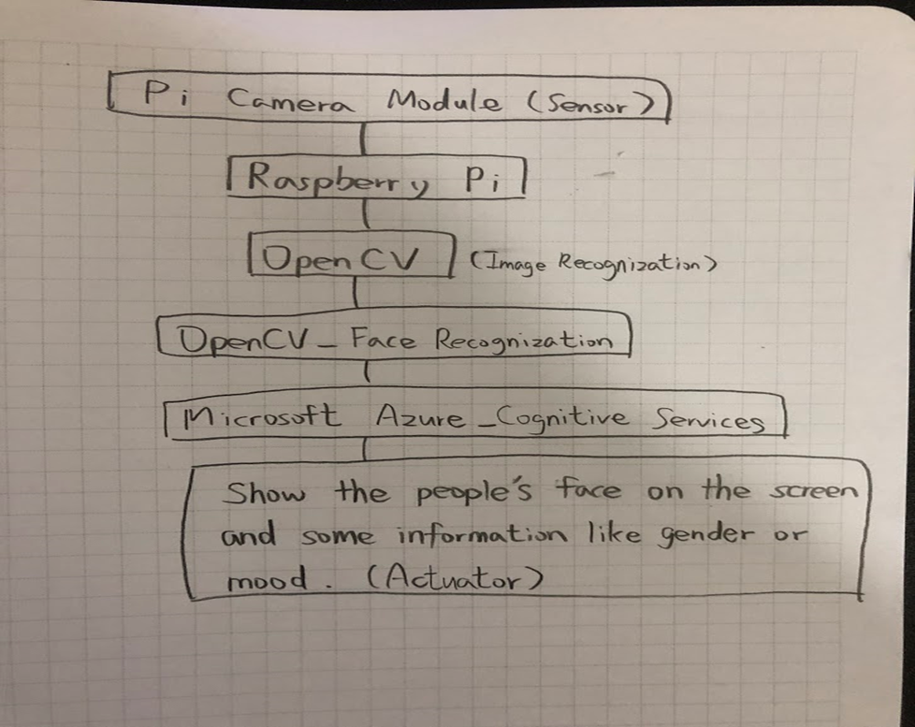

1. Testing of Components
2. Pi Camera Module: Use “raspistill” or “raspivid” command to take a picture or video. Check the picture or video are no problems.
3. Raspberry Pi: Plug the Raspberry pi into the power, and check its operating system can work normally.
4. OpenCV: Download compile tools, image IO suites and OpenCV. Set Python VirtualEnv and install OpenCV. Check OpenCV is successfully installed by command “workon cv” and “python”.
5. Microsoft Azure: Set the account of Microsoft Azure, and use Microsoft Azure_Cognitive Services. In the Azure Portal, click the plus-sign to create a new resource and search for cognitive services. Select Cognitive Services from the search result and click create. The Create Cognitive Services wizard appears:
6. Fill in a name
7. Select the API, in our case the Emotion API
8. Select the location (while the Emotion API is in preview, it is only available in West US)
9. Select the pricing tier (Free is fine for now)
10. Create a new Resource Group, you can delete this when you are done with this tutorial
11. Agree to the terms and click create

Alright, now to use the API in an application.

1. Raspberry Pi’s Screen: Use general personal computer screen to connect the Raspberry Pi by HDMI.
2. Integration Testing
3. Test Pi camera Module + Raspberry Pi + Raspberry Pi’s Screen.
4. Test Pi camera Module + Raspberry Pi + Raspberry Pi’s Screen + OpenCV.
5. Test Pi camera Module + Raspberry Pi + Raspberry Pi’s Screen + OpenCV + Microsoft Azure.