Team232 Feasibility Report

Xavier Andueza,

Ritchie Leong,

Ling Chen,

Kabir Chugh,

Jason Ung,

John Nguyen

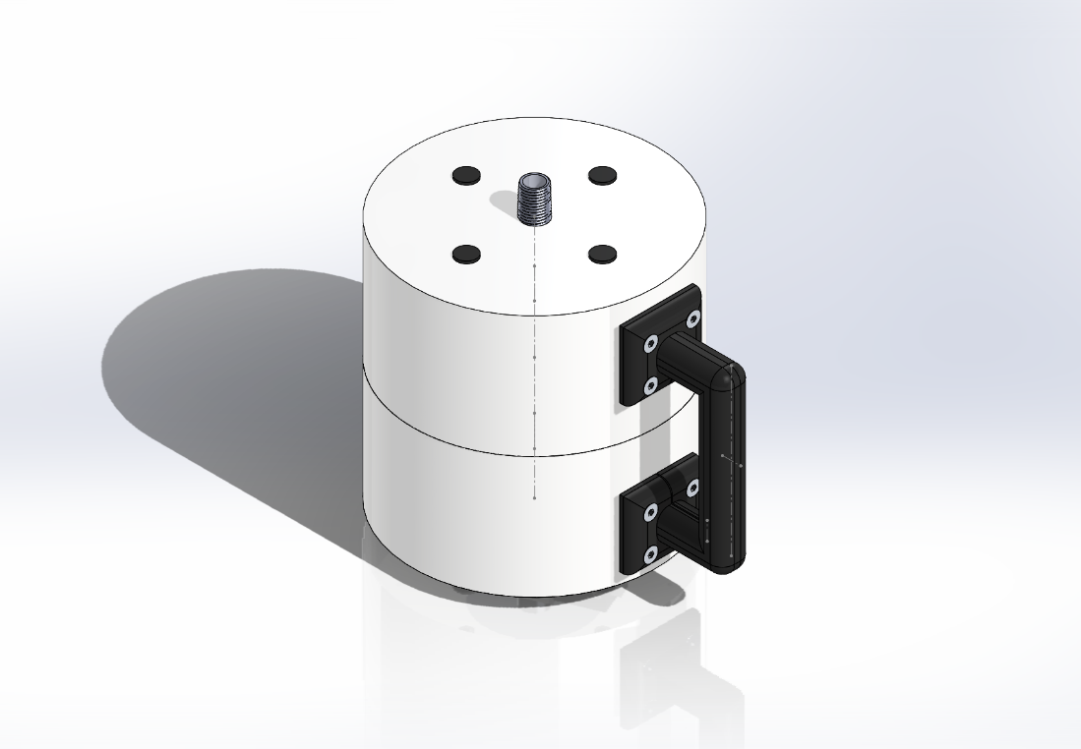

# Executive Summary

Anaerobic Digestion (AD) in bioreactors can be significantly affected by the quality of the digestate contained within. Indicators of poor digestate quality include colour, and foaming. Testing of digestate quality is typically done by removing digestate from the container in an intermediate container, and then placing this digestate into a testing unit.

Team 232 (T232) has proposed an innovative new design that will disrupt this process, where the testing unit will plug directly into bioreactor release valves, immediately testing the digestate. In this feasibility report, the design is presented, and the three design sub-assemblies are justified, including estimated costs. Design decisions, including the material selection choices, are highlighted and explained. Visuals are presented to assist the reader in understanding how these sub-assemblies are assembled.

Contents

1.0 Executive Summary 1

Contents 2

2 Introduction 3

2.1 Problem Statement 4

2.2 Proposed Solution 4

3 Design Summary 4

The Intention of the Design 5

4 The Chassis 5

5 The Fluid Container 8

6 The Electronics 10

6.1 Raspberry Pi 10

6.2 Battery 11

6.3 Camera 11

6.4 Peripherals 11

# 2 Introduction

In this report, the financial feasibility of the Team 232’s (T232’s) product is assessed. Justifications are made for the design decisions made, and costings are presented. References are made to the Bill of Material, which can be found accompanying this report.

## 2.1 Problem Statement

Anaerobic Digesters (AD) have been traditionally used in waste treatment to breakdown biodegradable waste and sewage sludge. It is also a source of renewable energy. However, the chemical processes can lead to a reduction in efficiency. This is indicated by foaming and a colour change in the digestate. Periodic testing of digestate must be performed, where the amount of foam and the foam colour is analysed. Intervention can occur if needed after analysing the digestate foam and colour.

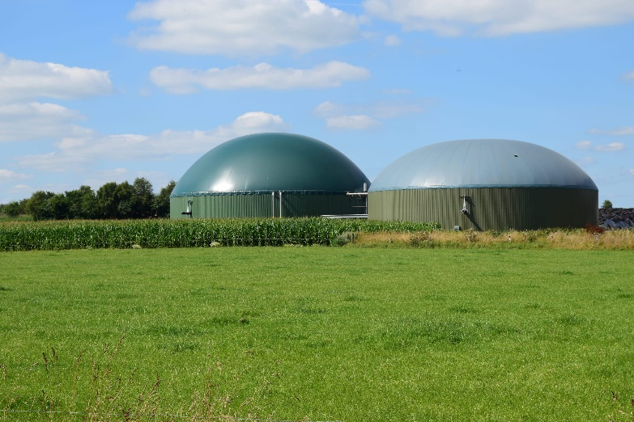

Figure 1: Anaerobic Digester plant

<https://www.fgsorganics.co.uk/wp-content/uploads/2022/07/shutterstock_304576766-1-scaled.jpg>

## 2.2 Proposed Solution

To enable better testing of ADs, Team 232 conducted successful proof-of-concept testing and has developed a proposed AD tester design, dubbed “T232’s Instrument”. T232’s Instrument enables rapid testing and diagnosis of digestate. The AD tester device allows users to extract a sample of the digestate from the AD tank and analyse digestate foam level and colour.

# 3 Design Summary



Figure 2: Image of the proposed final design of T232’s Instrument

T232’s Instrument can be broken down into three main sub-assemblies:

* **The Chassis**   
  The hard plastic outer container that features the grip and contains the Fluid Compartment and Electronics within.
* **The Digestate Container**  
  The metal and glass that contains the digestate during testing.
* **The Electronics**The circuits and other electrical components that enable analysis and diagnosis within the instrument.

These Sub-assemblies are broken down in their own segments, costings discussed, and design decisions justified.

## The Intention of the Design

To frame the design decisions made, the overall intended use of T232’s instrument will be explained.

Unlike other competitor products, where the digestate is brought to the instrument, T232’s is unique in that the instrument is brought to the unit. This is enabled through the design being such that the instrument is screwed into bioreactor fluid release valves. The digestate can then enter the body and be tested immediately.

# 4 The Chassis

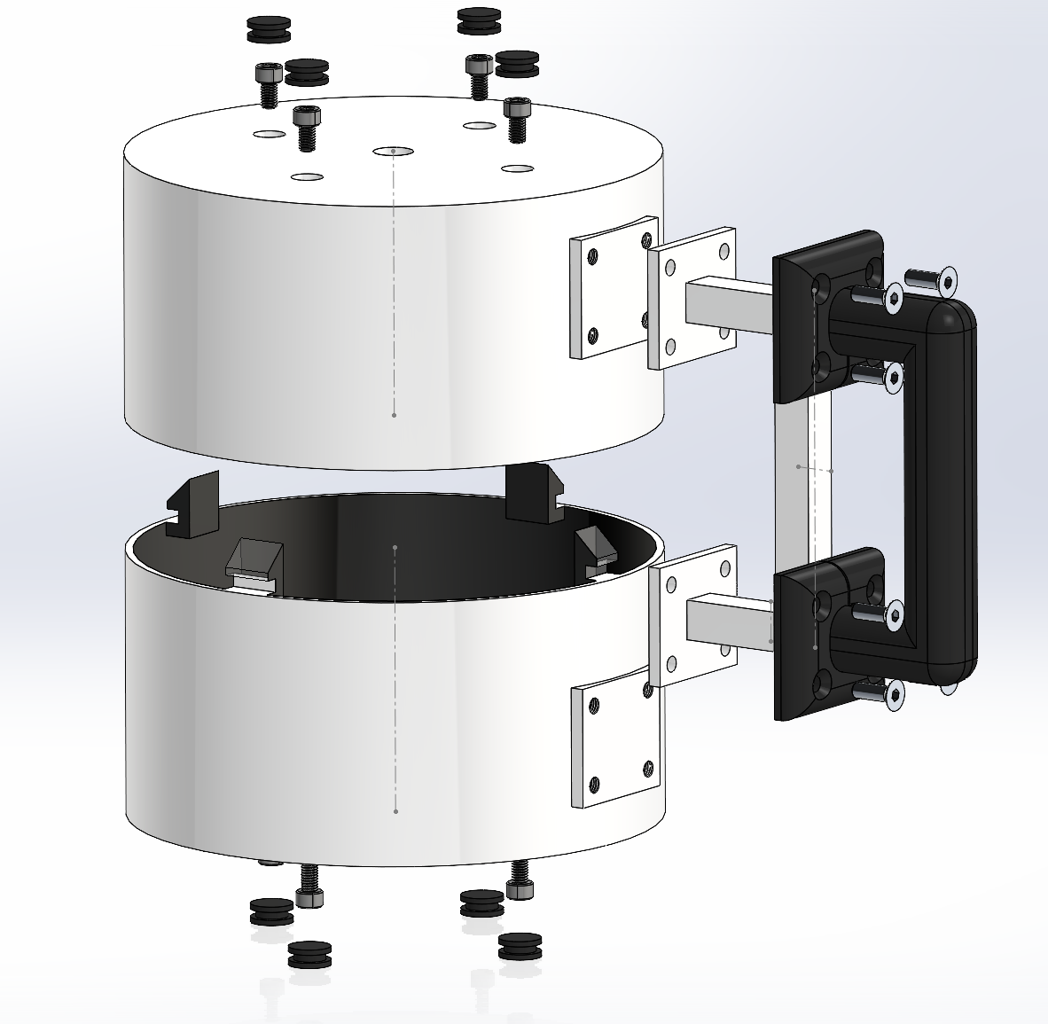

Figure 3: Disassembled view of T232’s Instrument’s Chassis

Table 1: Design justifications for the chassis

|  |  |  |  |  |
| --- | --- | --- | --- | --- |
| **Name** | **Material** | **Cost ($)** | **Qty** | **Justification** |
| Top Shell | Hard Plastic | 58.55 | x1 | The top shell was decided to be made using a hard plastic, that is injection moulded. Hard plastic was deemed to be the most appropriate as it was a high priority for the design to be lightweight, but sturdy. Making the entire instrument out of Aluminium was considered, however it was deemed as being both too costly and heavy compared to the hard plastic.  The Top shell features four clip holes, which the bottom shell clips into for easy assembly. One of the clips is smaller than the others, meaning that there is only one way to assemble these two together, as it will not fit in any other way. This ensures that the handle holes in the top shell are aligned. It is a simple method that ensures that the manufacturing process is simple, yet able to ensure fewer mistakes are made.  Both the top and bottom shell feature holes for the 10mm M6 HEX heads to pass through, securing the Digestate Compartment to the Chassis. To enable the large solenoids to enter the bottom sections, there is a large opening for them.  Both the top and bottom shell have their inside painted black so that the images easily have the foam and background distinguished. |
| Bottom Shell | Hard Plastic | 58.51 | x1 | The Bottom shell features the bottom clips, that clip into the top shell clip shells. |
| 10mm M6 HEX Bolt | Steel | 4.96 | x8 | These 10mm M6 HEX screws were chosen as they allow a large amount of torque to be applied. These secure the Digestate Compartment to the chassis. The top and bottom shell have holes, which allow the bolts to be screwed in through.  HEX heads have an advantage of being resistant to threading, which, due to large torques being applied to ensure that the chassis and the fluid compartment, is a risk for other heads. |
| Rubber Nibs | Rubber | 8.00 | x8 | The rubber caps are placed onto the screw holes that exist in the chassis, and were chosen as rubber material is already being used on the grip, and to strengthen the black-on-white aesthetic of the instrument. |
| Handle | Hard Plastic | 21.38 | x1 | The handle is made of hard plastic, which is strong yet lightweight. As a rubber grip is placed on top of this, costs were reduced by making the grip square. This part is simple to injection mould, and will be quite cheap. Metals would be more expensive and weigh more. |
| Grip | Rubber | 33.87 | x1 | The Grip was selected to be a custom rubber grip, which is screwed into the handle and chassis through the 18mm countersunk M6 HEX Screws. Rubber grips are commonplace, and are comfortable to many consumers. A softer rubber allowed the handle design to be simpler, further reducing costs. |
| 18mm countersunk M6 HEX Bolt | Steel | 8.70 | x8 | These 18mm countersunk M6 HEX screws are used to secure the grip and handle together, and into the chassis. These are utilised in place of the 10mm M6 HEX due to their need to be countersunk and the overall hole length being greater.  Countersunk screws were chosen as these screws were customer facing, and having bulkier HEX heads resulted in a significantly loss of visual appeal to the customer, as screws were jutting out from the grip, which most customers associate with being smooth. |

# 5 The Fluid Container

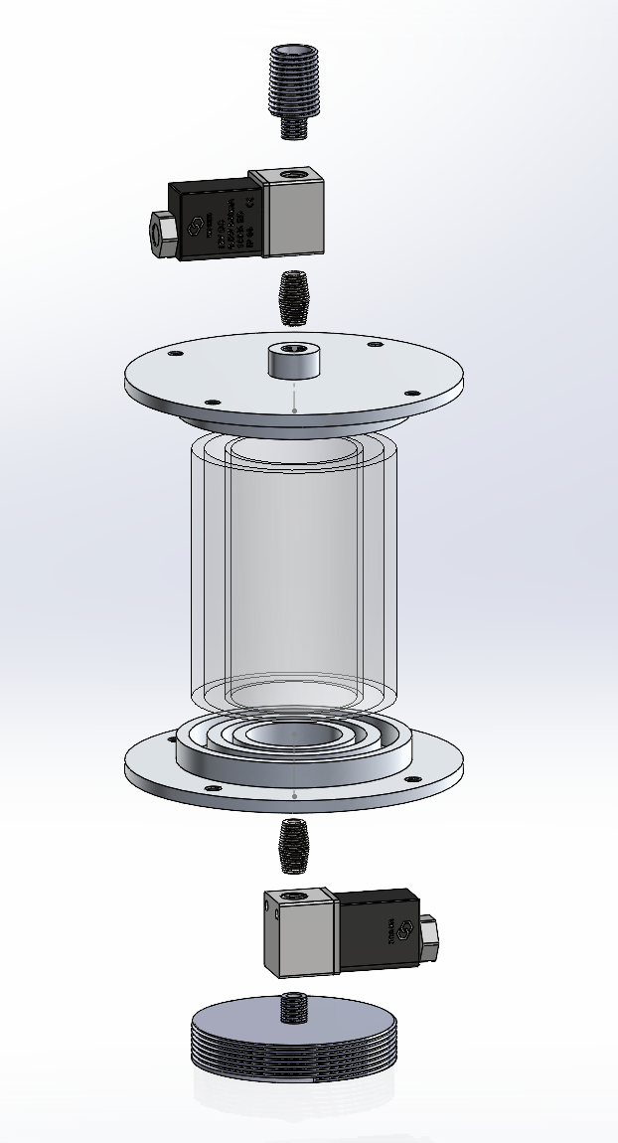

Figure 4: Disassembled view of the Digestate Container (flipped horizontally)

Table 2: Design justifications for the Digestate Container

|  |  |  |  |  |
| --- | --- | --- | --- | --- |
| **Name** | **Material** | **Cost ($)** | **Qty** | **Justification** |
| Valve connector | Stainless Steel Alloy | 66.00 | 1 | This valve connector was initially designed as a 20mm NPT head; however, it is extremely customisable to customer site needs. It was not worthwhile investigating off-the-shelf components due to the likely amount of variation from one customer site to another.  A stainless-steel alloy was chosen for this part as the digestate, although anaerobic, may induce some rusting effects over time as air enters when outside of testing environments. |
| 10mm 24V DC Solenoid Valve | NA | 99.00 | 2 | The solenoid valves are crucial to the intended purpose of the system. These valves control the flows in and out of the instrument and are highly precise. The valves are controlled via feedback from the raspberry Pi and will fill the glass vial up to the measurement point.  These specific valves were chosen due to their smaller size, and appropriate valve opening widths. |
| Male-to-Male 10mm NPT connector | Stainless Steel Alloy | 98.00 | 2 | An NPT male-to-male connector was used as it ensures that there is extremely low chance of leakage, and also is a very simple way of connecting the solenoid valves to the tube plates. |
| Tube plates | Aluminium Alloy | 165.00 | 2 | The tube plates are custom made, and feature two sections for the glass tubes to be inserted into. Glass tubes are secured to the plates with adhesive.  An aluminium alloy was selected due to the thicker nature of these components, and how the mass would make the unit less transportable and place greater strain on the glass tubes.  The part is as thick as it is as this is where the digestate container is secured to the chassis with the 10mm M6 HEX bolts. |
| 54mm wide, 2.5mm thick, 100mm tall tube | Glass | 32.24 | 1 | Glass was chosen as it is inert and allows for light to pass through for measurement purposes.  The dimensions of this were chosen as it enabled the digestate container to hold 100ml of fluid halfway up the glass vial, which was deemed the optimal camera location. The glass thickness was selected as this was the most representative of world-proven double-glazed glass.  This is also standard glass tubing that can be easily and cheaply ordered from many suppliers.  By providing insulation in this manner, the unit does not require heating elements to keep the digestate in its mesophilic state during testing. This significantly reduces design complexity and costs. |
| 80mm wide, 5mm thick, 100mm tall tube | Glass | 3.95 | 1 | These dimensions were chosen as they enabled the standard double-glazed glass air gap between the two glass tubes. They are also slightly thicker than the standard outer-glass size, ensuring extra robustness from shocks and vibrations.  This is also standard glass tubing that can be easily and cheaply ordered from many suppliers. |
| Bottom attachment | Aluminium Alloy | 54.00 | 1 | The aluminium alloy was selected as this is also one of the thickest parts and adds significant weight to the build. Stainless steel was deemed too heavy. This is a custom part and will be constant across all builds. |

# 6 The Electronics

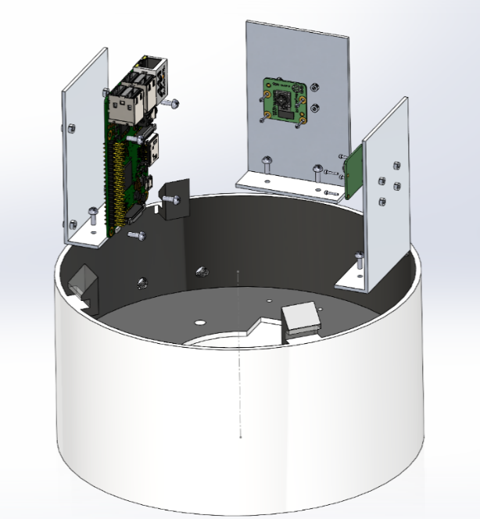

Figure 5: Disassembled Electronic Assembly

## 6.1 Raspberry Pi

The main computer for the device is the Raspberry Pi 4 Model B (Pi 4B), which has the sufficient random-access memory (RAM) of 4GB required to perform the live streaming and processing of the image taken. It is also relatively compact, lightweight, and affordable. Apart from the supply chain issues that prevent the scaling of manufacturing, the Pi 4B has a large community of users, which offers easily accessible help and support needed during development. The Pi 4B also comes with a variety of Linux based operating systems, which does not come with firmware development limitations from MacOS and Windows. The Pi Camera integrates well with the Pi 4B, which limits undetectable hardware malfunctions during later periods of the product life cycle. The Pi also has a typical 5.1V intake power, which can be provided with smaller battery and charging circuit packages. The GPIO pins on the Pi allows for affordable control of peripherals without investment into pricey Data Acquisition boards (DAQ).

## 6.2 Battery

The Pi Idle power consumption is measured using the prototype to be of 500mA, with the maximum peripheral consumption of 1000mA when the servo is activated (unrestricted). Since the operation of the servo is infrequent, the general power for the consumption is assumed to be of 600mA. With the inclusion of the PiJuiceHAT, we have 1820 mAh off the shelf Lipo, and additional 10000mAh PiJuice power pack equates to a total of 11820 mAh. The usage of the battery packs reduces weight, and space compared to cylindrical LiPo batteries. The PiJuiceHAT has inbuilt interruptible power supply, which is needed for a reliable product. The pi will not function predictably with slightly low/ high voltage fluctuations.

With an average consumption of 600mA, the device will last up to 19.2 hours per full charge.

## 6.3 Camera

The Pi Cam v2 has a max resolution of 1080p30 (1920x1080 progressive at 30 frames per second), which is sufficient for the 600x420 pixel photos that are needed for the foam height and digestate colour detection. Since the photo capture is instantaneous, the frames per second capacity is not a constraint.

## 6.4 Peripherals

Table 3: Electrical Peripherals Design Justifications

|  |  |  |  |
| --- | --- | --- | --- |
| **Name** | **Total Cost ($)** | **Qty** | **Justification** |
| White LED strips | 0.26 | 50mm | Any generic White LEDs can be used. |
| Load Cell and Amplifier | 24.4 | x1 | HX711 is used to amplify the voltages in the 1kg bending load cells used |
| Solenoid Valves | 28.48 | x2 | These are low cost 5V solenoids that can take power from the Pi |
| Camera, LED holder | 193.00 | x2 | Plate to mount Pi cameras onto |
| Pi holder | 120.00 | x1 | Plate to mount the Raspberry Pi onto |
| Pi Camera | 106.82 | x2 | Core components |
| Raspberry Pi 4B/4GB | 88.09 | x1 | Core component |