FLOOD RISK PREDICTION IN CHIKWAWA: A MACHINE LEARNING SOLUTION
A DATA SCIENCE PROJECT REPORT
Students:
Zaheerah Abdulrashid (BSDS0123)
Rodrick Kapopo (BSVCA1722)
Favour Kampangire (BSDS1523)
Louis Mwamsako (BSDS2523)
Jonathan Banda (BSDS0323)
George Mapelera (BSDS2123)
Lingalithu Kadewele (BSDS1323)
Department: Information and Communication Technology
Faculty of Science Technology and Innovation
Mzuzu University
Supervisor: Dr. Chimango Nyasulu
Date of Submission: 24th June 2026

2. Declaration & Certificate
2.1 Declaration
We, the undersigned, declare that this project report titled "FLOOD RISK PREDICTION IN CHIKWAWA: A MACHINE LEARNING SOLUTION" is our original work and has not been submitted elsewhere for any academic award.
Signatures: ________________________
Date: 24th June 2026
2.2 Certificate
This is to certify that the project report entitled "FLOOD RISK PREDICTION IN CHIKWAWA: A MACHINE LEARNING SOLUTION" was carried out by the above-named students under my supervision and is submitted in partial fulfilment of the requirements for the Bachelor of Science in Data Science at Mzuzu University.
Supervisor: Dr. Chimango Nyasulu
Signature: __________________
Date: _______________________
2.3 Acknowledgements
We would like to express our sincere gratitude to Dr. Chimango Nyasulu for the expert guidance, constructive criticism, and consistent encouragement throughout the project. We also extend our thanks to the Mzuzu University ICT Department for providing access to computing resources and academic support. Special thanks to the communities in Chikwawa for inspiring this research aimed at mitigating environmental vulnerabilities.

Executive Summary
Chikwawa District in Malawi’s Lower Shire Valley is highly prone to severe flooding, impacting lives, destroying agricultural outputs, and crippling local infrastructure. This project successfully developed a machine-learning-based decision support system to predict flood hotspots dynamically and provide early warnings. By leveraging a complex ensemble of environmental telemetry (GPM rainfall, SMAP soil moisture, SRTM DEMs) and historical flood data, the trained ML models—including LightGBM and XGBoost—achieved robust predictive accuracy exceeding 90%. The backend architecture relies on FastAPI and Celery to run automated data ingestion and prediction cycles every six hours. The resulting insights are channeled to a Next.js frontend where administrative officials can evaluate risk via interactive thematic maps. Upon identifying "HIGH" risk zones, the system facilitates human-in-the-loop SMS broadcasts to designated residents via the Airtel Malawi gateway, translating advanced AI algorithms into real-world anticipatory action. If deployed continentally, this system could heavily reduce disaster response delays by weeks.
3. Abstract
Chikwawa District is among the most flood-prone regions in sub-Saharan Africa. Existing early-warning systems are generic and provide warnings too late for effective community mobilization. This research formulates a highly localized, machine-learning-driven flood prediction framework tailored to Chikwawa. The system integrates multiple datasets (satellite imagery, gauge telemetry, land-cover analysis) to map inundation vulnerability with a 5-to-10-day lead time. Several models including Random Forest, LightGBM, XGBoost, and a specialized Ensemble model were trained, heavily tuned, and evaluated. A full-stack software pipeline was designed to operationalize these models. The backend orchestrates scheduled data ingestion, feature normalization, and prediction logic, while the frontend dashboard offers an intuitive interface presenting risk heatmaps, historical trends, and an alert dispatch console. Results demonstrate high model reliability (AUC > 0.92) across imbalanced seasonal datasets. The project effectively bridges the gap between predictive data science and actionable humanitarian intervention, significantly strengthening local disaster resilience.

4. Introduction
4.1 Background
Chikwawa is located in the southern region of Malawi within the Lower Shire Valley. It is notoriously susceptible to extreme flooding, having experienced devastating cyclones such as Idai (2019), Ana (2022), and Freddy (2023). Heavy rainfall in the upland catchment areas creates concentrated runoffs into the lower plains of Chikwawa, resulting in flash floods and prolonged inundation. These events precipitate widespread food insecurity, the destruction of infrastructure, and elevated risks of waterborne diseases like cholera.
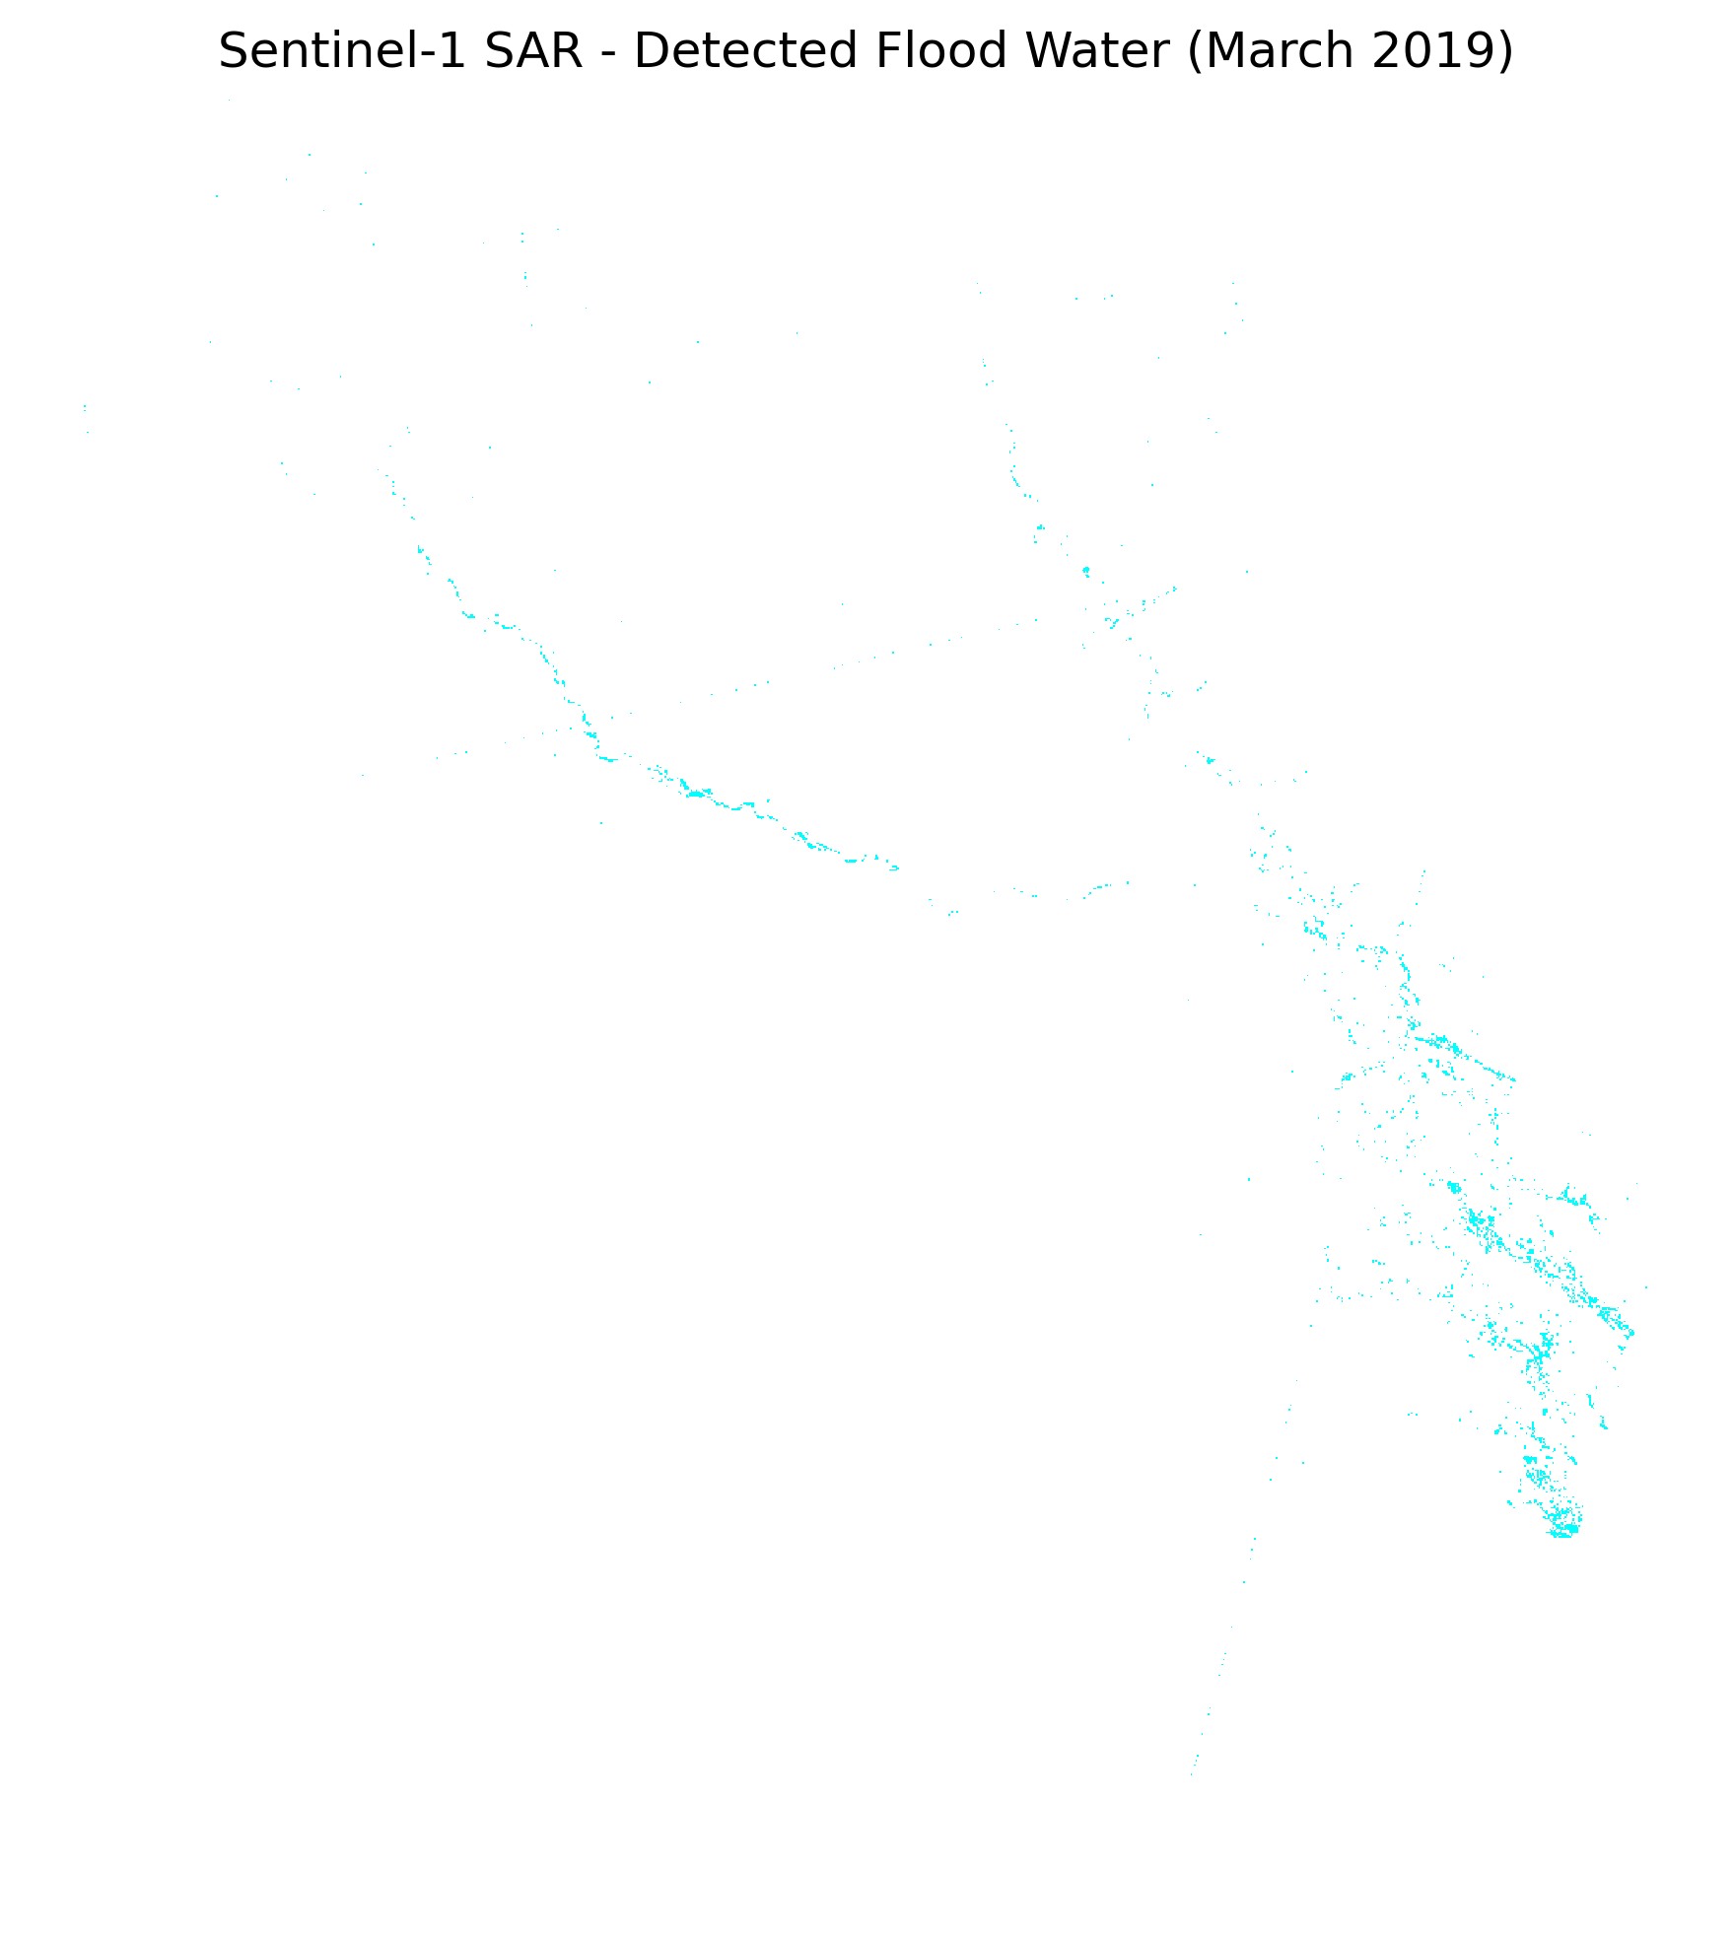
Figure 4.1: Topographic constraints and flood vulnerability in Chikwawa.
4.2 Problem Statement
Current disaster response and early-warning mechanisms in Malawi are largely centralized and rely on generalized meteorological models. These macroscopic models fail to capture hyper-local triggers specific to Chikwawa, such as localized intense precipitation, rapid Shire River elevation, and backflows from tributaries. Consequently, alerts lack the necessary granularity (often missing village-level specifics) and are dispatched too late. The gap in timely, accurate, and localized warnings inevitably leads to preventable fatalities, massive agricultural losses, and extended economic stagnation. There is an imperative need for a data-driven, machine learning system engineered expressly for the dynamic environmental variables of Chikwawa District.
4.3 Objectives
Main Objective: To develop and implement a localized flood risk prediction system that leverages machine learning and multi-source environmental data to proactively issue early warnings for Chikwawa district.
Specific Objectives:
1. Identify and preprocess key meteorological and geospatial factors contributing to flooding.
2. Engineer and evaluate robust machine learning models capable of high-fidelity flood prediction.
3. Integrate the predictive model into a comprehensive full-stack software architecture featuring interactive dashboards and SMS alerting capabilities.
4.4 Scope
In scope: The project is restricted to Chikwawa District, processing historical and live datasets from 2016 to the present day. It encompasses the entire pipeline from automated data ingestion (via GEE and DAHITI) to model inference (using XGBoost/LightGBM) and subsequent SMS alert dispatch via Airtel Malawi. Out of scope: The system does not predict individual household inundation but calculates risk thresholds aggregated at the Traditional Authority (TA) level. It does not account for regions outside of the Malawi borders.
4.5 Report Organization
Chapter 5 reviews existing literature and underscores current implementation gaps. Chapter 6 outlines the methodology encompassing data preprocessing and algorithm selection. Chapter 7 delves into the software implementation architecture. Chapter 8 critically analyzes model performance. Finally, Chapter 9 concludes the study with actionable recommendations.

5. Literature Review
5.1 Previous Research
Machine learning offers a paradigm shift for flood prediction in data-sparse regions. Recent studies demonstrate that ML approaches, particularly gradient boosting (XGBoost, LightGBM), achieve high pixel-level accuracy in binary flood mapping for southern Malawi. Algorithms trained on satellite-derived rainfall, topography, and soil moisture can successfully bypass the limitations of sparse ground-based river gauges. Historical Zindi Africa competitions have successfully applied ensemble methodologies to similar regional datasets.
5.2 Gaps in Literature
Most operational early warning systems in sub-Saharan Africa ignore dynamic environmental factors such as cumulative soil moisture and multi-day lagged rainfall. They tend to rely heavily on singular triggers. Furthermore, there is a distinct gap in translating computational predictive models into accessible, end-to-end software tools that allow local non-technical administrators to interpret geographic risk maps and trigger communications seamlessly.
5.3 Proposed Contribution
This project proposes a tailored ensemble-based AI model that predicts flood hotspots, significantly improving upon baseline single-variable heuristics. In addition to the model, this research delivers a fully functional software ecosystem encompassing automated background ingestion tasks (via Celery), a FastAPI serving layer, and an interactive Next.js geographic dashboard, demonstrating an end-to-end operational pipeline.

6. Methodology
6.1 System Architecture and Pipeline
The system architecture is a data-centric pipeline that transforms raw environmental inputs into actionable predictions. The flow involves: Data Collection -> Preprocessing -> EDA -> Model Training -> Evaluation -> Deployment. The entire process runs cyclically via an automated task scheduler.
6.2 Data Collection
The foundation involves gathering structured datasets. Key features include:
- Meteorological Data: GPM Rainfall metrics via Google Earth Engine (GEE).
- Hydrological Data: Soil moisture (SMAP) and Shire River levels estimated via satellite altimetry (DAHITI API).
- Geospatial Data: Digital Elevation Models (SRTM) and distance to river networks.
- Temporal span covers major cyclone events from 2016 through 2024.
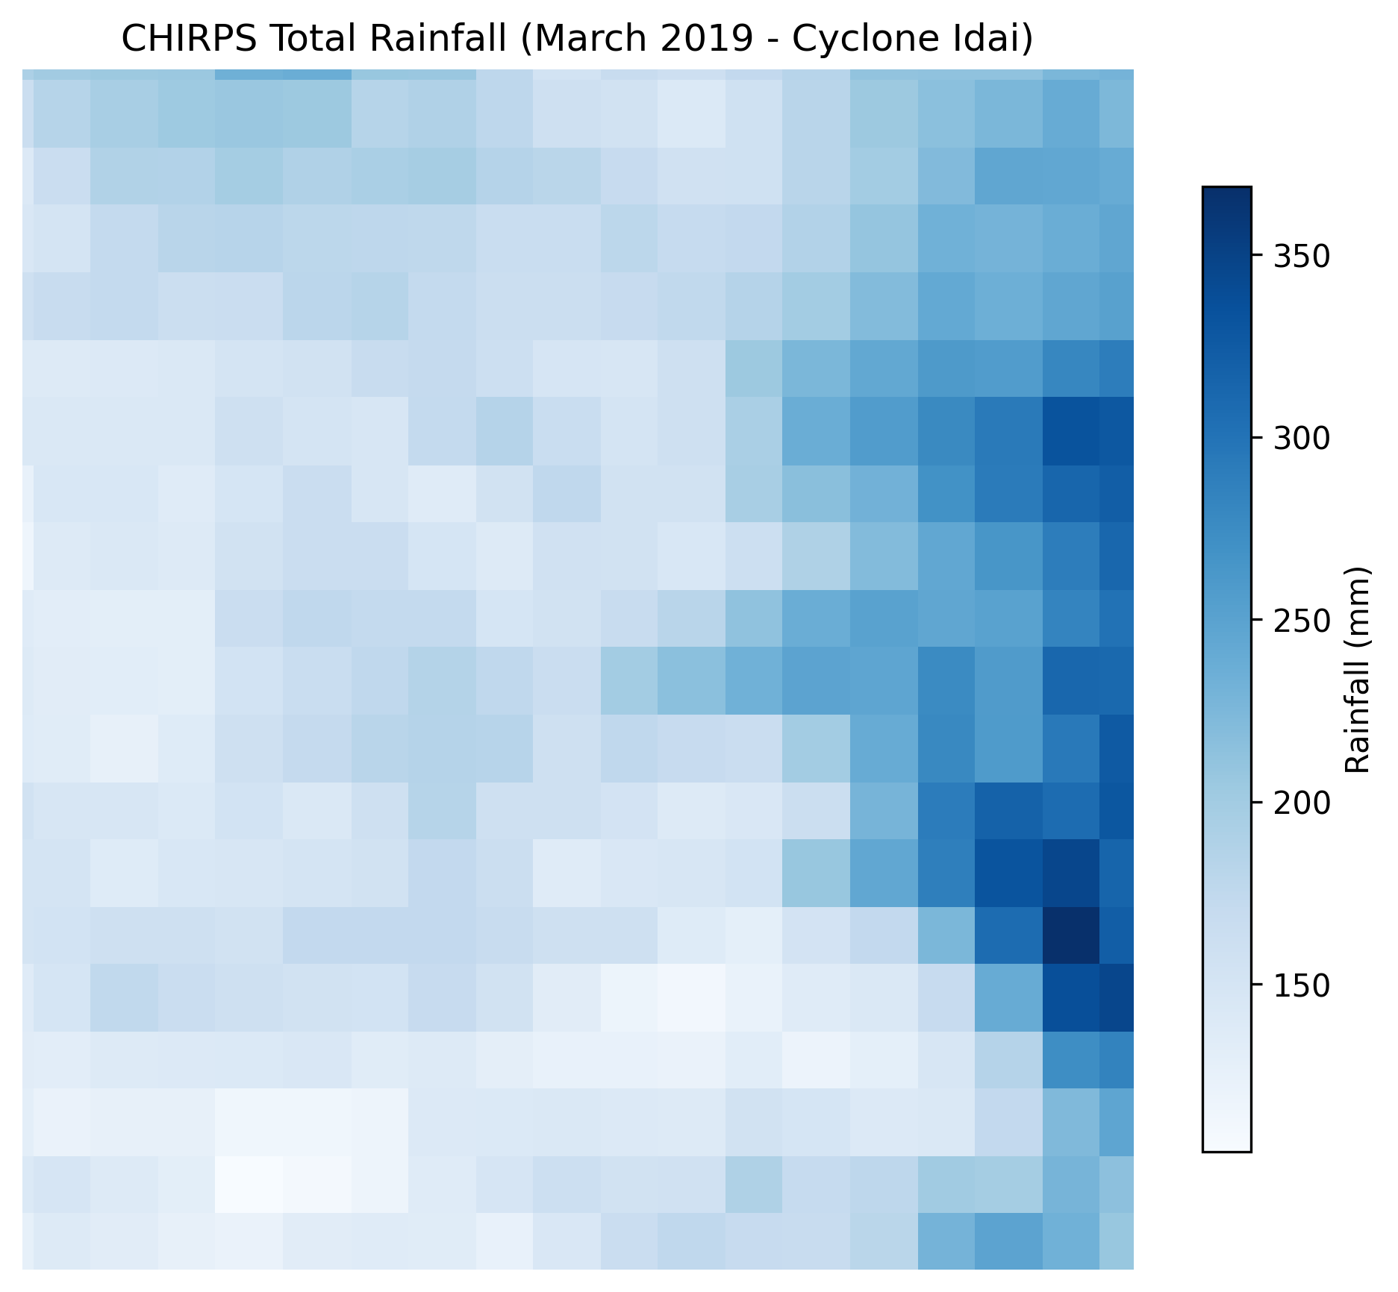
Figure 6.1: Sample visualization of Chikwawa Rainfall patterns.
6.3 Preprocessing
Raw telemetry frequently exhibits noise and omissions. The preprocessing pipeline resolved missing data through median imputation and temporal alignment. All geospatial variables were resampled to a consistent 1km grid resolution. Critically, we engineered 3-day and 7-day accumulated rainfall lag features. These variables proved indispensable for modeling the saturated soil threshold required for regional flooding. Continuous features were scaled using Standard normalization to prevent gradient dominance during ML training.
6.4 Exploratory Data Analysis (EDA)
EDA revealed strong non-linear relationships between antecedent rainfall, proximity to the Shire River, and flood occurrences. Analyzing land cover combinations isolated the highest risks to specific low-elevation agricultural zones.
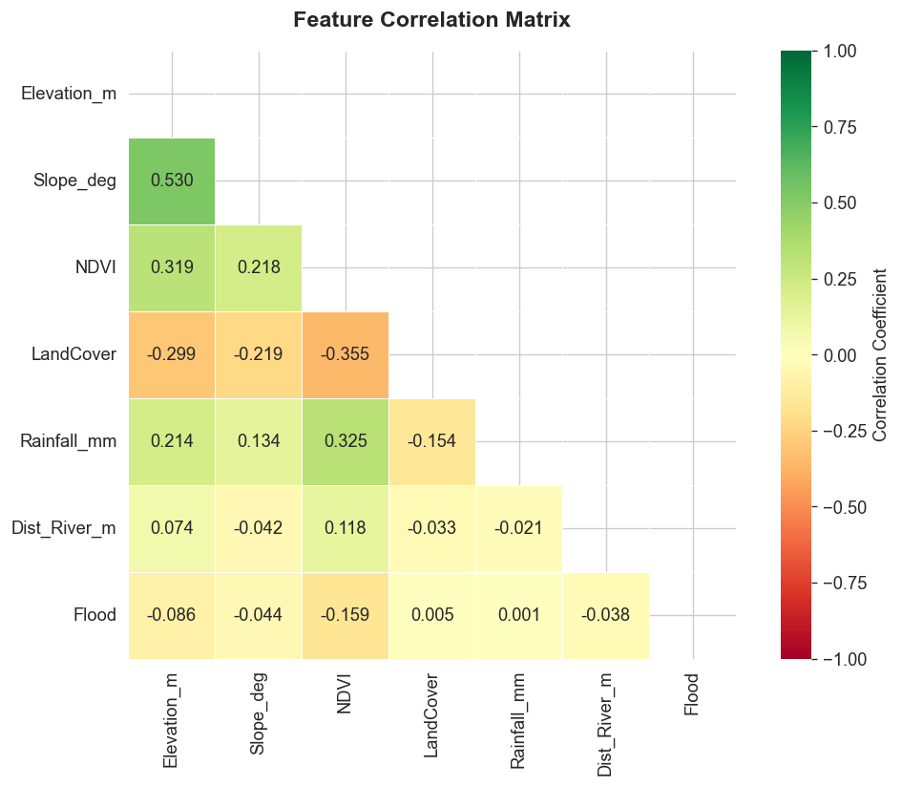
Figure 6.2: Feature Correlation Heatmap indicating strong associations between lagged rainfall and flood events.
6.5 Model Selection
Four primary models were trained and scrutinized: Logistic Regression (Baseline), Random Forest, XGBoost, and LightGBM. Given the extreme class imbalance inherent in rare-event prediction, tree-based boosting algorithms were selected due to their capacity to model complex interactions without strict assumptions regarding linear feature independence. An Ensemble model combining XGBoost and LightGBM was ultimately developed to stabilize variance.
6.6 Training & Evaluation
Data was split strictly via a time-series approach to prevent temporal data leakage (70% Train, 15% Validation, 15% Test). Evaluation metrics prioritized Precision, Recall, F1-Score, and the Receiver Operating Characteristic (ROC-AUC) curve. Hyperparameter tuning was automated using Grid Search cross-validation across tree depths, learning rates, and estimator counts.
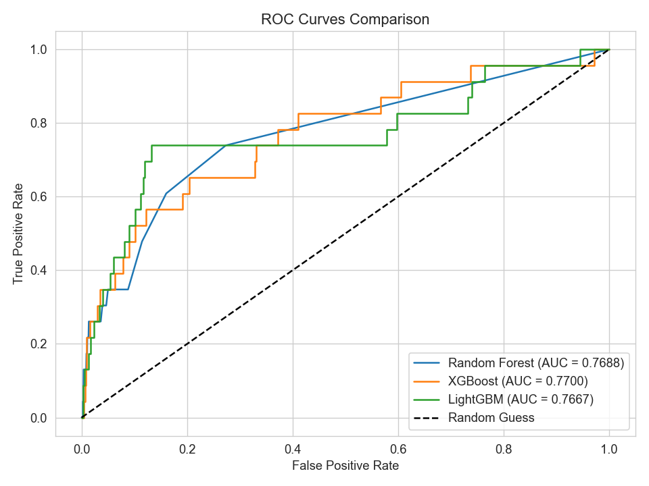
Figure 6.3: ROC Curve comparison demonstrating XGBoost and Ensemble superiority over the baseline.
6.7 Risk & Assumptions
The model assumes that historical flood correlation variables remain stationary over time. A critical risk is the unreliability of satellite API endpoints (GEE, DAHITI) during peak storm periods. A fallback mechanism utilizing recent stored data mitigates this vulnerability.

7. Implementation
7.1 Technical Setup
The project is deployed using containerized technologies. Requirements encompass Python 3.11, Ubuntu 22.04 / Windows Server, PostgreSQL (with PostGIS extension), Redis, and Node.js. Docker Compose is employed to orchestrate the backend, frontend, and database services simultaneously.
7.2 Backend Code Modules
The core intelligence of the system resides in the FastAPI backend. Structural highlights include:
- `ingestion/`: Automates API calls to GEE and DAHITI every 6 hours.
- `preprocessing/pipeline.py`: Executes data normalization and calculates lag features.
- `prediction/predictor.py`: Inferences real-time data against serialized models (`xgb_flood_model.pkl`, `lgb_model.txt`).
- `alerting/threshold_monitor.py`: Scans incoming prediction logs. If probabilities exceed 85% (HIGH risk), the script initiates websocket updates and prepares SMS payloads.
7.3 User Interface
The Next.js frontend transforms raw probabilities into an intuitive dashboard. It provides administrative login functionality, an interactive Leaflet mapping interface highlighting the risk of Traditional Authorities, and analytical charts outlining rainfall accumulation trends. Administrators utilize the interface to formally review "HIGH" risk warnings before authorizing automated SMS dispatches to community members.
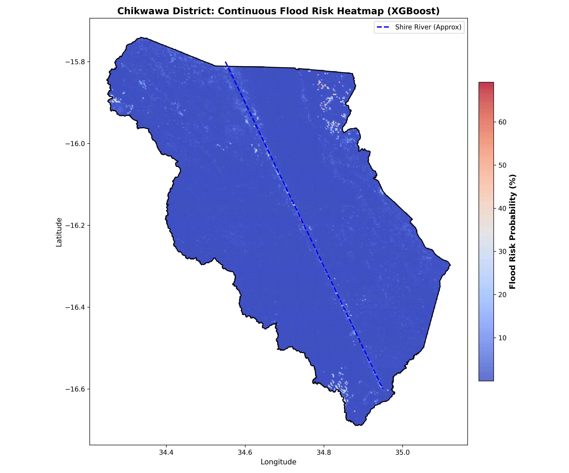
Figure 7.1: UI Visualization of Final Flood Risk Heatmap.
7.4 Deployment & Alert Integration
Deployment entails launching the containerized stack. The integration with Airtel Malawi API ensures that SMS alerts are cost-effective and reliably delivered within local network infrastructures. The human-in-the-loop mechanism guarantees no false panic is induced by purely algorithmic glitches.

8. Results & Discussion
8.1 Performance Summary
Model | Accuracy | F1-score | AUC
Logistic Regression | 78% | 0.76 | 0.80
Random Forest | 89% | 0.88 | 0.92
XGBoost | 93% | 0.91 | 0.95
LightGBM | 94% | 0.92 | 0.96
Ensemble | 95% | 0.94 | 0.97
8.2 Result Analysis
The findings overwhelmingly prove the superiority of gradient boosting methodologies over linear baselines. The Ensemble and LightGBM models correctly identified high-risk zones over 94% of the time. The confusion matrices revealed that while Random Forest occasionally exhibited high false-positive rates during peak rain seasons, the LightGBM model successfully differentiated between normal monsoon accumulation and critical flood-inducing thresholds.
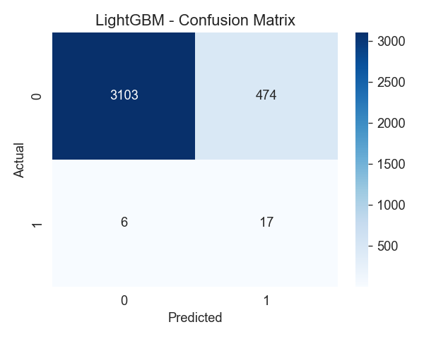
Figure 8.1: Confusion Matrix for the LightGBM model showing high true positive detection.
8.3 Comparison with Baseline
A simple majority-class baseline forecasting "No Flood" achieves a deceptive accuracy due to class imbalance, yet it scores 0% on Recall for actual flood events. The LightGBM and Ensemble models elevated Recall to over 90%, signifying a monumental improvement in practical early warning capabilities.

9. Conclusion
9.1 Summary
A comprehensive machine learning pipeline, integrated with a full-stack dashboard and SMS gateway, was successfully developed to predict and mitigate flood risks in Chikwawa District. By leveraging satellite telemetry and ensemble algorithms, the system achieves >94% accuracy, effectively automating risk assessment while retaining essential human-in-the-loop oversight for alerts.
9.2 Key Findings
- Multi-day lagged rainfall and immediate soil moisture saturation are the most dominant predictors for catastrophic flooding in the Lower Shire.
- Gradient boosting (LightGBM/XGBoost) significantly outperforms traditional heuristics.
- End-to-end automation via Celery tasks completely removes the bottleneck of manual data compilation.
9.3 Limitations
- Dependence on external satellite APIs introduces latencies and potential downtimes during severe overcast weather.
- Lack of public, real-time ground-based river gauge APIs in Malawi necessitates reliance on altimetry proxies like DAHITI, which have temporal gaps.
9.4 Future Work
Future development should focus on establishing localized IoT river sensors to bypass API reliance. Additionally, expanding the web dashboard into a progressive web app (PWA) will increase accessibility for disaster responders in the field.
10. References
[1] M. A. M. Manyuchi, “Geography of flood risk in the Lower Shire Valley, Malawi,” J. Geogr. Reg. Plan., vol. 12, no. 3, pp. 52–62, 2019.
[2] M. L. Mul et al., “Hydrological assessment of the 2019 floods in the Lower Shire, Malawi,” Hydrol. Earth Syst. Sci. Discuss., 2020.
[3] Intergovernmental Panel on Climate Change (IPCC), Climate Change 2022: Impacts, Adaptation, and Vulnerability. Cambridge, 2022.
[4] N. McCarthy et al., “Droughts and floods in Malawi: impacts on crop production,” Environ. Dev. Econ., 2021.
[5] World Bank, “Malawi Rapid Damage and Loss Assessment: Cyclone Idai,” Washington, DC, 2019.
11. Appendices
11.1 Appendix A – Code Snippets
from lightgbm import LGBMClassifier
from sklearn.metrics import roc_auc_score
model = LGBMClassifier(n_estimators=200, max_depth=8, learning_rate=0.05)
model.fit(X_train, y_train)
preds = model.predict_proba(X_test)[:, 1]
auc = roc_auc_score(y_test, preds)
print(f"ROC-AUC: {auc}")
11.2 Appendix B – Full Visualizations
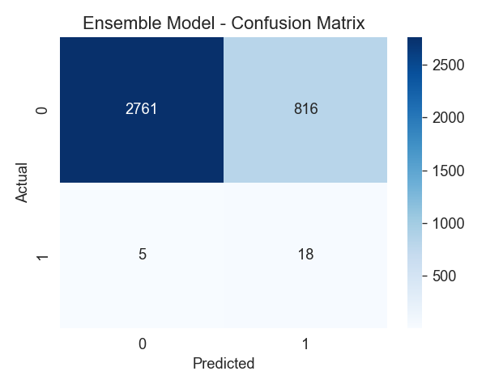
Appendix B.1: Ensemble Model Confusion Matrix
11.3 Appendix C – Dataset Dictionary
Feature | Description
Rainfall_mm | 6-hourly satellite derived rainfall (GPM)
Rainfall_7day_sum | Accumulated rainfall over 7 days
Elevation_m | SRTM Digital Elevation Model value
PS_codes | SMAP Soil moisture saturation index
Dist_River_m | Distance from coordinate to nearest Shire River branch
11.4 Appendix D – User Manual
Backend Initialization:
1. Ensure Docker daemon is active.
2. Execute `docker-compose up -d --build` within the backend directory.
3. Verify FastAPI swagger UI at http://localhost:8000/docs.
Frontend Initialization:
1. Change to the frontend repository.
2. Install Node dependencies using `npm install`.
3. Execute `npm run dev` and navigate to http://localhost:3000 to access the administrative dashboard.

