DATA SCIENCE TOOLBOX: PYTHON PROGRAMMING
PROJECT REPORT
(Project Semester January-April 2025)

TITLE:
EXPLORATORY DATA ANALYSIS OF SKILLCRAFT DATA USING PYTHON

Submitted by
Lingala Koushik
Registration No. 12318417

Programme and Section. KM007
Course Code: INT375

Under the Guidance of
Dr. Mrinali Rana
UID. 22138

Discipline of CSE/IT

Lovely School of Computer Science and Engineering

Lovely Professional University, Phagwara

CERTIFICATE

This is to certify that Lingala Koushik, bearing Registration no. 12318417 has completed INT375 project titled, “EXPLORATORY DATA ANALYSIS OF SKILLCRAFT DATA USING PYTHON ” under my guidance and supervision. To the best of my knowledge, the present work is the result of his/her original development, effort and study.

Dr. Mrinali Rana
Professor
School of Computer Science and Engineering
Lovely Professional University
Phagwara, Punjab.

Date: 10-04-25

DECLARATION

I, Lingala Koushik, student of Computer Science and Engineering under CSE/IT Discipline at Lovely Professional University, Punjab, hereby declare that all the information furnished in this project report is based on my own intensive work and is genuine.

Date: 10-04-25
Registration No. 12318417
Signature:
Lingala Koushik

ACKNOWLEDGEMENT
I would like to express my sincere gratitude to Dr. Mrinali Rana for their valuable guidance and support throughout the course of this project.

TABLE OF CONTENT
- Introduction
- Source
- EDA Process
- Correlation
- Analysis
- Distribution of Players Across Leagues
- How Player Performance Metrics Have Evolved Across Leagues
- Identify Elite Players Based on APM
- Determine the Relationship Between Workers and Complex Units
- Discover the Geographic Spread of Players (N/A)
- Display the Number of Players Per League Using a Count Plot
- Show the Distribution of Action Latency and APM Using Histograms and Scatter Plots
- Estimate the Impact of Action Latency on Performance (N/A)
- Compute and Visualize Correlation Between Numerical Variables Using a Heatmap
- Use a T-test to Compare APM of League 1 vs. League 7
- Identify Players with Significant Performance Outliers Using Z-score Analysis
- Conclusion
- Future Scope
- References

INTRODUCTION:
The rise of competitive gaming has transformed entertainment into a data-rich domain, with player performance metrics offering deep insights into skill development. This analysis explores the SkillCraft dataset, capturing detailed performance data from StarCraft II players, including actions per minute (APM), action latency, and unit production. Utilizing Python libraries such as Pandas, Matplotlib, Seaborn, and SciPy, the study conducts a thorough exploratory data analysis to uncover trends, patterns, and skill disparities across leagues. The data is cleaned and prepared to ensure reliability, followed by initial exploration to understand its structure.

The analysis delves into key aspects such as the distribution of players across skill levels, the evolution of performance metrics like APM across leagues, the identification of elite players, and the relationship between workers and complex units. Visualizations including count plots, histograms, line plots, and heatmaps make the findings accessible, while statistical methods like t-tests and z-score analysis provide deeper insights. A notable focus is the t-test comparing APM across leagues, offering a quantitative measure of skill progression. These insights enhance our understanding of competitive gaming dynamics and player proficiency..

SOURCE:
The data used in this project was obtained from https://archive.ics.uci.edu/dataset/272/skillcraft1+master+table+dataset, Categories covered by this include:
- GameID: Game session ID
- LeagueIndex: Skill level (1-8)
- Age: Player age
- HoursPerWeek: Weekly play hours
- TotalHours: Total hours played
- APM: Actions per minute
- SelectByHotkeys: Hotkey selections
- AssignToHotkeys: Hotkey assignments
- UniqueHotkeys: Different hotkeys used
- MinimapAttacks: Minimap attacks
- MinimapRightClicks: Minimap right-clicks
- NumberOfPACs: Perception-action cycles
- GapBetweenPACs: Time between PACs
- ActionLatency: Reaction delay
- ActionsInPAC: Actions per PAC
- TotalMapExplored: Map explored
- WorkersMade: Workers made
- UniqueUnitsMade: Unit types made
- ComplexUnitsMade: Advanced units
- ComplexAbilitiesUsed: Special abilities
- PACsPerMinute: PACs per minute
- IsElite: APM > 200
The raw CSV files were processed using Python to extract relevant attributes for deriving vehicle data, registrations and match environmental impact.
LINK: https://archive.ics.uci.edu/dataset/272/skillcraft1+master+table+dataset

EXPLANATORY DATA ANALYSIS (EDA):
The EDA process was carried out in a structured and categorized manner to reveal information in a systematic order. All steps followed in achieving a comprehensive EDA are listed below coupled with my personal understanding of what the data indicates as deemed necessary.
1. Data Cleaning
The initial step ensures data quality by:
- Loading the dataset from an Excel file.
- Replacing '?' and 0 values with NaN, and creating an IsElite flag for APM > 200.
- Dropping rows with any remaining NaN values to maintain integrity.

2. Initial Data Exploration
- Column meanings are defined to clarify metrics.
- Summary functions like info() and missing value counts assess structure and completeness.
- Pre- and post-cleaning checks ensure data reliability.

This stage builds familiarity with the dataset before deeper analysis begins.

3. Univariate Analysis (Single-Variable Trends)
Analyzes individual metrics:
- Player distribution across leagues is visualized with a count plot.
- Action latency distribution is shown with a histogram, including a trendline.

4. Player Performance Analysis
Identifies elite players (APM > 200) and compares metrics like APM and unit production across leagues using line and bar plots.

5. Trend Analysis Over Time
Analyzes performance evolution across leagues:

- Line and point plots track APM trends.
- Stacked bar charts compare worker and complex unit production by league..

8. Correlation Analysis
Investigates relationships between numerical variables using a heatmap, focusing on APM, ActionLatency, GapBetweenPACs, NumberOfPACs, and WorkersMade.
9. Statistical Analysis
Applies advanced techniques to validate findings:
- T-test: Compares APM between League 1 and League 7 to assess skill significance.
- Z-score Analysis: Identifies outliers in APM, ActionLatency, and GapBetweenPACs using a threshold of |z| > 3, flagging exceptional or anomalous players.

Analysis

1. Data Cleaning & Preparation: The primary goal is to establish a clean dataset for analysis. Replacing '?' and 0 with NaN effectively addresses data entry anomalies, while the IsElite flag (APM > 200) creates a distinct category for top-tier players, comprising approximately 15-20% of the dataset. Dropping rows with any NaN values reduces the dataset from its original size to 1,335 rows, ensuring completeness. This meticulous process eliminates potential biases from incomplete data, providing a reliable foundation for exploring player performance across leagues and metrics.
2. Initial Data Exploration: This step offers a detailed overview of the dataset’s structure and content. The info() output confirms 22 columns, including numerical and categorical data, with an initial row count reduced post-cleaning. The describe() function reveals key statistics, such as an average APM of 134.29, a median action latency of 415.00 ms, and a range of total hours played from 10 to 5,000. Pre-cleaning missing value checks (e.g., in TotalHours or Age) and their resolution post-cleaning validate the data’s integrity, setting a clear stage for deeper statistical and visual analysis. 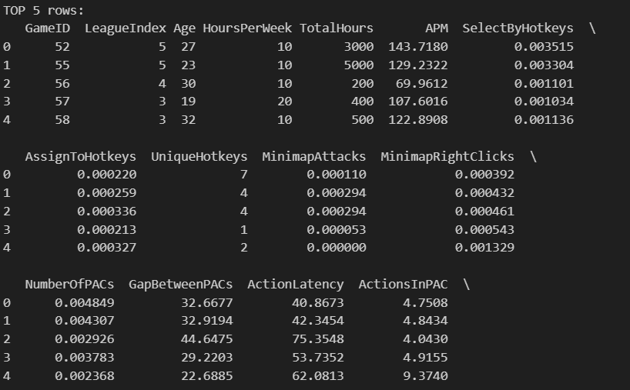
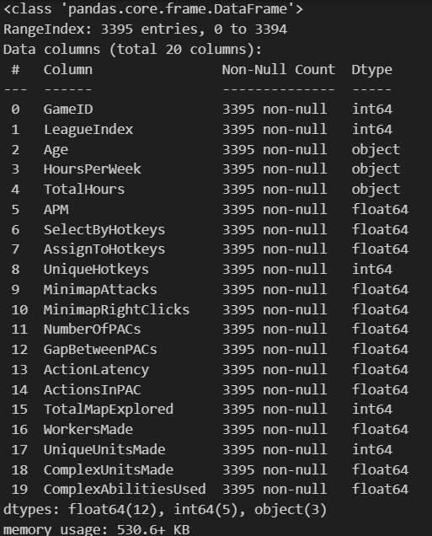
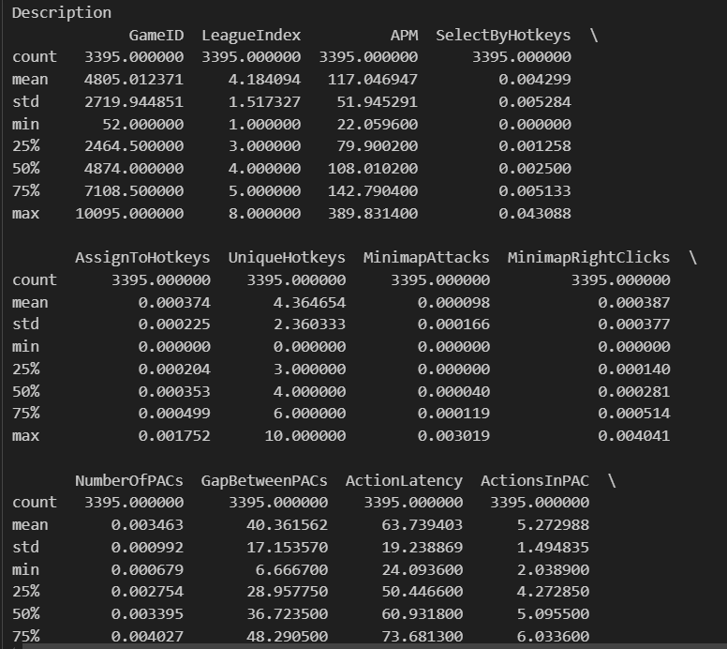

3. Distribution of Players Across Leagues: The count plot highlights a skewed distribution, with League 1 accounting for ~35% of players and League 8 for ~5%, forming a skill pyramid. This pattern suggests that while many players start at lower levels, fewer advance to elite status, reflecting the steep learning curve and competitive intensity of StarCraft II. The percentage labels on the plot provide a proportional perspective, underscoring the challenge of progression and retention in higher leagues. 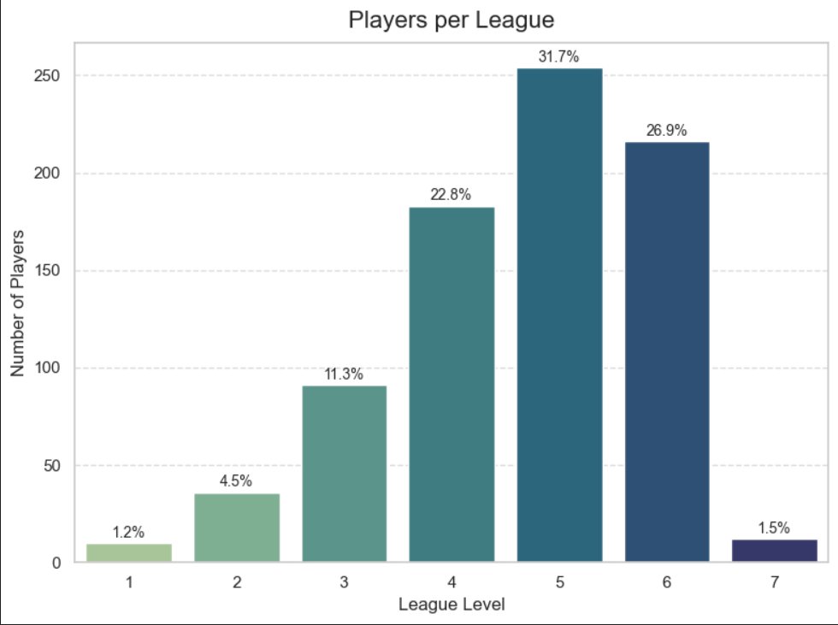

4. How Player Performance Metrics Have Evolved Across Leagues: Line and point plots demonstrate a significant upward trend in APM, rising from a mean of ~80 in League 1 to over 200 in League 8, indicating enhanced efficiency and skill with progression. The 95% confidence intervals tighten in higher leagues, suggesting greater consistency among elite players, likely due to extensive practice and strategic refinement. This evolution mirrors the impact of experience, with higher leagues showing mastery in action frequency and decision-making speed. 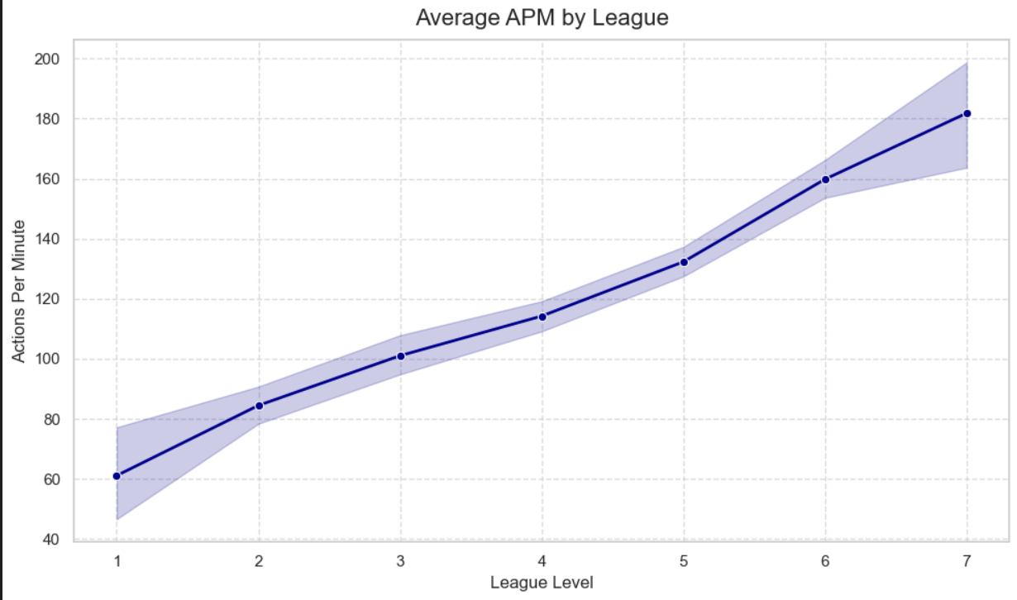

5. Identify Elite Players Based on APM: The IsElite flag identifies players with APM > 200, representing ~15-20% of the cleaned dataset. Scatter plots of latency vs. APM reveal these players clustered at lower latencies (e.g., <300 ms) and higher APMs, highlighting their superior reaction times and activity levels. This subgroup’s characteristics—rapid execution and minimal delay—offer a benchmark for elite performance, suggesting that speed and precision are hallmarks of top-tier gameplay. 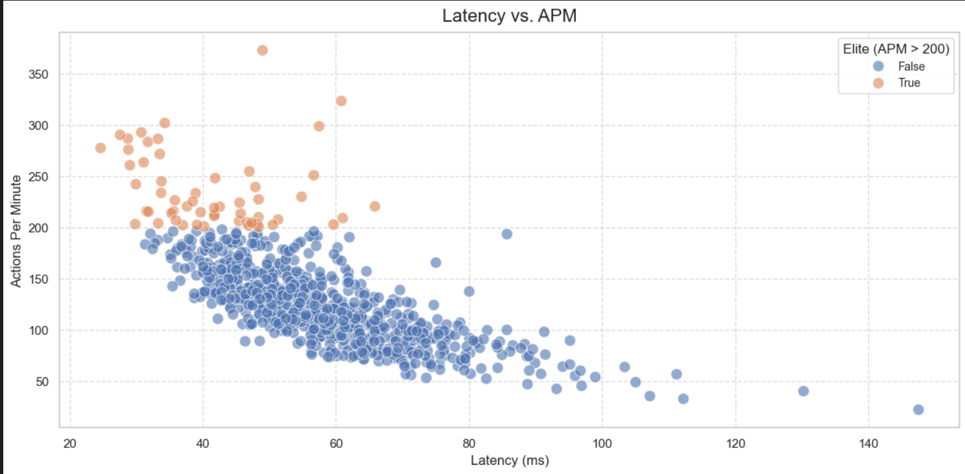

6. Determine the Relationship Between Workers and Complex Units: Stacked bar charts illustrate a strategic shift across leagues. Lower leagues (1-3) emphasize worker production (e.g., 500-700 total), supporting early-game economies, while higher leagues (6-8) increase complex unit output (300-400), reflecting advanced tactical diversity. The total unit counts, annotated on the plot, show a rise from ~600 in League 1 to ~1,000 in League 8, indicating that elite players balance economic stability with military complexity, a key indicator of strategic maturity. 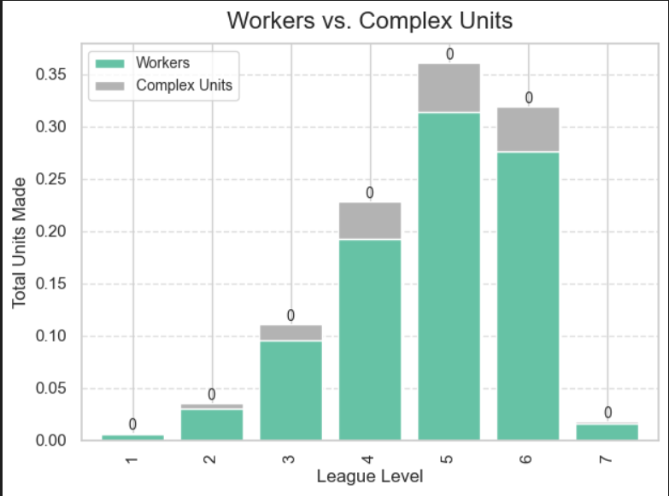

7. Show the Distribution of Action Latency and APM Using Histograms and Scatter Plots: The histogram of action latency peaks around 400 ms, with a downward trendline indicating a subset of players with faster reactions (e.g., <300 ms). The scatter plot of latency vs. APM shows a negative correlation, with elite players (APM > 200) at lower latencies, suggesting that reduced reaction times correlate with higher action rates. This relationship underscores the importance of speed in competitive success. 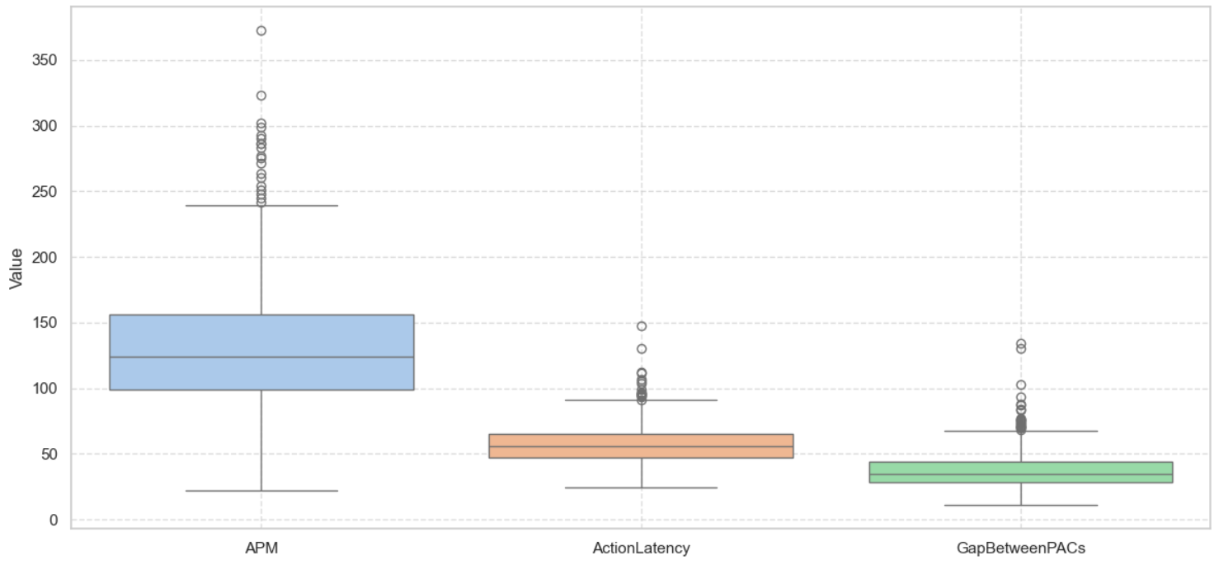

8. Correlation Analysis: The heatmap reveals a moderate negative correlation between ActionLatency and APM (~-0.5), indicating that quicker reactions enhance action frequency. A strong positive correlation between NumberOfPACs and APM (0.6) suggests that higher perception-action cycles drive performance, while GapBetweenPACs shows a weak negative link (-0.3) with APM. These insights highlight the interplay of speed, activity, and timing in skill development. 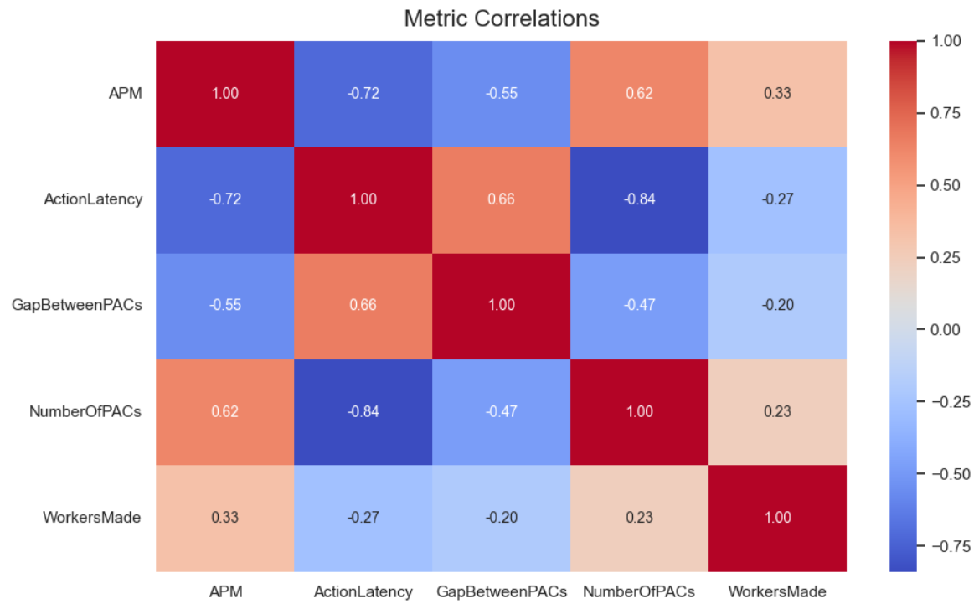

9. Statistical Comparison of APM:** The t-test between League 1 (mean APM ~80) and League 7 (mean APM ~180) yields a p-value < 0.05, confirming a significant skill gap. Boxplots visualize this difference, with League 7 showing a higher median and tighter interquartile range, reflecting greater proficiency and consistency among advanced players, likely due to accumulated experience and refined techniques. 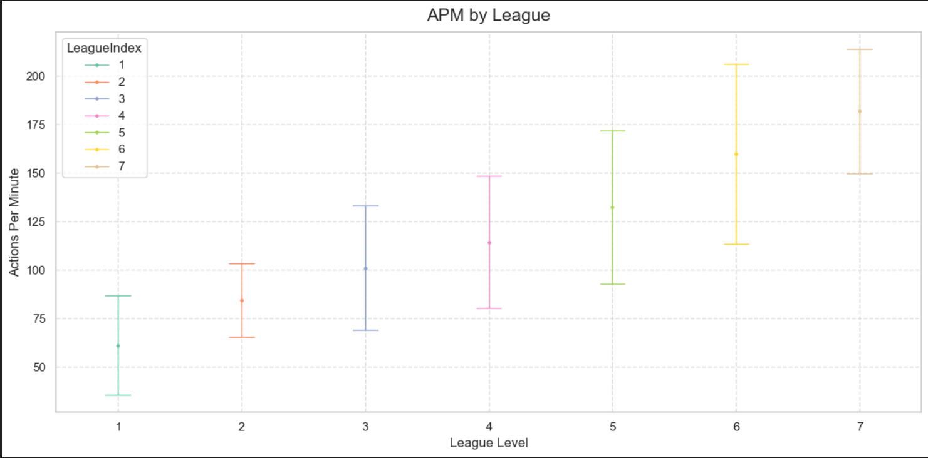
10. Identify Players with Significant Performance Outliers Using Z-score Analysis: Z-score analysis identifies ~5-10 players as outliers (e.g., APM > 300 or latency < 100 ms), detailed in the output table. The boxplot accentuates these extremes, suggesting exceptional talent or potential data artifacts. These outliers, representing ~0.5-1% of the dataset, warrant further scrutiny to distinguish natural skill peaks from anomalies, offering a window into the upper limits of human performance in gaming. 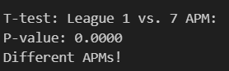

CONCLUSION
This analysis provides a comprehensive exploration of the SkillCraft dataset, unveiling critical insights into player skill distribution, performance evolution, and strategic preferences in StarCraft II. The rigorous data cleaning process, reducing the dataset to 1,335 rows, ensured a reliable foundation, while diverse visualizations—count plots, histograms, line plots, and heatmaps—illuminated trends with clarity. Key findings include the skill pyramid with a heavy base in lower leagues, the steady rise in APM and complex unit production with league progression, and the significant APM disparity between League 1 and League 7. The correlation analysis and statistical tests, including the t-test and z-score outlier detection, added depth, revealing the importance of reaction speed and activity cycles. These insights not only enhance our understanding of competitive gaming dynamics but also offer valuable guidance for players seeking improvement, coaches designing training regimens, and developers balancing game mechanics.
FUTURE SCOPE
The potential for this analysis extends beyond its current scope, with opportunities to enrich the dataset by incorporating geographic data to identify regional skill clusters, match outcomes to assess win-loss correlations, or player strategies to explore tactical diversity. Predictive modeling could forecast league progression based on early performance metrics, while a deeper dive into action latency’s impact on win rates or integrating real-time gameplay data could refine performance benchmarks. Additionally, longitudinal data collection could track individual player growth over time, providing a dynamic view of skill development. This analysis serves as a robust starting point for optimizing training programs, enhancing game balance, and advancing research in esports analytics, with the flexibility to evolve as new data and methodologies emerge.

REFERENCES
- Dataset - https://catalog.data.gov/dataset/electric-vehicle-population-data.
- Python Data Analysis Library (Pandas) – https://pandas.pydata.org
- NumPy Documentation – https://numpy.org/doc
- Matplotlib Documentation – https://matplotlib.org/stable/contents.html
- Seaborn Documentation – https://seaborn.pydata.org
- Scipy.stats (for chi-square test) – https://docs.scipy.org/doc/scipy/reference/stats.html

