**Assisted Practice: 2.2 Constructors**

* Create a Java project in your IDE
* Write a program in Java to create constructors

This lab has three subsections, namely:

* + 1. Writing a program in Java to verify the implementations of constructor types
    2. Executing the program and verifying constructors
    3. Pushing the code to your GitHub repositories

**Step 2.2.1:** Write a program in Java to verify the implementations of constructor types

**//default constructor**

public class Student {

String firstName;

String lastName;

int age;

public static void main(String args[]) {

Student myStudent = new Student();

myStudent.firstName = "Lingala";

myStudent.lastName = "Lakshmi";

myStudent.age = 22;

System.out.println(myStudent.lastName);

System.out.println(myStudent.age);

System.out.println(myStudent.firstName);

}

}

Output:

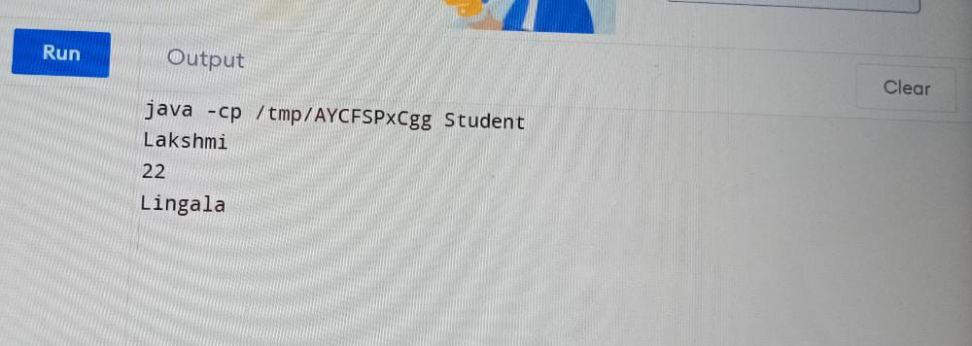

//**parameterized constructor**

public class Lingala{

String studentName;

Lingala(String name){

studentName = name;

}

Lingala(Lingala myObj){

this.studentName = myObj.studentName;

}

void display(){

System.out.println("Student:" + studentName);

}

public static void main(String args[])

{

Lingala obj1 = new Lingala("Lakshmi");

/* passing the object as an argument for the constructor

* this will invoke the copy constructor

*/

Lingala obj2 = new Lingala(obj1);

System.out.println("Printing obj1 - ");

obj1.display();

System.out.println("Printing obj2 - ");

obj2.display();

}

}

**Output:**

