ASSIGNMENT-6.5
HT.NO-2303A51726
Task Description #1 (AI-Based Code Completion for Conditional
Eligibility Check)
Task: Use an AI tool to generate eligibility logic.
Prompt:
“Generate Python code to check voting eligibility based on age and
citizenship.”
Expected Output:
• AI-generated conditional logic.
• Correct eligibility decisions.
• Explanation of conditions.
CODE:
def check_voting_eligibility(age: int, citizenship: str) -> bool:
"""
Returns True if the person is eligible to vote.
Eligibility: age >= 18 AND citizenship matches required country or 'yes' for citizen flag.
"""
# Normalize inputs
citizenship = citizenship.strip().lower()
# Check age first (fast fail)
if age < 0:
raise ValueError("Age cannot be negative.")
if age < 18:
return False
# Check citizenship: allow either exact country name or boolean-like answers
allowed_yes = {"yes", "y", "true", "citizen"}
if citizenship in allowed_yes:
return True
# If user provided a country name, replace "yourcountry" with the real country you require
required_country = "india" #<-- change as needed
if citizenship == required_country:
return True
return False
# Example usages / tests
print(check_voting_eligibility(20, "India")) # True (if required_country is india)
print(check_voting_eligibility(17, "yes")) # False
print(check_voting_eligibility(30, "No")) # False

OUTPUT:
EXPLANATION:
- We normalize citizenship to make checks robust.
- We validate age >= 0. AI-generated snippets often forget input normalization and negative-age checks.
- Replace required_country with your country or provide an explicit policy (the assignment likely expects a simple age >= 18 and citizenship == "Yes" approach — above is a slightly more robust version).

Task Description #2(AI-Based Code Completion for Loop-Based
String Processing)
Task: Use an AI tool to process strings using loops.
Prompt:
“Generate Python code to count vowels and consonants in a string
using a loop.”
Expected Output:
• AI-generated string processing logic.
• Correct counts.
• Output verification.
CODE:
def count_vowels_consonants(s: str) ->dict:
s = s.lower()
vowels = set("aeiou")
vowel_count = 0
consonant_count = 0
for ch in s:
if ch.isalpha():
if ch in vowels:
vowel_count += 1
else:
consonant_count += 1
return {"vowels": vowel_count, "consonants": consonant_count}
# Example tests
print(count_vowels_consonants("Hello World!")) # {'vowels': 3, 'consonants': 7}
print(count_vowels_consonants("AEIOU aeiou")) # {'vowels': 10, 'consonants': 0}
OUTPUT:
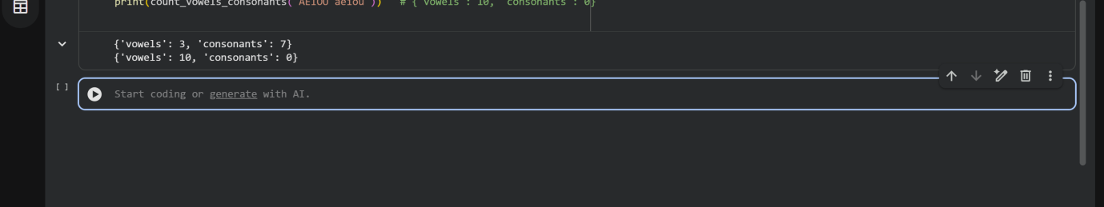
EXPLANATION:
- Use str.isalpha() to ignore digits/punctuation — many AI outputs forget this and count punctuation as consonants or letters.
- The loop-based method explicitly shows the algorithm (as required by the assignment). If you want to be concise, a comprehension or sum(...) could be used, but the loop is clearer for demonstration.
Task Description #3 (AI-Assisted Code Completion Reflection
Task)
Task: Use an AI tool to generate a complete program using classes,
loops, and conditionals.
Prompt:
“Generate a Python program for a library management system
using classes, loops, and conditional statements.”
Expected Output:
• Complete AI-generated program.
• Review of AI suggestions quality.
• Short reflection on AI-assisted coding experience
CODE:
class Book:
def __init__(self, book_id: int, title: str, author: str):
self.book_id = book_id
self.title = title
self.author = author
self.is_borrowed = False
def __str__(self):
status = "Borrowed" if self.is_borrowed else "Available"
return f"[{self.book_id}] {self.title} by {self.author} - {status}"
class Library:
def __init__(self):
self.books = {} #book_id -> Book
self.next_id = 1
def add_book(self, title: str, author: str):
b = Book(self.next_id, title, author)
self.books[self.next_id] = b
self.next_id += 1
return b.book_id
def list_books(self):
return list(self.books.values())
def borrow_book(self, book_id: int) -> bool:
book = self.books.get(book_id)
if not book:
return False # not found
if book.is_borrowed:
return False # already borrowed
book.is_borrowed = True
return True
def return_book(self, book_id: int) -> bool:
book = self.books.get(book_id)
if not book or not book.is_borrowed:
return False
book.is_borrowed = False
return True
def run_library_cli():
lib = Library()
# add some sample books
lib.add_book("1984", "George Orwell")
lib.add_book("To Kill a Mockingbird", "Harper Lee")
while True:
print("\nLibrary Menu:")
print("1. List books")
print("2. Add book")
print("3. Borrow book")
print("4. Return book")
print("5. Exit")
choice = input("Choose an option: ").strip()
if choice == "1":
for b in lib.list_books():
print(b)
elif choice == "2":
title = input("Title: ").strip()
author = input("Author: ").strip()
book_id = lib.add_book(title, author)
print(f"Added with id {book_id}")
elif choice == "3":
try:
bid = int(input("Book id to borrow: ").strip())
except ValueError:
print("Invalid id.")
continue
ok = lib.borrow_book(bid)
print("Borrowed." if ok else "Cannot borrow (not found or already borrowed).")
elif choice == "4":
try:
bid = int(input("Book id to return: ").strip())
except ValueError:
print("Invalid id.")
continue
ok = lib.return_book(bid)
print("Returned." if ok else "Cannot return (not found or not borrowed).")
elif choice == "5":
print("Goodbye.")
break
else:
print("Invalid option. Try again.")
# To run the CLI, uncomment below:
if __name__ == "__main__":
run_library_cli()
OUTPUT:
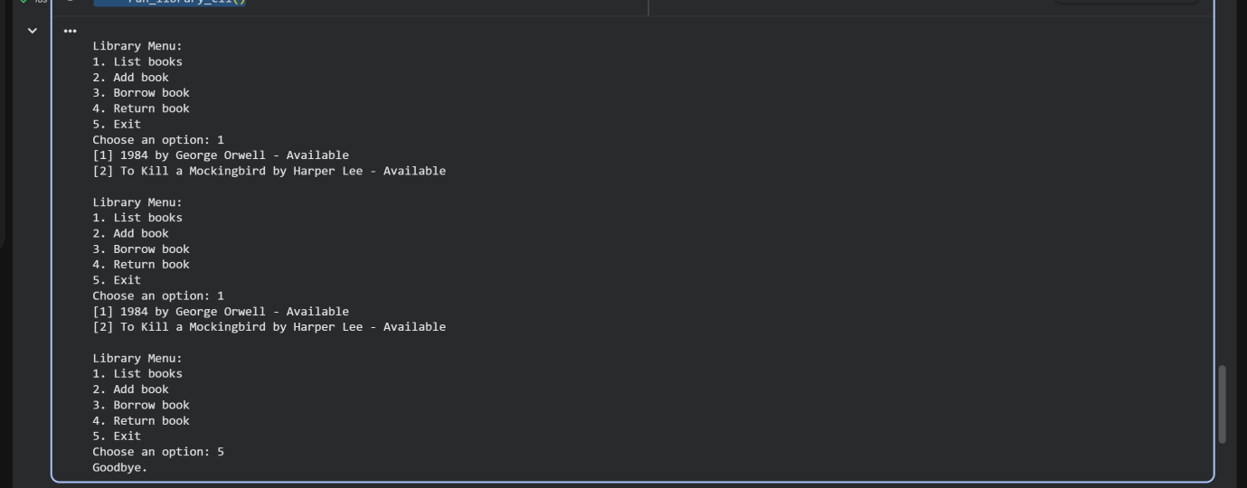
EXPLANATION:
- The solution uses Book and Library classes, demonstrates loops (menu loop) and conditionals for option handling.
- AI tends to produce huge monolithic programs — prefer small, testable methods (add_book, borrow_book) which are easy to unit test.
- Test ideas: borrow a non-existent book, borrow twice, return without borrowing.
Task Description #4 (AI-Assisted Code Completion for Class-
Based Attendance System)
Task: Use an AI tool to generate an attendance management class.
Prompt: “Generate a Python class to mark and display student
attendance using loops.”
Expected Output:
• AI-generated attendance logic.
• Correct display of attendance.
• Test cases
CODE:
class Attendance:
def __init__(self, students: list):
# students: list of student names or ids
self.students = list(students)
# Initialize attendance map: student -> list of dates (or boolean per session)
self.records = {s: [] for s in self.students}
def mark_attendance(self, date: str, present_list: list):
"""
date: string like '2026-01-23'
present_list: list of student names/ids who are present
"""
present_set = set(present_list)
for s in self.students:
self.records[s].append((date, s in present_set))
def display_attendance(self):
# Pretty print summary: student -> attendance count / total sessions
total_sessions = 0
# infer total sessions from first student (or 0)
if self.students:
total_sessions = len(self.records[self.students[0]])
print(f"Total sessions: {total_sessions}")
for s in self.students:
present_count = sum(1 for _, present in self.records[s] if present)
print(f"{s}: {present_count}/{total_sessions} present")
def get_attendance_percentage(self, student):
sessions = self.records.get(student, [])
if not sessions:
return 0.0
present_count = sum(1 for _, present in sessions if present)
return (present_count / len(sessions)) * 100.0
# Test cases
students = ["Alice", "Bob", "Charlie"]
att = Attendance(students)
att.mark_attendance("2026-01-20", ["Alice", "Charlie"])
att.mark_attendance("2026-01-21", ["Alice"])
att.mark_attendance("2026-01-22", ["Bob", "Alice"])
att.display_attendance()
print("Alice %:", att.get_attendance_percentage("Alice"))
print("Bob %:", att.get_attendance_percentage("Bob"))

OUTPUT:
EXPLANATION:
- records stores tuples (date, present_flag) so you can later expand to reasons, late marks, etc.
- Tests added demonstrate marking multiple sessions and computing percentages.
- AI outputs sometimes use parallel lists incorrectly; prefer dictionary keyed by student for clarity.
Task Description #5 (AI-Based Code Completion for Conditional
Menu Navigation)
Task: Use an AI tool to complete a navigation menu.
Prompt: “Generate a Python program using loops and conditionals
to simulate an ATM menu.”
Expected Output:
• AI-generated menu logic.
• Correct option handling.
• Output verification
CODE:
def atm_cli():
balance = 1000.0 # starting balance
while True:
print("\nATM Menu:")
print("1. Check Balance")
print("2. Deposit")
print("3. Withdraw")
print("4. Exit")
choice = input("Choose: ").strip()
if choice == "1":
print(f"Balance: {balance:.2f}")
elif choice == "2":
try:
amt = float(input("Enter deposit amount: ").strip())
if amt <= 0:
print("Enter a positive amount.")
else:
balance += amt
print("Deposit successful.")
except ValueError:
print("Invalid amount.")
elif choice == "3":
try:
amt = float(input("Enter withdrawal amount: ").strip())
if amt <= 0:
print("Enter a positive amount.")
elif amt > balance:
print("Insufficient funds.")
else:
balance -= amt
print("Withdrawal successful.")
except ValueError:
print("Invalid amount.")
elif choice == "4":
print("Thank you. Exiting.")
break
else:
print("Invalid option. Try again.")
# To run ATM, uncomment:
# if __name__ == "__main__":
# atm_cli()
OUTPUT:
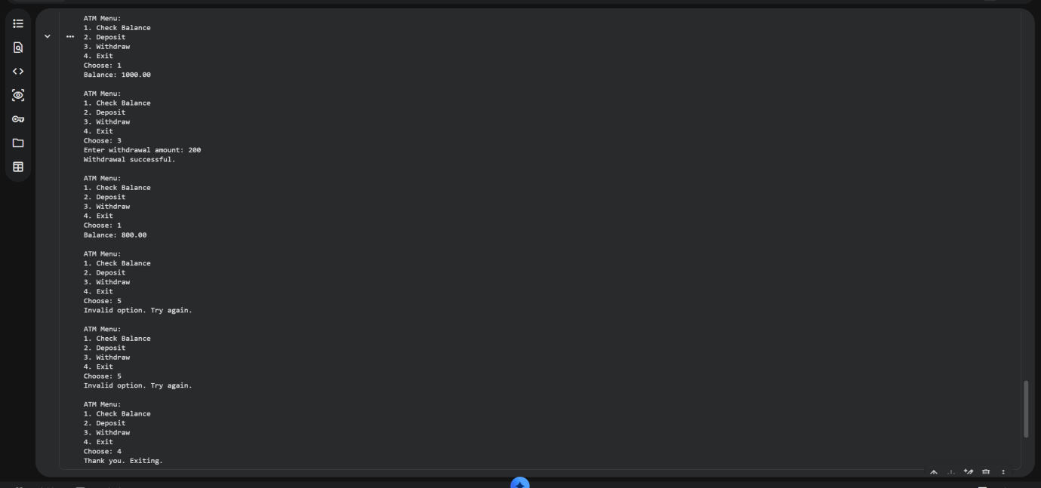
EXPLANATION:
- This is a standard menu loop with input validation.
- Important AI pitfalls: forgetting to validate numeric input or allowing negative deposits/withdrawals.

