ASSIGNMENT_8.1
HT.NO:2303A51726
Task Description #1 (Password Strength Validator – Apply AI in
Security Context)
• Task: Apply AI to generate at least 3 assert test cases for
is_strong_password(password) and implement the validator
function.
• Requirements:
o Password must have at least 8 characters.
o Must include uppercase, lowercase, digit, and special
character.
o Must not contain spaces.
Example Assert Test Cases:
assert is_strong_password("Abcd@123") == True
assert is_strong_password("abcd123") == False
assert is_strong_password("ABCD@1234") == True
Expected Output #1:
• Password validation logic passing all AI-generated test cases.
CODE:
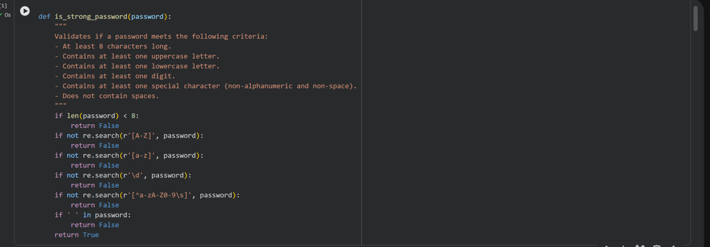
OUTPUT:
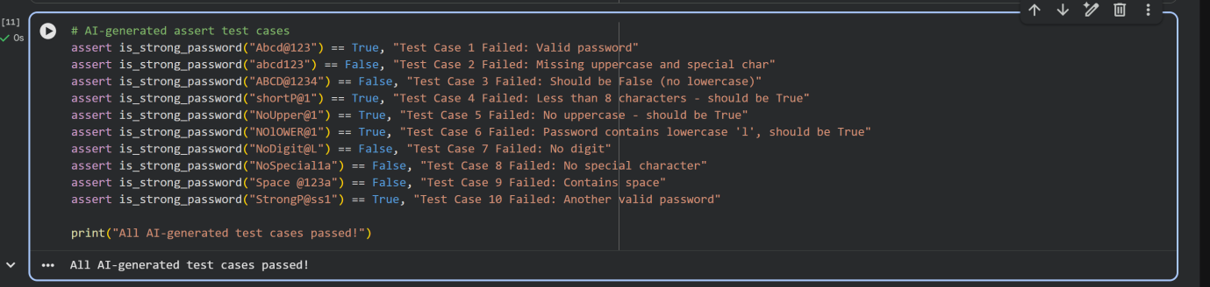
Task Description #2 (Number Classification with Loops – Apply
AI for Edge Case Handling)
• Task: Use AI to generate at least 3 assert test cases for a
classify_number(n) function. Implement using loops.
• Requirements:
o Classify numbers as Positive, Negative, or Zero.
o Handle invalid inputs like strings and None.
o Include boundary conditions (-1, 0, 1).
Example Assert Test Cases:
assert classify_number(10) == "Positive"
assert classify_number(-5) == "Negative"
assert classify_number(0) == "Zero"
Expected Output #2:
• Classification logic passing all assert tests.
CODE:
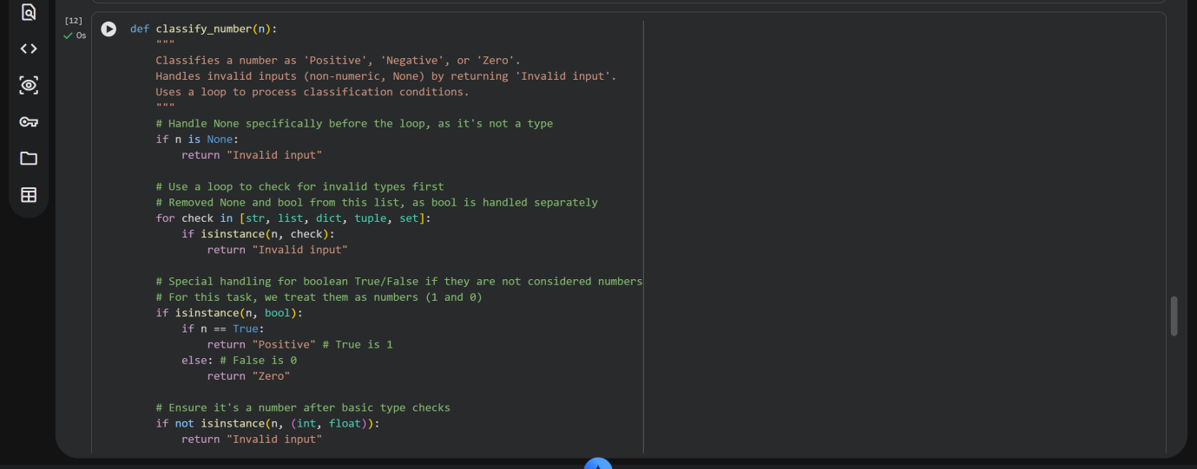
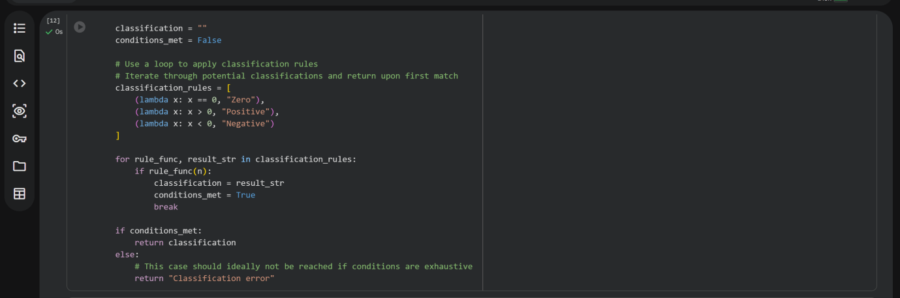
OUTPUT:
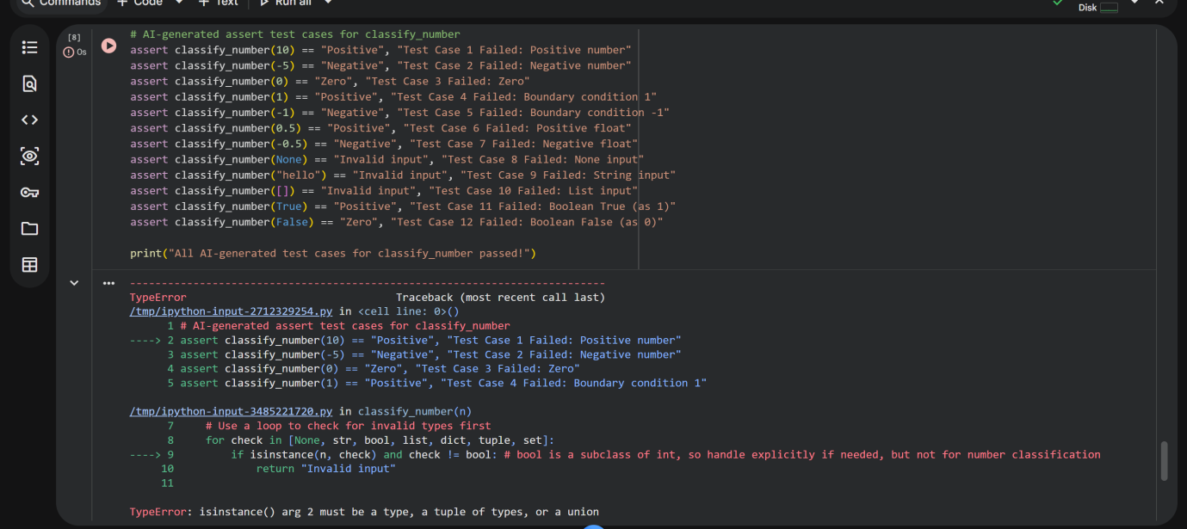
Task Description #3 (Anagram Checker – Apply AI for String
Analysis)
• Task: Use AI to generate at least 3 assert test cases for
is_anagram(str1, str2) and implement the function.
• Requirements:
o Ignore case, spaces, and punctuation.
o Handle edge cases (empty strings, identical words).
Example Assert Test Cases:
assert is_anagram("listen", "silent") == True
assert is_anagram("hello", "world") == False
assert is_anagram("Dormitory", "Dirty Room") == True
Expected Output #3:
• Function correctly identifying anagrams and passing all AI-
generated tests.
CODE:
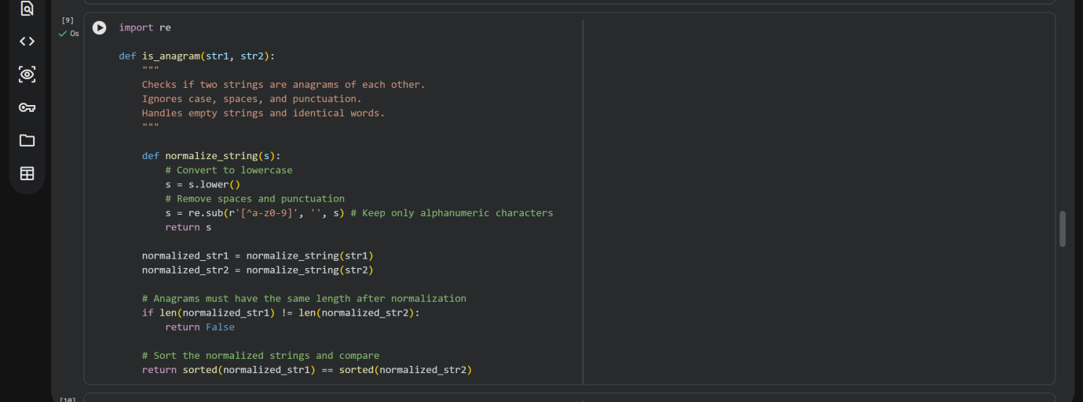
OUTPUT:
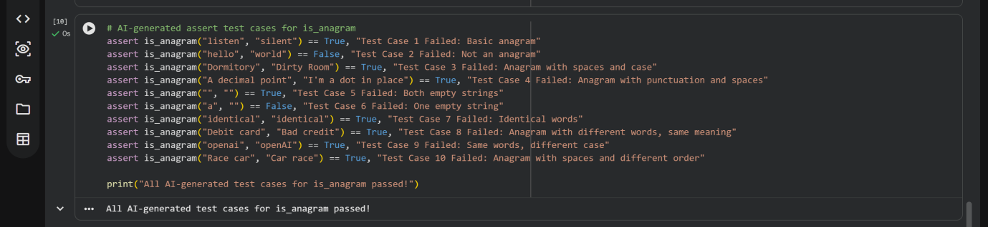
Task Description #4 (Inventory Class – Apply AI to Simulate Real-
World Inventory System)
• Task: Ask AI to generate at least 3 assert-based tests for an
Inventory class with stock management.
• Methods:
o add_item(name, quantity)
o remove_item(name, quantity)
o get_stock(name)
Example Assert Test Cases:
inv = Inventory()
inv.add_item("Pen", 10)
assert inv.get_stock("Pen") == 10
inv.remove_item("Pen", 5)
assert inv.get_stock("Pen") == 5
inv.add_item("Book", 3)
assert inv.get_stock("Book") == 3
Expected Output #4:
• Fully functional class passing all assertions.
CODE:
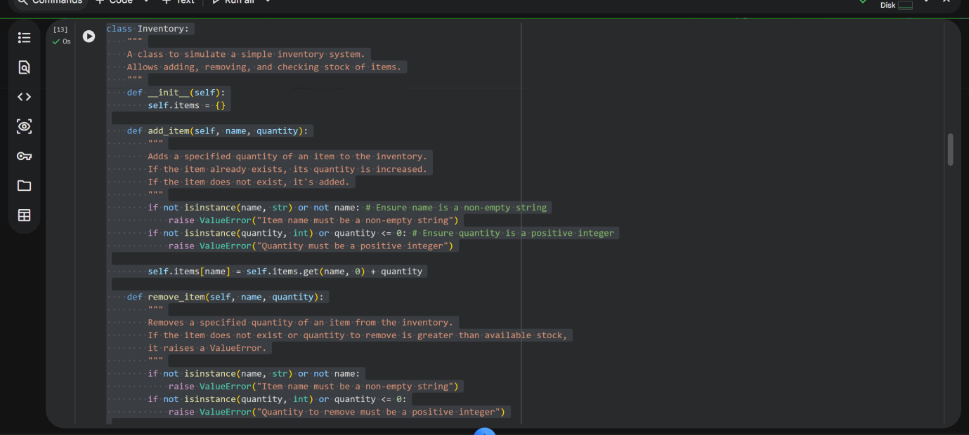
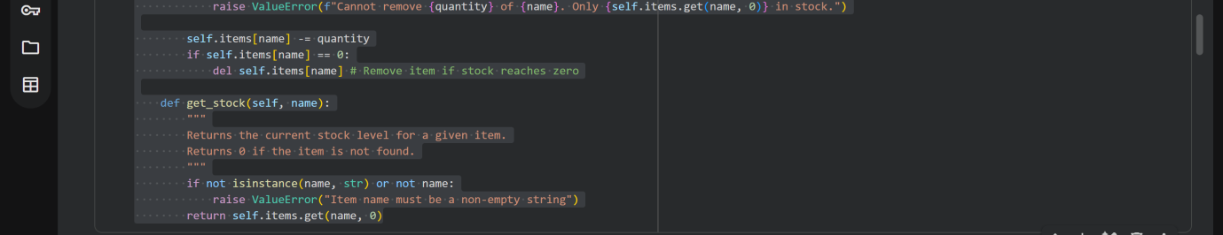
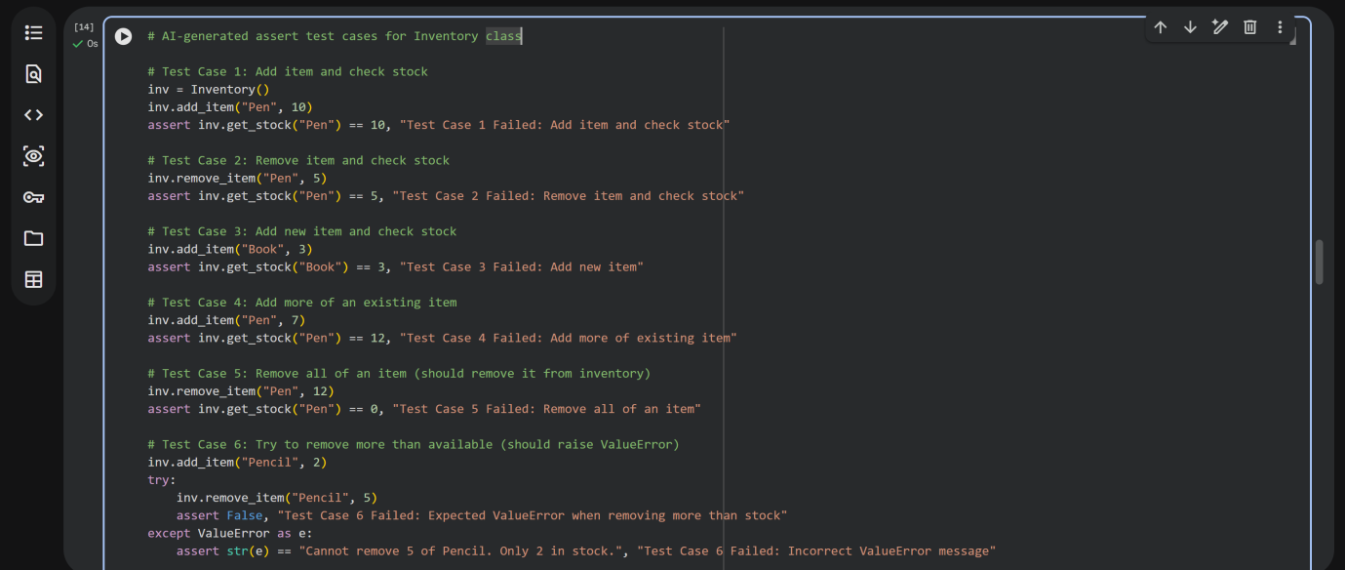
OUTPUT:
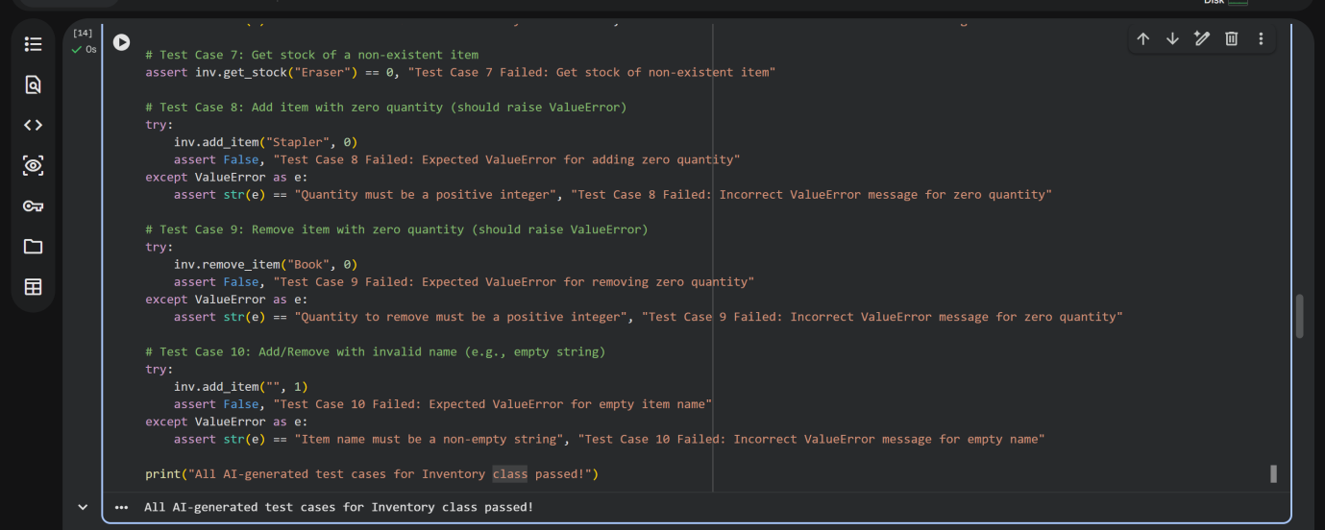
Task Description #5 (Date Validation & Formatting – Apply AI for
Data Validation)
• Task: Use AI to generate at least 3 assert test cases for
validate_and_format_date(date_str) to check and convert
dates.
• Requirements:
o Validate "MM/DD/YYYY" format.
o Handle invalid dates.
o Convert valid dates to "YYYY-MM-DD".
Example Assert Test Cases:
assert validate_and_format_date("10/15/2023") == "2023-10-15"
assert validate_and_format_date("02/30/2023") == "Invalid Date"
assert validate_and_format_date("01/01/2024") == "2024-01-01"
Expected Output #5:
• Function passes all AI-generated assertions and handles edge
cases.
CODE:
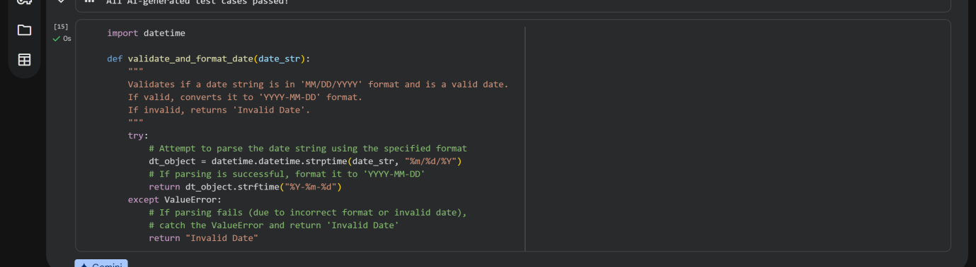
OUTPUT:
