Name: Hannah Mngoli

Email: [hmngoli@gmail.com](mailto:hmngoli@gmail.com)

Phone number: 8855023201

Number: +265880820996(W/A)

Domain: Web Development

**CODE: HTML & CSS**

**<!Doctype html>**

**<html lang="en">**

**<head>**

**<title>**

**Resume Builder**

**</title>**

**<link rel="icon" type="image/x-icon" href="fav1.png">**

**</head>**

**<style>**

**@import url('https://fonts.googleapis.com/css2?family=Macondo&display=swap');**

**\*{**

**font-family: "Macondo";**

**font-weight: 400;**

**font-style: normal;**

**}**

**body{**

**display: grid;**

**grid-template-columns: 40% 60%;**

**font-size: 1.2em;**

**}**

**.input{**

**margin: 1%;**

**}**

**#form input{**

**padding: 10px;**

**border-radius: 10px;**

**width: 70%;**

**margin: 5px;**

**}**

**button{**

**padding: 1% 2%;**

**border-radius: 10px;**

**font-style: oblique;**

**font-weight: 600;**

**border: transparent;**

**}**

**button:hover{**

**transition: background-color 1s ease, transform 1s ease;**

**background-color: grey;**

**transform: scale3d(1.1,1.1,1.1);**

**}**

**h1, h2{**

**text-align: center;**

**}**

**.skills ul{**

**display: flex;**

**justify-content: flex-start;**

**flex-wrap: wrap;**

**}**

**.skills li{**

**flex: 1 0 21%;**

**list-style-type: none;**

**padding: 5px;**

**border-radius: 10px;**

**border: 1px solid grey;**

**margin: 1%;**

**}**

**.skills li:hover{**

**border: transparent;**

**transition: background-color 1s ease;**

**background-color: gray;**

**cursor: pointer;**

**}**

**li{**

**list-style-type: square;**

**}**

**.education{**

**right: 0;**

**}**

**.buttons{**

**display: flex;**

**gap: 30%;**

**}**

**.buttons button{**

**width: 30%;**

**padding: 5px;**

**}**

**.pic{**

**display: flex;**

**justify-content: space-around;**

**}**

**img{**

**width: 100px;**

**height: 100px;**

**display: none;**

**border-radius: 50%;**

**}**

**#output{**

**font-family: serif;**

**margin: 1%;**

**}**

**#education1{**

**display: grid;**

**grid-template-columns: repeat(2, 1fr);**

**}**

**@media (orientation: portrait){**

**body, #education1{**

**grid-template-columns: repeat(1, 1fr);**

**}**

**.input, #output{**

**align-items: center;**

**margin: auto;**

**width: 1000px;**

**}**

**input{**

**width: 700px;**

**}**

**}**

**</style>**

**<body>**

**<section class="input">**

**<h1>Build Your Resume</h1>**

**<div id="form">**

**<input oninput="name_data()" type="text" id="name" placeholder="Name"><br>**

**<input type="file" title="upload a picture" id="pic" accept="image/*" onchange="dispic(event)">**

**<input oninput="contact()" type="text" id="email" placeholder="Email"><br>**

**<input oninput="contact()" type="tel" id="phone" placeholder="Phone"><br>**

**<input oninput="summary_data()" type="text" id="summary" placeholder="profile summary"><br>**

**<input type="text" id="education" placeholder="Education" onfocus="this.value=''"><button onclick="addedu()" title="cant undo add">+</button><br>**

**<input type="text" id="skills" placeholder="Skills" onfocus="this.value=''"><button onclick="addskill()" title="cant undo add">+</button><br>**

**<input type="text" id="experience" placeholder="Experience" onfocus="this.value=''"><button onclick="addexpo()" title="cant undo add">+</button><br>**

**</div><br>**

**<div class="buttons">**

**<button onclick="Clear()">Clear</button>**

**<button onclick="Print()">Print</button>**

**</div><br>**

**</section>**

**<section id="output">**

**<div class="pic">**

**<h1 id="name2"></h1>**

**<img id="displayedImage">**

**</div>**

**<div class="summary">**

**<h2 id="Summary"></h2>**

**<p id="summary1"></p>**

**</div>**

**<div class="education">**

**<h2 id="Education"></h2>**

**<ul id="education1">**

**</ul>**

**</div>**

**<div class="skills">**

**<h2 id="Skills"></h2>**

**<ul id="skill1">**

**</ul>**

**</div>**

**<div class="experience">**

**<h2 id="Experience"></h2>**

**<ul id="experience1">**

**</ul>**

**</div>**

**<div class="contact">**

**<h2 id="Contact"></h2>**

**<p id="email1"></p>**

**<p id="phone1"></p>**

**</div>**

**</section>**

**</body>**

**<script src="MP.js"></script>**

**</html>**

**JAVASCRIPT**

 function name_data(){

    const names = document.getElementById("name");

    const name2 = document.getElementById("name2");

    name2.textContent = names.value;

 }

 function summary_data(){

    const summary = document.getElementById("summary");

    const summary1 = document.getElementById("summary1");

    const Summary = document.getElementById("Summary");

    Summary.textContent = "Personal Summary";

    summary1.textContent = summary.value;

 }

 function addedu(){

    const node = document.createElement("li");

    const adder = document.getElementById("Education");

    adder.textContent = "Education";

    let edu = document.getElementById("education");

    let text =  document.createTextNode(edu.value);

    node.appendChild(text);

    document.getElementById("education1").appendChild(node);

 }

 function addskill(){

    const node = document.createElement("li");

    const adder = document.getElementById("Skills");

    adder.textContent = "Skills";

    let skill = document.getElementById("skills");

    let text =  document.createTextNode(skill.value);

    node.appendChild(text);

    document.getElementById("skill1").appendChild(node);

    console.log("work");

 }

 function addexpo(){

    const node = document.createElement("li");

    const adder = document.getElementById("Experience");

    adder.textContent = "Experience";

    let experience = document.getElementById("experience");

    let text =  document.createTextNode(experience.value);

    node.appendChild(text);

    document.getElementById("experience1").appendChild(node);

 }

 function contact(){

    const adder = document.getElementById("Contact");

    adder.textContent = "Contact";

    let email1 = document.getElementById("email1");

    let phone1 = document.getElementById("phone1");

    let phone = document.getElementById("phone");

    let email = document.getElementById("email");

    email1.textContent = `Email: ${email.value}`;

    phone1.textContent = `Phone num: ${phone.value}`;

 }

 function Print(){

    let printContent = document.getElementById("output").innerHTML;

    let originalContent = document.body.innerHTML;

    document.body.innerHTML = printContent;

    window.print();

    document.body.innerHTML = originalContent;

}

function Clear(){

    document.getElementById("experience").value = null;

    document.getElementById("skills").value = null;

    document.getElementById("pic").value = null;

    document.getElementById("name").value = null;

    document.getElementById("email").value = null;

    document.getElementById("phone").value = null;

    document.getElementById("summary").value = null;

    document.getElementById("education").value = null;

    document.getElementById("output").textContent = " ";

}

function dispic(event){

    let image = document.getElementById("displayedImage");

    image.style.display = "block";

    image.src = URL.createObjectURL(event.target.files[0]);

}

**OUTPUT**

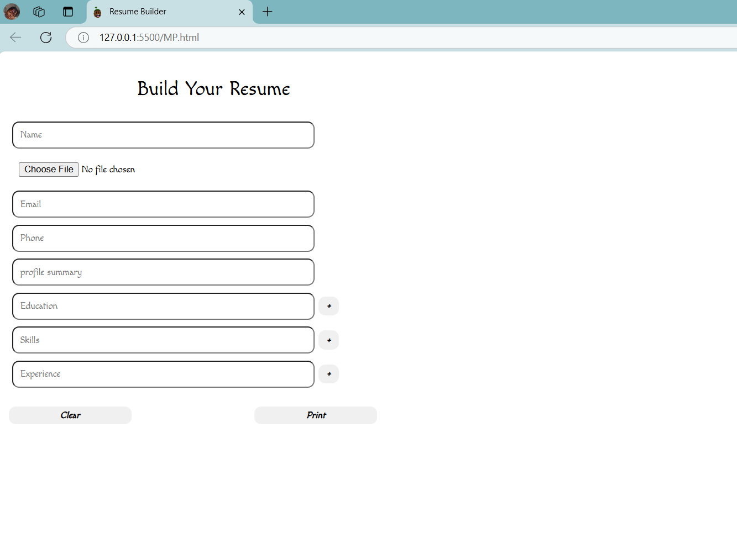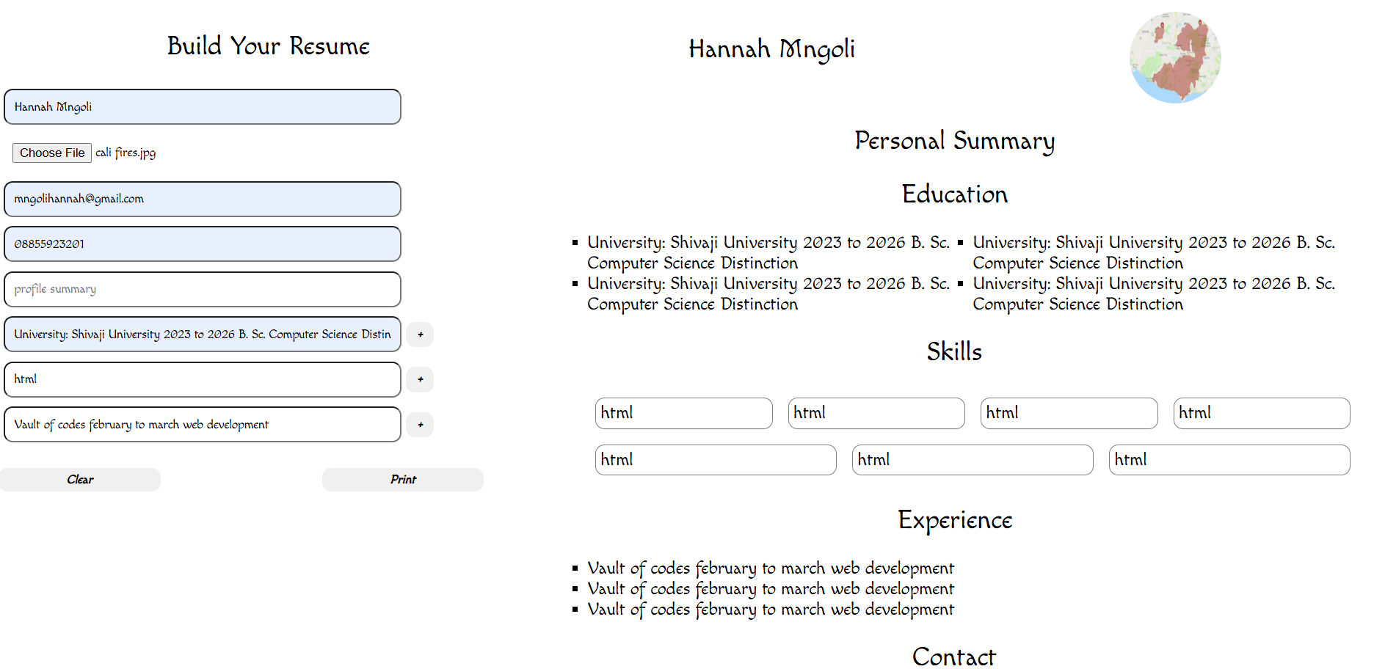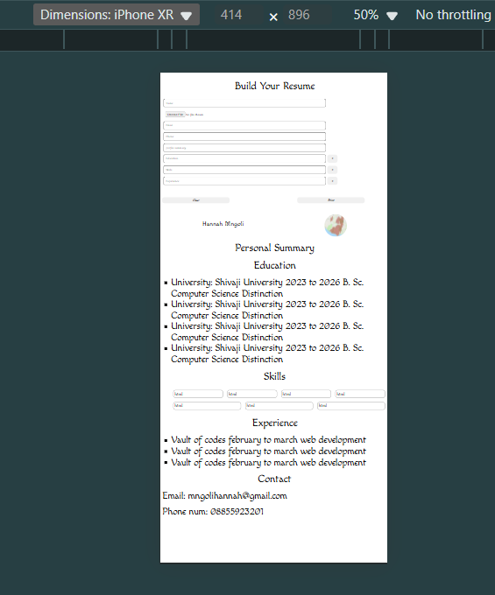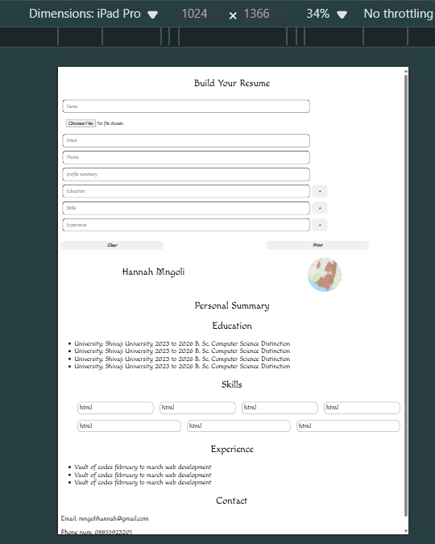

**Link:** <https://lingaombe.github.io/ResumeBuilder/>