MemoryArchitect: Prototype Design Documentation

1. Introduction
MemoryArchitect is a model-agnostic, external policy framework designed to oversee LLM- and RAG-based systems. It governs how tokens are budgeted, memory is stored and retrieved, and how context is managed-without altering or training the underlying model. The framework operates as a standalone library that can be imported into any Python-based AI agent or long-context system.

1.1 Purpose and Scope
The prototype aims to demonstrate adaptive, rule-based memory and token governance for local LLaMA or other open-source LLMs. It manages token allocation, retrieval ranking, and memory consolidation using a policy schema defined in YAML. The focus is on runtime efficiency, memory optimization, and reducing hallucinations through context-aware evidence retrieval.

1.2 Key Objectives and Success Criteria
• Token efficiency - Achieve zero context overflows and at least 50–70% token reduction versus full-history baselines.
• Reliable recall and consistency - Maintain ≥70% recall accuracy and ≥0.90 persona consistency score.
• Grounded responses - Keep ungrounded claim (hallucination) rate ≤5–8% under evaluation conditions.
• Efficient runtime - Maintain acceptable p95 latency and ≥3× memory compression compared to raw transcripts.

2. Project Timeline
Phase | Duration / Hours | Key Deliverables
1. Foundation & Environment | 1 week / ~20h | Repository scaffold, dependency setup, default policy.yaml, LLaMA smoke test
2. Memory Store & Retrieval | 1 week / ~20h | Memory schema, Chroma integration, vector add/query, top‑k prompt injection
3. Token Budgeter & Governance | 1 week / ~20h | Token counting, S+U+M+R+G+ε ≤ C enforcement, TTL/merge/update
4. Reflection & Summarization | 1 week / ~20h | Micro‑summary + golden summary; importance scoring; recency bias retrieval
5. CLI Demo | 1 week / ~20h | Interactive CLI with dev commands (!mem, !policy, !stats); optional mini UI
6. Evaluation Harness | 1 week / ~20h | Metrics (LoCoMo, Persona), scripts, logs/CSVs
7. Optimization & Tuning | 1 week / ~20h | Policy tuning, caching, profiling, doc updates
8. Finalization & Packaging | 1 week / ~20h | v1.0 tag, reproducible runs, final report, demo script

3. Performance Metrics and Benchmarks

Metric Name | Target Value | Measurement Method | Frequency
Context Overflow Rate | 0 per run | Count overflows during evaluation | Per conversation
Avg Tokens per Turn | ≥50–70% lower vs baseline | Log token usage; compare to full history | Per eval
Recall QA Accuracy | ≥70% | Replay benchmark dialogues (LoCoMo) | Per dataset
Persona Consistency | ≥0.90 | Check contradictions vs stored persona | Per dataset
precision@5 | ≥0.80 | Count correct memory retrievals | Per retriever test
Ungrounded Claim Rate | ≤5–8% | Compare answers to provided evidence | Per eval
Memory Compression | ≥3× vs raw text | Stored vs raw token count | Weekly
p95 Latency | Within local target | Measure response latency including retrieval | Per run
Fatal Error Rate | 0 | Scan logs/exceptions in CI | Per CI

Benchmark datasets include LoCoMo for long‑dialogue QA and summarization, PersonaChat for consistency, and small QA subsets for retrieval sanity.

4. Workflow Description

The workflow begins with user input and proceeds through policy enforcement, token budgeting, retrieval, prompt assembly, generation, verification, and reflection. Each turn updates the memory store while maintaining a balance between relevance and token constraints.

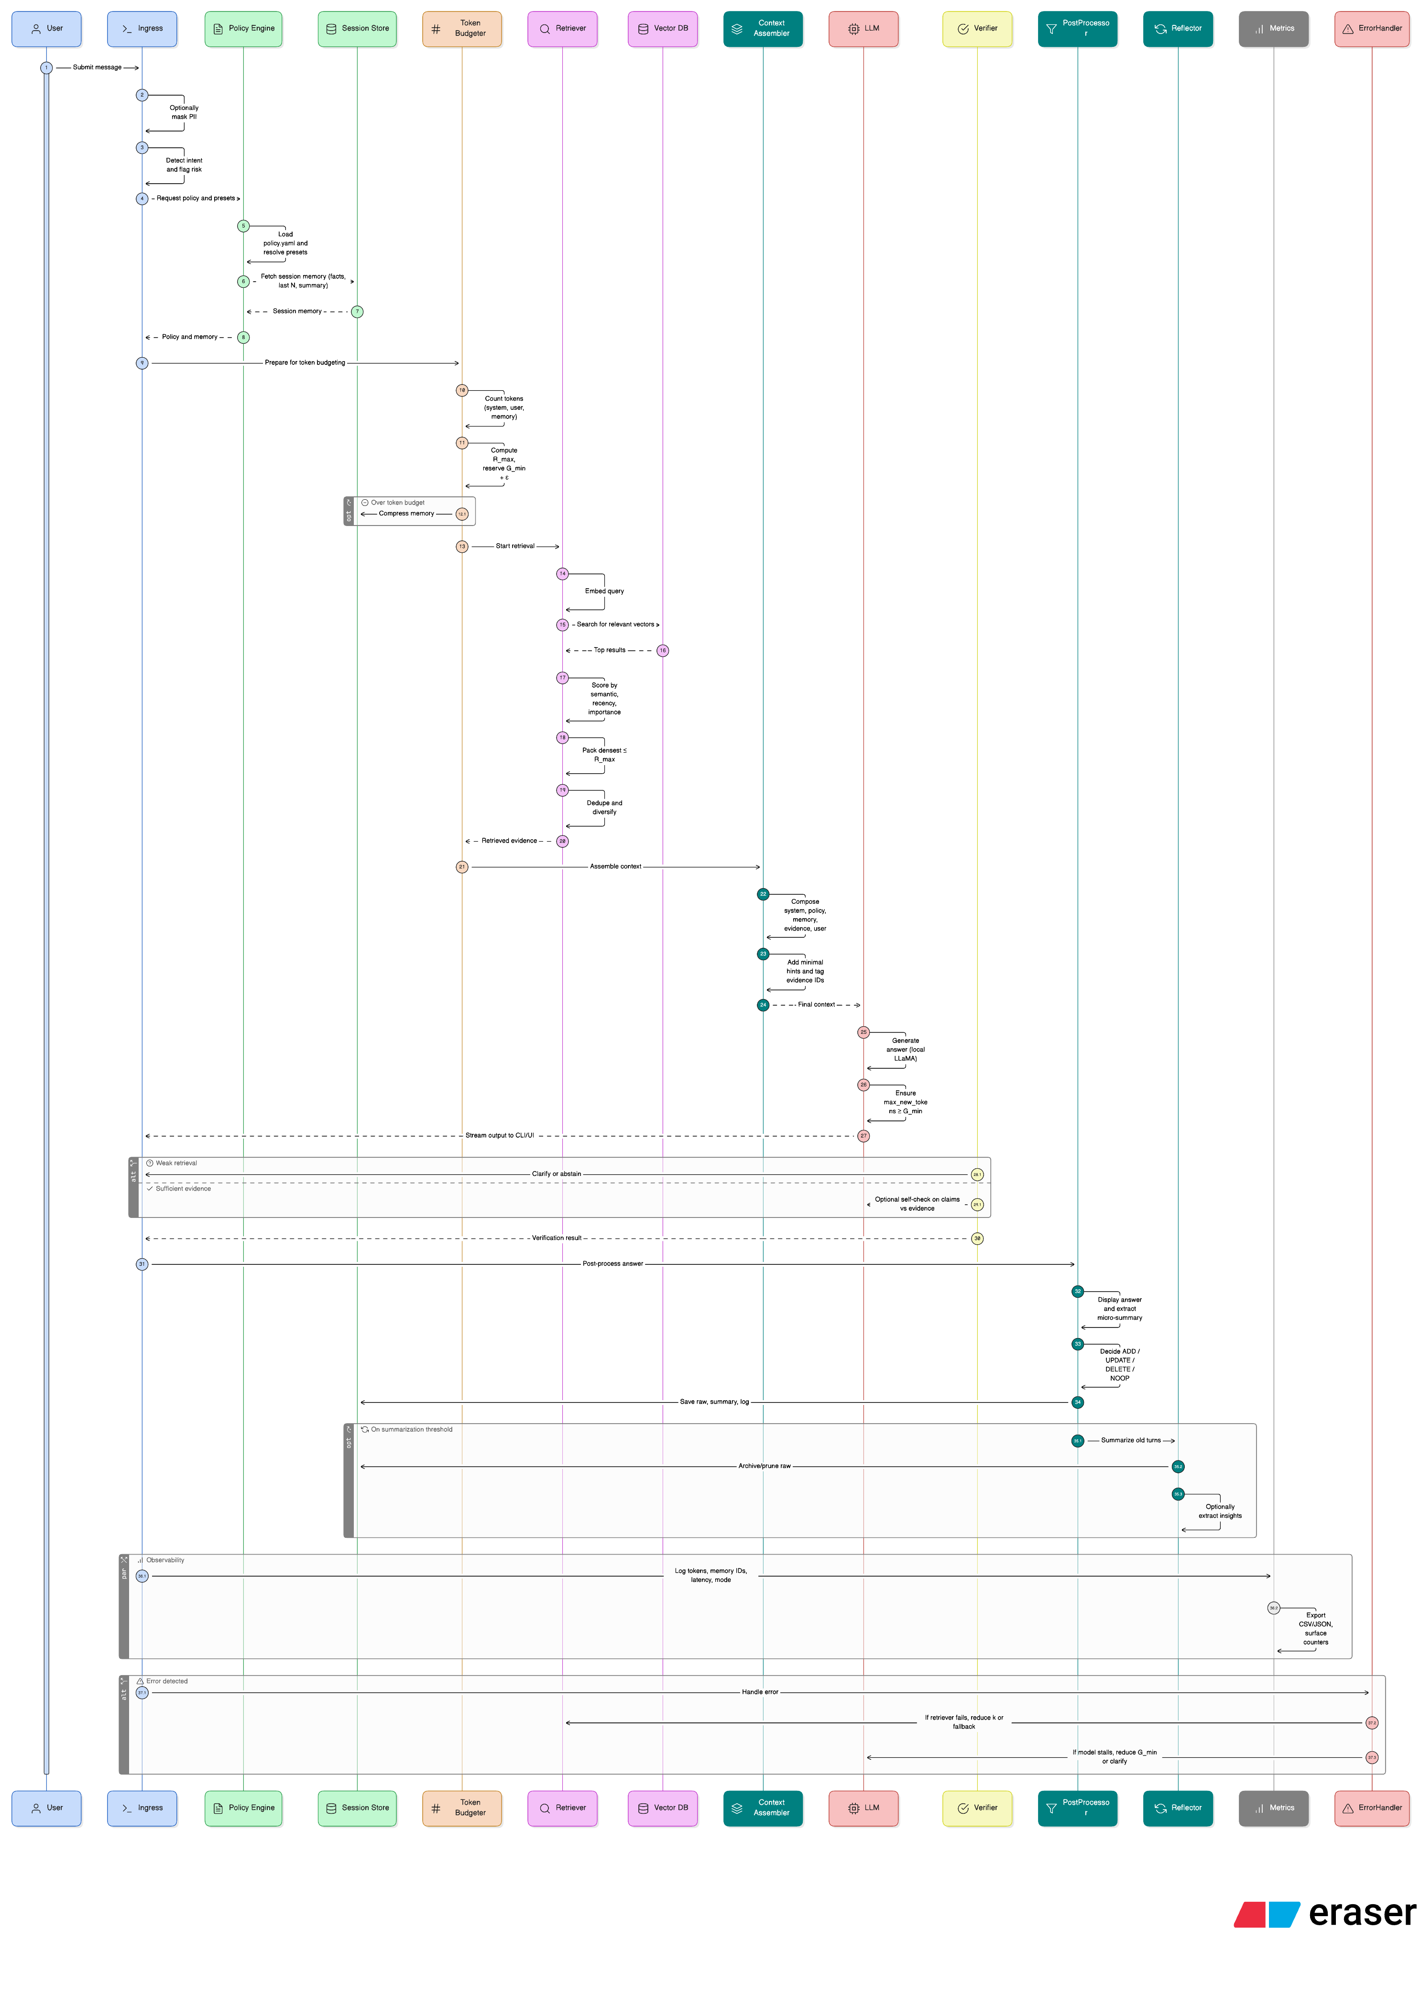
• User submits a message via CLI/UI; optional PII masking and intent detection occur.
• Policy Loader retrieves active configuration (policy.yaml).
• Token Budgeter computes S+U+M+R+G+ε ≤ C, compressing memory if needed.
• Retrieval Controller embeds the query, searches the vector DB, ranks candidates, and selects evidence.
• Prompt Assembler constructs the context (System → Memory → Evidence → User).
• LLM Adapter invokes the local LLaMA model and streams the response.
• Verifier checks grounding confidence; low-confidence responses trigger clarify/abstain.
• Memory Manager extracts micro‑summaries, applies ADD/UPDATE/DELETE per policy, and persists data.
• Reflector periodically summarizes older memory spans into golden summaries and prunes archives.
• Observability logs tokens, latency, and selected memory IDs for evaluation.

5. Architecture Overview
The architecture comprises modular components that interact via defined data contracts. No component modifies the underlying model weights; all logic is external and policy-driven.

Component | Description
Policy Loader | Parses YAML/JSON policy; exposes typed config; supports hot-reload.
Token Budgeter | Enforces context constraints deterministically; trims memory and evidence.
Memory Governance Engine | Manages ADD/UPDATE/DELETE/TTL; compresses and persists memory entries.
Retrieval Controller | Performs vector search and hybrid scoring; applies benefit-per-token packing.
Summarizer/Reflector | Generates micro and golden summaries; performs insight extraction.
LLM Adapter | Handles prompt formatting and LLaMA inference (HF or llama.cpp).
Observability | Logs all runtime metrics and supports evaluation.
CLI / Optional UI | Interactive interface with developer commands.
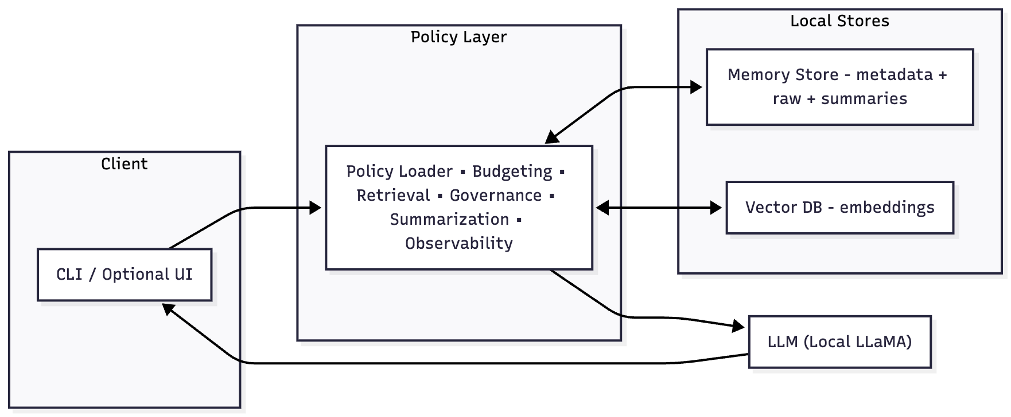

6. Data Flow Overview

Step | Input | Process | Output
Ingress | User text | Preprocess, redact, intent classification | Clean query
Policy Load | policy.yaml | Parse schema and apply presets | Config object
Token Budget | S,U,M,C | Compute R_max and G_min; enforce limits | Budget plan
Retrieval | Query + embeddings | Vector search, ranking, density pack | Evidence set
Prompt Assembly | System + M + R + User | Concatenate ordered context | LLM prompt
Generation | Prompt | Run local LLaMA model | Assistant answer
Governance | Turn data | Apply ADD/UPDATE/DELETE/TTL | Updated memory DB
Reflection | Old turns | Summarize and prune | Golden summary
Metrics | Logs | Compute analytics | Evaluation CSV/JSON

7. Future Semester Extensions
Planned Enhancement | Description / Next Steps
Multi‑session Memory Graph | Entity linking and cross‑session TTL management.
Hybrid Retrieval | Combine BM25 keyword search with dense vector retrieval.
Topic Segmentation | Automatic clustering and hierarchical summaries.
Web Dashboard | Memory visualization and runtime policy tuning.
LangChain Plugin | Custom BaseChatMemory wrapper for easy integration.

