Workflow-draft

分工：

**LSQ-导入gis数据，例如：road/direction/census block**

**LRC-设计每个patch的属性**

**LLD-设计agent属性**

**DJH-定义movement方法**

**CYC-定义agent与环境/其他agent交互**

**DJH-整合workflow内容**

DJH:

1.<https://github.com/acrooks2/ClassModels/tree/master/CSS645Models/Food_Desert>, 这个github中有一个food desert的案例，研究个体的属性特征与food desert area的关系。

个体属性定义包括：

edu ; [education] of patch-here) / ([population] of patch-here

fs ; [foodstamps] of patch-here) / ([population] of patch-here

pov ; [poverty] of patch-here) / ([population] of patch-here

stores-in-radius ; patch set of patches with supermarket-here? = TRUE or notSupermarket-here? = TRUE

accessibility ; a persons accessibility score

countdown ; the number of days before a person "goes to the store"

my-GEOID

my-ward

health

heart

overweight

Store-choice

代码流程：

**Setup**: 导入census block，supermarket，非supermarket，病房与健康数据

**draw**： draw the map and apply the vector data to the rastor in netlogo for the socioeconomic data

**Make-pop**：设置每个census tract中心点属性：education，foodstamp, poverty等等

**Mark-supermarkets**: mark-notSupermarkets：给每个patch对应supermaket和not Supermarket的位置

**Calculate-accessibility**：计算可达性

**Calculate-accessibility-plus**： If the agent is determined to have some form of food assistance that will add to the Sj term in the equation and cause the overall accessibility to increase.

**voronoi**：使用NetLogo Voronoi model.

。。。

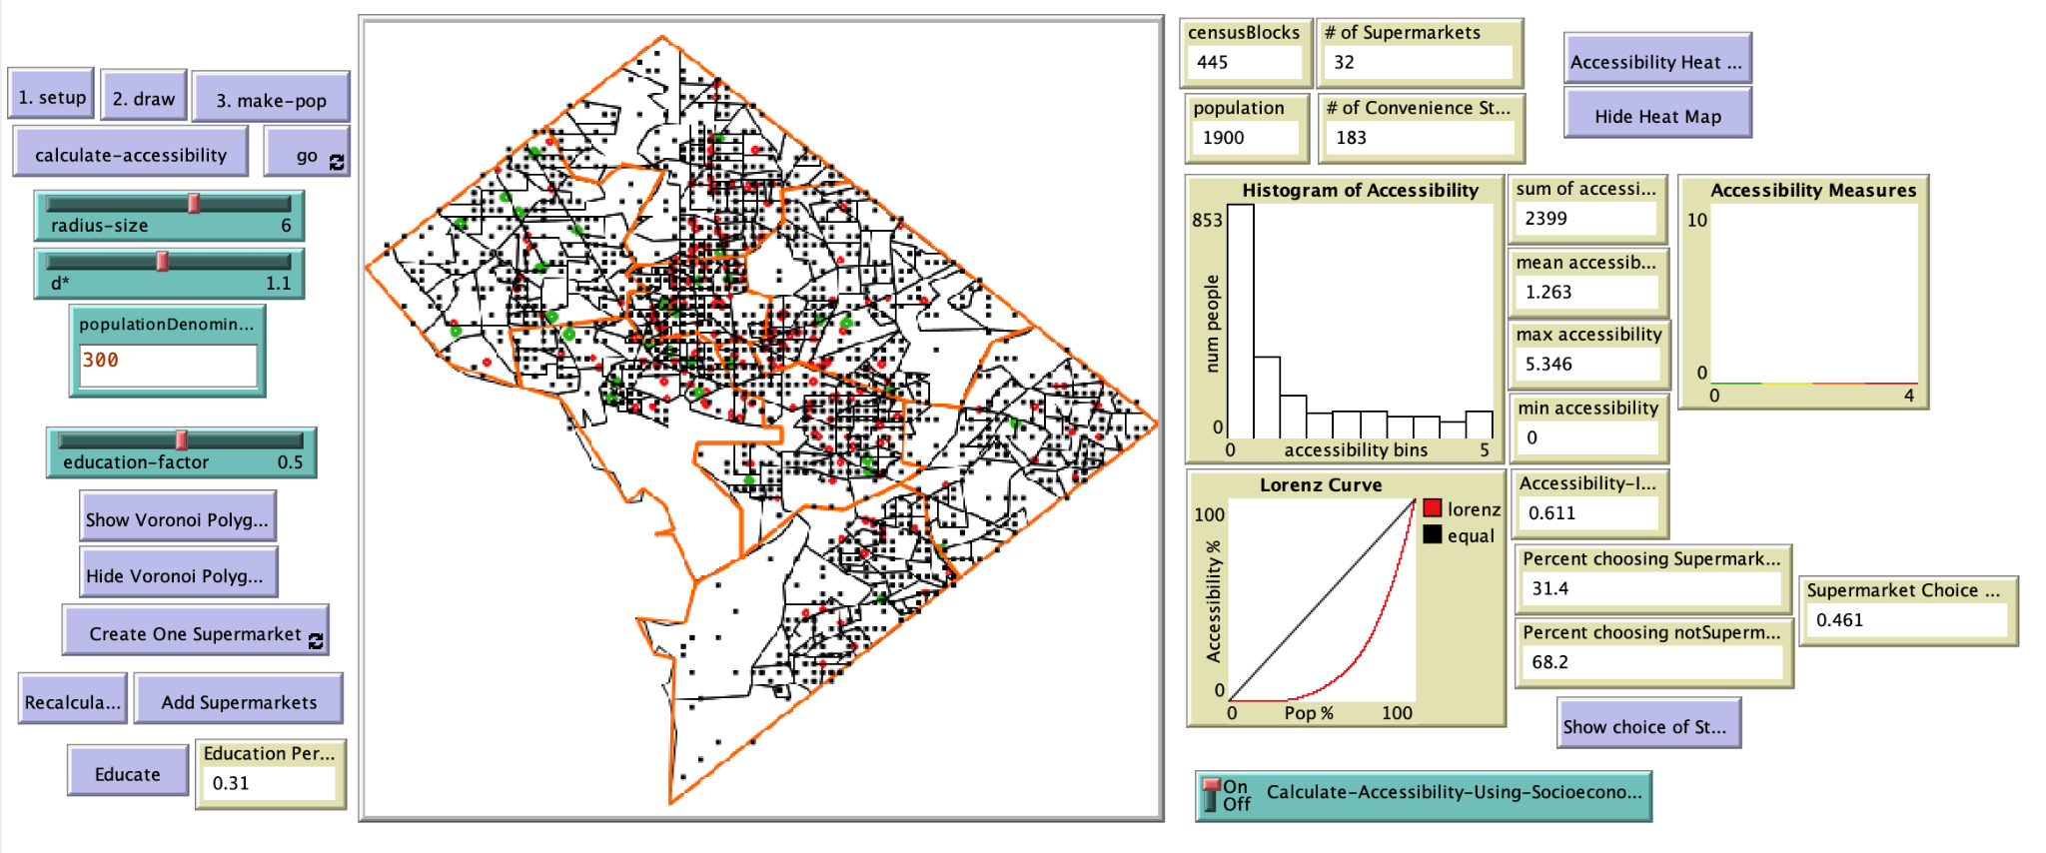

## **i. State the model you are editing**

## **ii. Identify the spatial data you are editing**

The original data in the model:

| dataset | description |
| --- | --- |
| DC supermarkets | Point feature of supermarkets and other grocery stores in DC |
| DC census block data | Census block boundary with population, education, food stamp, and poverty data |
| DC ward and health data | Health data in DS, including obesity, heart disease, and overall health indicator |

The data we use to replace for our project:

| dataset | source | description |
| --- | --- | --- |
| SF Health Facilities | DataSF | Point feature of health facilities in SF(with type senior health or others) |
| SF Census Blocks | DataSF | Boundary and senior population |
| SF Economy Data | Esri | Food stamp, Poverty, Health Insurance, Education to enrich the census blocks data |
| Environmental Justice Index(EJI) | CDC | Health Vulnerability Indicators: High estimated prevalence of cancer, high blood pressure and diabetes |
| SF Road and Speed Limits | DataSF | Line feature of roads in SF with speed limit |

## **iii. Describe the steps needed to prep the spatial data**

1. **Project**

According to the NetLogo GIS Extension, NetLogo only support limit kinds of coordinate systems and projections. To fit the coordinate system to NetLogo, I have project the datasets into NAD83.

1. **Join and enrich**

To merge all the data into one layer, I use the Join and Enrich tool in ArcGIS Pro. The eji data I collected from the CDC’s website was joined to the Census Blocks data on the GEO_ID field. I also use the Enrich tool to join the economy data I found in Esri’s data portal to the census blocks.

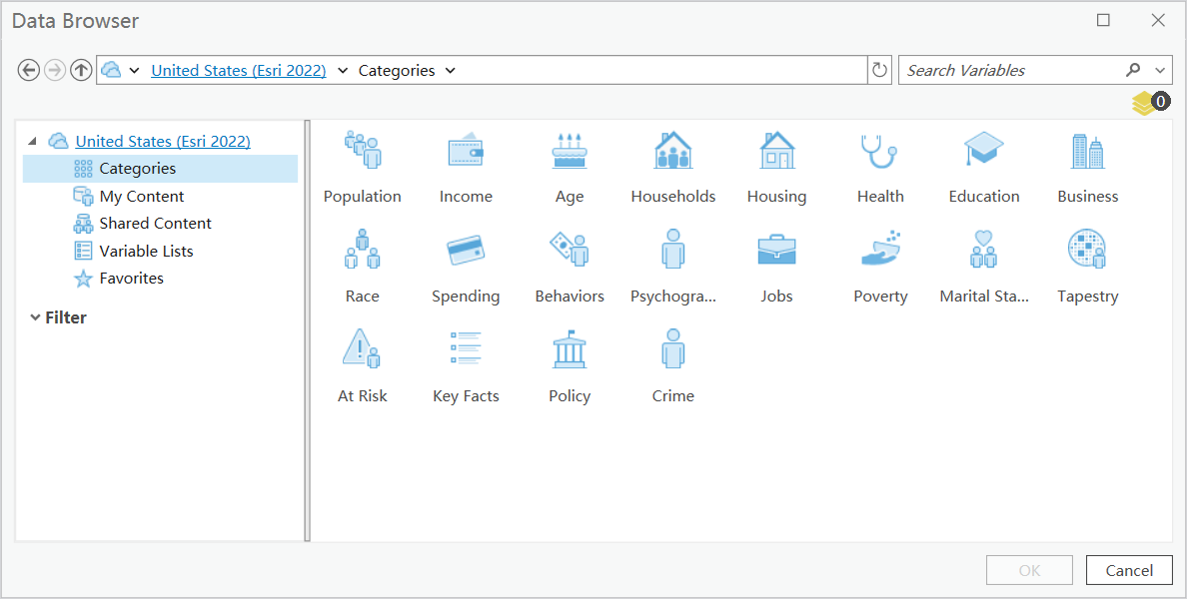

## **iv. Describe the procedures that need to be added/or edited in the NetLogo code.**

## 1.LSQ-导入gis数据+LRC-设计每个patch的属性

1. **Change variable names**

First, our team edit the variable names and add new variables to make it fits the topic in our project. For example, we changed the supermarket into seniorClinics.

| **Original code:** | **New code:** |
| --- | --- |

1. **Edit patches-own:**

Second, to design the properties of pathes, we edit the code below to replace them with our own property names.

| **Original code:** | **New code:** |
| --- | --- |

1. **people-own**

To edit the agent properties, we edit the people-own part of the code as below:

| **Original code:** | **New code:** |
| --- | --- |

1. **to setup**

After editing the variables, we started to edit the functions. The first function to be edit, which connects to the first button in the panel, is the setup function. We change the linked data source into the projection data and shapefile data we use for this project.

**Original code:**

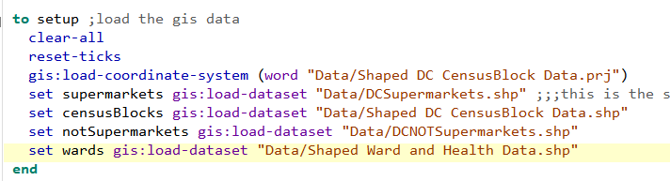

**New code:**

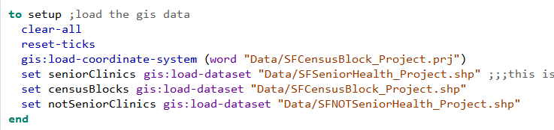

1. **to draw**

To draw the base map and required data on the panel, we need to edit the draw function. In detail, we replaced the variable names with our variable names, field names with the capital letter of the field names of our datasets. The reason to use all capital letters is to accommodate the syntax of NetLogo.

**Original code:**

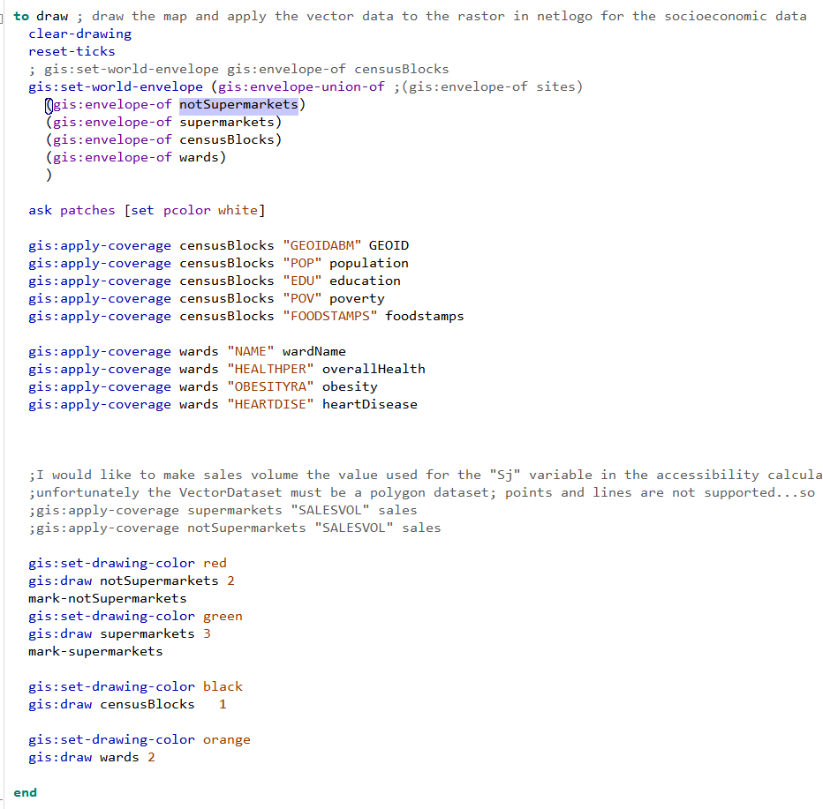

**New code:**

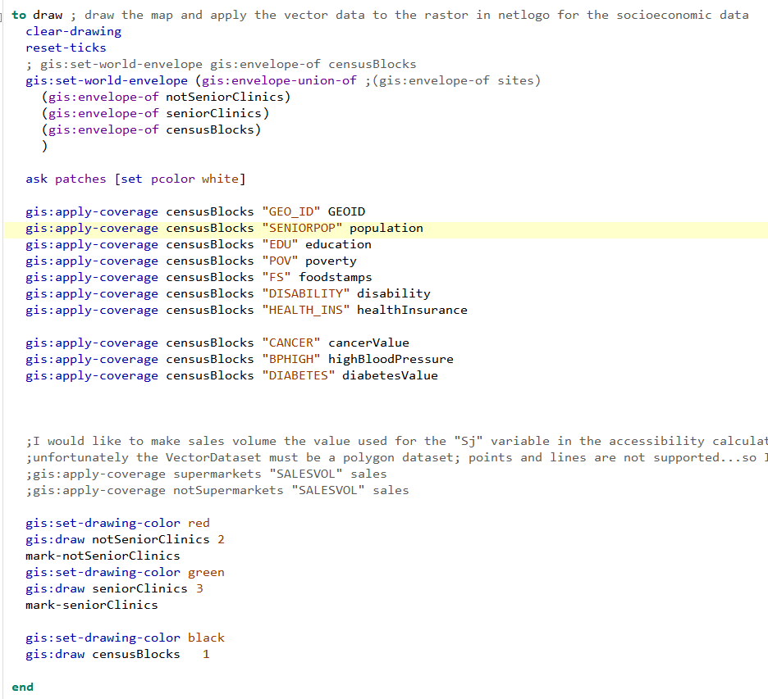

## 3.LLD-生成agents

to make-patient

;随机设置每个census block，patient-rate以内的病人数，例如1000老年人中假设20%会在current tick （例如按15分钟计算）准备就诊，随机生成patient number <= 1000*20% =200，可能结果：35人

;随机设置到达医院时间patient-arrive-time（最好有分布数据可以佐证）

;随机设置duration属性patient-duration（最好有分布数据可以佐证）

end

to set-healthcare-facility-capacity

;随机设置（最好有分布数据可以佐证）每个医院在current tick的出诊医生

end

The agents would be elderly residents of San Francisco.

Attributes may include age, income, health status and preferred modes of transportation.

## 4.DJH-定义movement方法

to make-patient-to-healthcare-facility

;Randomly create patients based on the potential percentage of elderly people who intend for healthcare services.

##codes##

ask patient[

;in the radius of ‘distance-tolerance’ miles

find-healthcare-facilities-in-radius

ifelse any? patient-healthcare-facilities-in-radius

[

;randomly select one healthcare facility

let healthcare-facility-x one-of patient-healthcare-facilities-in-radius

set patient-healthcare-facility healthcare-facility-x

; Check if the demand is less than the capacity at the selected facility

ask healthcare-facility with [who = healthcare-facility-x][

ifelse healthcare-facility-demand < healthcare-facility-capacity[

set [patient-A?] of myself True

set healthcare-facility-demand healthcare-facility-demand+1

set healthcare-facility-patient-list lput [patient-duration] of myself healthcare-facility-patient-list

][set [patient-A?] of myself False]

]

][set patient-A? False]

]

end

to find-healthcare-facilities-in-radius ;called by make-patient-to-healthcare-facility

end

## 5.CYC-计算accessibility

to create-accessibility-map

let color-ramp gis:make-color-ramp (list 0.0 blue 1.0 red)

ask censusBlocks[

;count the number of True of patient-A in this censusBlock

let count-patient-A-True count patients with [patient-census-block = [censusBlocks] of myself and patient-A? = True]

let count-patients count patients with [patient-census-block = [censusBlocks] of myself]

set censusBlocks-accessibility count-patient-A-True/count-patients

; set the drawing color for each census block based on its accessibility value

let color gis:set-drawing-color color-ramp (map [cb -> [censusBlocks-accessibility] of cb] self)

gis:fill-polygon gis:centroid self

]

end

to go

make-patient-to-healthcare-facility

ask healthcare-facility[

foreach healthcare-facility-patient-list[

pd ->

set pd pd-1

if pd = 0[

set healthcare-facility-patient-list remove pd healthcare-facility-patient-list

]

]

set healthcare-facility-demand healthcare-facility-demand - 1

]

create-accessibility-map

end

## 6.DJH-整合workflow内容