

**Mini Project Report – 03**

Master of Computer Application – General

Semester – I

**Sub: Front-End Frameworks and Technologies**

# Topic: Employee Details

# By

**Name:** Lingesh kumar M

**Reg no.:** PROV/ASAC/MCA/7/25/066

**Faculty Name:** VEERA RAGHAV K

**Faculty Signature: _______________**

# Department of Computer Application Alliance University Chandapura - Anekal Main Road, Anekal Bengaluru - 562 106

# Sepetember 2025

**Index:**

1. Introduction
   * HTML
   * CSS
2. Input Code
3. Output
4. Conclusion

**Introduction**

HTML (HyperText Markup Language)

* HTML is the foundation of every webpage. It was first developed by Tim BernersLee in 1991 as a way to share and link documents on the World Wide Web.
* It provides the structure and meaning of web content. For example, a heading, a paragraph, an image, or a link is all defined in HTML.
* HTML uses tags enclosed in < >. Most tags come in pairs:
  + Opening tag: <p>
  + Closing tag: </p>
* Tags are organized in a tree-like structure called the DOM (Document Object Model).
* The main parts of an HTML document are:

1. <!DOCTYPE html> → Defines the type of document (HTML5).
2. <html> → Root element of the page.
3. <head> → Contains metadata, title, styles, and links.
4. <body> → Contains all the visible content of the webpage.

## CSS (Cascading Style Sheets)

* CSS was introduced in 1996 by the W3C to separate content (HTML) from design (style).
* It defines how HTML elements are displayed on the screen, on paper, or on different devices.
* CSS follows the principle of “Separation of Concerns”:

o HTML = Structure o CSS = Presentation • Ways to apply CSS:

1. Inline CSS → Inside the tag using style="".
2. Internal CSS → Inside <style> within <head>.
3. External CSS → In a separate .css file linked with <link>.

• CSS follows a cascading priority system:

1. Browser default
2. External stylesheet
3. Internal stylesheet
4. Inline styles (highest priority)

Relationship Between HTML & CSS

* + HTML provides the content and structure, while CSS adds style and layout.
* HTML says: “There’s a heading and a paragraph.”
* CSS says: “Make the heading blue and center it. Make the paragraph gray and larger.”

Importance of HTML & CSS in Web Development

* HTML and CSS are the core building blocks of web development.
* They are essential for:
  + Creating static web pages (resumes, portfolios, blogs).
  + Designing modern, responsive websites (e-commerce, apps, dashboards).
  + Ensuring cross-platform compatibility (desktop, tablet, mobile).
* Every web technology (like JavaScript frameworks or backend systems) starts with HTML & CSS at the base.

**Input Code:**

<html>

    <head>

        <title>

        </title>

        <style>

            h1{

               text-align: center;

            }

            div{

                border:1px solid black;

                width:500px;

                margin-left: 500px;

                background-color: rgb(106, 122, 223);

                border-radius: 20px;

                box-shadow: 5px 5px 15px rgb(32, 11, 11);

            }

            form{

                margin-left: 130px;

            }

            input{

                width:150px;

            }

            input,label{

                margin:5px;

            }

            input:hover{

                background-color: rgb(10, 30, 23);

            }

            .i1{

                margin-left: 60px;

            }

            .i2{

                margin-left: 10px;

            }

            .i4{

                margin-left: 55px;

            }

            .i5{

                 margin-left: 75px;

            }

            .i6{

                 margin-left: 15px;

            }

            .i7{

                 margin-left: 90px;

            }

            .i8{

                 margin-left: 65px;

            }

            .i9{

                 margin-left: 50px;

                 width:155px;

                 margin-top: 10px;

                 margin-bottom: 8px;

            }

             .i9:hover{

                background-color: rgb(63, 74, 203);

            }

            .i10{

                 margin-left: 45px;

            }

            .i11{

                margin-left: 20px;

            }

            .b1{

                margin-left: 220px;

                margin-bottom: 10px;

                padding: 5px;

                width:100px;

                background-color:rgb(184, 240, 194);

                color:rgb(123, 53, 53);

                border-radius: 12px;

                box-shadow: 2px 2px 5px rgb(123, 53, 53);

            }

            button:hover{

                background-color:rgb(134, 139, 230);

            }

            ::placeholder{

                text-align: center;

                color:rgb(157, 204, 81);

            }

            a{

                text-decoration: none;

            }

        </style>

    </head>

    <body>

        <div>

            <h1>Employee Details</h1>

            <form>

            <label> Emp_id:</label>

            <input  class='i1' type="number" placeholder="enter your Emp_id"><br>

            <label> Employee name:</label>

            <input  class='i2' type="text" placeholder="enter your name"><br>

            <label> Emp_designation:</label>

            <input type="text" placeholder="enter your designation"><br>

            <label> Company:</label>

            <input  class="i4" type="text" placeholder="enter your company"><br>

            <label> Salary:</label>

            <input class="i5" type="number" placeholder="enter your salary"><br>

            <label> Phone_number:</label>

            <input type="number" class="i6" placeholder="enter your number"><br>

            <label> Dob:</label>

            <input type="date" class="i7" placeholder="enter your dob"><br>

            <label> Address:</label>

            <input type="text" class="i8" placeholder="enter your address"><br>

            <label class="l1">feed back:</label>

            <textarea class="i9" placeholder="enter your feedback"></textarea><br>

            <label>Emp email:</label>

            <input type="text" class="i10" placeholder="enter your email"><br>

             <label>Emp Password:</label>

            <input type="password" class="i11" placeholder="enter your password"><br>

            </form>

            <button class="b1"><a href="https://www.alliance.edu.in/">Submit</a></button>

        </div>

    </body>

</html>

**Output:**

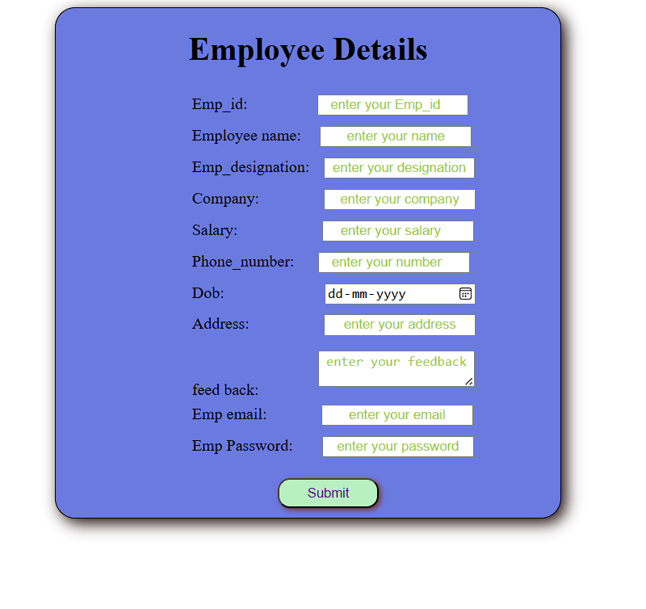

**Conclusion:**

HTML and CSS together form the backbone of web development.

* HTML defines the structure and organizes the content of a webpage, ensuring that information is properly presented and accessible.
* CSS enhances the visual appearance by adding design, style, and responsiveness, making webpages more attractive and user-friendly.

Without HTML, there would be no content, and without CSS, that content would appear plain and unstyled. Their combined use creates webpages that are both functional and visually engaging.

In today’s digital era, mastering HTML and CSS is essential for anyone aspiring to become a web developer, as they are the first step towards building interactive, responsive, and professional websites.