RESEARCH PROPOSAL
Same Accuracy, Different Futures
Causal Evaluation Leverage in Self-Improving Agents
Lingge Meng
Mathematics-Computer Science, University of California San Diego
Proposed duration: six months
August 2026
Central thesis: static evaluator accuracy on a common reference distribution does not identify downstream risk once verdicts control persistent adaptive updates; risk depends on where errors occur, how their effects propagate, and how multiple errors compose.

Abstract
Self-improving agents increasingly rely on automated evaluators to decide which experiences, memories, skills, tools, or policy updates should influence future behavior. Static metrics such as accuracy and calibration measure how often an evaluator is wrong, but not how consequential those errors become after verdicts enter a persistent adaptive loop. This project develops a causal framework that separates three objects: the signed marginal effect of one evaluator decision, the fixed-probe temporal propagation of that perturbation, and the higher-order composition of multiple errors. Randomized paired interventions will share an exact pre-intervention prefix and then allow both branches to evolve naturally. A complete corruption mask, randomized from pre-treatment information, makes the risk decomposition identifiable in controlled experiments. Empirically, the project begins with a tractable teacher-student system and then studies a coding agent with persistent self-authored memory and sealed hidden tests. Offline interventions provide causal consequence labels; a separate model estimates natural evaluator-error probability. Frozen predictors are evaluated prospectively under unseen corruption processes and used to allocate a limited trusted-evaluation budget. The central empirical bar is not merely to show that noise hurts, but to demonstrate reproducible causal heterogeneity, incremental out-of-distribution prediction beyond strong observable baselines, and greater regret prevention at equal oracle cost.
Research question. When two evaluators have the same static accuracy, which errors matter enough to alter an adaptive agent’s future, and can those consequences guide scarce trusted evaluation?

1. Motivation and Problem Statement
Consider a coding agent that solves a sequence of tasks and stores persistent experience in a skill memory, tool library, or workflow. After each task, an evaluator may decide whether the solution succeeded and whether the resulting experience should be retained. Two evaluators can attain the same accuracy on the same reference distribution while making their errors on decisions with very different authority. A false approval attached to an ephemeral reflection may disappear; the same false approval attached to a persistent workflow replacement may alter many future actions.
The distinction arises because evaluator outputs are not passive predictions. They can change the state that generates future behavior, data, and evaluation contexts. Static evaluation therefore compresses a sequential causal object into a marginal error frequency.
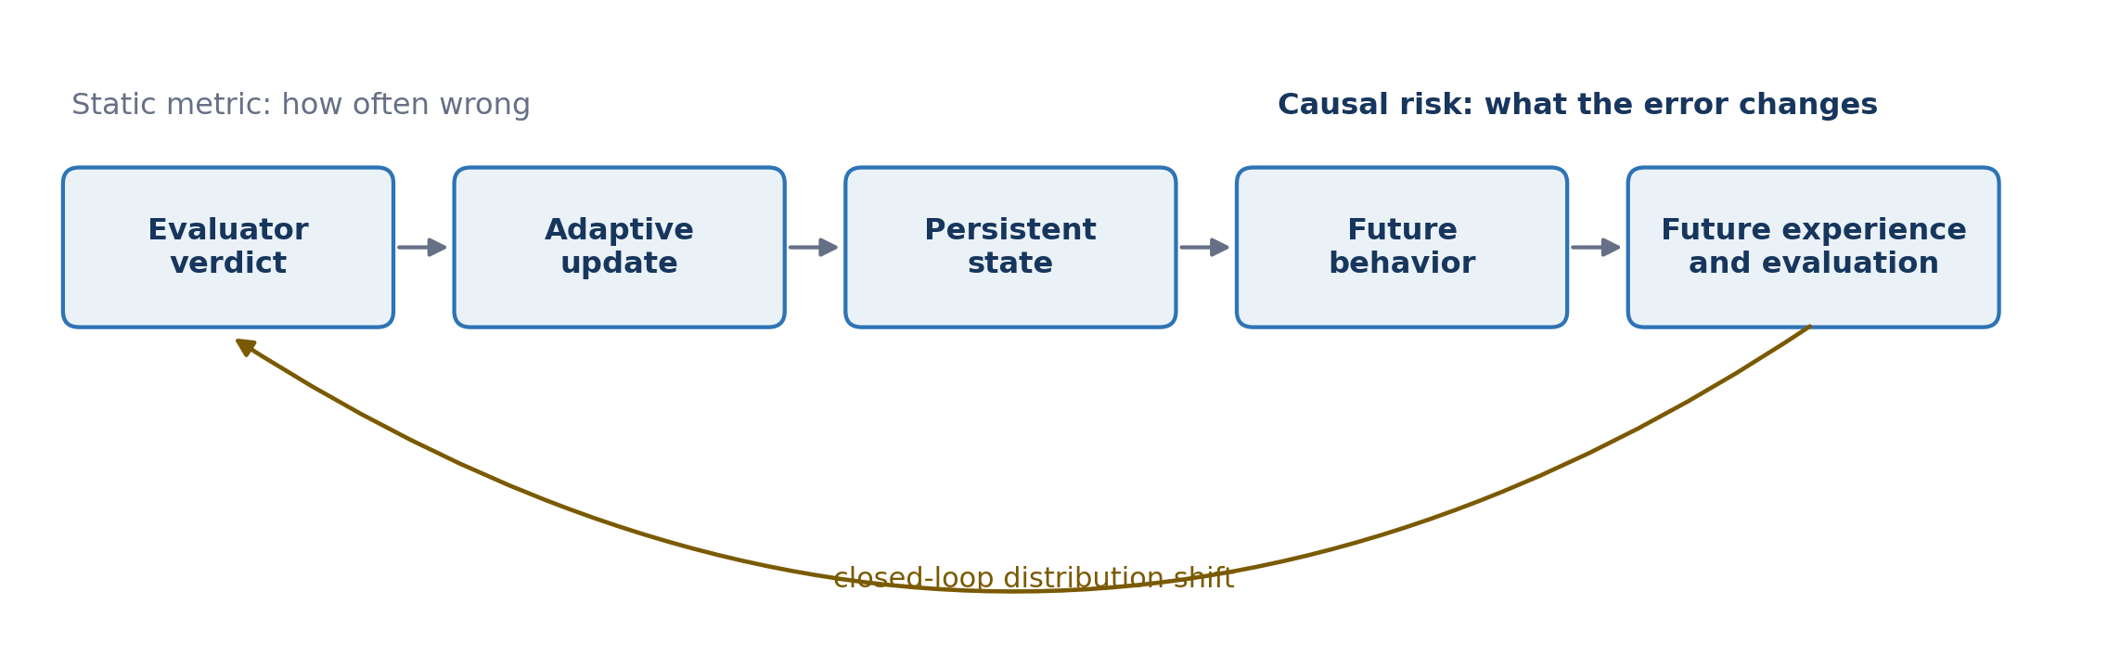
Figure 1. Evaluator decisions enter a closed adaptive loop; identical error rates can induce different futures.

2. Research Objectives and Novelty Boundary
The project does not claim that predictive accuracy and downstream utility are generally equivalent. Decision-focused learning already shows otherwise; imitation learning establishes that local errors can change future state distributions; performative prediction studies prediction-induced distribution shift; and influence functions estimate the effect of individual training examples. Recent self-evolving-agent work further documents misevolution, task-order fragility, verifier-deployment gaps, memory poisoning and attribution, memory-write credit assignment, evolving evaluators, sequential evaluation, and automated harness optimization [1-19].
The intended contribution is narrower and joint: the treatment is an evaluator verdict that controls a persistent adaptive update, the estimands separate signed consequence from propagation and multi-error interaction, and the operational objective is prospective allocation of scarce trusted evaluation under corruption shift. The work succeeds only if the causal supervision adds value beyond task difficulty, position, evaluator uncertainty, update magnitude, and early observable performance.
Closest-overlap audit. SEA-Eval tracks sequential trajectories but does not intervene on evaluator verdicts. Memory- and skill-attribution work (MemAudit, HiMPO, paired audits, and BACKTRACE) targets artifacts rather than evaluator-mediated persistent updates plus audit allocation. SEAL and co-evolving graders motivate external trust but do not allocate a scarce budget. CUDAnalyst freezes generations and disclaims global adaptive causality. The residual novelty is event-level evaluator intervention in naturally diverging loops, fixed-probe propagation and composition, and prospective probability-by-consequence auditing under shift.
Intended contribution. Evaluator decision -> causal consequence -> temporal propagation -> multi-error structure -> prospective risk prediction -> budgeted trusted evaluation.

3. Formal Framework

3.1 Matched accuracy on a common distribution
Because different evaluators may induce different future state distributions, accuracy measured separately on each evaluator’s own trajectory is not comparable. Let H be a decision context drawn from a shared reference distribution D, let V*(H) be the trusted reference verdict, and let evaluator randomness be xi. Define
Matched-accuracy experiments will use a fixed oracle-labeled context bank, replayed identical decision contexts, a common pre-generated task stream, or experimentally constructed masks with exactly matched error counts. For coding tasks, hidden tests will be treated as a sealed trusted reference evaluator rather than an infallible oracle unless the executable specification is complete.

3.2 Adaptive dynamics and branch-local corruption
Let Sₜ denote persistent agent state at round t. The state may contain textual memory, reusable skills, accepted tools, workflow rules, curriculum state, or policy parameters. Given task Xₜ, action Aₜ, and delivered evaluator verdict Dₜ, the transition is
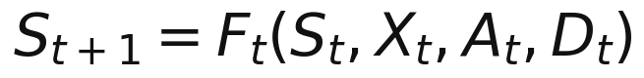
After an early intervention, branches may encounter different tasks and trusted verdicts. A corruption event must therefore be defined locally to the current branch. Let eₜ be a pre-sampled binary corruption switch, Uₜ external corruption randomness, and Cₜ a predefined corruptor. Then
For binary PASS/FAIL labels, the corruptor flips the trusted verdict; for structured evaluation it may generate an incorrect score, critique, failure reason, or update recommendation. The intervention has a stable meaning after trajectories diverge: activate the predefined corruption mechanism at the branch-local decision context.

3.3 Marginal causal influence
Let Hₜ be the complete history immediately before the evaluator intervention. Clean and corrupted trajectories share the exact prefix Hₜ and differ first in the delivered verdict. Subsequent trajectories evolve naturally. For downstream loss, define the signed conditional effect
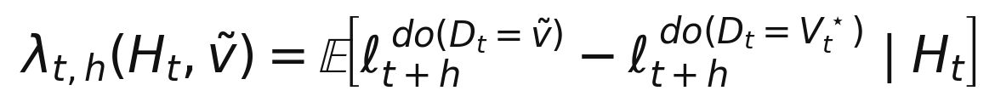
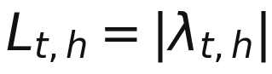
A positive signed effect denotes harm; a negative effect denotes an error that unexpectedly improves downstream performance; and L measures magnitude only. With N paired repetitions, the empirical estimator is the mean corrupt-minus-clean difference. Paired seeds and common random numbers reduce variance without changing the estimand.

3.4 Fixed-probe temporal propagation
Online trajectory performance alone cannot separate state degradation from changes in future task difficulty. At selected horizons, both branches will therefore be evaluated on the same frozen probe distribution:
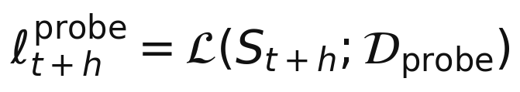
The primary propagation estimand is the fixed-probe causal effect. Online performance, fixed-probe capability, and state or memory divergence will be reported separately. The impulse response across horizon h defines contractive, persistent, or amplifying regimes.

3.5 Local propagation analysis
For a smooth controlled approximation with exogenous noise ξₖ held fixed, write the closed-loop transition as Sₖ₊₁ = Gₖ(Sₖ, ξₖ). Let Aₖ be the state Jacobian of Gₖ and Bₜ the verdict Jacobian of Fₜ. A first-order perturbation satisfies
This separates initial injection from closed-loop propagation. A sufficient pathwise contraction condition is that the operator norm of every Aₖ is bounded by ρ < 1 over the relevant horizon, which yields
This analysis is limited to smooth controlled systems. Discrete LLM memory, tool, and workflow updates will be evaluated through paired finite differences rather than by claiming differentiability.

3.6 Multi-error composition
Temporal propagation of one error is distinct from interaction among multiple errors. Let S be a set of activated corruption positions and Z a fixed pre-randomization experimental context. Define terminal regret relative to the clean regime as R(S | Z). Its Möbius coefficients are
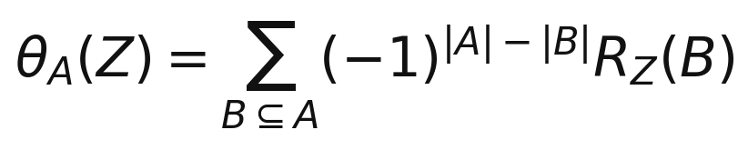
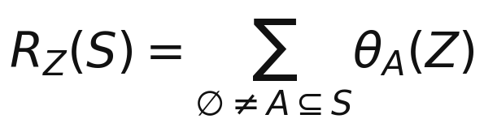
Singleton coefficients are marginal effects. A pairwise coefficient compares the joint two-error regret with the sum of the two isolated regrets, thereby classifying super-additivity, additivity, or redundancy. A linear unstable system may amplify individual errors while having zero interaction; a nonlinear outcome may produce interaction even when state perturbations decay. The two phenomena will be tested separately.

3.7 Expected risk and the limits of static accuracy
For the core theoretical experiments, fix a finite set I of evaluator-decision opportunities and pre-sample the complete corruption mask E ⊆ I conditional only on pre-treatment context Z. Define R_Z(∅) = 0. Because the mask is external to all post-treatment outcomes, the Möbius expansion yields an exact contextual risk identity:
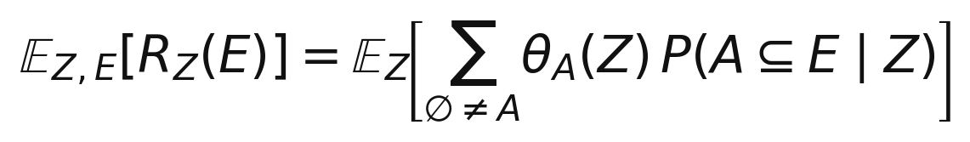
The singleton component is Σ_t p_t(Z) θ_{t}(Z), where p_t(Z) = P(t ∈ E | Z); higher-order terms depend on joint inclusion probabilities. Thus equal average error probability controls neither alignment between errors and high-consequence decisions nor the correlations that activate interaction terms.
Proposition 1 - What accuracy identifies. Fix a finite decision set and a common pre-treatment context distribution. If corruption processes may allocate errors arbitrarily across decisions and contexts while preserving only the expected error count, then that count determines expected regret for every such process if and only if every singleton coefficient equals the same constant almost surely and every higher-order coefficient is zero. Otherwise, matched static accuracy permits different expected regret.
Proof sketch. Static accuracy fixes only the expected number of corrupted opportunities. If singleton effects vary across decisions or pre-treatment contexts, the same expected error count can be concentrated on larger or smaller effects. If any higher-order coefficient is nonzero, error correlations can change its joint inclusion probability without changing the expected count. Conversely, if every singleton effect is the same constant c and all higher-order terms vanish, then expected regret equals c times the expected error count.

4. From Causal Measurement to Budgeted Audit

4.1 Deployment-time audit value
At ranking time the proxy verdict is observed but the trusted verdict is not. Let Y(d) denote terminal loss under delivered verdict d followed by natural evolution. The expected value of auditing the current decision is
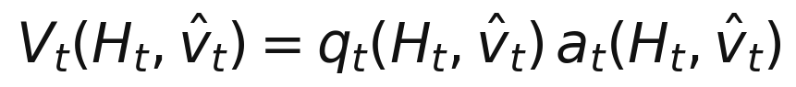
Here q is the posterior probability that the observed proxy verdict is wrong, and a is the expected preventable harm conditional on error. This definition integrates over the unknown trusted verdict and naturally supports multiple structured error types. Negative audit value is possible if a formally incorrect verdict would improve the specified downstream objective; the default intervention policy will audit only positive predicted value.

4.2 Separate supervision for error probability and consequence
The two components require different data. The error model q is trained from natural proxy outputs paired with trusted labels. The consequence model a is trained from randomized clean-versus-corrupt verdict interventions, stratified by error direction and update type so that deployment strata have intervention support. Synthetic mask labels are not used as substitutes for natural evaluator-error labels. Short-horizon counterfactual responses are training supervision and scientific diagnostics, not deployment-time features: the frozen audit policy may use only information available before trusted evaluation, including the observed proxy verdict and proposed update metadata.
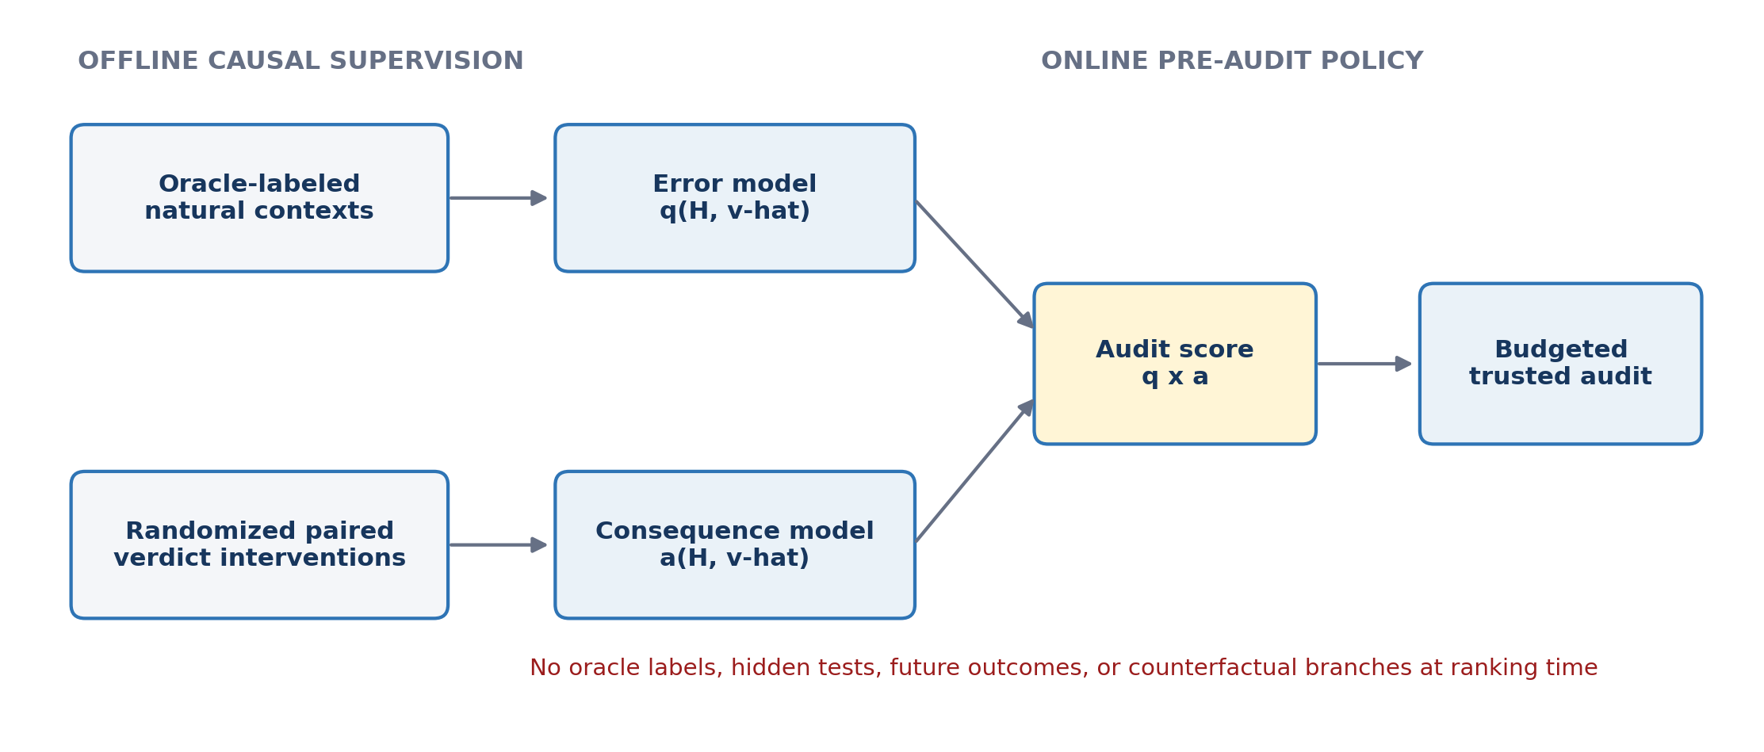
Figure 2. Modular estimation separates natural evaluator error probability from randomized causal consequence.

4.3 Additive and structured audit guarantees
Under additive nonnegative harm, equal audit cost, reliable correction, a fixed candidate set, and exogenous future error probabilities, auditing the B decisions with largest expected audit values is optimal. If every estimated value is within epsilon of its target, the selected top-B set obeys:
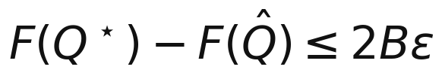
This connects predictive error directly to policy value. A structured special case is available when all interaction coefficients are nonnegative, the corruption opportunities are fixed ex ante, correcting an audited error removes that error without creating or changing the remaining opportunities, and any interaction term disappears when at least one of its member errors is corrected. Assign each error subset A the weight w(A) = theta(A) P(A subset E). The expected harm prevented by a fixed audit set Q is then:
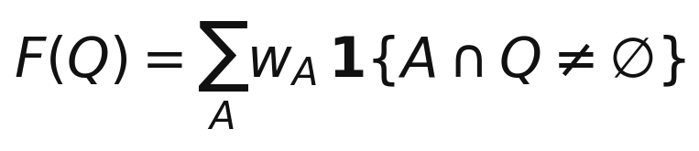
Under exactly those assumptions, the objective is monotone submodular weighted hyperedge coverage, so greedy selection achieves the classical (1 - 1/e) approximation under a cardinality budget. This is a boundary result, not a generic online guarantee. If auditing changes later states, candidate opportunities, or error probabilities, marginal values must be recomputed and submodularity may fail.

5. Hypotheses
- H1 - Causal heterogeneity. Between-decision variance in long-horizon causal effects exceeds within-decision paired estimation noise; high- and low-influence groups show a pre-specified effect-size separation and stable held-out rankings.
- H2 - Incremental prospective prediction. A predictor trained on offline causal consequence labels, but restricted at test time to pre-audit observable features, improves out-of-distribution prediction of long-horizon harm beyond task difficulty, decision position, observable early performance, update magnitude, evaluator uncertainty, and memory divergence.
- H3 - Distinct propagation and composition regimes. Update mechanisms exhibit distinguishable fixed-probe decay, persistence, or amplification, while multi-error interventions separately exhibit sub-additive, additive, or super-additive composition.
- H4 - Pre-audit value prediction. A frozen predictor using only pre-audit observable features ranks decisions by expected preventable harm under unseen corruption processes.
- H5 - Budgeted intervention benefit. At equal trusted-oracle cost, causal-value auditing prevents more downstream regret than random, uncertainty-only, error-probability-only, position, and update-magnitude baselines.

6. Empirical Program

6.1 Work Package 1: controlled theory and simulation
A differentiable teacher-student or adaptive-control system will establish when the estimators succeed or fail. Experiments will vary feedback gain, learner plasticity, update persistence, task-selection sensitivity, corruption density, temporal correlation, and horizon. The deliverables are the contextual decomposition, finite-horizon propagation analysis, non-identifiability result, and audit-selection guarantees.

6.2 Work Package 2: persistent-memory coding agent
The core real-agent platform is a sequential coding agent with self-authored persistent memory. Each round consists of a coding task, LLM solution, visible proxy evaluation, reflection, and memory update. A sealed hidden-test suite serves as the trusted reference evaluator and is never exposed to the agent or memory writer.
- Clean and corrupted branches share the exact prefix and submitted solution at the intervention round.
- Visible and hidden test results are held fixed; only the delivered evaluator verdict changes.
- Subsequent branches evolve naturally under paired exogenous seeds.
- At selected horizons, both states are evaluated on the same frozen probe bank.
Primary outcomes are fixed-probe causal effect, future hidden-test regret, and regret prevented by auditing. Secondary diagnostics include memory and solution divergence, persistence of incorrect strategies, and task-family-specific effects. Text distance is treated as a mediator or diagnostic, not as the causal outcome itself.

6.3 Work Package 3: held-out corruption prediction
Offline isolated interventions produce consequence labels for a pre-audit predictor. After training, the error model, consequence model, feature set, probe bank, and decision rule are frozen. Evaluation then uses unseen corruption processes - IID errors, task-correlated errors, temporal bursts, and systematic bias toward particular update types - while the ranking policy receives only pre-audit observables. The primary scientific criterion is incremental OOD performance relative to strong observable baselines, not in-distribution fit to the intervention dataset.
A complementary metric is partial Spearman correlation between predicted consequence and realized long-horizon harm after controlling for baseline features. Privileged early true-performance and counterfactual-response features will be reported only as diagnostic ceilings and will never enter the deployable audit policy. Calibration, ranking stability, and regret-weighted precision at the available audit budget will also be reported.

6.4 Work Package 4: budgeted trusted evaluation
With a fixed trusted-evaluation budget B, the study will compare random auditing, evaluator uncertainty, predicted error probability, update magnitude, predicted consequence, predicted probability times consequence, and adaptive marginal audit value where feasible. Every method receives the same oracle budget. Evaluation metrics are final fixed-probe capability, downstream regret prevented, regret prevented per query, and robustness under corruption shift.

6.5 Conditional second update mechanism
If the coding-memory study passes the pre-specified heterogeneity and prospective-audit gates, the project will add one higher-authority update mechanism: tool or skill acceptance, workflow replacement, or curriculum adaptation. SimWorld curriculum selection is a stretch external-validity test, not part of the six-month core claim; it will be attempted only after the coding-agent estimands and audit protocol are stable.

7. Identification, Leakage Control, and Statistical Plan
Control | Implementation
Randomization | Pre-sample complete corruption masks conditional only on pre-treatment context Z; record propensities and preserve positivity.
Paired estimation | Reuse exact prefixes and paired exogenous seeds; report corrupt-minus-clean effects with cluster-aware confidence intervals.
Leakage | Exclude trusted labels, hidden tests, future outcomes, and counterfactual results from online ranking features.
Model separation | Train q from natural proxy-versus-trusted labels and a from randomized verdict interventions; evaluate both separately and jointly.
Uncertainty | Use hierarchical models or clustered bootstrap over task, prefix, model, and seed; report within- and between-decision variance.
Interactions | Estimate a pre-registered stratified sample of pairs rather than attempting exponential recovery of the full hypergraph.
Multiplicity | Pre-specify primary horizons and outcomes; use Holm correction for planned secondary comparisons.
Robustness | Repeat across task orderings, probe banks, corruption mechanisms, and at least two model seeds or model families where budget permits.

8. Preliminary Evidence and Falsification
A preliminary teacher-student adaptive system tested the stronger hypothesis that evaluator noise generically causes runaway closed-loop instability. The result was negative. With matched 90% evaluator accuracy, final performance differed across IID and clustered placements, but only at roughly the 10^-3 scale. Early closed-loop features predicted held-out regimes (Spearman about 0.87; log-space R-squared about 0.97), yet after controlling for early true performance the incremental log-space R-squared was only about 0.006. Single-error effects decayed, harm scaled approximately linearly with error density, mean pairwise interaction was near zero, and bursts were not consistently worse than IID errors. The toy system is therefore evidence for a contractive, approximately additive regime - not evidence for snowballing in real agents.
This falsification motivates the revised factorization rather than being hidden. Four stage gates control scope: G1, the paired intervention must be faithful and produce measurable fixed-probe outcomes; G2, between-decision causal heterogeneity must exceed paired estimation noise; G3, a frozen pre-audit predictor must add OOD signal beyond strong baselines; and G4, the resulting policy must prevent more regret at equal oracle cost. Failure at G2 triggers a pre-specified shift to one higher-authority update mechanism; failure at G3 or G4 converts the paper into a boundary result rather than an auditing claim.

9. Success Criteria and Expected Contributions
- Causal attribution. A randomized paired-intervention protocol for estimating the downstream effect of individual evaluator decisions.
- Structured risk theory. A formal separation of marginal influence, temporal propagation, and higher-order composition, including an accuracy non-identifiability result.
- Prospective prediction. Evidence for or against transport of causal consequence signals to unseen evaluator-error processes.
- Budgeted trusted evaluation. A deployable pre-audit policy and guarantees connecting prediction error to preventable regret.
- Reproducible benchmark. A controlled corruption harness, fixed probe bank, paired-trajectory dataset, and evaluation protocol suitable for future agent-auditing work.
Main-conference bar. A strong submission must show reproducible causal heterogeneity, leakage-free incremental OOD prediction beyond strong baselines, and greater regret prevention at equal oracle cost. The identification lemma and standard optimization guarantees support the empirical contribution; they are not presented as sufficient theoretical novelty by themselves.

10. Scope and Timeline
Period | Primary milestone
Month 1 | Complete the coding-agent causal pilot; validate intervention fidelity, power, task families, and fixed probe bank (Gate G1).
Month 2 | Estimate single-decision effects across repeated prefixes and model/task strata; test causal heterogeneity (Gate G2).
Month 3 | Measure fixed-probe propagation and a pre-registered sample of pairwise interactions; finalize the formal decomposition.
Month 4 | Train separate natural-error and causal-consequence models; freeze features and estimators; run unseen-corruption evaluation (Gate G3).
Months 5-6 | Run equal-budget audit comparisons (Gate G4), robustness checks, artifact release, and conference manuscript preparation.
Core scope: controlled theory, one persistent-memory coding agent, single- and double-error interventions, fixed-probe propagation, frozen OOD consequence prediction, and additive budgeted auditing. Conditional extension: one higher-authority update mechanism after G2-G4 pass. Stretch goals: SimWorld curriculum selection, cross-model transfer, higher-order interaction recovery, and history-dependent auditing. This ordering keeps the six-month project feasible while preserving a path to the breadth expected for a top ML conference.

11. Central Thesis
Thesis. Static evaluator accuracy on a common reference distribution does not identify downstream risk in adaptive agents. Long-run regret depends on which evaluator decisions fail, the signed consequences of the updates they control, how individual perturbations propagate, and how multiple errors compose. Randomized sequential interventions can provide offline causal supervision, and frozen pre-audit predictors can use that supervision to allocate scarce trusted evaluation - if they generalize beyond strong observable baselines under corruption shift.

References
[1] Ross, S., and Bagnell, D. (2010). Efficient Reductions for Imitation Learning. AISTATS.
[2] Ross, S., Gordon, G., and Bagnell, D. (2011). A Reduction of Imitation Learning and Structured Prediction to No-Regret Online Learning. AISTATS.
[3] Perdomo, J., Zrnic, T., Mendler-Dunner, C., and Hardt, M. (2020). Performative Prediction. ICML.
[4] Koh, P. W., and Liang, P. (2017). Understanding Black-box Predictions via Influence Functions. ICML.
[5] Wilder, B., Dilkina, B., and Tambe, M. (2019). Melding the Data-Decisions Pipeline: Decision-Focused Learning for Combinatorial Optimization. AAAI.
[6] Shao, S., Ren, Q., Liu, D., et al. (2026). Your Agent May Misevolve: Emergent Risks in Self-Evolving LLM Agents. ICLR.
[7] Ye, Q., Li, Y., Pruksachatkun, Y., Zhang, J., and Wu, C.-S. (2026). On the Fragility of Self-Improving Agents: Variance, Task Order, and Underspecification. arXiv:2608.18066.
[8] Tan, Z., Yao, Y., Jin, H., et al. (2026). MemAudit: Post-hoc Auditing of Poisoned Agent Memory via Causal Attribution and Structural Anomaly Detection. arXiv:2605.23723.
[9] Yan, J., Shen, Y., Zhang, W., et al. (2026). HiMPO: Hindsight-Informed Memory Policy Optimization for Less-Entangled Credit in Long-Horizon Agents. arXiv:2606.16285.
[10] Rocchi, A. (2026). Does Memory Credit Travel? Paired Factorial Audits of LLM-Agent Memory. Working paper.
[11] Guo, D., Cao, C., Yuan, F., et al. (2026). Self-Authored Verification Is Unreliable in Heuristic Self-Improving Agents. arXiv:2607.24300.
[12] Liu, Z. (2026). A Diagnostic Framework and Multi-Evaluator Audit of Evaluator-Driven Preference Dynamics in Self-Adapting LLM Agents. arXiv:2606.29719.
[13] Bhargava, N., and Barrento, R. S. (2026). MemAudit: An Exact Package-Oracle Evaluation Protocol for Budgeted Long-Term LLM Memory Writing. arXiv:2605.02199.
[14] Ren, Z., Chen, Y., Guo, D., et al. (2026). Self-Improvements in Modern Agentic Systems: A Survey. arXiv:2607.13104.
[15] Jiang, S., Ma, L., Hong, Z., et al. (2026). SEA-Eval: A Benchmark for Evaluating Self-Evolving Agents Beyond Episodic Assessment. arXiv:2604.08988. https://arxiv.org/abs/2604.08988
[16] Chong, Y. H., Wu, J., Zhang, Y., and Qu, P. (2026). Towards Feedback-to-Plan Decisions for Self-Evolving LLM Agents in CUDA Kernel Generation. arXiv:2605.26720. https://arxiv.org/abs/2605.26720
[17] Hu, J., Qi, Y., Huang, X., et al. (2026). Skill Use or Skill Theater? Evaluating the Reasoning Backroom in Skill-Augmented Language Agents. arXiv:2607.27484. https://arxiv.org/abs/2607.27484
[18] Zhang, X., Wang, G., Cui, Y., et al. (2026). Who Grades the Grader? Co-Evolving Evaluation Metrics and Skills for Self-Improving LLM Agents. arXiv:2607.12790. https://arxiv.org/abs/2607.12790
[19] Lee, Y., Nair, R., Zhang, Q., et al. (2026). Meta-Harness: End-to-End Optimization of Model Harnesses. arXiv:2603.28052. https://arxiv.org/abs/2603.28052

