RESEARCH PROPOSAL
Same Accuracy, Different Futures
Causal Structure of Evaluator Errors in Self-Improving Agents
Lingge Meng
Mathematics-Computer Science, University of California San Diego
Proposed duration: six months
August 2026
Central thesis: static evaluator accuracy on a common reference distribution does not identify downstream risk once evaluator decisions control persistent adaptive updates.

Abstract
Self-improving agents increasingly rely on automated evaluators to decide which experiences, memories, skills, tools, or policy updates should influence future behavior. Evaluator reliability is usually summarized by static metrics such as accuracy, calibration, or error rate. These metrics measure how often an evaluator is wrong, but not how consequential its errors become after evaluator outputs enter an adaptive feedback loop. This project develops a causal framework that separates three properties of evaluator error: marginal causal influence, temporal propagation, and higher-order composition. Randomized paired interventions will estimate the downstream effect of changing a single evaluator verdict while holding its preceding trajectory fixed. Fixed-probe evaluation will distinguish true persistence or amplification from changes in the future task distribution. A Möbius decomposition will characterize additive, redundant, and synergistic combinations of multiple errors. The theory establishes when matched static accuracy fails to identify long-run risk and connects estimation error to the performance of budgeted audit policies. Empirically, the project will begin with controlled adaptive systems and then study a coding agent with persistent self-authored memory. Offline interventions will provide causal consequence labels; a separate error model will be learned from oracle-labeled natural evaluator decisions. Both models will be frozen and tested prospectively under unseen corruption processes. The final objective is budgeted trusted evaluation: allocating a limited oracle budget toward evaluator decisions with the greatest expected downstream value, using only information available before trusted evaluation.
Research question. When two evaluators have the same static accuracy, which features of their errors determine whether a self-improving agent recovers, drifts, or degrades - and can those features guide scarce trusted evaluation?

1. Motivation and Problem Statement
Consider a coding agent that solves a sequence of tasks and stores persistent experience in a skill memory, tool library, or workflow. After each task, an evaluator may decide whether the solution succeeded and whether the resulting experience should be retained. Two evaluators can attain the same accuracy on the same reference distribution while making their errors on decisions with very different authority. A false approval attached to an ephemeral reflection may disappear; the same false approval attached to a persistent workflow replacement may alter many future actions.
The distinction arises because evaluator outputs are not passive predictions. They can change the state that generates future behavior, data, and evaluation contexts. Static evaluation therefore compresses a sequential causal object into a marginal error frequency.
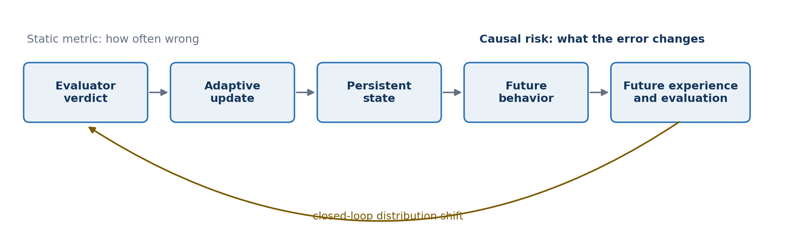
Figure 1. Evaluator decisions enter a closed adaptive loop; identical error rates can induce different futures.

2. Research Objectives and Novelty Boundary
The project does not claim that predictive accuracy and downstream utility are generally equivalent. Decision-focused learning already shows otherwise; imitation learning establishes that local errors can change future state distributions; performative prediction studies feedback between prediction and future data; and influence functions estimate the effect of individual training examples. Recent work on self-improving agents further narrows the novelty boundary by documenting misevolution, task-order fragility, harmful memory attribution, memory-write credit assignment, and verifier-deployment mismatch [1-11].
The intended contribution is the joint problem in which the treatment is specifically an evaluator decision that controls an adaptive update, and the operational objective is prospective allocation of scarce trusted evaluation. The project asks whether randomized verdict interventions can identify consequential decisions, whether short-horizon causal signals predict long-horizon harm under corruption shift, and whether those predictions improve audit allocation.
Intended contribution. Evaluator decision -> causal consequence -> temporal propagation -> multi-error structure -> prospective risk prediction -> budgeted trusted evaluation.

3. Formal Framework

3.1 Matched accuracy on a common distribution
Because different evaluators may induce different future state distributions, accuracy measured separately on each evaluator's own trajectory is not comparable. Let H be a decision context drawn from a shared reference distribution D, let V*(H) be the trusted reference verdict, and let evaluator randomness be xi. Define
Matched-accuracy experiments will use a fixed oracle-labeled context bank, replayed identical decision contexts, a common pre-generated task stream, or experimentally constructed masks with exactly matched error counts. For coding tasks, hidden tests will be treated as a sealed trusted reference evaluator rather than an infallible oracle unless the executable specification is complete.

3.2 Adaptive dynamics and branch-local corruption
Let Sₜ denote persistent agent state at round t. The state may contain textual memory, reusable skills, accepted tools, workflow rules, curriculum state, or policy parameters. Given task Xₜ, action Aₜ, and delivered evaluator verdict Dₜ, the transition is
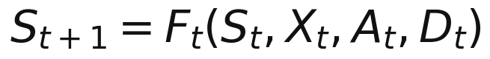
After an early intervention, branches may encounter different tasks and trusted verdicts. A corruption event must therefore be defined locally to the current branch. Let eₜ be a pre-sampled binary corruption switch, Uₜ external corruption randomness, and Cₜ a predefined corruptor. Then
For binary PASS/FAIL labels, the corruptor flips the trusted verdict; for structured evaluation it may generate an incorrect score, critique, failure reason, or update recommendation. The intervention has a stable meaning after trajectories diverge: activate the predefined corruption mechanism at the branch-local decision context.

3.3 Marginal causal influence
Let Hₜ be the complete history immediately before the evaluator intervention. Clean and corrupted trajectories share the exact prefix Hₜ and differ first in the delivered verdict. Subsequent trajectories evolve naturally. For downstream loss, define the signed conditional effect
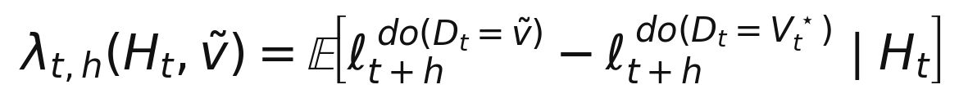
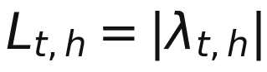
A positive signed effect denotes harm; a negative effect denotes an error that unexpectedly improves downstream performance; and L measures magnitude only. With N paired repetitions, the empirical estimator is the mean corrupt-minus-clean difference. Paired seeds and common random numbers reduce variance without changing the estimand.

3.4 Fixed-probe temporal propagation
Online trajectory performance alone cannot separate state degradation from changes in future task difficulty. At selected horizons, both branches will therefore be evaluated on the same frozen probe distribution:
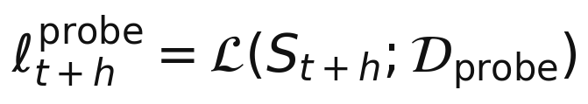
The primary propagation estimand is the fixed-probe causal effect. Online performance, fixed-probe capability, and state or memory divergence will be reported separately. The impulse response across horizon h defines contractive, persistent, or amplifying regimes.

3.5 Local propagation analysis
For a smooth controlled approximation with exogenous noise ξₖ held fixed, write the closed-loop transition as Sₖ₊₁ = Gₖ(Sₖ, ξₖ). Let Aₖ be the state Jacobian of Gₖ and Bₜ the verdict Jacobian of Fₜ. A first-order perturbation satisfies
This separates initial injection from closed-loop propagation. A sufficient pathwise contraction condition is that the operator norm of every Aₖ is bounded by ρ < 1 over the relevant horizon, which yields
This analysis is limited to smooth controlled systems. Discrete LLM memory, tool, and workflow updates will be evaluated through paired finite differences rather than by claiming differentiability.

3.6 Multi-error composition
Temporal propagation of one error is distinct from interaction among multiple errors. Let S be a set of activated corruption positions and Z a fixed pre-randomization experimental context. Define terminal regret relative to the clean regime as R(S | Z). Its Möbius coefficients are
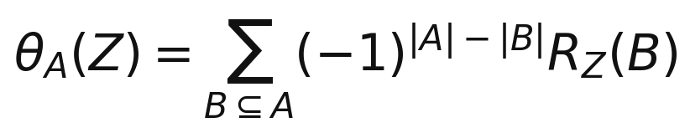
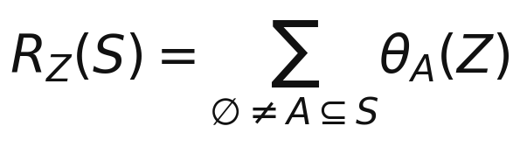
Singleton coefficients are marginal effects. A pairwise coefficient compares the joint two-error regret with the sum of the two isolated regrets, thereby classifying super-additivity, additivity, or redundancy. A linear unstable system may amplify individual errors while having zero interaction; a nonlinear outcome may produce interaction even when state perturbations decay. The two phenomena will be tested separately.

3.7 Expected risk and the limits of static accuracy
For the core theoretical experiments, the entire corruption mask E will be randomized before the trajectory begins, conditional only on pre-treatment context Z. This makes E external to the potential outcomes. The expected regret is then exactly
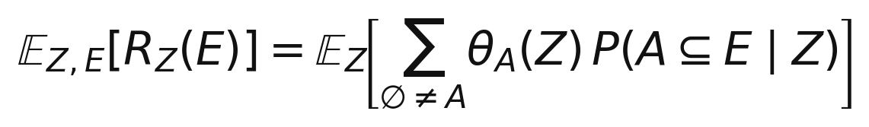
To first order, expected regret is the expectation of the sum of pₜ(Z)θₜ(Z). Thus equal average error probability does not control alignment between errors and high-consequence decisions, nor the higher-order inclusion probabilities that activate interaction terms.
Proposition 1 - Non-identifiability from accuracy. Over unrestricted corruption processes, matched average accuracy identifies expected downstream regret for every process only if all singleton effects are equal and every higher-order Möbius coefficient is zero. Otherwise there exist two evaluators with identical accuracy and different expected regret.

Proof sketch. Static accuracy fixes only the average singleton inclusion probability. Different error placements preserve that average while changing its inner product with unequal singleton coefficients. If any higher-order coefficient is nonzero, different correlation structures can preserve all marginal error rates while changing the probability that the corresponding subset is jointly corrupted.

4. From Causal Measurement to Budgeted Audit

4.1 Deployment-time audit value
At ranking time the proxy verdict is observed but the trusted verdict is not. Let Y(d) denote terminal loss under delivered verdict d followed by natural evolution. The expected value of auditing the current decision is
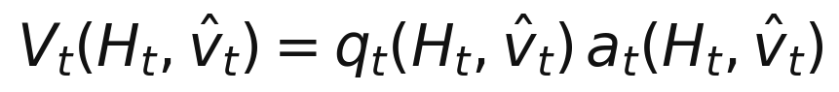
Here q is the posterior probability that the observed proxy verdict is wrong, and a is the expected preventable harm conditional on error. This definition integrates over the unknown trusted verdict and naturally supports multiple structured error types. Negative audit value is possible if a formally incorrect verdict would improve the specified downstream objective; the default intervention policy will audit only positive predicted value.

4.2 Separate supervision for error probability and consequence
The two components require different data. The error model q is trained from natural proxy outputs paired with trusted labels. The consequence model a is trained from randomized clean-versus-corrupt verdict interventions. Synthetic mask labels are not used as a substitute for natural evaluator-error labels. Both models are trained offline, frozen, and evaluated prospectively.
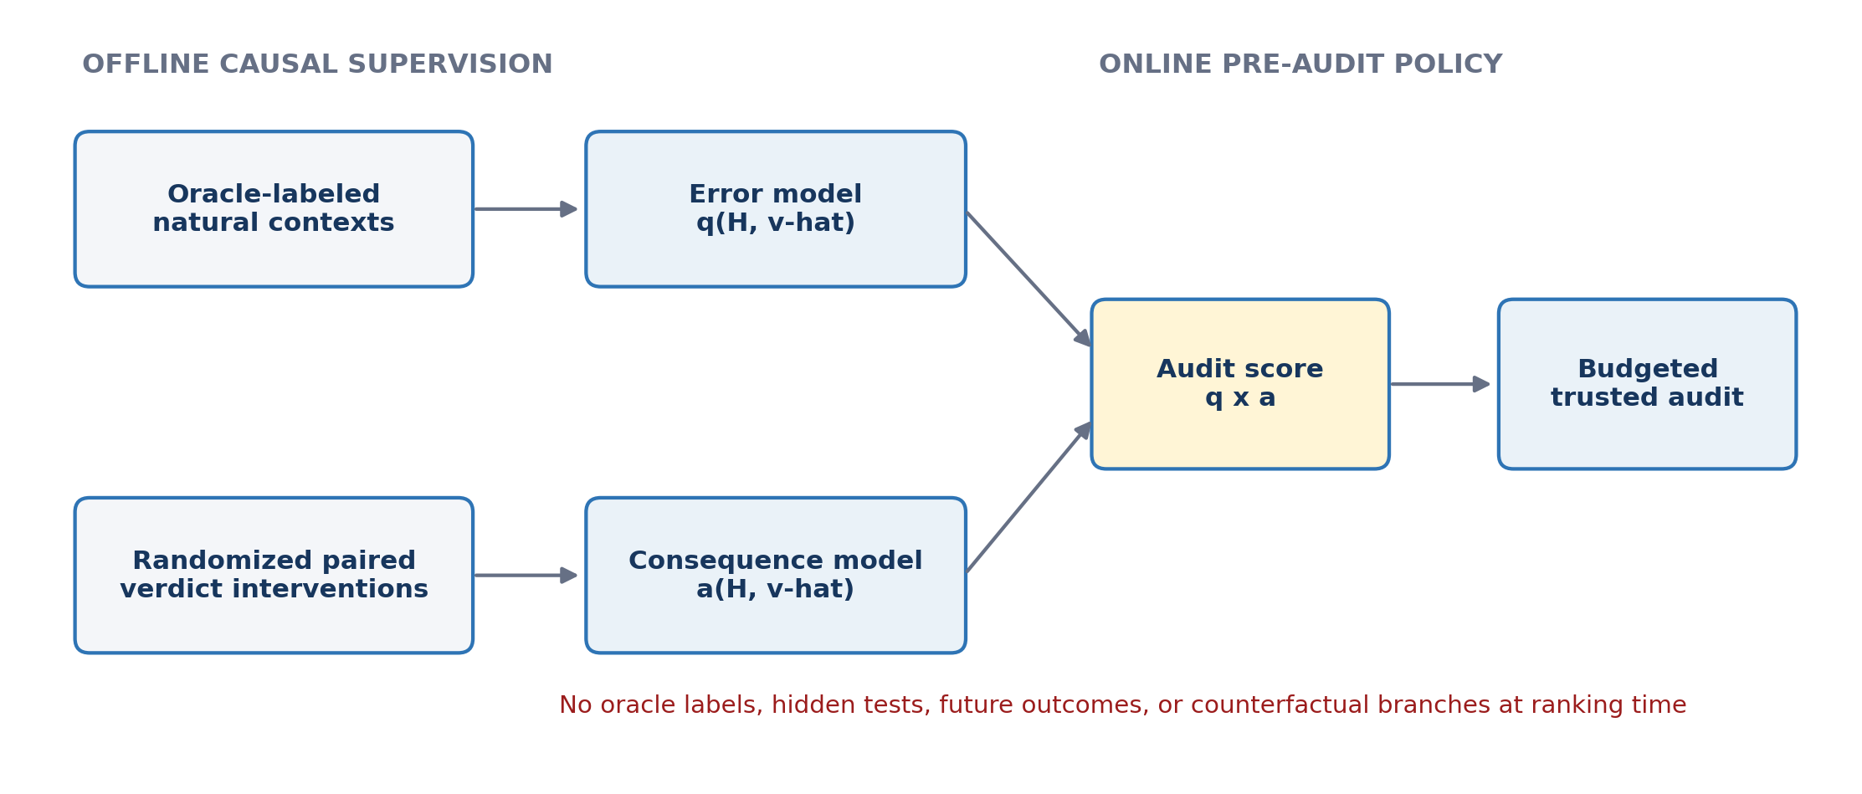
Figure 2. Modular estimation separates natural evaluator error probability from randomized causal consequence.

4.3 Additive and structured audit guarantees
Under additive nonnegative harm, equal audit cost, reliable correction, and exogenous future error probabilities, auditing the B decisions with largest expected audit values is optimal. If every estimated value is within ε of its target, the selected top-B set obeys
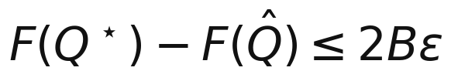
This connects predictive error directly to policy value. For nonnegative interaction coefficients, assign each error subset A the weight w(A) = θ(A)P(A ⊆ E). The expected harm prevented by a fixed audit set Q is
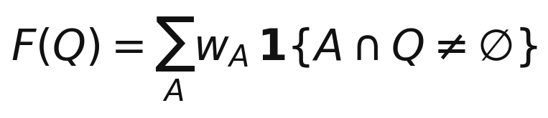
This is a monotone submodular weighted hyperedge-coverage objective, so greedy selection achieves the classical (1 - 1/e) approximation under a cardinality budget. The guarantee is a special case: online auditing may change later states, opportunities, and error probabilities, in which case the policy must recompute marginal value and need not remain submodular.

5. Hypotheses
- H1 - Causal heterogeneity. Between-decision variance in long-horizon causal effects exceeds within-decision paired estimation noise; high- and low-influence groups show a pre-specified effect-size separation and stable held-out rankings.
- H2 - Incremental prospective prediction. Short-horizon causal measurements improve out-of-distribution prediction of long-horizon harm beyond task difficulty, decision position, observable early performance, update magnitude, evaluator uncertainty, and memory divergence.
- H3 - Distinct propagation and composition regimes. Update mechanisms exhibit distinguishable fixed-probe decay, persistence, or amplification, while multi-error interventions separately exhibit sub-additive, additive, or super-additive composition.
- H4 - Pre-audit value prediction. A frozen predictor using only pre-audit observable features ranks decisions by expected preventable harm under unseen corruption processes.
- H5 - Budgeted intervention benefit. At equal trusted-oracle cost, causal-value auditing prevents more downstream regret than random, uncertainty-only, error-probability-only, position, and update-magnitude baselines.

6. Empirical Program

6.1 Work Package 1: controlled theory and simulation
A differentiable teacher-student or adaptive-control system will establish when the estimators succeed or fail. Experiments will vary feedback gain, learner plasticity, update persistence, task-selection sensitivity, corruption density, temporal correlation, and horizon. The deliverables are the contextual decomposition, finite-horizon propagation analysis, non-identifiability result, and audit-selection guarantees.

6.2 Work Package 2: persistent-memory coding agent
The core real-agent platform is a sequential coding agent with self-authored persistent memory. Each round consists of a coding task, LLM solution, visible proxy evaluation, reflection, and memory update. A sealed hidden-test suite serves as the trusted reference evaluator and is never exposed to the agent or memory writer.
- Clean and corrupted branches share the exact prefix and submitted solution at the intervention round.
- Visible and hidden test results are held fixed; only the delivered evaluator verdict changes.
- Subsequent branches evolve naturally under paired exogenous seeds.
- At selected horizons, both states are evaluated on the same frozen probe bank.
Primary outcomes are fixed-probe causal effect, future hidden-test regret, and regret prevented by auditing. Secondary diagnostics include memory and solution divergence, persistence of incorrect strategies, and task-family-specific effects. Text distance is treated as a mediator or diagnostic, not as the causal outcome itself.

6.3 Work Package 3: held-out corruption prediction
Offline isolated interventions produce consequence labels. After training, all estimators are frozen and evaluated under unseen corruption processes: IID errors, task-correlated errors, temporal bursts, and systematic bias toward particular update types. The primary scientific criterion is incremental OOD performance relative to strong observable baselines.
A complementary metric is partial Spearman correlation between predicted consequence and realized long-horizon harm after controlling for baseline features. Privileged early true-performance baselines will be reported only as diagnostic ceilings and will never supply features to the deployable audit policy.

6.4 Work Package 4: budgeted trusted evaluation
With a fixed trusted-evaluation budget B, the study will compare random auditing, evaluator uncertainty, predicted error probability, update magnitude, predicted consequence, predicted probability times consequence, and adaptive marginal audit value where feasible. Every method receives the same oracle budget. Evaluation metrics are final fixed-probe capability, downstream regret prevented, regret prevented per query, and robustness under corruption shift.

6.5 Conditional second update mechanism
If the coding-memory results establish reproducible causal heterogeneity and prospective audit benefit, the study will add one higher-authority update mechanism: tool or skill acceptance, workflow replacement, or curriculum adaptation. This tests whether update authority moderates evaluator risk. It is conditional rather than required for the six-month core deliverable.

7. Identification, Leakage Control, and Statistical Plan
Control | Implementation
Randomization | Pre-sample complete corruption masks conditional only on pre-treatment context Z; record propensities and preserve positivity.
Paired estimation | Reuse exact prefixes and paired exogenous seeds; report corrupt-minus-clean effects with cluster-aware confidence intervals.
Leakage | Exclude trusted labels, hidden tests, future outcomes, and counterfactual results from online ranking features.
Model separation | Train q from natural proxy-versus-trusted labels and a from randomized verdict interventions; evaluate both separately and jointly.
Uncertainty | Use hierarchical models or clustered bootstrap over task, prefix, model, and seed; report within- and between-decision variance.
Interactions | Estimate a pre-registered stratified sample of pairs rather than attempting exponential recovery of the full hypergraph.
Multiplicity | Pre-specify primary horizons and outcomes; use Holm correction for planned secondary comparisons.
Robustness | Repeat across task orderings, probe banks, corruption mechanisms, and at least two model seeds or model families where budget permits.

8. Preliminary Evidence and Falsification
A preliminary teacher-student adaptive system tested the stronger hypothesis that evaluator noise generically causes runaway closed-loop instability. The results did not support that claim. Under matched static accuracy, corruption placement changed final outcomes and early counterfactual effects predicted later deviations, but strong early-performance baselines explained much of the signal. Single-error effects decayed, harm scaled approximately linearly with error density, mean pairwise interaction was near zero, and bursty errors were not consistently worse than IID errors. The toy system is therefore best described as a contractive, approximately additive regime.
This negative result motivates the revised factorization rather than being hidden. The project will be considered informative if it establishes any of the following boundaries: textual memory has low causal authority; all single-error effects decay; higher-order terms are negligible; causal features add little beyond observable baselines; or update mechanisms occupy qualitatively different regimes. The central auditing claim is supported only if causal consequence prediction yields prospective benefit at equal trusted-evaluation cost.

9. Success Criteria and Expected Contributions
- Causal attribution. A randomized paired-intervention protocol for estimating the downstream effect of individual evaluator decisions.
- Structured risk theory. A formal separation of marginal influence, temporal propagation, and higher-order composition, including an accuracy non-identifiability result.
- Prospective prediction. Evidence for or against transport of causal consequence signals to unseen evaluator-error processes.
- Budgeted trusted evaluation. A deployable pre-audit policy and guarantees connecting prediction error to preventable regret.
- Reproducible benchmark. A controlled corruption harness, fixed probe bank, paired-trajectory dataset, and evaluation protocol suitable for future agent-auditing work.
Main-conference bar. The core result should demonstrate reproducible causal heterogeneity, incremental OOD prediction beyond strong baselines, no oracle leakage, and greater regret prevention at equal audit cost. Mechanistic breadth is added only after the core result succeeds.

10. Scope and Timeline
Period | Primary milestone
Months 1-2 | Complete coding-agent causal pilot, diversify tasks, add paired repetitions, and freeze the probe bank.
Months 2-3 | Measure single-error propagation and a stratified set of pairwise interactions; finalize core theory.
Months 3-4 | Train separate error and consequence models; freeze them before OOD corruption evaluation.
Months 4-5 | Run budgeted-audit comparisons with equal oracle cost; conduct calibration and ablation studies.
Months 5-6 | Complete robustness checks, statistical analysis, release artifacts, and prepare the manuscript.
Core scope: controlled theory, persistent-memory coding agent, single- and double-error interventions, fixed-probe propagation, held-out corruption prediction, and additive budgeted auditing. Conditional extension: one additional update mechanism. Stretch goals: cross-model transfer, higher-order interaction estimation, full submodular implementation, and history-dependent audit policies.

11. Central Thesis
Thesis. Static evaluator accuracy on a common reference distribution does not identify downstream risk in adaptive agents. Long-run regret depends on which evaluator decisions fail, the causal consequences of the updates they control, how individual perturbations propagate, and how multiple errors compose. Randomized sequential interventions can measure these quantities offline, and frozen pre-audit predictors can use them to allocate scarce trusted evaluation.

References
[1] Ross, S., and Bagnell, D. (2010). Efficient Reductions for Imitation Learning. AISTATS.
[2] Ross, S., Gordon, G., and Bagnell, D. (2011). A Reduction of Imitation Learning and Structured Prediction to No-Regret Online Learning. AISTATS.
[3] Perdomo, J., Zrnic, T., Mendler-Dunner, C., and Hardt, M. (2020). Performative Prediction. ICML.
[4] Koh, P. W., and Liang, P. (2017). Understanding Black-box Predictions via Influence Functions. ICML.
[5] Wilder, B., Dilkina, B., and Tambe, M. (2019). Melding the Data-Decisions Pipeline: Decision-Focused Learning for Combinatorial Optimization. AAAI.
[6] Shao, S., Ren, Q., Liu, D., et al. (2026). Your Agent May Misevolve: Emergent Risks in Self-Evolving LLM Agents. ICLR.
[7] Ye, Q., Li, Y., Pruksachatkun, Y., Zhang, J., and Wu, C.-S. (2026). On the Fragility of Self-Improving Agents: Variance, Task Order, and Underspecification. arXiv:2608.18066.
[8] Tan, Z., Yao, Y., Jin, H., et al. (2026). MemAudit: Post-hoc Auditing of Poisoned Agent Memory via Causal Attribution and Structural Anomaly Detection. arXiv:2605.23723.
[9] Yan, J., Shen, Y., Zhang, W., et al. (2026). HiMPO: Hindsight-Informed Memory Policy Optimization for Less-Entangled Credit in Long-Horizon Agents. arXiv:2606.16285.
[10] Rocchi, A. (2026). Does Memory Credit Travel? Paired Factorial Audits of LLM-Agent Memory. Working paper.
[11] Guo, D., Cao, C., Yuan, F., et al. (2026). Self-Authored Verification Is Unreliable in Heuristic Self-Improving Agents. arXiv:2607.24300.
[12] Liu, Z. (2026). A Diagnostic Framework and Multi-Evaluator Audit of Evaluator-Driven Preference Dynamics in Self-Adapting LLM Agents. arXiv:2606.29719.
[13] Bhargava, N., and Barrento, R. S. (2026). MemAudit: An Exact Package-Oracle Evaluation Protocol for Budgeted Long-Term LLM Memory Writing. arXiv:2605.02199.
[14] Ren, Z., Chen, Y., Guo, D., et al. (2026). Self-Improvements in Modern Agentic Systems: A Survey. arXiv:2607.13104.

