Monoplanner Final Project Report
PE6201 Emerging AI Technologies
Li Linghao G2604055K Section C
Body word count 1289

Executive outcome
Monoplanner is a full-stack context orchestrator that converts an evolving requirement into versioned product assets and a synchronized pair of frontend and backend coding-agent prompts. I built the application because coding agents work on the text they receive, while a product change often spans interface behavior, API contracts, permissions, validation, persistence, and error handling. When those instructions are rewritten separately, they can describe incompatible implementations. Monoplanner keeps the requirement history and related design state, then produces one reviewable prompt-pack version for both sides.
The final outcome is mixed and useful. The application workflow is operational, and the refined evaluation protocol exceeded its overall 90 percent strict-success target. However, the LLM-based joint method did not beat a deterministic rule baseline. The strongest contribution is therefore a transparent way to expose missing or contradictory implementation context, supported by checked-in data, requests, responses, human labels, and reproducible reports. I do not claim that the project has measured better code quality or faster development.

Problem and product contribution
The milestone problem statement identified a practical gap for full-stack teams using coding agents: prompts are often treated as disposable text rather than maintained product context. It also cited developer reports about plausible but faulty AI output and time lost to non-coding work. The original proposal was broad, covering requirements, design, API, database, code quality, and efficiency. Instructor feedback sharpened the deliverable to the part Monoplanner directly controls: whether one requirement change gives frontend and backend agents synchronized instructions.
This narrower framing changes what the product adds to current practice. A technical lead records a requirement change, reviews its business story and affected layers, applies it to versioned assets, and exports a frontend/backend prompt pack. The previous versions remain inspectable. The product does not generate or deploy the target application. It creates traceable implementation context that a developer can approve before giving it to coding agents. That distinction keeps human review at the point where plausible language can otherwise hide a contract error.

Architecture and technical decisions
I implemented a Next.js and React interface, a FastAPI service, PostgreSQL persistence, and a durable background worker. The API validates and queues generation requests. Workers claim jobs with database locks, call an OpenAI-compatible model, validate structured output, and store versioned requirements, change sets, design assets, and prompt packs. This design prevents long model calls from blocking the request thread and preserves the state needed for later changes. The same prompt-pack construction logic is available through a database-free core so evaluation units cannot reuse an old cached pack.
The build-versus-rent boundary remained deliberate. I own orchestration, schemas, prompts, queue behavior, persistence, validation, and evaluation because they express the product's contract. I rent foundation-model inference because requirement interpretation and prompt writing are open-ended language tasks. The final experiments used openai/gpt-5-mini at temperature 0.2 with two structured retries, rather than the model assumed in the milestone. This configuration was available through the implemented provider abstraction and was recorded with every run. Deterministic checks handle structure and explicit fact coverage; a human remains the authority for semantic agreement.

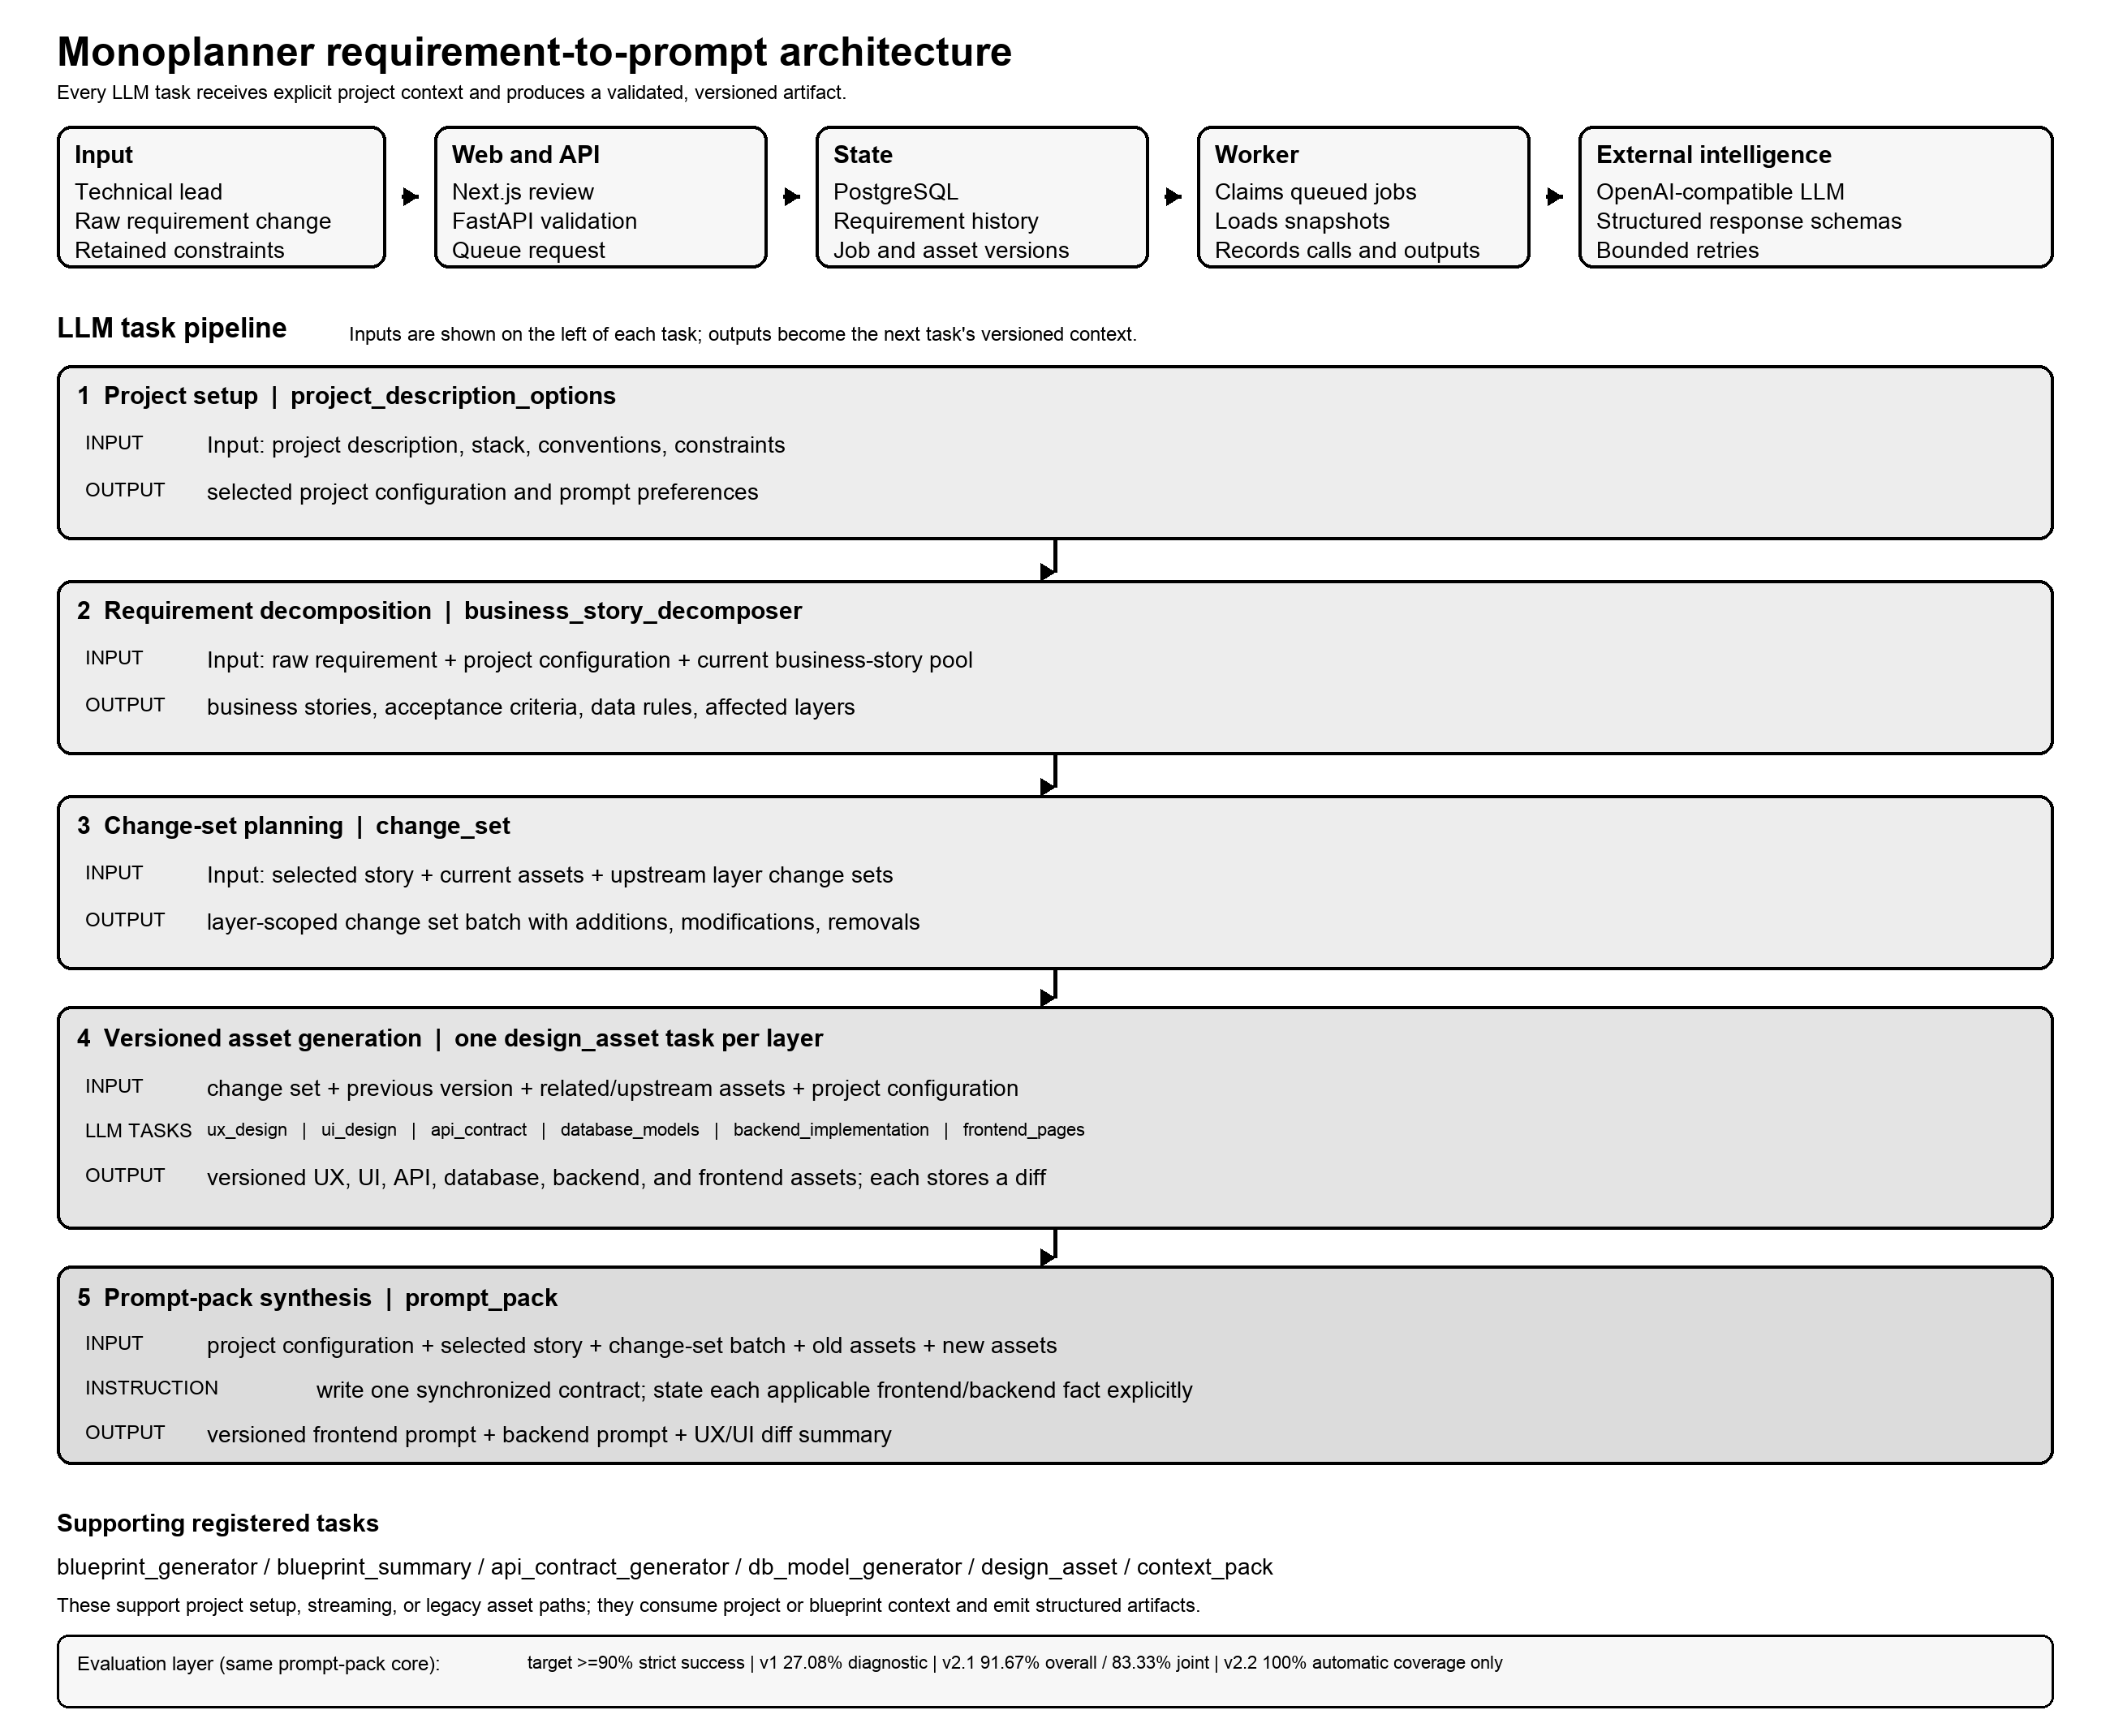
Figure 1 Requirement-to-prompt architecture, LLM tasks, and evaluation evidence

Data and evaluation redesign
The milestone proposed self-generated synthetic data and broad metrics including build success, code quality, time, and cost. That design would have allowed model-generated data to be graded by another model and would have attributed coding-agent performance to the orchestrator. I replaced it with ten authored requirement chains grounded in the pinned FastAPI full-stack template. Each chain contains three consecutive hypothetical changes. Two chains form the development set and eight form the held-out test set. They are documented as designed scenarios rather than upstream project history.
The first protocol evaluated atomic facts expected after each change. Human review classified each fact as consistent, contradictory, omitted, uncertain, or a common error. A contradiction required quoted evidence from both prompts. Missing and uncertain facts made a pack non-evaluable, while a common error prevented strict success even when the two prompts agreed. This matters because a contradiction count of zero can be misleading when a prompt is empty or incomplete.
The first run exposed a flaw in my measurement. Many expected historical facts were absent from the model input, so both methods omitted the same information. I redesigned the data around change_facts and active_contract_facts. Each active fact specifies applicable sides and whether it must be explicit or may be derived. Stable markers support traceability, but marker and exact-statement checks remain separate from human semantic judgment. Answers remain separate from generation, review is blinded, and failed units remain in the denominator.

Measured outcomes and performance tuning
The v1 held-out run completed all 48 planned packs across 24 changes and two methods. Human review covered 688 fact judgments. Strict success was 27.08 percent, the omission rate was 39.68 percent, and two contradictions were observed. The rule baseline achieved seven successful packs and the joint method achieved six. More importantly, 19 of 24 paired steps had identical omission sets, confirming that hidden historical expectations dominated the score. I treated the low score as a protocol diagnosis rather than tuning the model against faulty labels.
The v2 pilot supplied the active contract explicitly and tested six development changes with the rule and joint methods. The first version showed that the joint prompt could emit a fact ID without stating the value. I changed the instruction to require the complete statement and target value. In v2.1, all 12 packs completed with 100 percent structural validity, marker coverage, and exact-statement coverage. Human review of 82 facts found 81 consistent and one uncertain. Overall semantic coverage was 98.78 percent and strict success was 91.67 percent. The rule baseline scored 100 percent strict success; the joint method scored 83.33 percent.
The uncertain fact was technically informative. The prompt correctly required a 120 Unicode-code-point limit but also suggested HTML maxlength, which counts UTF-16 code units and can reject some non-BMP characters early. I then prohibited optional platform mechanisms unless their boundary, null, default, and counting semantics match the contract. The v2.2 automatic regression again completed 12 of 12 packs with 100 percent structural, marker, and statement coverage, and the unsafe suggestion disappeared. I did not repeat the same 82-item human review, so v2.2 has no semantic-success claim.
Evidence | Measured result | Interpretation
v1 | 27.08% strict success; 39.68% omissions; 2 observed contradictions | Protocol diagnosed hidden expectations
v2.1 | 91.67% overall strict success; 98.78% semantic coverage | Human-reviewed final semantic evidence
v2.2 | 100% structural and exact coverage | Automatic regression only; semantic score undefined
Table 1 Evaluation outcomes and evidence boundaries

Critical evaluation
The refined protocol is more credible than the original plan, but the evidence remains limited. All scenarios are grounded in one public repository. The v2 result covers only two development chains, one generation per step, and one reviewer, so it cannot estimate model variance or inter-rater reliability. The rule baseline's perfect v2.1 result also shows that the structured contract, rather than language generation, produced most of the measured value. Joint generation may improve readability or implementation guidance, but this study did not measure those benefits.
The direct prompt-pack experiment is also narrower than the product workflow. The supplied dataset has requirements and facts but lacks authored old and new asset snapshots and full change sets. Running the database-backed chain would therefore require inventing missing inputs after the evaluation had begun. I chose to report that layer as untested. This preserves the validity of the result but leaves a rough edge between the demonstrated product and the measured component. Operationally, the system also depends on model availability, correct project context, and developer review; schema validity alone cannot prevent a plausible shared mistake.

Future path
The next study should convert the eight held-out chains to the v2 contract schema, use sampled or two-stage review after prompt revisions, add a second reviewer, and run repeated paired generations. A separate dataset with authored asset snapshots and change sets can then test the complete database-backed workflow. Product development should add evidence links from each prompt fact to its requirement or asset source and stronger review controls for sensitive projects. Only after those steps should the project test whether synchronized prompt packs reduce implementation defects or developer time.

