**MaterialProperty:PhaseChangeDualCurve**

Material property phase change dual curve uses an equation based approach for modeling dynamic phase change materials “PCM's” with minimal inputs. The inputs are designed to match the results of differential scanning calorimetry “DSC” testing. It has outputs that show the phase change state at the timestep and averaged for the reporting frequency. By individually modeling both melting and freezing curves the dual curve PCM model provides hysteresis capabilities. Two options for modeling effects of hysteresis, shifting between curves as a straight line when temperatures change directions and tracking previous timestep phase change state.

**Construction of Enthalpy Curve**

The model uses polynomial fitting curves to describe the properties of PCM adapted from the Ginzburg-Landau theory of phase transitions. Dependent upon the composition, congruency and if the material is eutectic; PCM's can exhibit discontinuity at the melting temperature (Figure 1 Curve A) thus enthalpy is not a unique function of temperature, or can exhibit enthalpy as a continuous function of temperature (Figure 1 Curve B). This results in a ‘mushy’ phase change state between solid and liquid regions.

To address this “mushy region” explicit equations adapted from the work of Egolf and Manz (1994) are used for the enthalpy as a function of temperature. This method is applicable to PCMs that show different widths of melting or freezing regions and different specific heats in the solid and liquid phases. Performance of the curve depends on the width of the melting and freezing regions. For a narrow melting or freezing range, the curve is steep (Figure 1 Curve A) and includes minimal characteristic rounding above and below the melting region.

**Figure 1** Discontinuous (A) and continuous (B) functions for enthalpy (Adapted from Egolf and Manz 1994)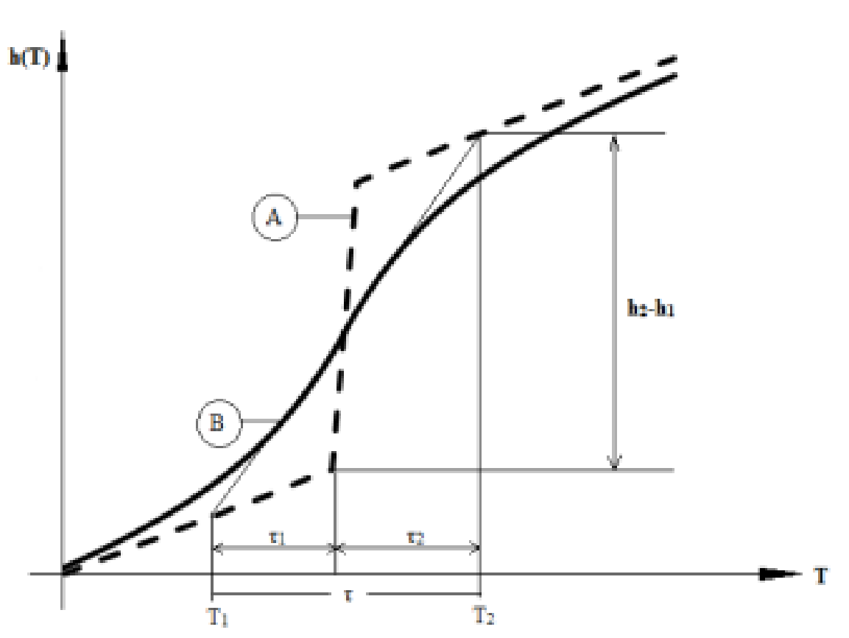

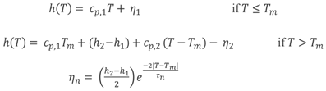

Where

Cp,1 = specific heat in solid state (J/kg-k)

Cp,2 = specific heat in liquid state (J/kg-k)

Tm = Melt (Or Freeze) temperature (°C)

h2-h1 = Latent Heat stored (J/kg)

Tn = Melt (Or Freeze) range

**Figure 2: Equations used in Dual Curve PCM model:** Above are the equations for enthalpy as a function of temperature used in the model for both the melting and freezing curves adapted from the work of Egolf and Manz (1994).

**Modeling options:** There are two hysteresis modeling methods, curve switch and curve track as described below:

## CurveShift:

Figure 3a shows the transition between melting and freezing is a straight line model (y = mx + c) between the two curves. Hysteresis modeling is accomplished as the current thermo-physical state of PCM is based upon the temperature of the material sampled at a previous time; if the temperature shows an increase the model assumes melting curve, whereas if it decreases, the model assumes freezing curve. The transition process is modeled as a straight line between the two curves. Reference: Bony and Citherlet 2007.

## CurveTrack:

The curve track method assumes that the material will follow the same curve until a full transition has been made. CurveTrack tracks the phase change state, and when a full transitions has been made switches from melting to freezing curve, as shown in Figure 3(b). This transition occurs similarly when switching from the freezing to the melting curve. Hysteresis for such materials is seen only when it cools from a complete liquid state This approach is based on the research of Som Shrestha, PhD at Oak Ridge National Lab.

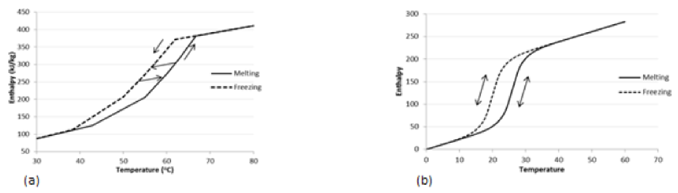

Figure 3 Hysteresis methods: (a) CurveShift and (b) CurveTrack

**Input correlations**

The following inputs use the corresponding formulas to calculate their values.

***Temperature Coefficient of Thermal Conductivity***

Units for this parameter are W/m-K2. The thermal conductivity is obtained from:



***Latent Heat of Fusion***

*(h2 - h1)*  (See Figure 4)

***Latent Heat of Solidification***

*(h2’ – h1’)* (See Figure 4)

***Peak Melting Temperature***

***(Tm)*** (See Figure 4)

***Peak Melting Temperature***

***(Tf)*** (See Figure 4)

***Melting Curve Low Temperature Difference (τ1)***

 (See Figure 4) The total melting range *τ* of the material is the sum of *τ1* and *τ2*

***Melting Curve High Temperature Difference (******)***

 *(*See Figure 4)The total melting range *τ* of the material is the sum of *τ1* and *τ2*

***Freezing Curve Low Temperature Difference (***

 *(*See Figure 4)The total freezing range *τ’* of the material is the sum of *τ1’*and *τ2’*

***Freezing Curve High Temperature Difference (***

 (See Figure 4) The total freezing range *τ’* of the material is the sum of *τ1’*and *τ2’*

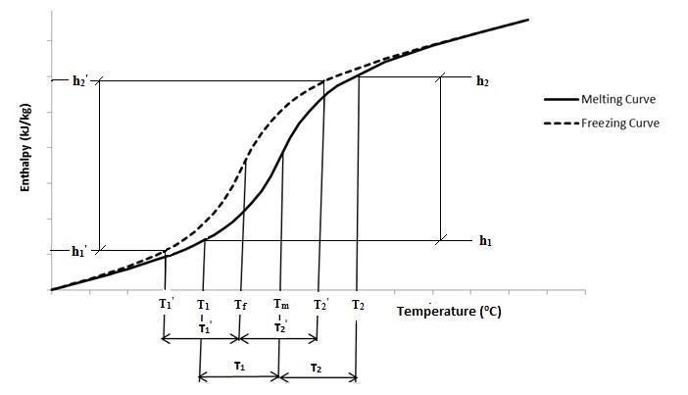

***Figure 4: Enthalpy vs. Temperature graph showing Energy Plus input parameters***